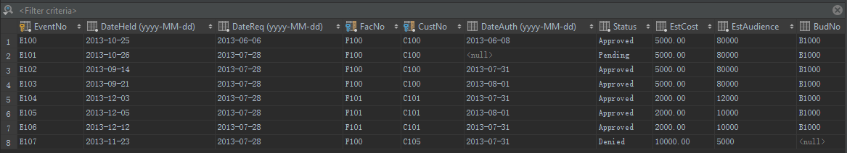

**CREATE TABLE** EventRequest  
(  
 EventNo **CHAR**(8) **PRIMARY KEY NOT NULL**,  
 DateHeld **DATE NOT NULL**,  
 DateReq **DATE NOT NULL**,  
 FacNo **CHAR**(8) **NOT NULL**,  
 CustNo **CHAR**(8) **NOT NULL**,  
 DateAuth **DATE**,  
 **Status VARCHAR**(8) **NOT NULL**,  
 EstCost **DECIMAL**(10, 2) **NOT NULL**,  
 EstAudience **INT NOT NULL**,  
 BudNo **CHAR**(8),  
 **CONSTRAINT** EventRequest_facility_FacNo_fk **FOREIGN KEY** (FacNo) **REFERENCES** facility (FacNo),  
 **CONSTRAINT** EventRequest_customer_CustNo_fk **FOREIGN KEY** (CustNo) **REFERENCES** customer (CustNo),  
 **CONSTRAINT** Chk_Status **CHECK** (**Status IN** ("Approved", "Denied", "Pending"))  
)

Added a constraint after the table was created

**ALTER TABLE** eventrequest  
 **ADD CONSTRAINT CHECK** (EstAudience > 0);