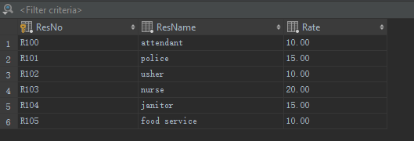

CREATE TABLE ResourceTbl

(

ResNo CHAR(8) PRIMARY KEY NOT NULL,

ResName VARCHAR(50) NOT NULL,

Rate DECIMAL(8, 2) NOT NULL,

CONSTRAINT chk_Rate CHECK (Rate > 0)

);