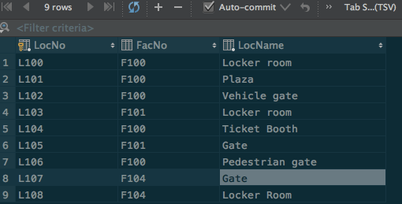

**UPDATE** location  
**SET LocName** = **'Gate'**  
**WHERE LocNo** = **'L107'**;