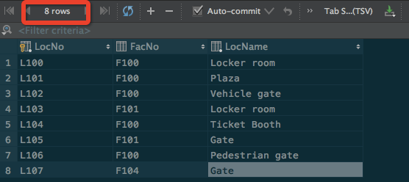

**DELETE FROM** location **WHERE LocNo** = **'L108'**;