**Shop Bridge Development Tracking**

|  |  |  |
| --- | --- | --- |
| **Sr. No.** | **Task** | **Time in Hrs.** |
|  | Backend Functionality | 6 |
|  | Frontend Functionality | 1 |
|  | Fronted Presentational aspects | 2 |
|  | Backend Fronted Integration | 2.5 |
|  | Unit Test Coverage | 3.5 |
|  | Documentation | 4 |

Notes:

1. Download folder provided at github at link <https://github.com/Vrushh47/ShopBridge>
2. Go to the link
3. Click on “Code” button
4. Click on Download Zip

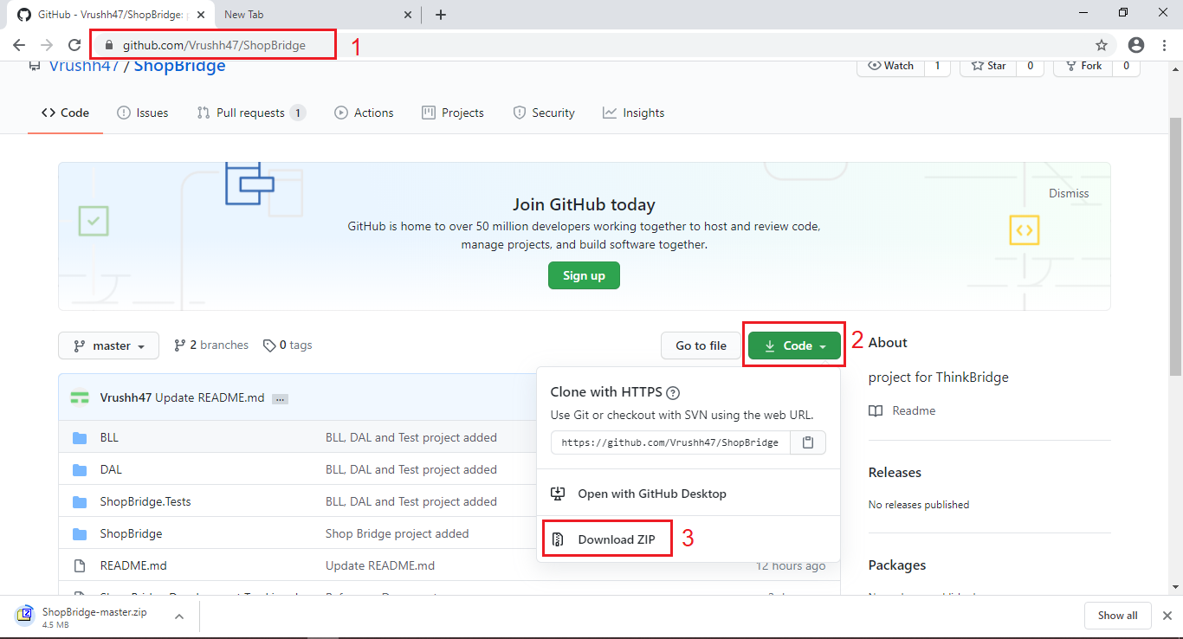

1. Extract Project to local computer
2. Double click on zip file

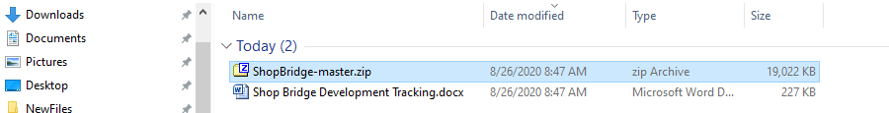

1. Click “Extract” button

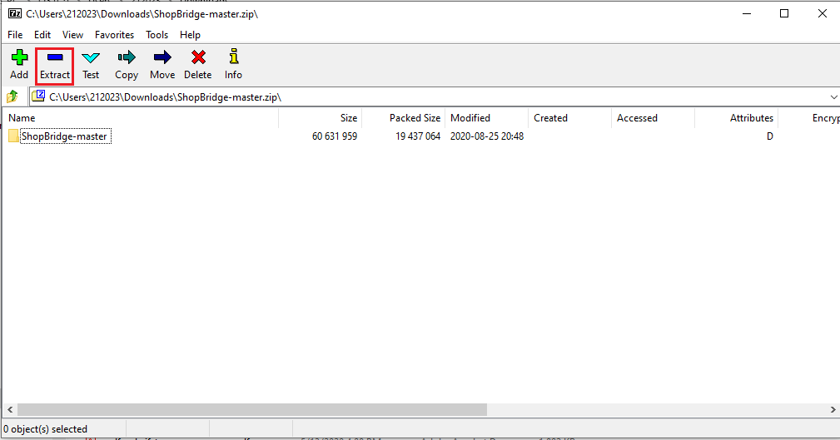

1. Choose desired location and press “OK” button

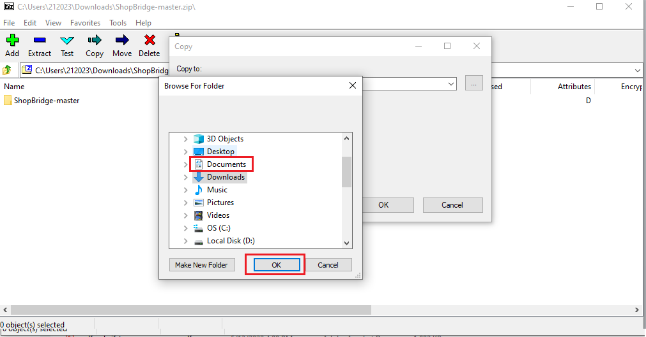

1. Attach Database files
2. Make Sure you have SQL Server installed at your local machine

Open Sql Server management Studio, login to localhost.

Right click on database, Then click Attach. Choose .ShopBridgeDB.mdf present in “\ShopBridge-master\Database Files” i.e. extracted folder.

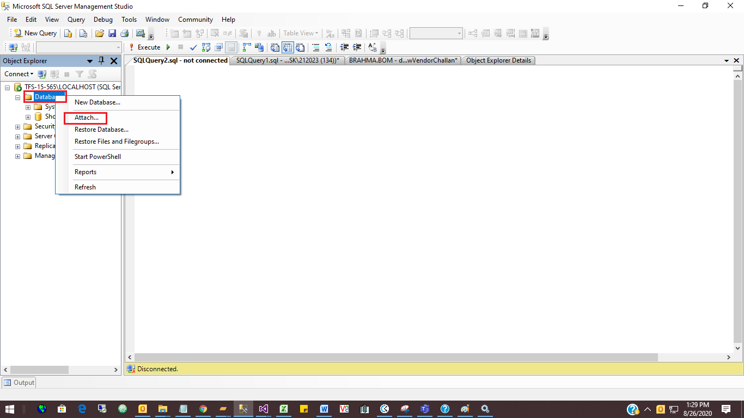

After attaching file you will able to see ShopBridgeDB database

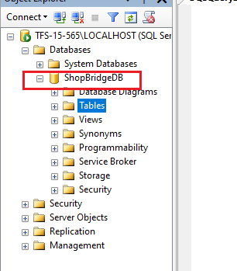

1. Open Solution & Restore packages
   1. Go to the extracted location, double click on ShopBridge.sln file

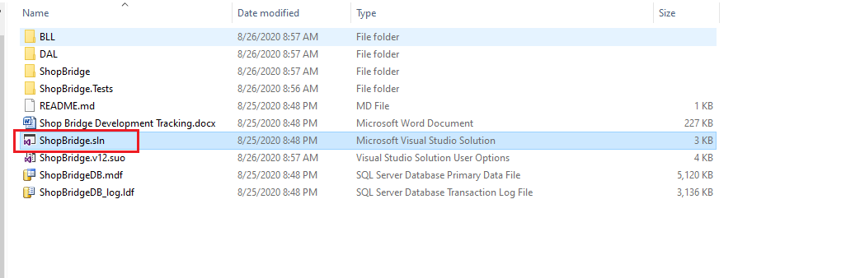

* 1. Make Sure you have Visual Studio 2017 or above. Also .Net Framework 4.7.2 or above. If desired framework is not present not it will promt. Select Download Framework option and press OK.

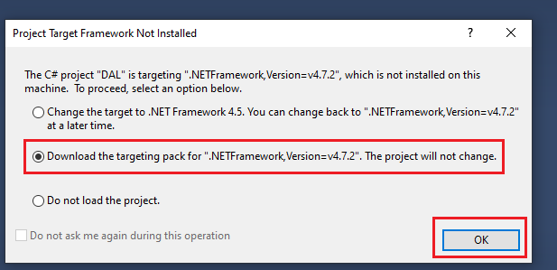

* 1. Now click on Tools->Nuget Package Manager->Package Manager Console

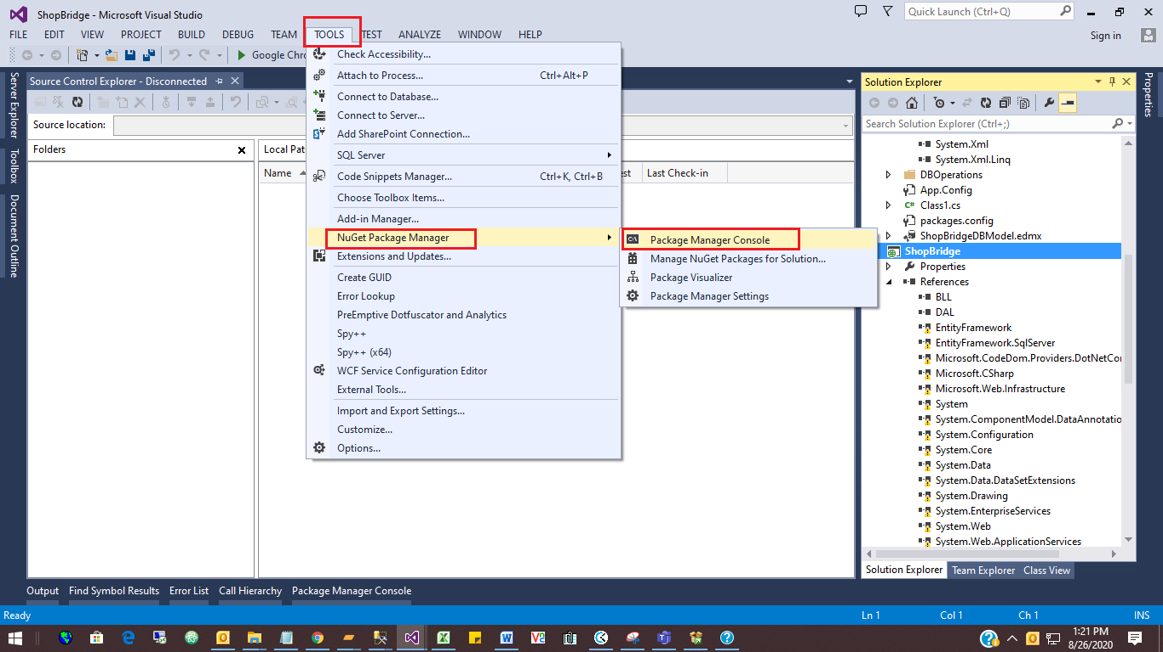

Then Click on “Restore” button to get nugget packages

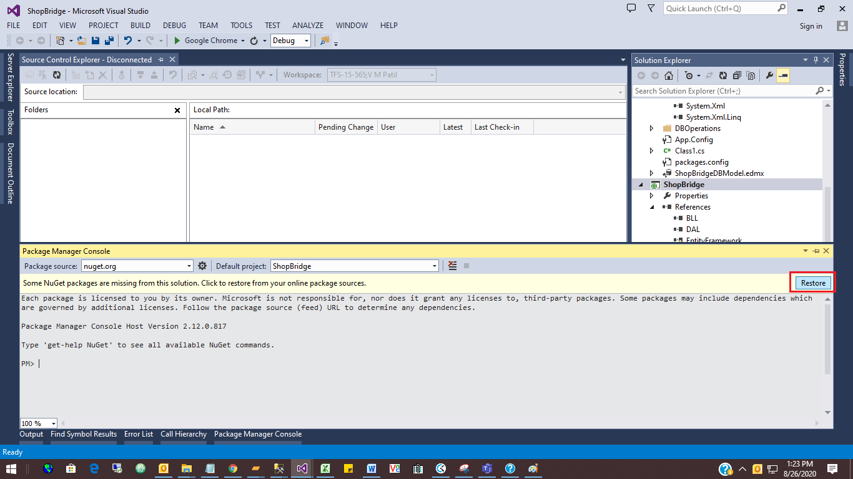

1. Change connection string to present in DAL/App.config & ShopBridge/web.config file
2. Now Run the project

Demo:

1. Start-up page

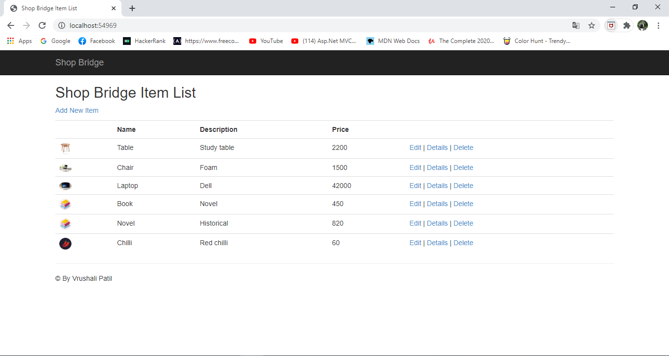

1. New item Add page

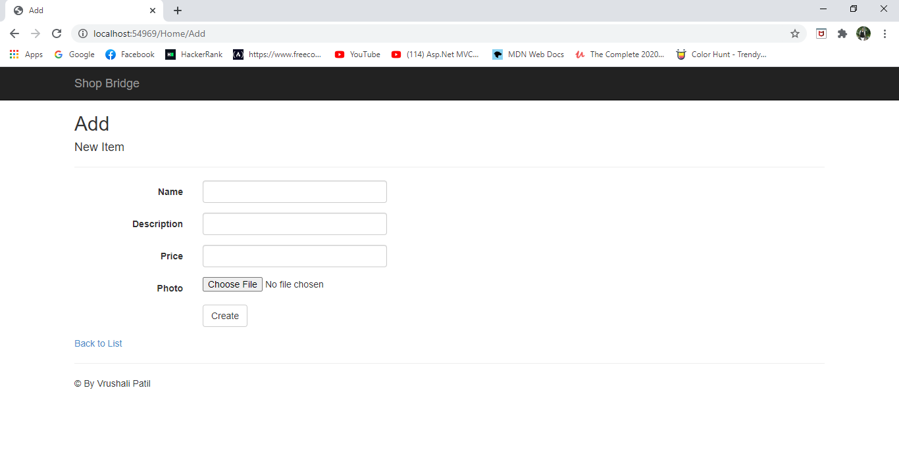

1. Edit Item Page

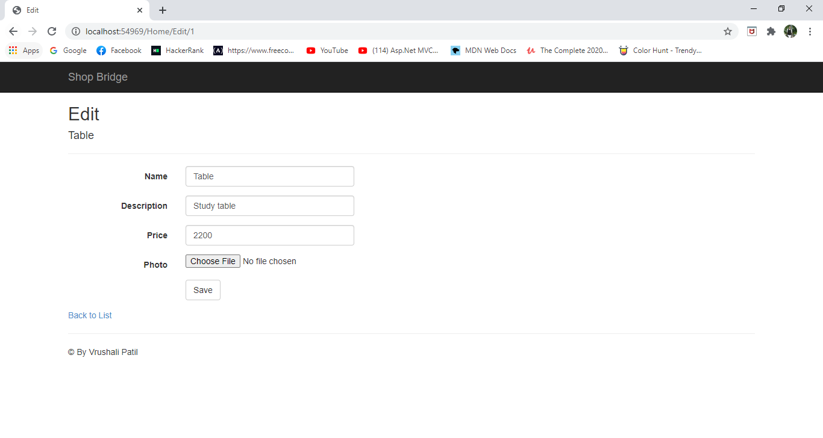

1. Details page

