BIG MOUNTAIN RESORT

$81.00 | $95.87 | +$14.87 | ~$0.88
Current Ticket Price | Model-Supported Price | Pricing Opportunity | New Chairlift Cost/Ticket

1. Problem Statement
Big Mountain Resort (Montana, 105 trails) recently installed a new chairlift adding $1,540,000 in seasonal operating costs. The business needed a data-driven answer to two questions: are we pricing our tickets correctly, and which facility investments will strengthen our market position?
A machine learning model was trained on competitor US resort data to predict the ticket price Big Mountain's facilities can support — and four investment scenarios were modelled. Revenue calculations assume 350,000 annual visitors buying an average of 5 tickets each.

2. Data Wrangling and Exploratory Analysis
The raw dataset had 330 US ski resorts and 27 features. Key cleaning steps:
- fastEight column dropped — over 50% missing, all remaining values were zero.
- Silverton Mountain corrected — skiable area recorded as 26,819 acres (transcription error); confirmed real value is 1,819 acres.
- 53 rows dropped — resorts with no ticket price data at all. Final dataset: 277 rows, 25 columns.
- Target: AdultWeekend — Montana resorts charge identical weekday/weekend prices; weekend had fewer missing values.
State PCA captured 77% of variance in 2 components with no geographic pricing pattern — all states treated equally.
The correlation heatmap below confirms fast quads, vertical drop, and snow making as the strongest positive predictors.
Skiable terrain area is slightly negative — more terrain with the same lifts means thinner coverage per skier.

Figure 1: Feature Correlation Heatmap (Notebook 03 — EDA, Section 3.5. 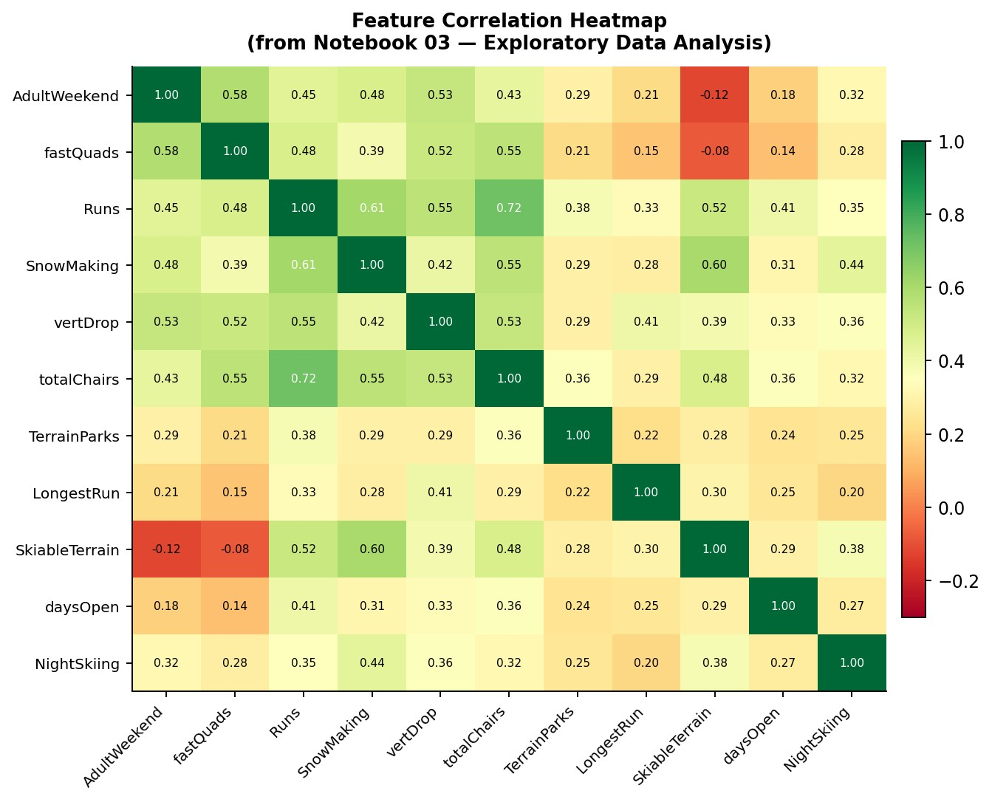5.2). Green = strong positive correlation with ticket price. fastQuads, vertical_drop, Snow Making_ac, and Runs are the top drivers. SkiableTerrain_ac is slightly negative.
3. Modelling and Evaluation
 | Preprocessing | Median imputation, StandardScaler (linear only), SelectKBest k=8 via GridSearchCV
 | Train / Test | 70% train, 30% test — random_state=47 for reproducibility
 | Validation | 5-fold cross-validation on all models before final test evaluation
 | Big Mountain | Excluded from training — price predicted purely from competitor data
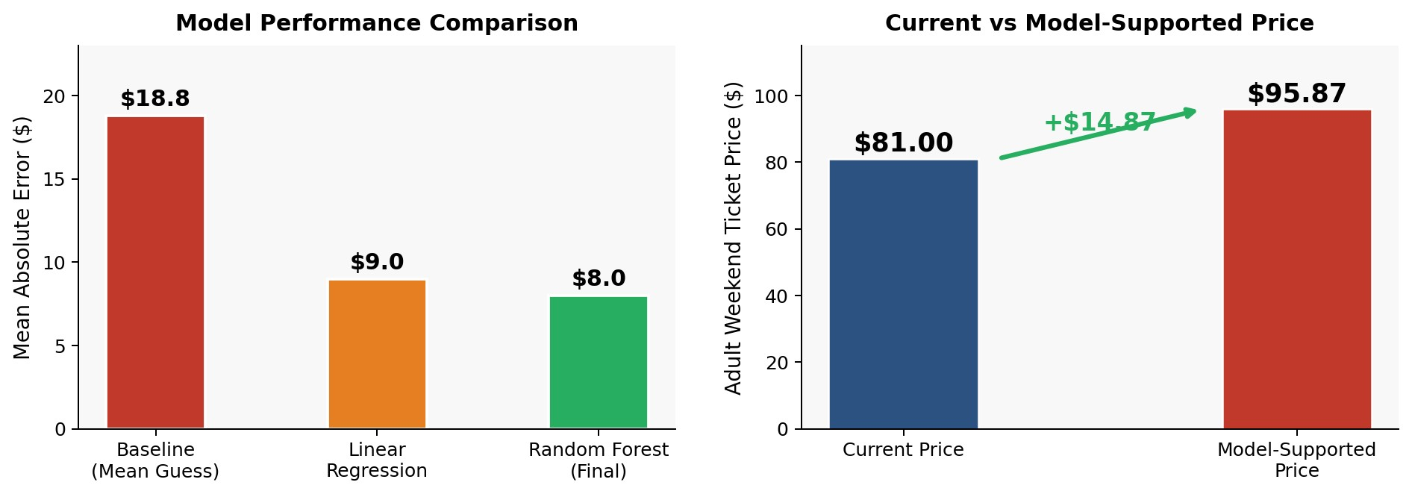
Figure 2 (left): Model MAE comparison — Random Forest cuts the baseline error by over 57%. Figure 2 (right): Big Mountain's current $81.00 vs the model-supported $95.87 — a $14.87 pricing gap.
- Baseline (Dummy): Always predicts the training mean. MAE = $18.80, R² = 0. The floor every real model must beat.
- Linear Regression: Median imputation + scaling + SelectKBest (k=8). Explains 80%+ variance on train, 70%+ on test. MAE ≈ $9.00. CV and test consistent.
- Random Forest (selected): Median imputation, no scaling needed. CV MAE ≈ $8.00 — nearly $1 lower than linear regression, less fold variability, test matched CV.
Why Random Forest? Better accuracy, handles non-linear patterns naturally, stable cross-validation, and test results matched CV — clear signs the model genuinely generalises to unseen data.
4
. Pricing Recommendation
Ticket-days/season
350,000
visitors x 5 =
1,750,000
New lift cost/ticket
$1,540,000 / 1,750,000 = ~$0.88
Pricing gap
$95.87 - $81.00 = $14.87 (17x the lift cost per ticket)
Break-even
A $1/ticket increase = $1,750,000 — covers the lift cost in full
How to present to leadership:
Lead with the facility comparison charts — once executives see Big Mountain in the top
quartile on snow making, chairs, vertical drop, fast quads, and runs while charging less than inferior competitors, the
$95.87 lands as a natural confirmation. Recommend a phased approach: $86 in Year 1, $91 in Year 2. Be honest about the
~$8 model margin of error.

5. Scenario Analysis
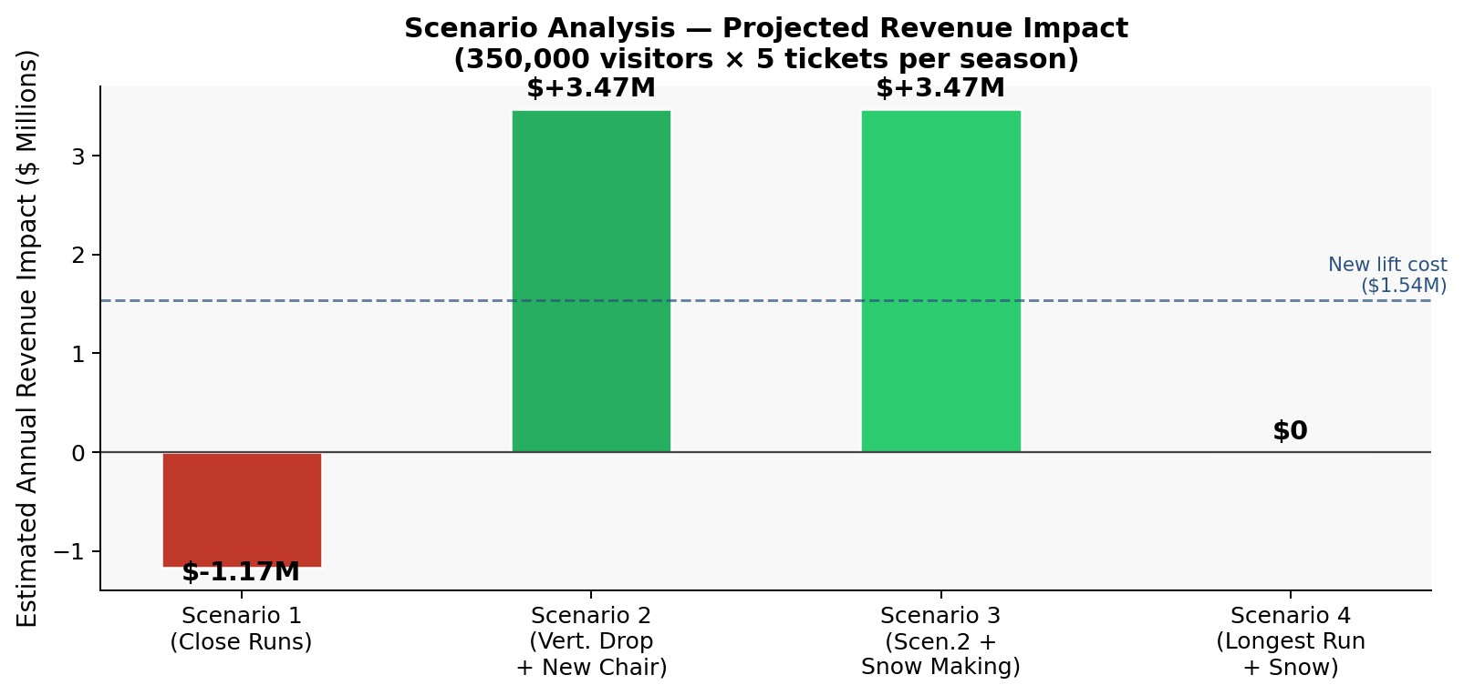
Figure 3: Projected annual revenue impact by scenario (350k visitors x 5 tickets). Scenario 2 generates +$3.47M — more than double the new lift's $1.54M operating cost (dashed blue line).
- Scenario 1 — Close Runs: Only reduces revenue. Closing 1 run = no impact. Closing 2-5 = gradual drop (~$0.67/ticket). Closing 6+ = large drop (>$1.26/ticket). Pilot 1-2 runs off-peak before any permanent decision.
- Scenario 2 — Vertical Drop +150ft + New Chair RECOMMENDED: +$1.99/ticket, estimated +$3,474,638 seasonal revenue. Targets the two strongest price drivers simultaneously.
- Scenario 3 — Scenario 2 + 2 Acres Snow Making: Identical result to Scenario 2. Big Mountain already leads the market on snow coverage — 2 extra acres adds nothing to price.
- Scenario 4 — Extend Longest Run + Snow Making NOT RECOMMENDED: Zero revenue impact. Longest run ranks very low in feature importance.
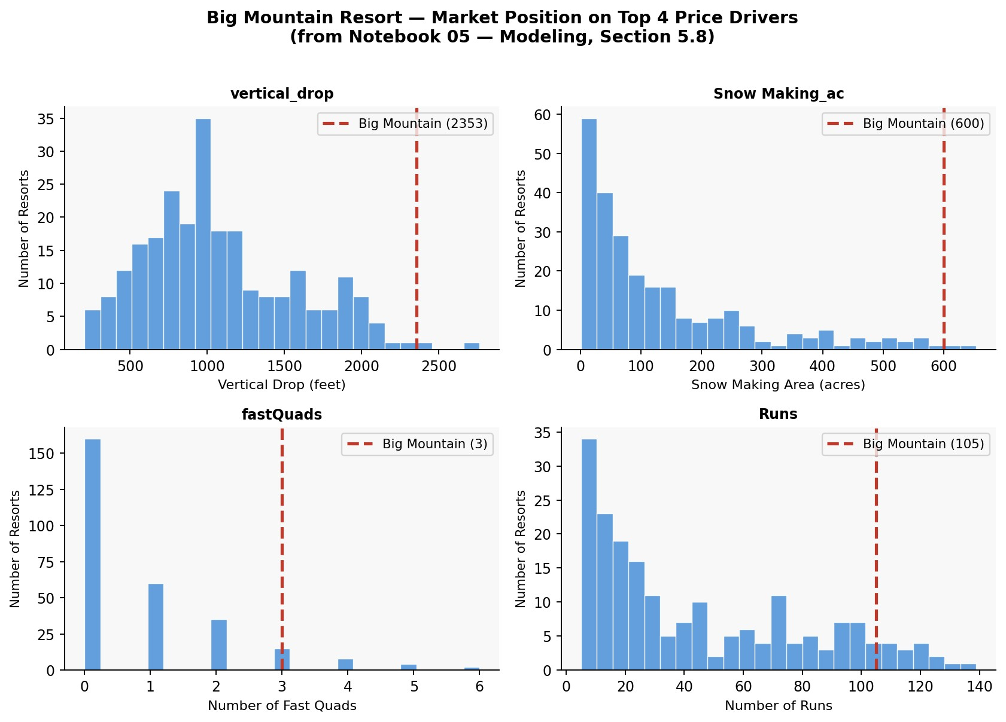
Figure 4: Big Mountain's position vs all US resorts on the 4 key price drivers (Notebook 05 — Modeling, Section 5.8). The red dashed line marks Big Mountain — well above the market average on every metric, confirming the $14.87 underpricing gap.

6. Conclusion and Future Scope

Conclusion
Big Mountain has elite-level facilities yet charges less than resorts with fewer amenities. The model confirms a $14.87 pricing gap. The new chairlift at $0.88/ticket is easily absorbed within this headroom. Scenario 2 (vertical drop extension + new chair) is the priority investment at an estimated +$3.47M seasonal revenue. Raise prices in phases — $86 then $91 — while piloting run closures carefully.

Future Scope
- Real visitor count data to replace the assumed 350k figure — improves revenue accuracy.
- Full operating cost breakdown (staffing, maintenance, utilities) to assess profitability, not just revenue.
- Demand elasticity analysis — understand how visitor numbers respond to price increases.
- Deploy as a Streamlit self-service tool so analysts can run scenarios without needing a data scientist each time.
- Incorporate multi-year data and guest satisfaction scores for a richer model.

