**Pidgeoto Angry Birds Strategy: An AI Bot to Combat the Angry**

|  |  |  |
| --- | --- | --- |
|  | **Birds Game Engine** |  |
| Vrushti Joshi | Devaja Shah | Nikhil Reddy |
| DA-IICT | DA-IICT | DA-IICT |

# ABSTRACT

The paper briefly describes the approach taken in developing *Pidgeoto Angry Birds Combat Agent* for solving the AI Bird problem. The approach takes into account the various scenarios based on a detailed analysis of the game-play levels and the structure and after learning from its environment and observing it; accordingly, dynamically modifies the shooting strategy, w.r.t. the different bird types as well as the structure positioning.

# INTRODUCTION

*Pidgeoto* is an automated Angry Birds agent developed by aforementioned students of DA-IICT as a part of the project for the Artificial Intelligence Course taught by Professor Sourish Dasgupta.

# APPROACH OVERVIEW

Here; we apply the principles of our learning in Artificial Intelligence to simulate the bot that we create to battle the Angry Birds environment.

Just like any other AI agent we start out by observing and analyzing as well as learning from our surroundings, which comprises of obstacles in the form of wood, ice, stone and hills. The obstacles have been divided into non-reward bearing ones – the hills and reward bearing ones which includes the remaining, and have been targeted accordingly.

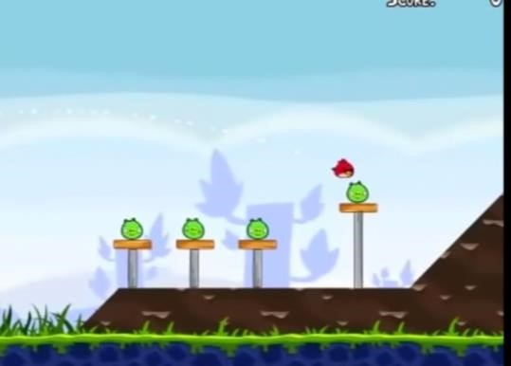

1. Pigs are completely exposed with no frontal obstacle but with a supporting obstacle scenario

The location of the structures has been calculated in the analysis of the environment section by utilizing the MBR functionality and deducing the particular obstacles and classifying them. Based on the location of the reward bearing obstacles and their types; they were grouped into their wood, ice and stone object arrays.

The pigs are the main reward earning target point for the bot and are supposed to be the goal checkpoints/mini goals as per the terms of the environments described in normal AI problems. Henceforth while carrying out the main attacking action of the Agent our primary target point is the pig and hence, the basic target aim deduction techniques are aimed at effectively locating and destroying them. We locate all the pigs in the picture via the MBR and store them in an array with increasing X coordinates from the bird to facilitate easy access. After selecting pigs from amongst them based on a randomized algorithm we implement the deduction of the coordinates of the surrounding obstacles based on the location of the pig.

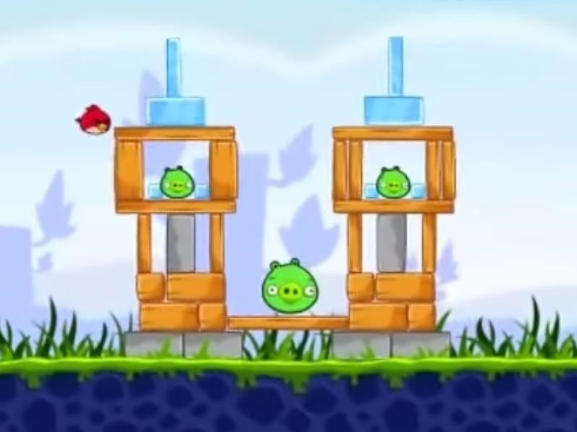

1. Pigs are surrounded by obstacles with supporting structures scenario

After storing all the obstacles to the left of the pig and classifying them, the obstacles of minimum distance to the pig are procured.

After that we use the function to determine the type of the bird that performs out the shooting action, since different birds have different penetration capacities for the different types of obstacles.

We finalized on the characteristics of the birds at our disposal and based on that linked each to the corresponding surfaces which are preferable to attack as a part of the strategic planning; thus looking at maximizing the point collection by hitting the correct surfaces with the instantaneous bird at hand.

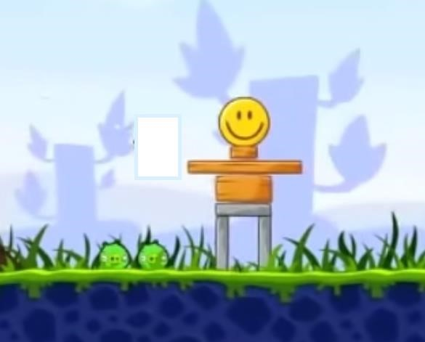

1. Pigs are directly on the ground with no obstacle scenario

We determine the type of the bird and carry out the normal procedure for the common red bird. But search out for the wood obstacles first, then ice and then stone in the case of the yellow bird and ice obstacle first, then wood and then stone in the case of the blue bird. Also; for the blue bird, the timing of the tapping for splitting into three birds is also arranged strategically so as to receive maximum coverage of the target area.

Then amongst the finalized array of obstacles we finally check for the supporting structures to the pig and aim at the one nearest to the pig as per the Y coordinates.

If none of these conditions return a recognized obstacle as its output value then the scenario under consideration will be that of the pig touching the ground in which case we hit the pig directly.

The three generalized classified game play scenarios covered here are:

All the pigs are completely exposed

All the pigs are completely covered/enclosed

Some pigs are exposed (in the outer areas serving themselves as obstructions to the other pigs) and the rest are enclosed behind wood/glass/stone

Here; while carrying out all the functions, the primary importance is allotted to the killing of the pigs since birds cannot be afforded to be wasted as their lives carry a larger point chunk than mere destruction of a few logs of wood or stone pieces and so all the strategic decisions are kept in mind aiming at direct pig destruction instead of indirect pig destruction via the obstacle deraignment.

Score till 21st level is: 718640

# ACKNOWLEDGMENTS

We deeply acknowledge the authors and developers of *Angry Birds* for the help and guidance through the development period. We would like to thank our professor Sourish Dasgupta under whose guidance we worked on the formulation of the strategy.