Assignment – 5
VRUTTI PATIL – 150096724165
GITHUB LINK - https://github.com/Vrutti88/EMBatchAssignments.git

1. Assignment Overview
This assignment implements a modern Todo List application using Flutter and Dart. The primary objective is to demonstrate local reactive state management using StatefulWidget and setState(). The application supports adding tasks, marking tasks as completed or incomplete, and deleting tasks. It also includes dynamic Total, Done, and Pending counters and an empty-state UI.
The supplied project README identifies the project as a Flutter & Dart Todo List application using StatefulWidget, setState(), ListView.builder, TextEditingController, and Material Design 3.

2. Assignment Objectives
- Use StatefulWidget to maintain changing application state.
- Use setState() to refresh the UI after state changes.
- Allow users to add Todo tasks.
- Allow users to mark tasks complete or incomplete.
- Allow users to delete tasks.
- Display tasks dynamically using ListView.builder.
- Maintain real-time Total, Completed, and Pending task counts.
- Provide a clean, responsive, and user-friendly Material 3 interface.

3. Key Features
Feature | Description
Quick Task Creation | Tasks can be entered through the input field and added with the Add button. Empty tasks are prevented.
Real-time Statistics | Total, Done, and Pending counters update as tasks change.
Task Completion | Tasks can be toggled complete/incomplete with visual strikethrough and status text.
Task Deletion | Tasks can be removed with a single tap on the delete icon.
Empty State | A helpful message is shown when no tasks are present.
Material 3 UI | Uses a modern indigo theme, rounded cards, curved header, icons, spacing, and soft shadows.

4. User Interface and Layout
The interface is designed to be simple and modern. A deep indigo header contains the application title, a dynamic remaining-task message, and three statistics cards. Below the header is a rounded task-entry field and an Add button. Todo items are displayed as white rounded cards with a custom completion control, task title, status, and delete icon.
- Header banner with curved bottom corners.
- Total, Done, and Pending statistics cards.
- Rounded task input field with edit icon.
- Large Add button for quick task creation.
- Rounded task cards with subtle shadows.
- Custom animated completion checkbox.
- Strikethrough styling for completed tasks.
- Empty-state illustration and message.

5. State Management and Reactive Flow
The application follows Flutter's declarative UI model: the interface is a function of the current state. When the user performs Add, Toggle, or Delete, the corresponding state handler modifies the _tasks list inside setState(). Flutter then rebuilds the dependent widgets and the statistics are recalculated.
User Action
↓
State Handler Method
↓
Update _tasks List
↓
setState()
↓
Recalculate Total / Done / Pending
↓
Flutter rebuilds UI
↓
Updated screen

6. Main Concepts Used

6.1 StatefulWidget
StatefulWidget is used because the Todo list changes during runtime. The state class stores the current tasks and handles user actions.
class TodoHomePage extends StatefulWidget {
const TodoHomePage({super.key});
@override
State<TodoHomePage> createState() => _TodoHomePageState();
}

6.2 setState()
setState() informs Flutter that the state has changed and that the affected UI should be rebuilt.
setState(() {
_tasks.add({
'title': task,
'completed': false,
});
});

6.3 TextEditingController
TextEditingController is used to read and manage text entered by the user. The controller is cleared after a task is successfully added.

6.4 ListView.builder
ListView.builder dynamically creates task widgets based on the number of items in the _tasks list.

6.5 Task Completion State
Each task stores a completed Boolean value. Toggling this value changes the task's visual state and status.
void _toggleTask(int index) {
setState(() {
_tasks[index]['completed'] =
!_tasks[index]['completed'];
});
}

7. Code Implementation Highlights

7.1 Adding a Task
void _addTask() {
final task = _controller.text.trim();
if (task.isEmpty) return;
setState(() {
_tasks.add({
'title': task,
'completed': false,
});
});
_controller.clear();
}

7.2 Deleting a Task
void _deleteTask(int index) {
setState(() {
_tasks.removeAt(index);
});
}

7.3 Dynamic Counters
int get completedTasks {
return _tasks
.where((task) => task['completed'] == true)
.length;
}
int get pendingTasks {
return _tasks.length - completedTasks;
}

8. Report & Screenshots
The final submission should include screenshots demonstrating the main working steps. Insert the actual screenshots in the spaces below before converting this report to PDF.

Screenshot 1 – Empty Todo List
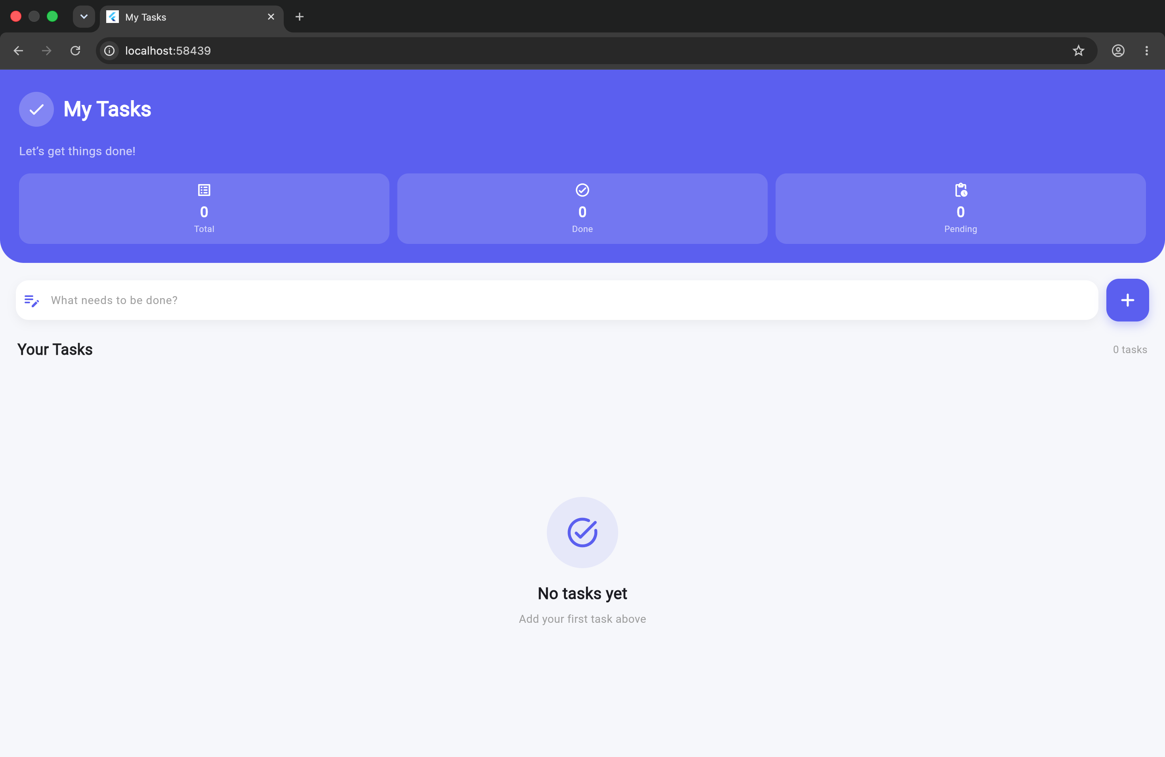

Screenshot 2 – Task Added
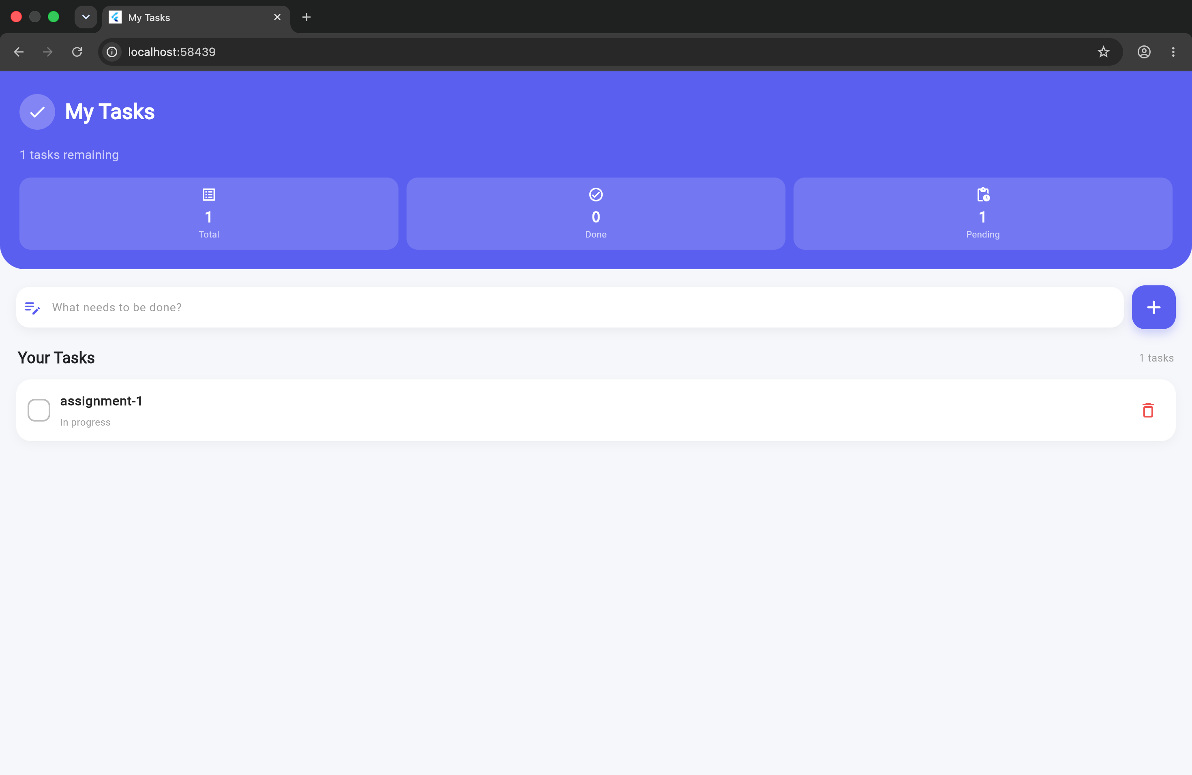

Screenshot 3 – Multiple Tasks
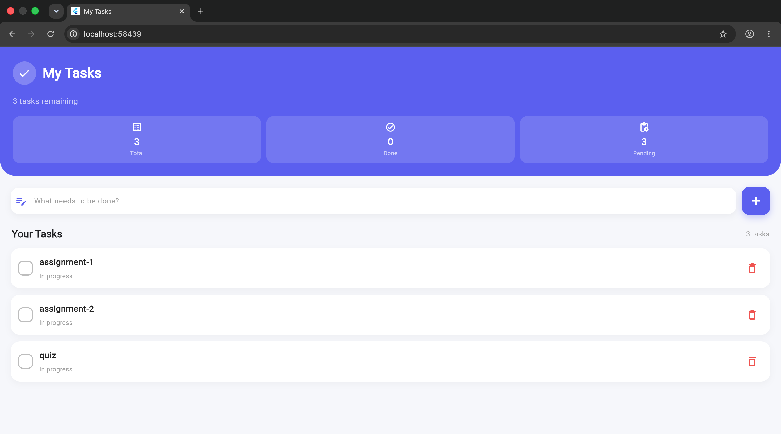

Screenshot 4 – Task Completed
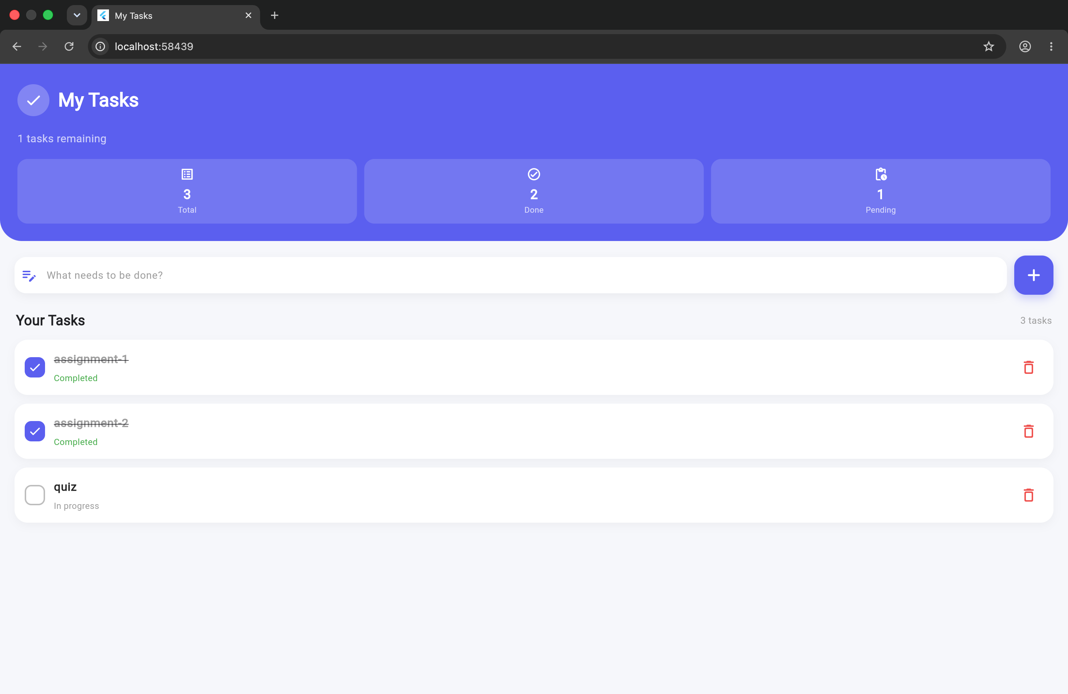

Screenshot 5 – Task Deleted
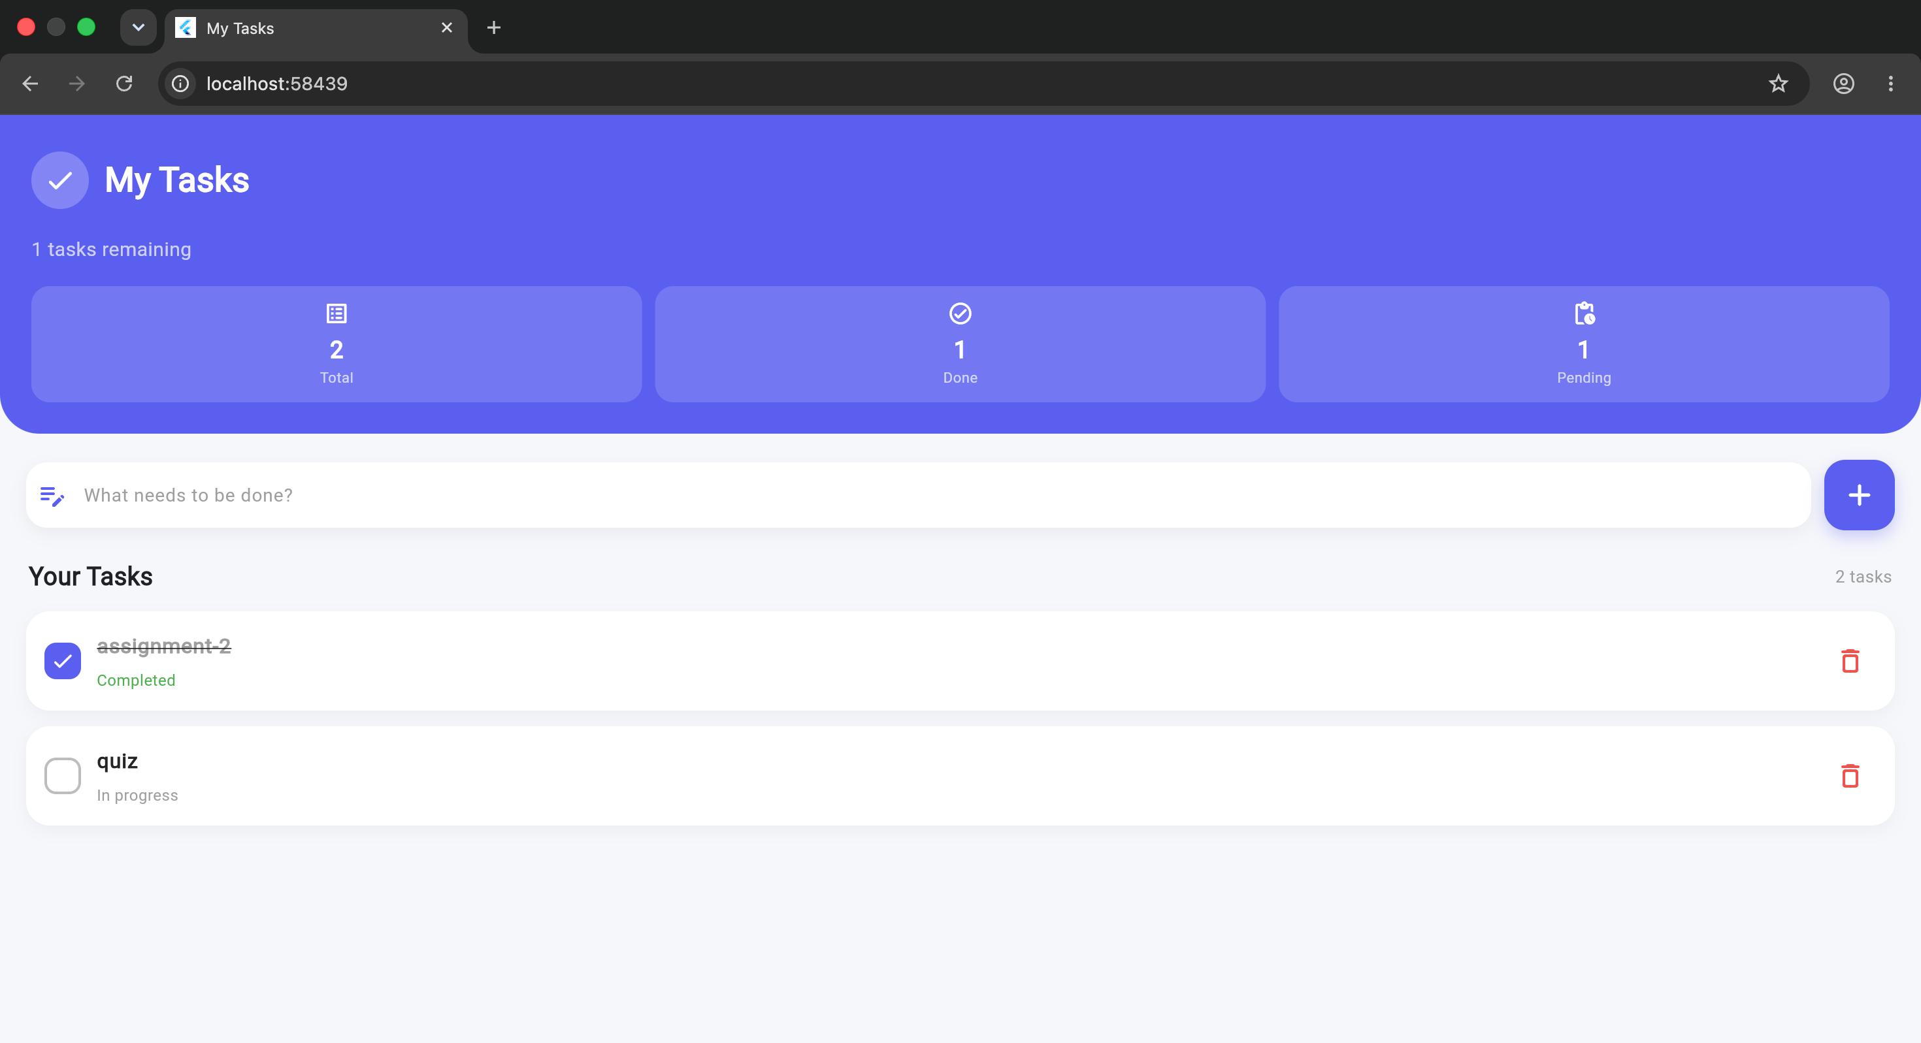

9. What I Learned
This assignment helped me understand the basic structure of a Flutter application and, more importantly, how Flutter handles changing data using StatefulWidget and setState(). Building a Todo application made the concepts practical because the screen has to react immediately whenever the user adds, completes, or deletes a task.

9.1 Understanding StatefulWidget
I learned that StatefulWidget is useful when the data or appearance of a widget can change while the application is running. A Todo List is a good example because the number of tasks and their completion states are not fixed. The state class stores the current task data and provides the methods required to change it. This helped me understand the difference between a static UI and a UI that depends on changing state.

9.2 Understanding setState()
The most important concept I learned from this assignment was setState(). I understood that simply changing a Dart variable or list does not automatically tell Flutter to update the screen. When a state value changes, the change is placed inside setState() so Flutter knows that the widget needs to rebuild. I used this concept for all three required operations: adding, deleting, and completing tasks.
setState(() {
_tasks.removeAt(index);
});
This example removes the selected task and then causes the relevant widgets to rebuild. As a result, the deleted task disappears and the statistics are recalculated.

9.3 Working with Lists and Dynamic Data
I learned how a List can be used to store multiple Todo items and how each item can contain both a title and a completed status. I also learned how indexes are used to identify a particular item when deleting or updating a task. This was useful for understanding how dynamic collections are handled in Flutter.

9.4 User Input with TextEditingController
I learned how TextEditingController can be used with a TextField to read the text entered by a user. The input is trimmed before it is stored, and empty input is rejected. After adding a task, the controller is cleared so the user can immediately enter another task. I also learned the importance of disposing the controller when the widget is removed.

9.5 Building Dynamic Lists with ListView.builder
I learned how ListView.builder() can generate a list of widgets dynamically. Instead of creating a separate widget manually for every task, the builder receives an index and creates the appropriate task card. This makes the Todo list flexible because the number of tasks can increase or decrease while the application runs.

9.6 Understanding UI Based on State
I learned how the same data can control different parts of the UI. For example, when a task is incomplete, it is shown normally with an 'In progress' status. When the completed value becomes true, the task receives a checkmark, strikethrough text, and a 'Completed' status. The Total, Done, and Pending values also change automatically based on the current list.

9.7 Learning Basic Flutter UI Design
I also learned that functionality and UI design need to work together. I used Flutter widgets such as Container, Row, Column, ListTile, TextField, IconButton, and ListView.builder to create the interface. Rounded corners, spacing, icons, cards, shadows, and a consistent indigo theme make the application easier to understand and more pleasant to use.

9.8 Problems Faced and Solutions
One problem I faced was understanding why the UI did not change if the list was modified without properly calling setState(). This helped me understand that Flutter needs to be notified when state changes.
Another problem was identifying the correct task during delete and completion operations. I solved this by using the index supplied by ListView.builder() and passing that index to the relevant state-handling method.
I also needed to prevent empty tasks from being added. I solved this by trimming the input and checking whether the resulting string was empty before modifying the list.
Finally, I had to make sure that completing one task did not change other tasks. Storing a separate completed Boolean value for each task solved this issue.

9.9 Overall Learning Outcome
Overall, this assignment gave me practical understanding of Flutter's reactive approach to UI development. I learned that the UI should be designed around the application's current state, and that state-changing operations should be handled carefully. I now have a clearer understanding of StatefulWidget, setState(), lists, controllers, dynamic builders, event handling, and basic Flutter UI composition.
The Todo List project was especially useful because every required operation produces a visible result. Adding a task increases the Total and Pending values, completing a task changes Pending to Done, and deleting a task removes it and updates the counters. Seeing these changes immediately helped reinforce how state and UI are connected in Flutter.

10. Conclusion
The Todo List application fulfills the required assignment operations using StatefulWidget and setState(). It provides add, delete, and mark-complete functionality together with dynamic statistics and a modern Material 3 interface. The project demonstrates the practical use of Flutter state management concepts taught in class.

