GREENBIN
Community Recycling Pickup Scheduler App
Platform | Flutter cross-platform application
Backend | Firebase Authentication + Cloud Firestore
Hosting | Firebase Hosting
Target | Responsive Mobile, Tablet, Desktop & Web

1. Project Overview
GreenBin is an eco-friendly, responsive cross-platform Flutter application designed to help communities schedule recyclable-waste pickups, learn proper waste segregation, and track collection status in real time using Cloud Firestore.
The application connects residents with the community collection process through a simple flow: learn what can be recycled, schedule a pickup, review the request, and track its status after submission.

2. Live Web Deployment & Android APK
Target | Distribution Channel | Link / Path | Status
Web App (Live) | Firebase Hosting (Global CDN) | https://greenbin-41080.web.app | Live & Active
Alternative Web Link | Firebase App Edge | https://greenbin-41080.firebaseapp.com | Live
Android Release APK | Standalone Release Package | greenbin-release.apk | Built (Android 15 / SDK 35)
Firebase Project | Google Cloud / Firebase | greenbin-41080 | Auth + Cloud Firestore Active

3. Problem Statement
“GreenBin wants an app where a resident schedules a recyclable-waste pickup by selecting waste type and preferred date/time, and the request is stored centrally so the community's collection team can view and manage it.”

3.1 Proper Justification
Urban and suburban communities face increasing environmental and logistical challenges in handling municipal solid waste. Traditional collection processes can create problems such as:
- Inefficient Segregation at Source: Residents may not have clear, localized guidelines about recyclable materials, which can lead to contaminated recyclable waste being sent to landfills.
- Unpredictable Collection Logistics: Without centralized scheduling, collection vehicles may follow inefficient routes, wasting fuel, time, and human resources.
- Lack of Resident Feedback: Residents often have limited visibility after handing over waste, which can reduce confidence and long-term participation in recycling programs.

3.2 How GreenBin Solves the Problem
- Educational Waste Guide: Categorizes recyclables such as Paper, Plastic, Glass, Metal, Electronics, and Organic waste with clear Allowed and Not Allowed guidance. Users can start a pre-filled pickup request directly from a category.
- Centralized Cloud Scheduling: Stores pickup requests centrally in Cloud Firestore and uses clear status states such as Scheduled, Collected, and Cancelled.
- Real-Time Accountability: Firestore snapshot streams allow residents to see status changes immediately when an authorized collection team updates a pickup.

4. Objectives
- UI / Widgets: Build Schedule Pickup, My Pickups, and Waste Category Guide screens using standard Flutter Form, ListView, and Card widgets.
- Styling & Theming: Apply an eco-friendly Material 3 theme with recycling-category color coding using greens, blues, ambers, slates, and clean neutrals.
- Dart Logic: Implement type-safe named routes with arguments using AppRoutes so the selected waste category can be passed from the Guide to the Schedule form.
- Figma & UX: Design a clean, guided flow covering all required screens with step progress cues, intuitive touch targets, and responsive layouts.
- Pickup Entry Details: Show waste category, scheduled date/time, pickup address, and real-time pickup status on My Pickups cards.

5. Outcomes
- Strict Form Validation: The Schedule Pickup form validates waste category, address fields, date selection, and time slots before submission. Past dates are prevented.
- Deterministic Firestore Storage: Submitted pickup requests are created directly in Cloud Firestore with an initial Scheduled status.
- Live Status Synchronization: My Pickups reflects Scheduled, Collected, and Cancelled status changes directly from Firestore document snapshots without artificial client-side status changes.
- Seamless Guided Routing: The Waste Category Guide can open the Schedule form with the selected category already filled, reducing duplicate input.

6. Deliverables
Deliverable | Requirement | Implementation in GreenBin
Figma Design | Category guide through pickup-tracking flow | Complete design system with atomic components, multi-step scheduling forms, and tracking feeds.
UI / Widgets | Schedule form, category guide, and pickup list | SchedulePickupScreen (Form), WasteGuideScreen (Card grid), and MyPickupsScreen (ListView.separated).
Styling / Theming | Eco-friendly Material 3 theme | AppTheme with AppColors, AppTextStyles, dark mode, and category tags.
Dart Logic | Named routes with arguments & validation | AppRoutes.onGenerateRoute handling SchedulePickupArguments, PickupModel, and custom Validators.
Firestore Integration | Storing & tracking pickup request status | FirestoreService manages real-time collections, user profiles, and role-based security rules.
Responsive Prototype | Working schedule-to-track recycling journey | Responsive across Mobile (Bottom Nav), Tablet (Nav Rail), and Desktop/Web (Nav Drawer).

7. Complete Screen Catalog
Screen | Route | Description
Splash Screen | / | Initializes the app environment and verifies the Firebase Auth session.
Onboarding Screen | /onboarding | 3-step carousel introducing recycling goals and app features.
Login Screen | /login | Email/password authentication with validation and error feedback.
Register Screen | /register | New resident registration with community selection.
Forgot Password | /forgot-password | Firebase password reset email dispatch.
Profile Setup | /profile-setup | Initial address and default contact details configuration.
Home Dashboard | /home | Dynamic waste metrics, upcoming pickup banner, and quick action tiles.
Waste Category Guide | /guide | Interactive grid of all six recyclable waste streams.
Category Details | /category-details | Preparation instructions, allowed/unallowed items, and Schedule Pickup CTA.
Schedule Pickup | /schedule | 4-step form covering category, date, time slot, address, and notes.
Review Pickup | /review-pickup | Final summary review before Firestore commit.
Pickup Confirmation | /pickup-confirmation | Success animation, generated tracking ID (GB-XXXXX), and status badge.
My Pickups | /pickups | Filterable All, Scheduled, Collected, and Cancelled tabs with live stream.
Pickup Details | /pickup-details | Real-time tracking, collection notes, and cancellation trigger.
Notifications Screen | /notifications | Activity log, unread alerts, and pickup reminders.
Profile Screen | /profile | Resident statistics, eco-impact points, and community badge.
Edit Profile | /edit-profile | Live user profile updates synced to Firestore users/{uid}.
Settings Screen | /settings | Reminder preferences, notification toggles, and theme switcher.
Change Password | /change-password | Secure credential re-authentication and password change.
Help & FAQ | /help-faq | Categorized questions, waste guidelines, and support contact.
Design System | /design-system | Visual component gallery for buttons, inputs, chips, and cards.

8. Named Routes & Argument Architecture
GreenBin uses centralized named routing in lib/routes/app_routes.dart. Route arguments allow data to move between screens in a controlled way.
// Navigating from Category Guide to Schedule with a pre-filled category
Navigator.pushNamed(
context,
AppRoutes.schedule,
arguments: category.name, // e.g., 'Plastic'
);
// Navigating to Review Pickup with a validated PickupModel
Navigator.pushNamed(
context,
AppRoutes.reviewPickup,
arguments: pickupModel,
);
// Navigating to Pickup Details by ID
Navigator.pushNamed(
context,
AppRoutes.pickupDetails,
arguments: pickupId,
);

9. Design System & Recycling Category Colors
Category | Primary Color | Hex Code | Items Covered
Plastic | Vibrant Teal | #00897B | Bottles, containers, hard plastics
Paper & Cardboard | Warm Amber | #F57C00 | Cardboard boxes, newspapers, magazines
Glass | Ocean Blue | #0288D1 | Bottles, glass jars, cullet
Metal | Cool Slate | #546E7A | Aluminum cans, tin, copper scrap
Electronics | Deep Violet | #7E57C2 | Batteries, old cables, small appliances
Organic | Emerald Green | #2E7D32 | Food scraps, compost, garden clippings

The design system uses Material 3 principles, consistent typography, reusable components, category tags, responsive layouts, and a clear visual hierarchy. The category colors help users identify waste types quickly.

10. Cloud Firestore Data Models

10.1 pickups/{pickupId}
{
"id": "doc_id_auto_generated",
"userId": "firebase_auth_uid",
"userName": "Jane Doe",
"wasteCategory": "Plastic",
"pickupDate": "Timestamp",
"timeSlot": "09:00 AM - 11:00 AM",
"address": "123 Green St, Apt 4B",
"notes": "Left near the blue recycling bin",
"status": "Scheduled",
"assignedTeam": null,
"createdAt": "Timestamp",
"updatedAt": "Timestamp"
}
Possible status values: Scheduled, Collected, and Cancelled.

10.2 users/{userId}
{
"id": "firebase_auth_uid",
"name": "Jane Doe",
"email": "resident@greenbin.org",
"phone": "+1-555-0199",
"community": "Oakridge Green Society",
"address": "123 Green St, Apt 4B",
"role": "resident",
"totalPickups": 12,
"points": 360,
"createdAt": "Timestamp"
}
Possible role values: resident, collector, and admin.

11. Firestore Security Rules
The Firestore rules protect pickup data by checking authentication, ownership, and role-based permissions. Residents can create their own Scheduled requests, owners can read their own requests, collectors/admins can manage collection requests, and residents can cancel their own requests.
rules_version = '2';
service cloud.firestore {
match /databases/{database}/documents {
match /pickups/{pickupId} {
// Residents can create Scheduled requests
allow create: if request.auth != null
&& request.resource.data.userId == request.auth.uid
&& request.resource.data.status == 'Scheduled';
// Owners, collectors, and admins can view requests
allow read: if request.auth != null && (
resource.data.userId == request.auth.uid ||
request.auth.token.role in ['collector', 'admin']
);
// Only collectors/admins can mark status as Collected.
// Owners can cancel their own request.
allow update: if request.auth != null && (
(request.auth.token.role in ['collector', 'admin']) ||
(resource.data.userId == request.auth.uid &&
request.resource.data.status == 'Cancelled')
);
}
}
}

12. Testing Suite & Quality Assurance
GreenBin includes automated tests covering business logic, widget rendering, responsiveness, form validation, and Firestore-related behavior.
Run the complete test suite and analyzer with:
# Run all tests
flutter test
# Run code analyzer
flutter analyze

12.1 Key Test Suites
Test File | Purpose
test/pickup_status_logic_test.dart | Verifies status integrity and ensures the Scheduled → Collected transition is controlled by the collection role.
test/schedule_pickup_test.dart | Validates form inputs, date picker behavior, slot selection, and route-argument pre-population.
test/my_pickups_test.dart | Tests real-time pickup cards, status chips, and tab filtering.
test/complete_responsive_audit_test.dart | Checks layout stability at mobile (390px), tablet (768px), and desktop (1200px+) widths.
test/validators_test.dart | Tests input validation rules.

13. Local Development & Deployment

13.1 Run Locally
# Clone the repository
git clone https://github.com/Vrutti88/GreenBin.git
cd GreenBin
# Get packages
flutter pub get
# Run on Chrome
flutter run -d chrome
# Run on Android device / emulator
flutter run -d android

13.2 Build for Production
# Web production build
flutter build web --release
# Deploy to Firebase Hosting
firebase deploy --only hosting
# Android release APK build
flutter build apk --release

14. Application Flow
The main resident journey is designed as a simple end-to-end flow:
- Open the application and complete onboarding or authentication.
- View the Home Dashboard and open the Waste Category Guide.
- Select a waste category and review the category details.
- Open Schedule Pickup with the selected category pre-filled.
- Complete the date, time slot, address, and notes fields.
- Review the pickup information before submission.
- Create the pickup request in Cloud Firestore with Scheduled status.
- Display the confirmation screen with a generated tracking ID.
- Track the request from My Pickups and Pickup Details.
- Receive live status updates when the authorized collection team changes the request to Collected or when the request is Cancelled.

15. Responsive Design Strategy
Device Type | Primary Navigation | Layout Approach
Mobile | Bottom Navigation | Single-column content, touch-friendly controls, compact cards, and step-by-step forms.
Tablet | Navigation Rail | Wider content area with adaptive grids and expanded form layouts.
Desktop / Web | Navigation Drawer | Multi-column layouts, wider cards, larger content regions, and desktop-friendly spacing.

The responsive approach keeps the same visual identity and user flow while adapting navigation, spacing, grids, and content widths to the available screen size.

16. Technology Stack
Layer | Technology
Frontend | Flutter / Dart
UI Framework | Material 3
Authentication | Firebase Authentication
Database | Cloud Firestore
Hosting | Firebase Hosting
Testing | Flutter Test / Widget Tests
Source Control | Git / GitHub
Design | Figma
Target Platforms | Android and Web; responsive layouts for mobile, tablet, and desktop

17. Conclusion
GreenBin provides a complete digital workflow for community recycling pickup management. It combines an educational waste guide, guided scheduling, centralized Firestore storage, role-based security, and real-time status updates in one responsive Flutter application.
The project focuses on making recycling easier for residents while giving collection teams a structured way to receive and manage pickup requests. Its reusable design system, named routing, validation, responsive layouts, automated testing, and Firebase deployment make it suitable as a practical academic project and a foundation for further community waste-management features.

18. Project Repository
GitHub Repository: https://github.com/Vrutti88/GreenBin.git

19. ScreenShots
19.1 Splash Screen
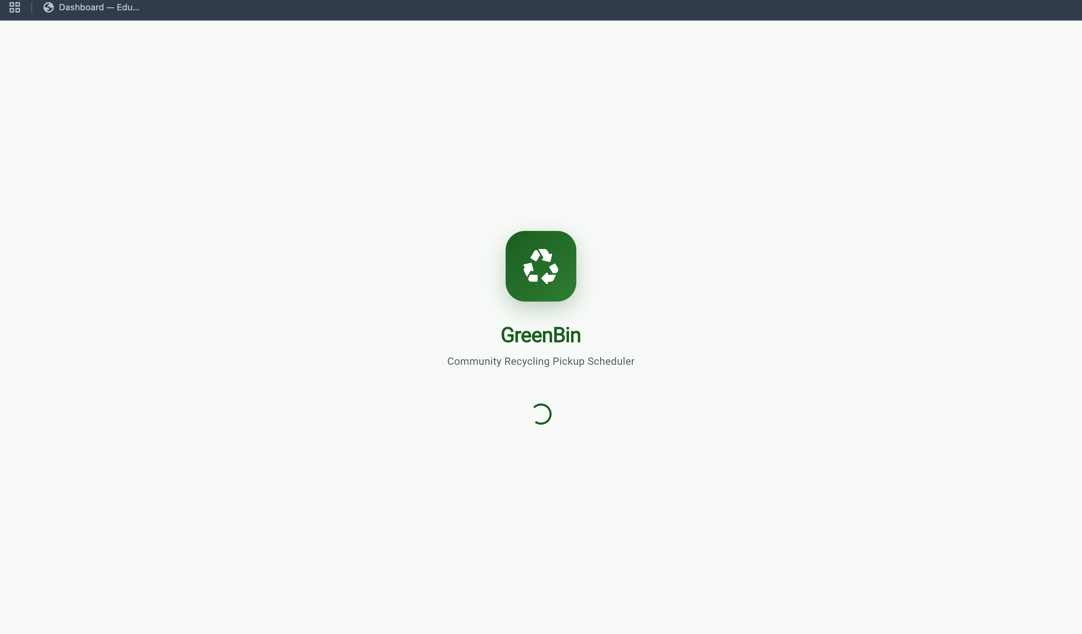
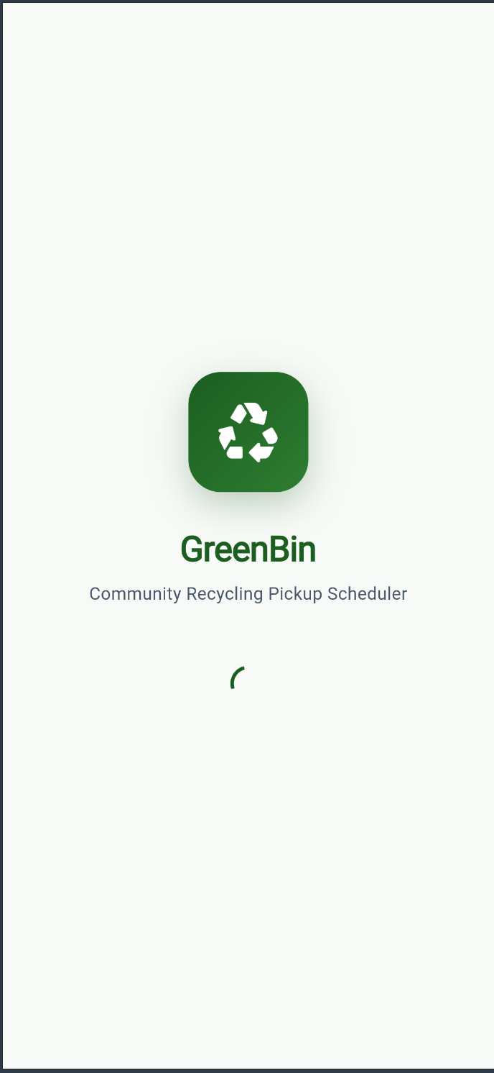
19.2 Onboarding Page - 1
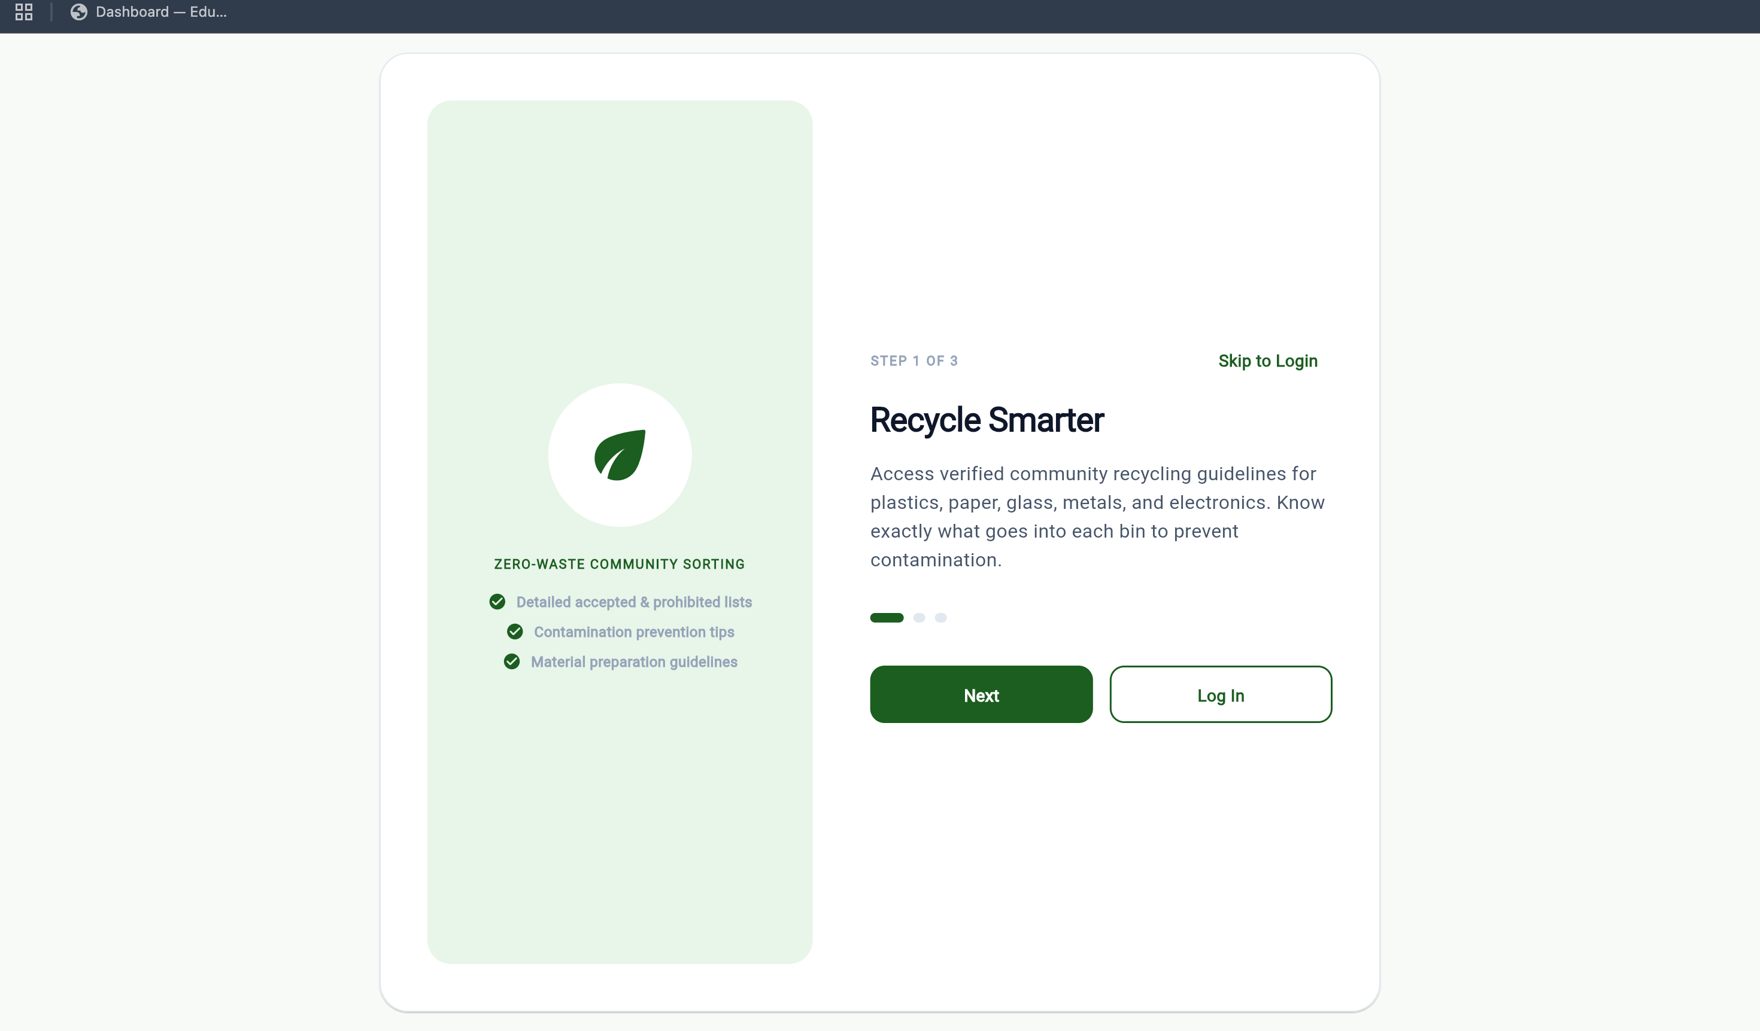
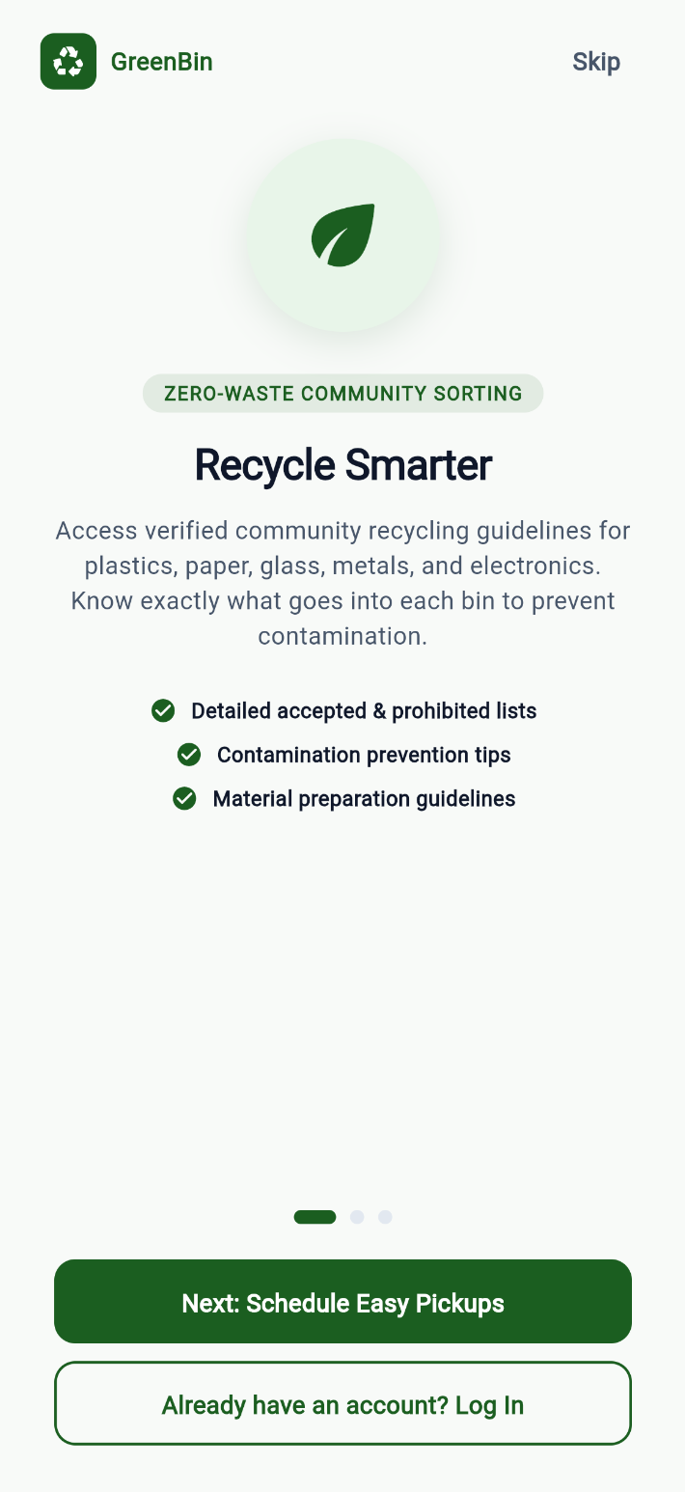
19.3 Onboarding Page - 2
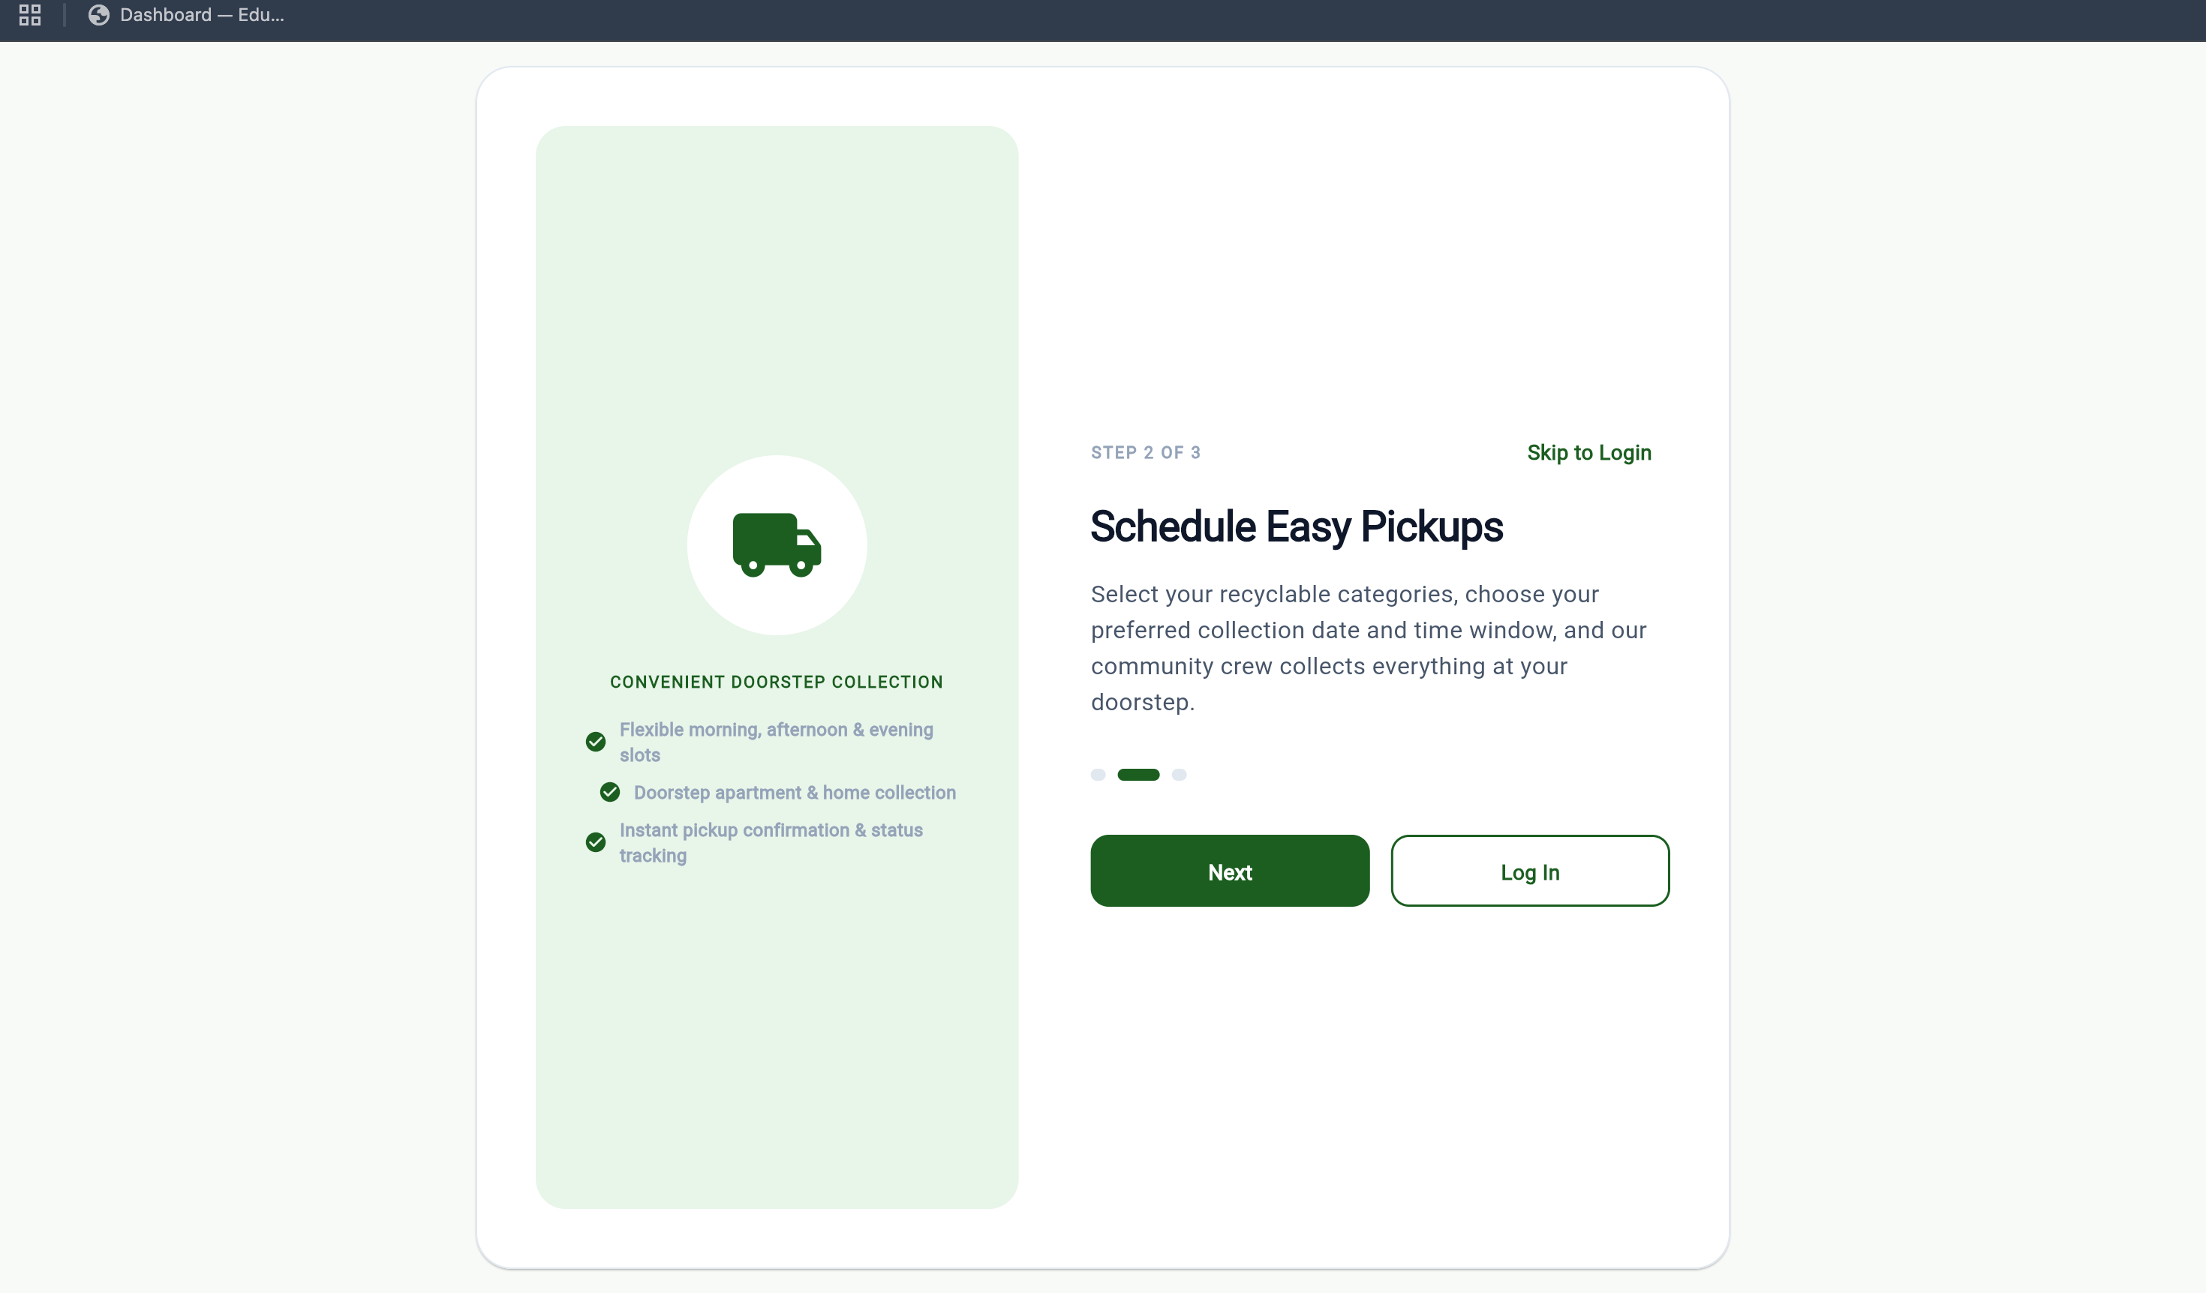
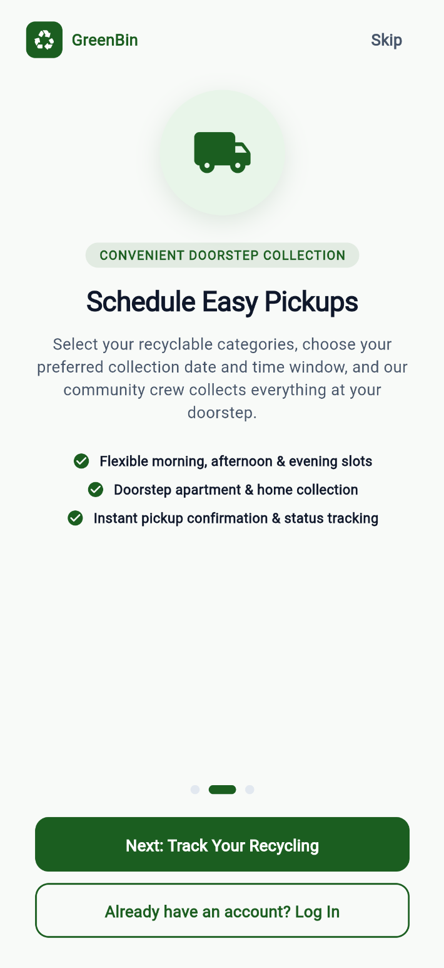
19.4 Onboarding Page - 3
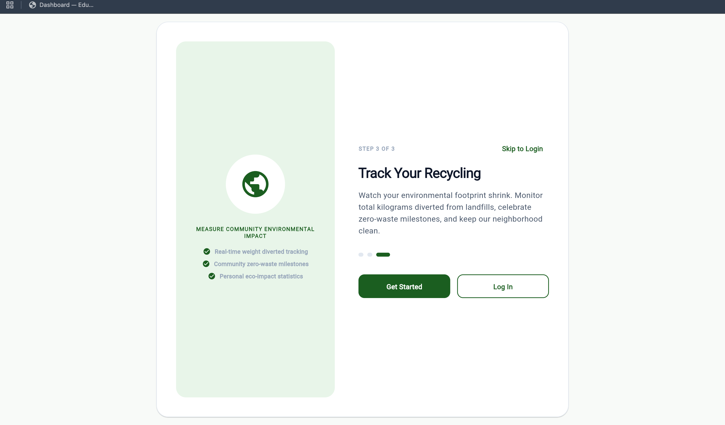
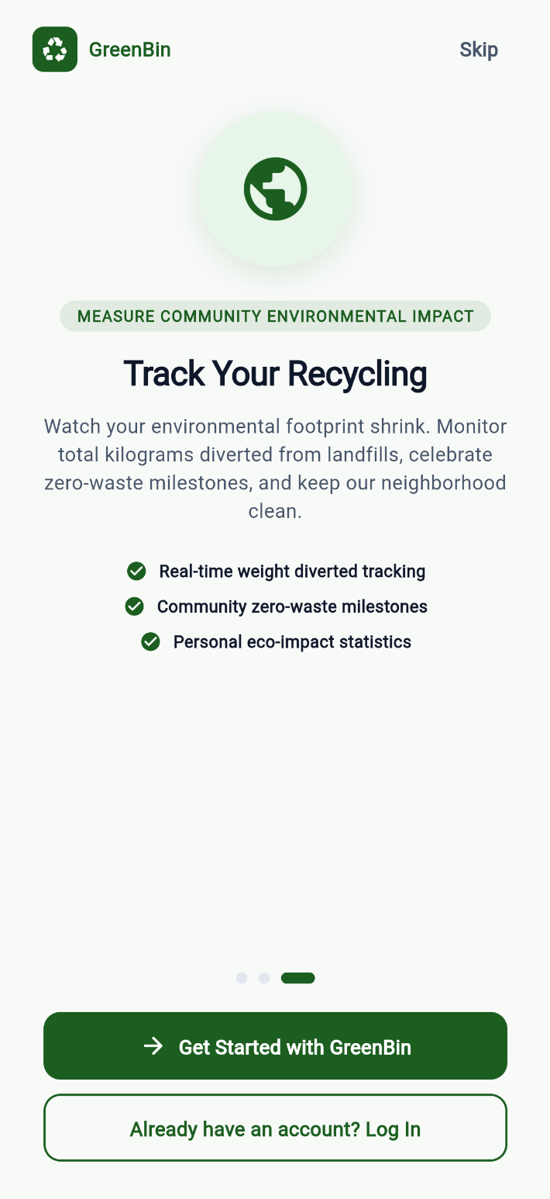
19.5 Register Page
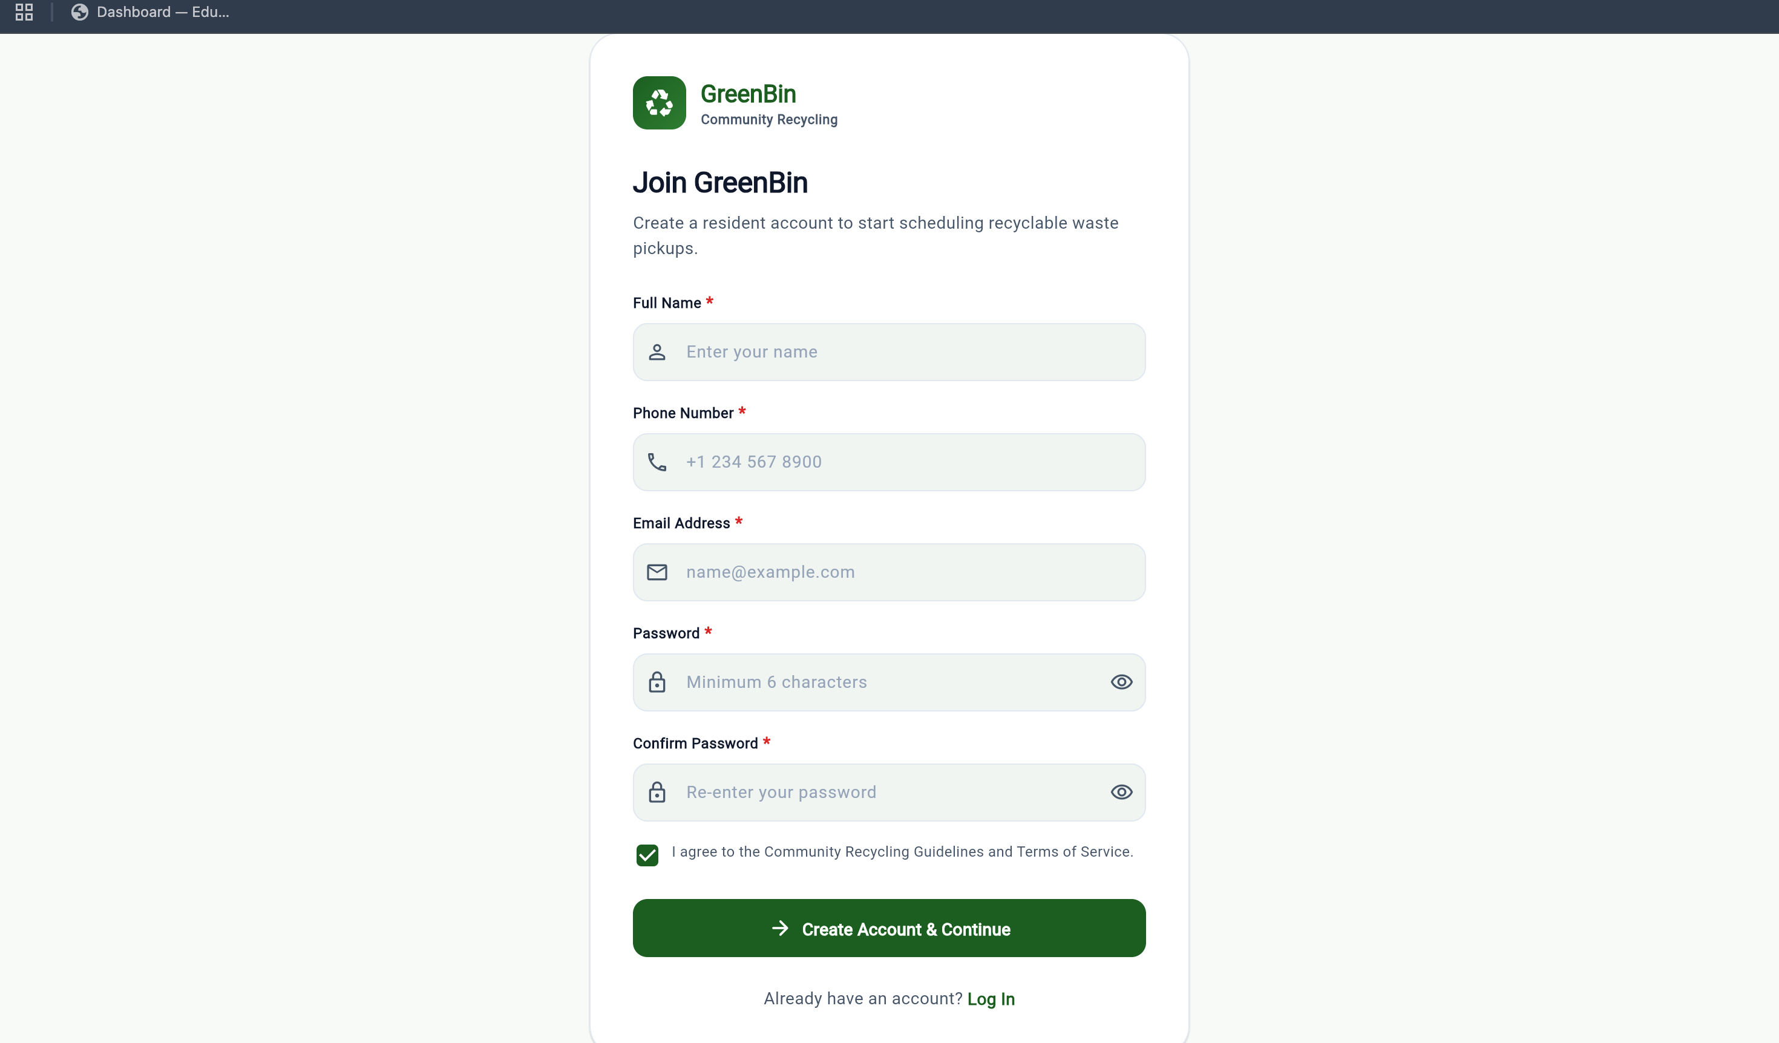
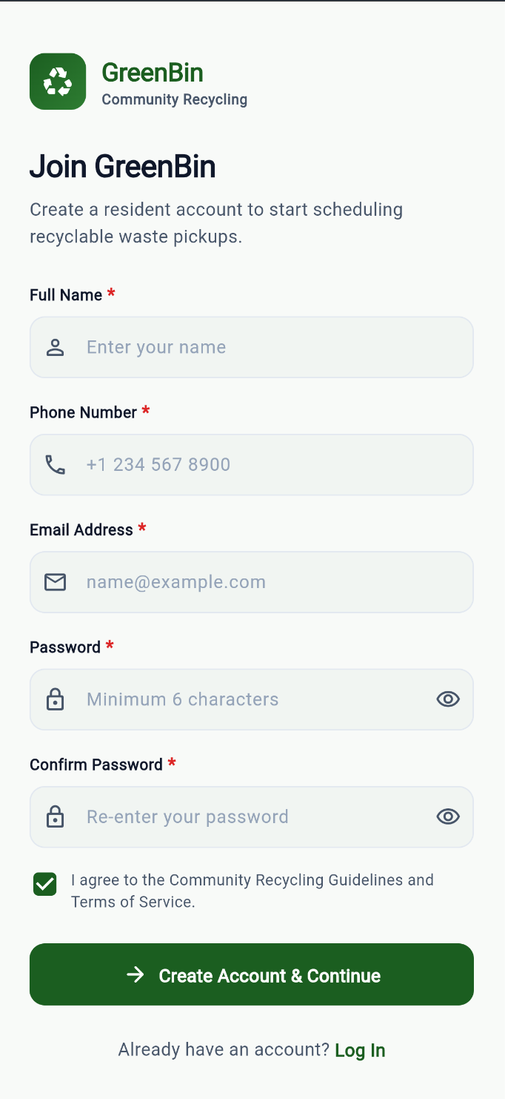
19.6 Login Page
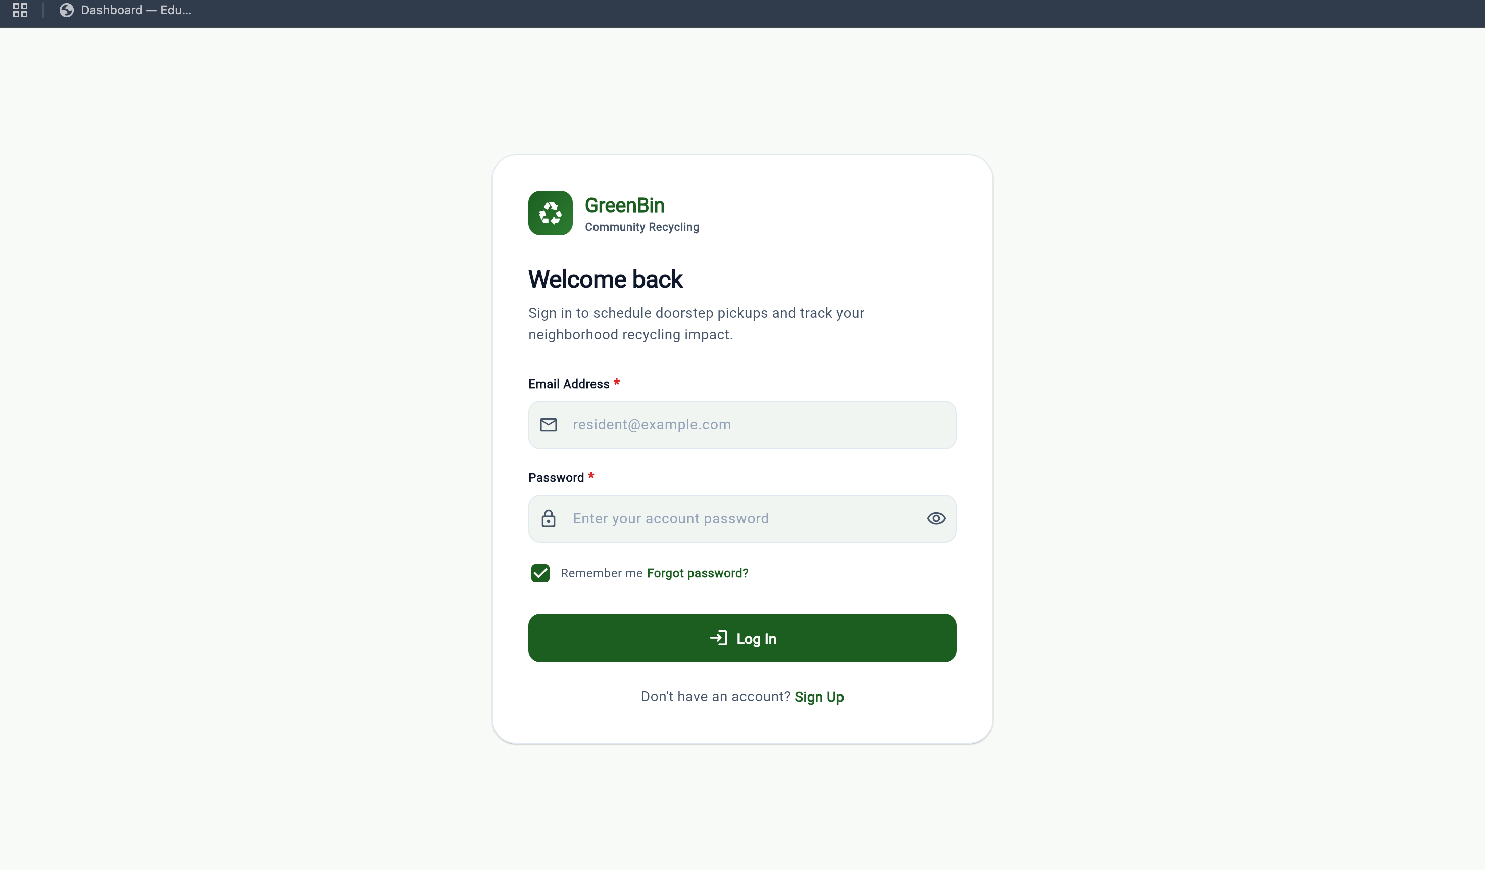
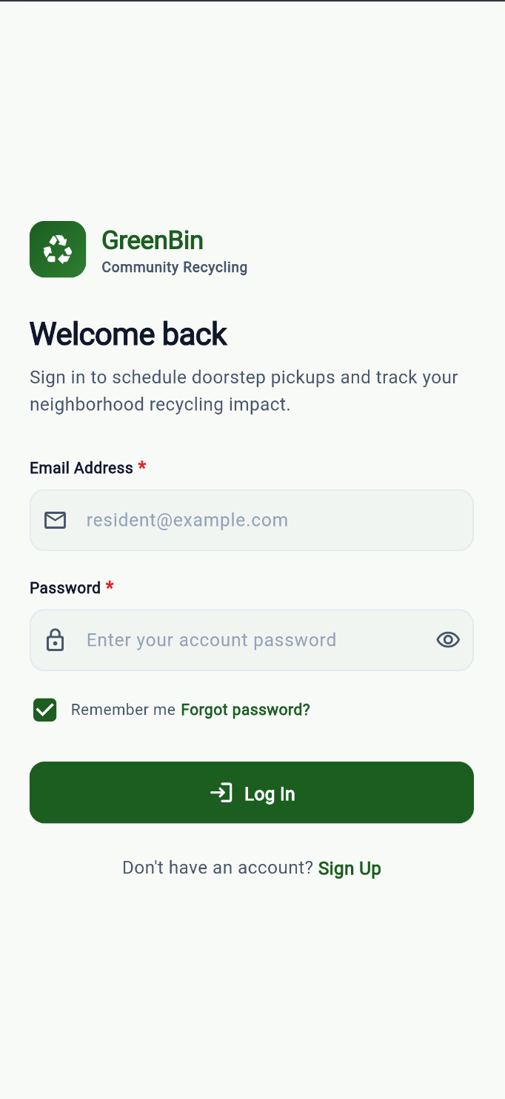
19.7 Home Page
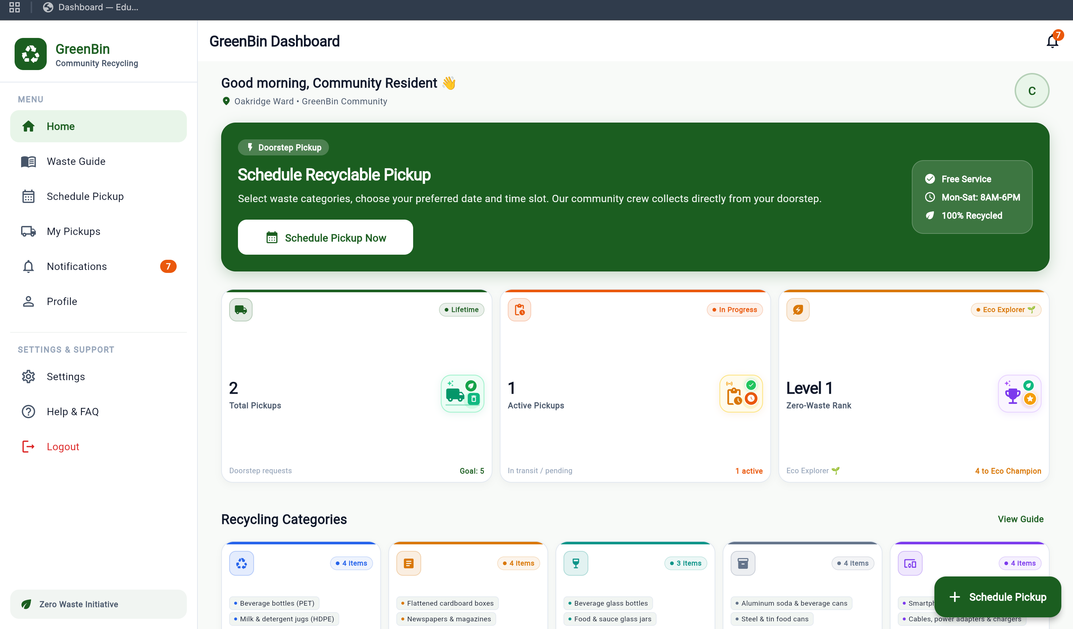
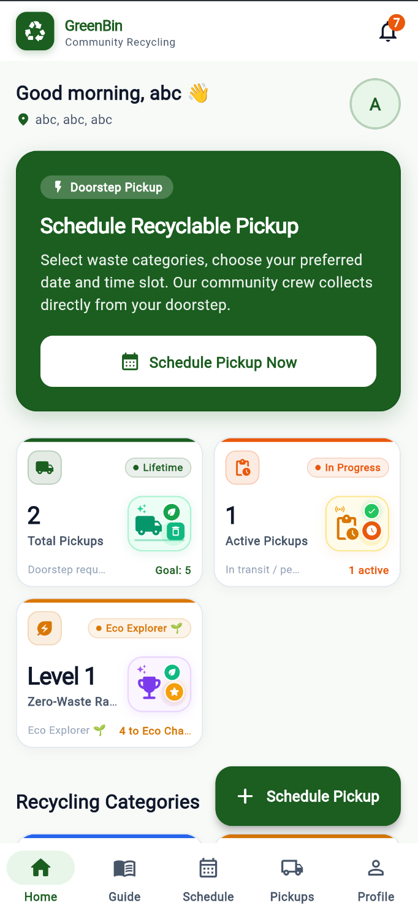
19.8 Waste Guide Page
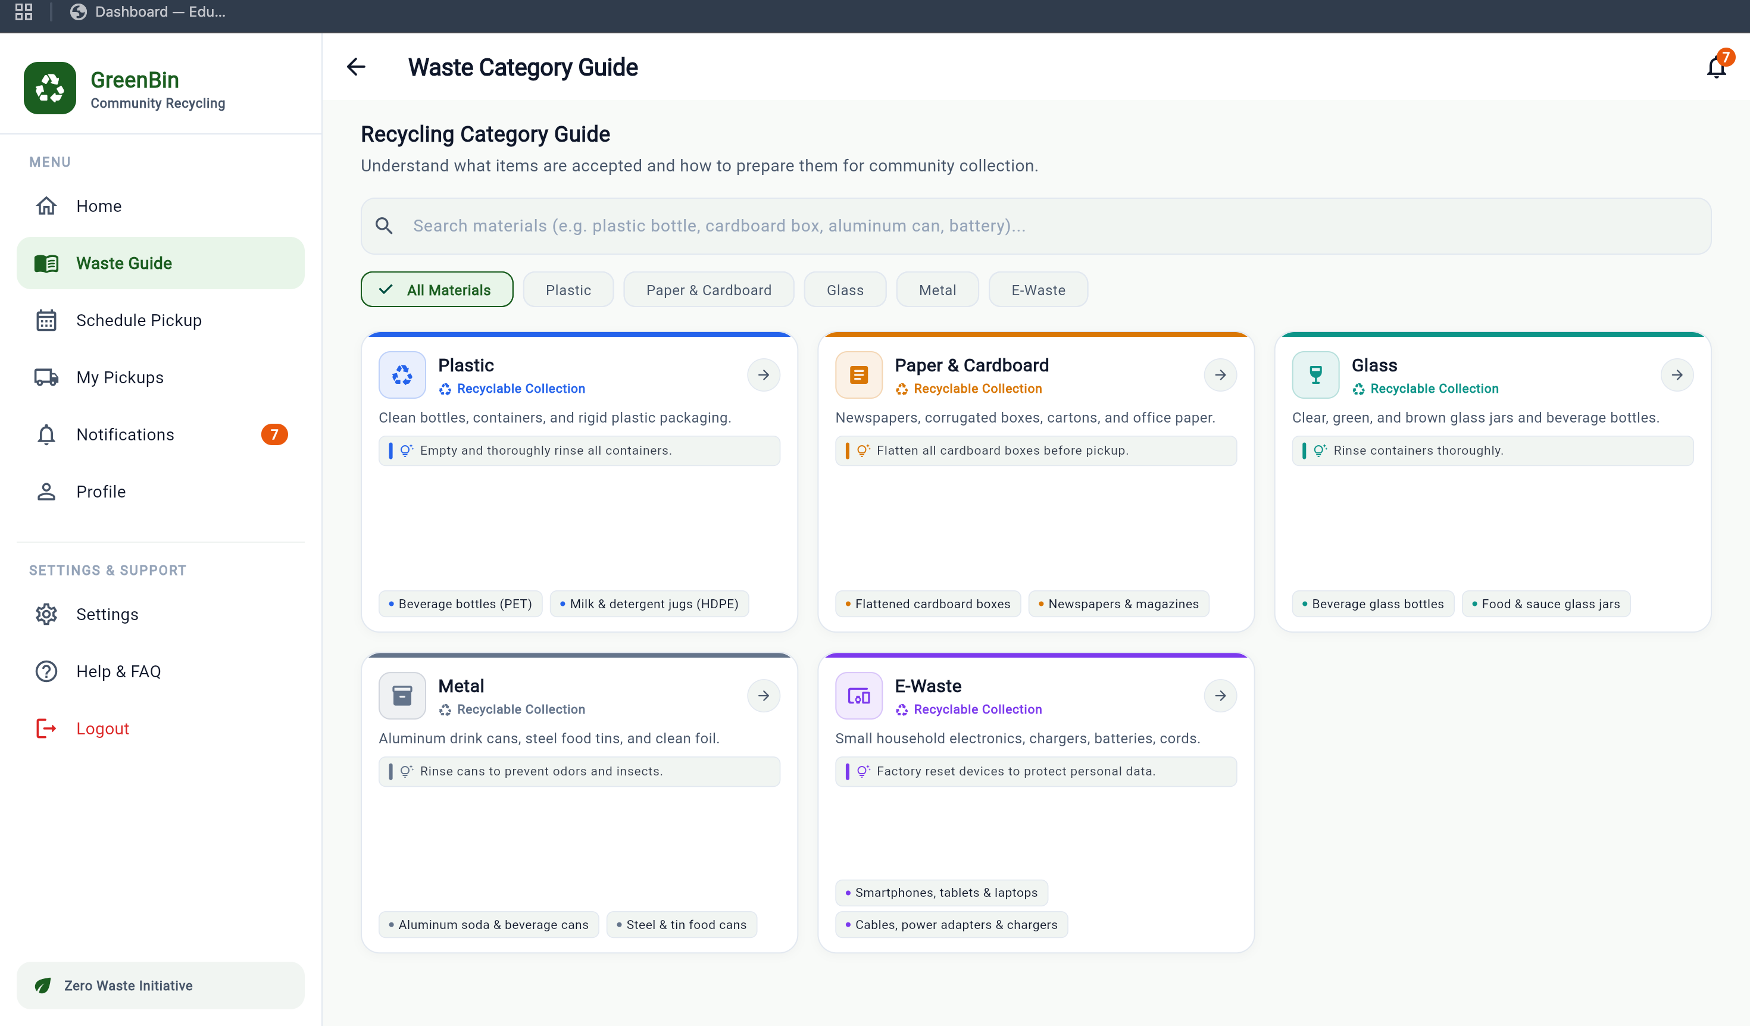
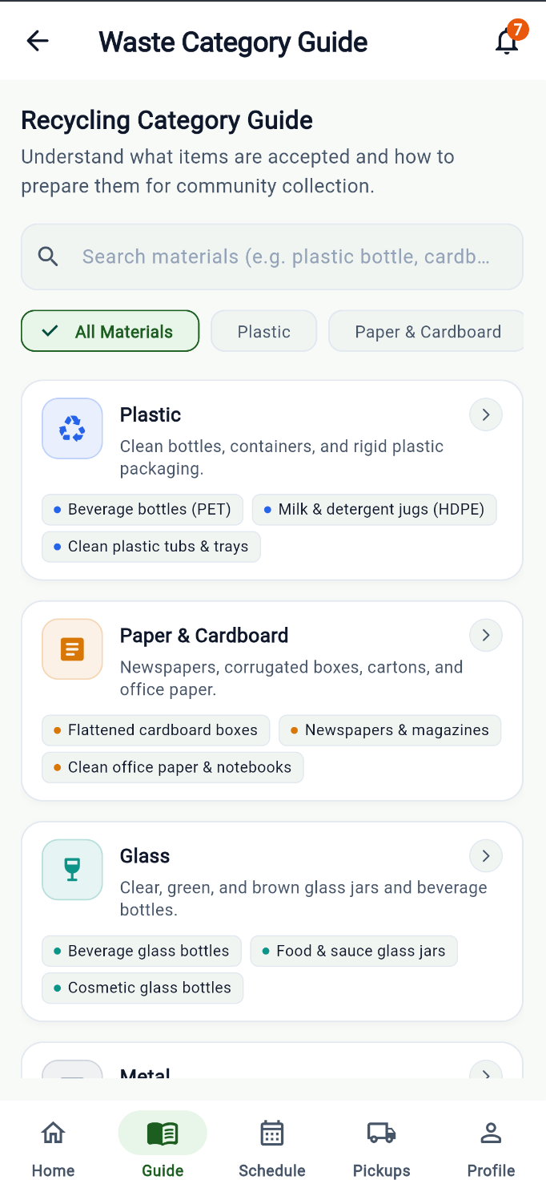
19.9 Schedule Pickup Page
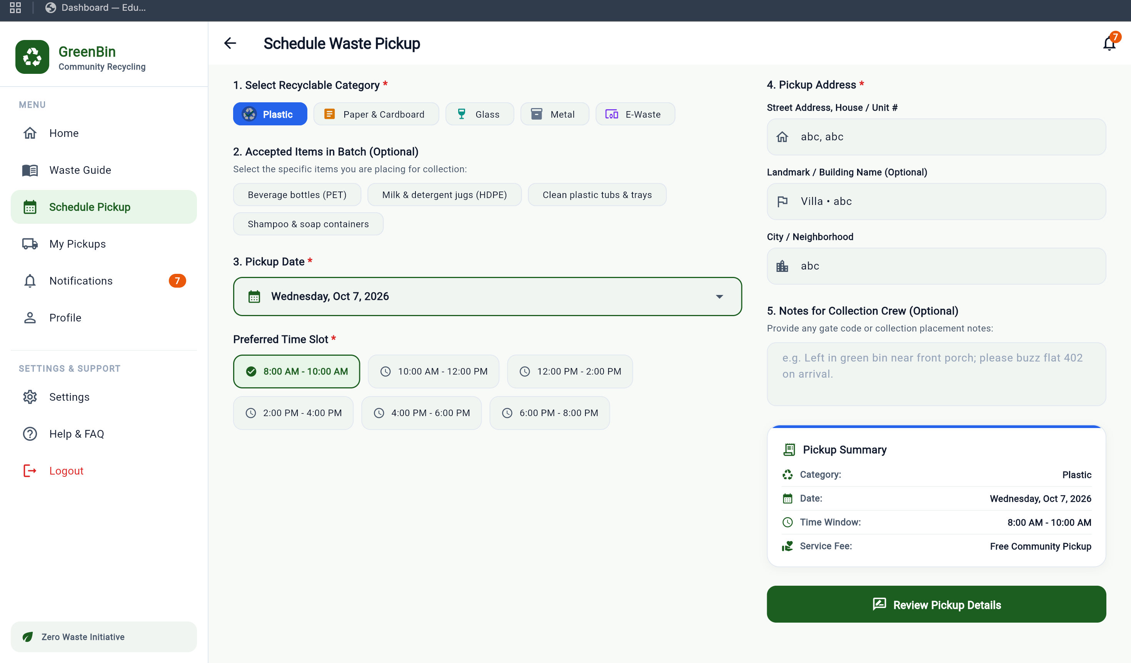
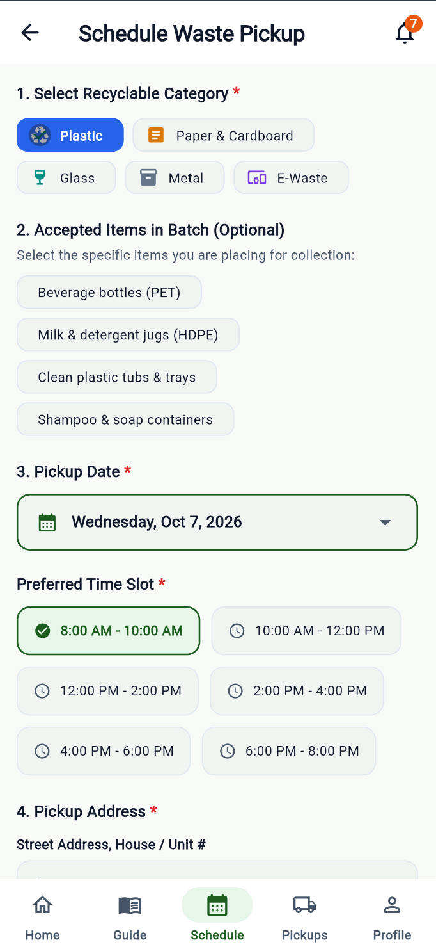
19.10 My Pickups Page
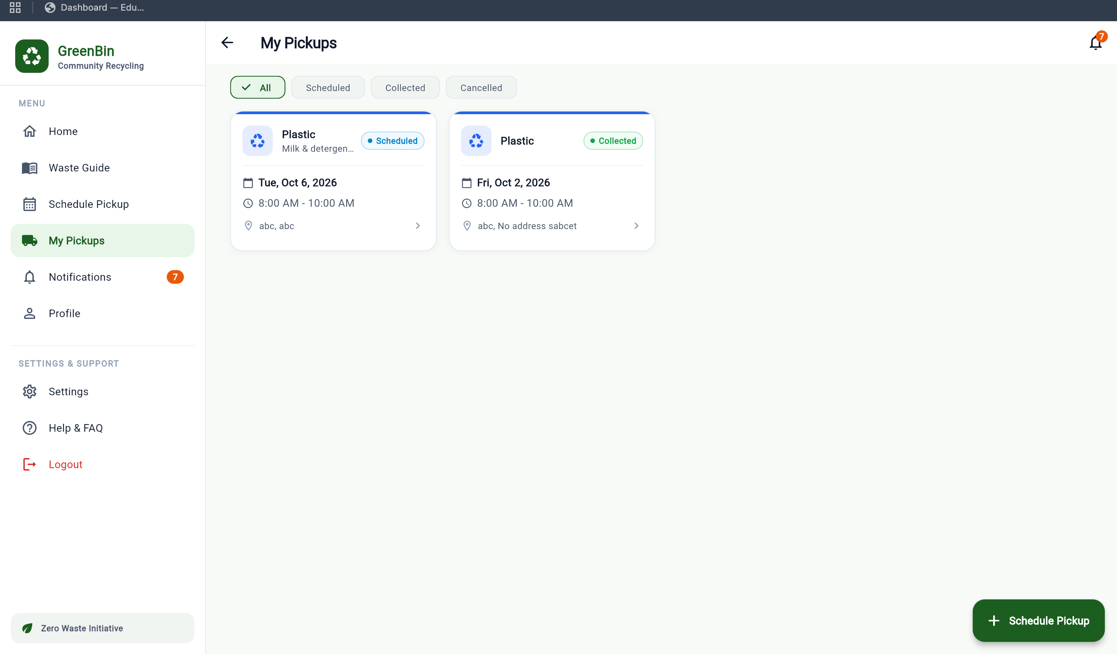
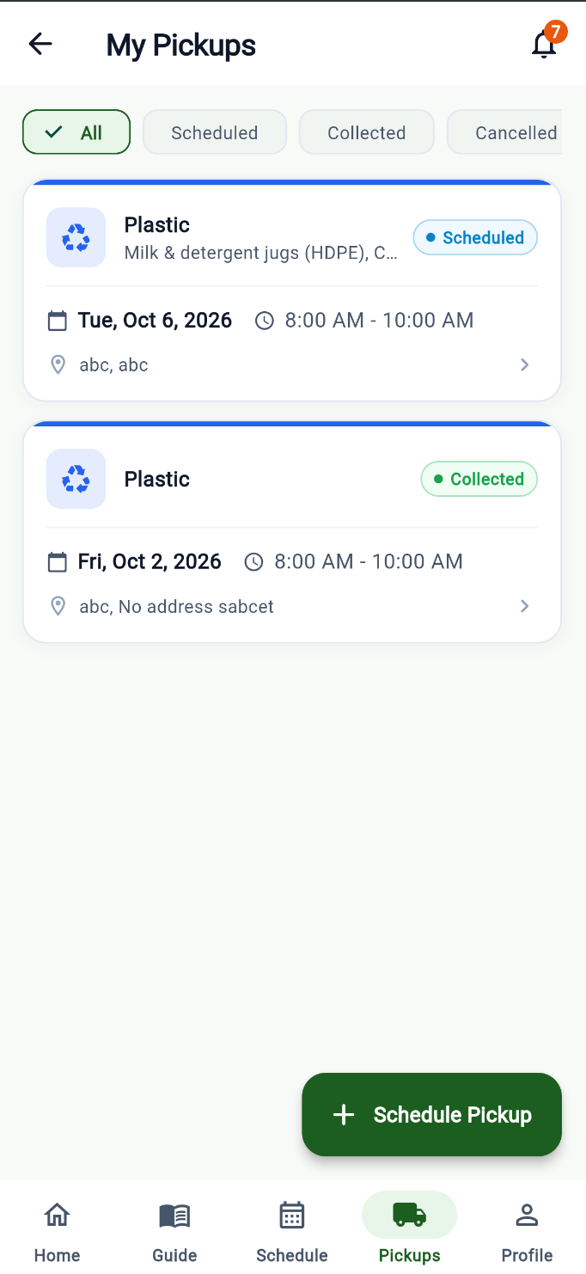
19.11 Notifications Page
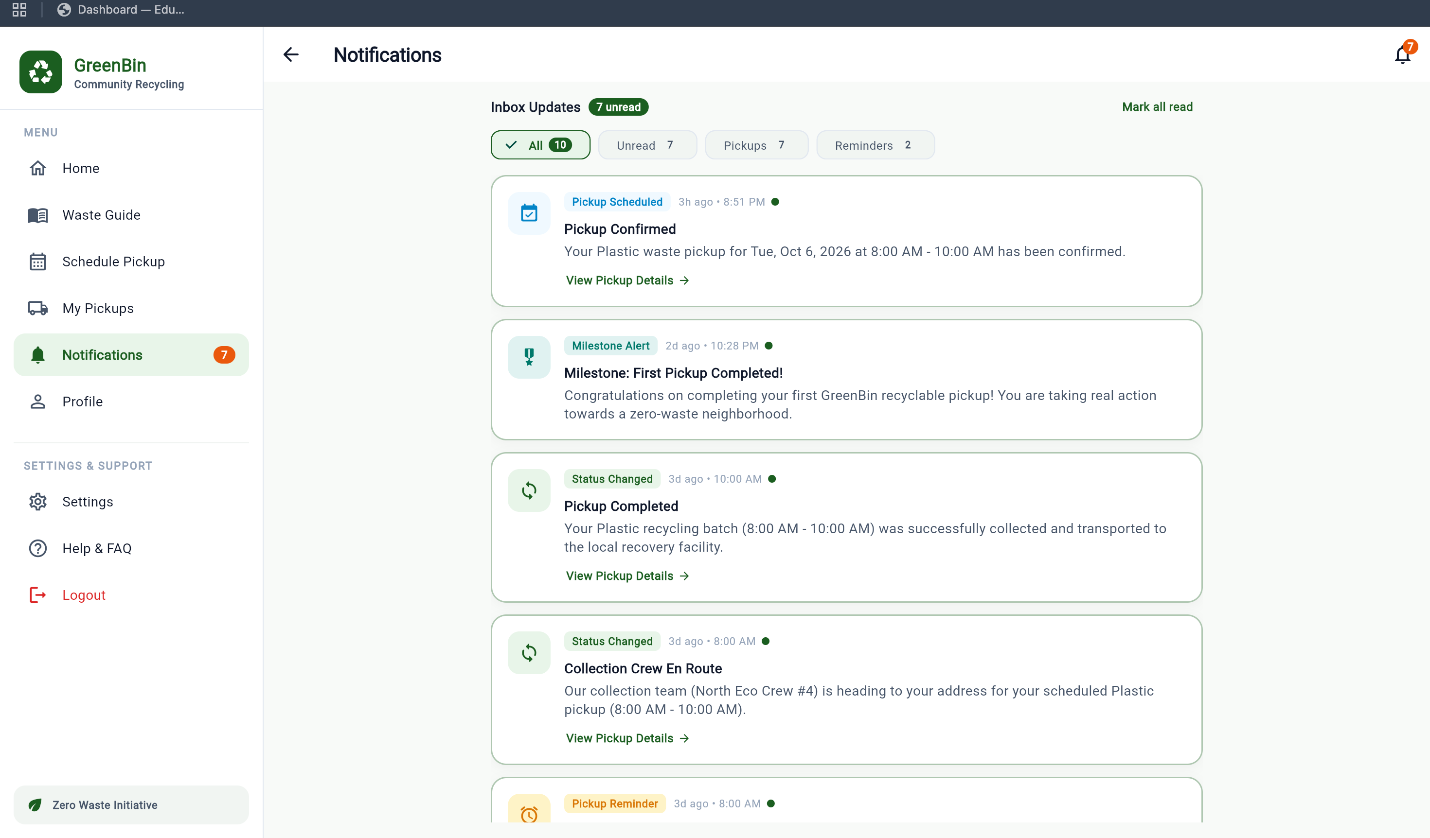
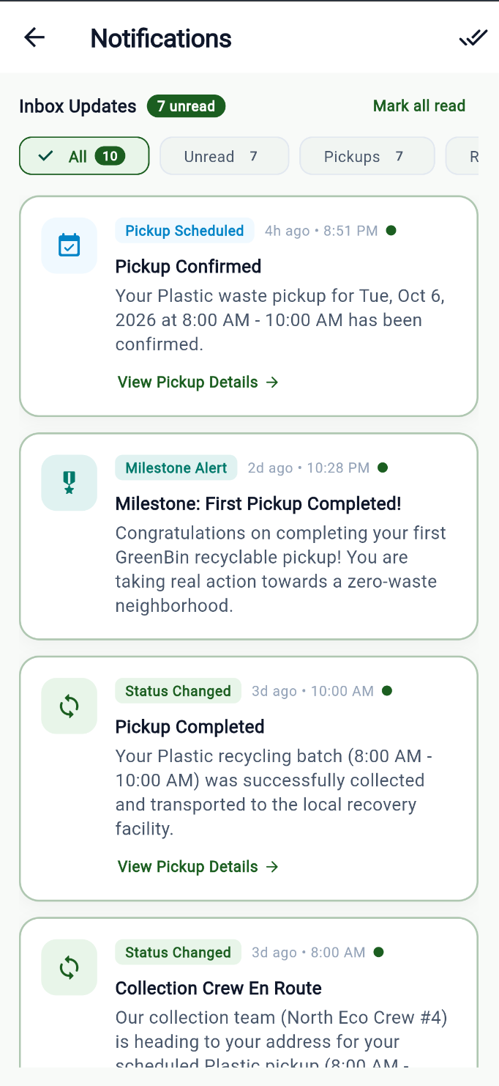
19.12 Profile Page
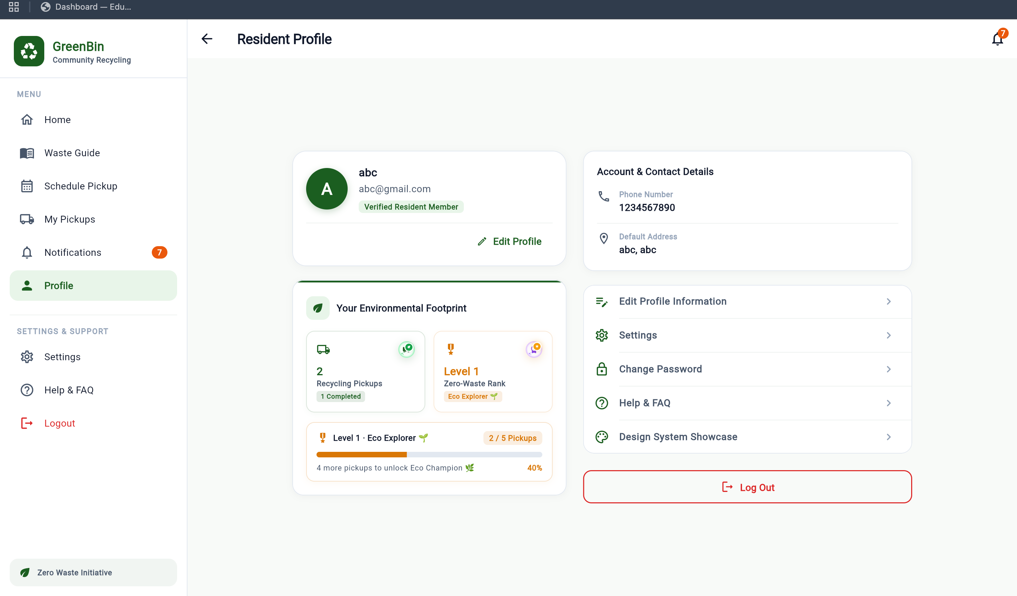
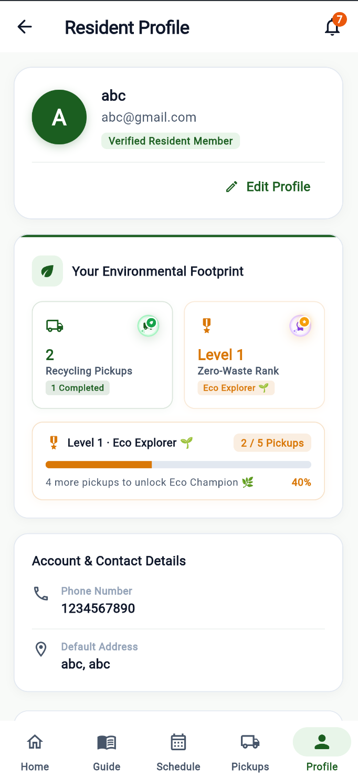
19.13 Settings Page
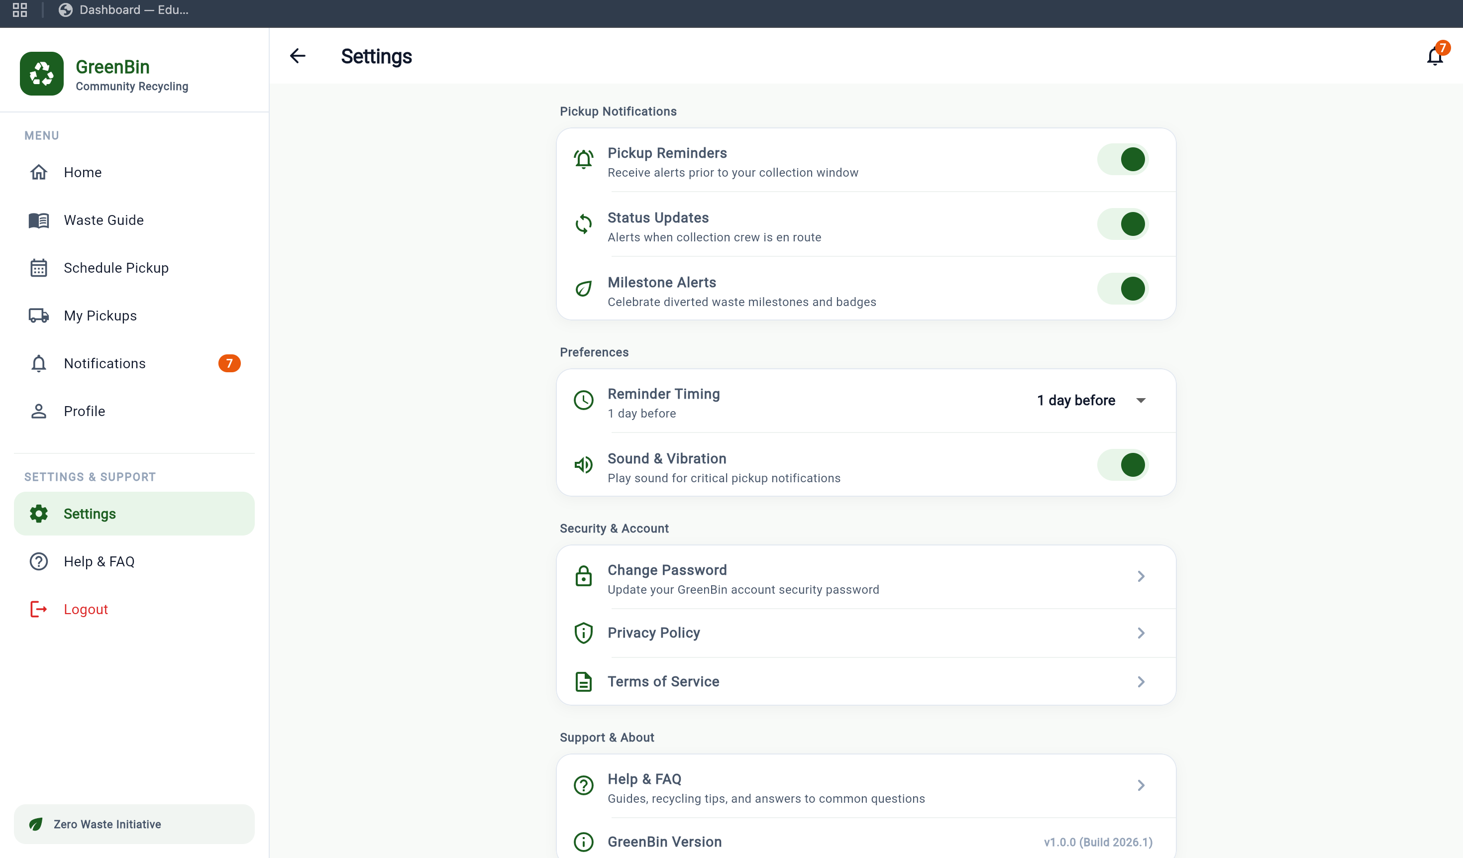
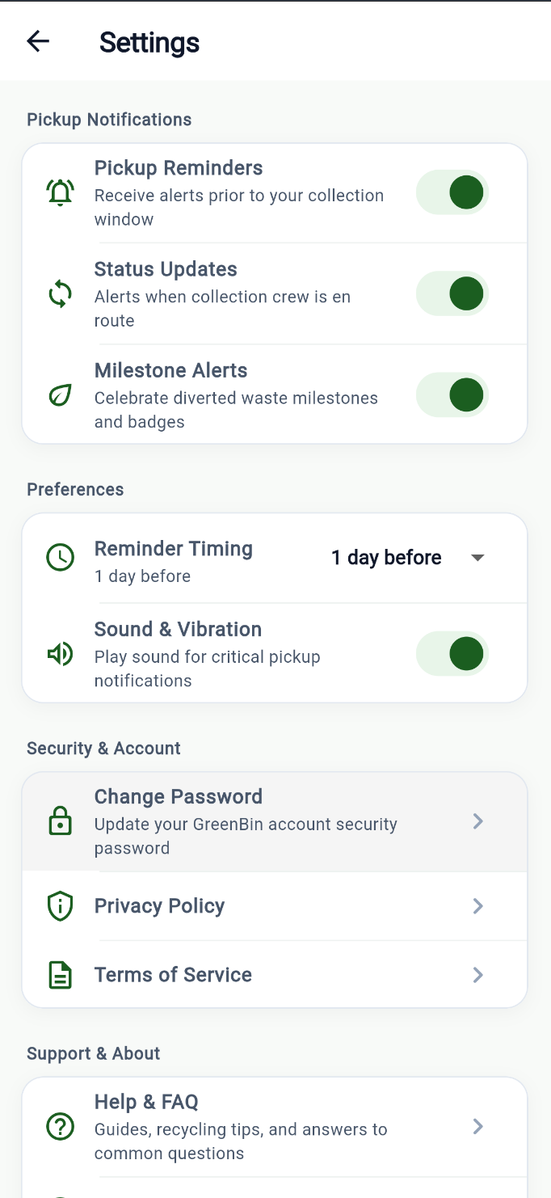
19.14 Help & FAQ Page
