LinguaHub – MERN Stack Language Learning Platform
Problem Statement
This means putting in lots of practice, engaging lessons, and continuous motivation to learn a new language. Most language learning systems currently lack personalization in progress tracking, teacher-driven content creation, and gamification features. Furthermore, user progress management, lessons management, and assessments should be maintained securely and efficiently.
A scalable, interactive, and user-friendly language learning platform should be provided to give effective practice opportunities for the learners while providing an ability for the instructor to create and manage learning content, track learner progress, and motivate users through the use of gamification features such as streaks and leaderboards.
Proposed Solution
LinguaHub is an online language learning platform developed on the MERN technology stack, designed to make language learning interactive and gamelike.
The platform allows:
- Learners to register, log in securely, access structured lessons, attempt quizzes, and track their learning streaks and progress.
- Teachers/Admins to create, update, and manage lessons and quizzes via backend APIs.
- System that automatically tracks user progress and updates streaks upon quiz completion.
With gamification features like streaks and leaderboards, the learners get motivated to maintain consistency. It uses JWT-based authentication for secure access to user data. The architecture is aimed to be scalable and modular to add future enhancements like voice recognition and advanced analytics.

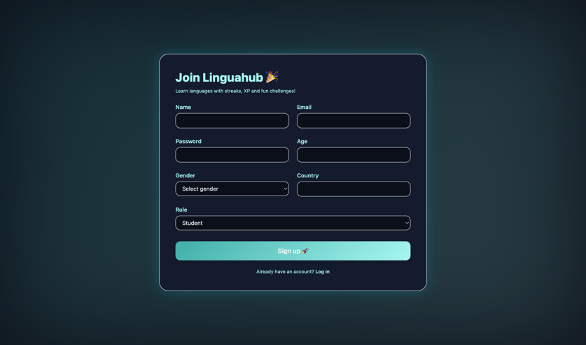 | 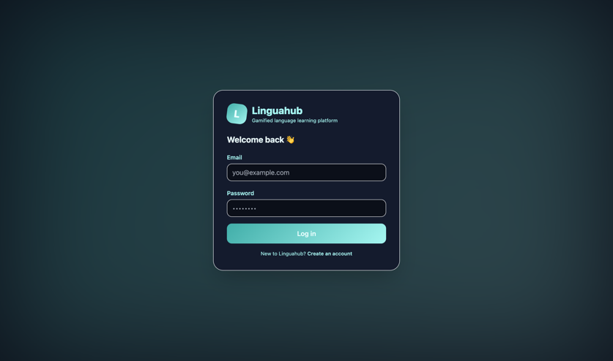
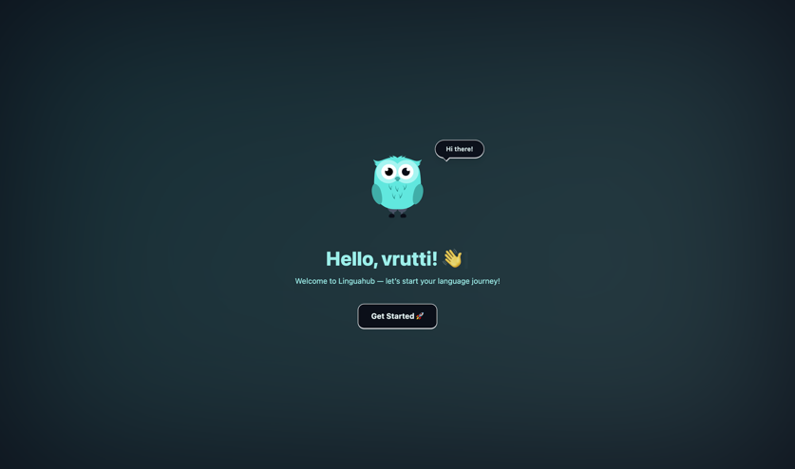 | 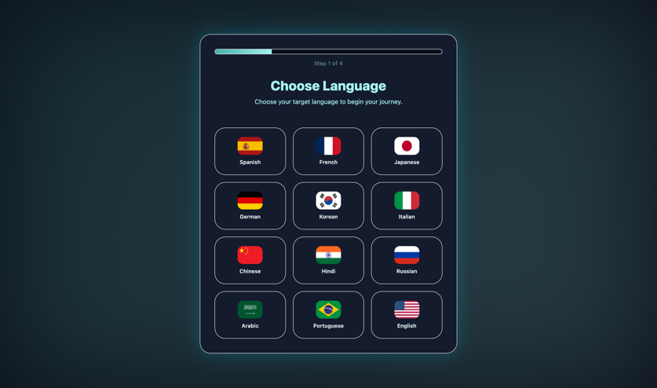
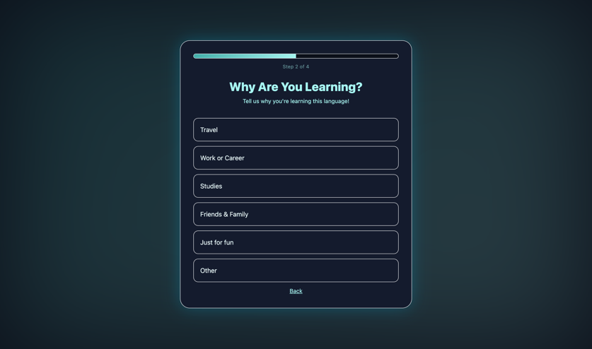 | 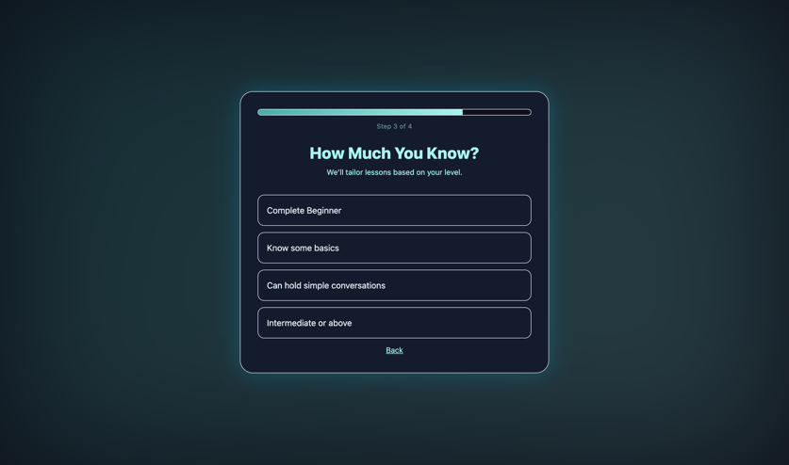
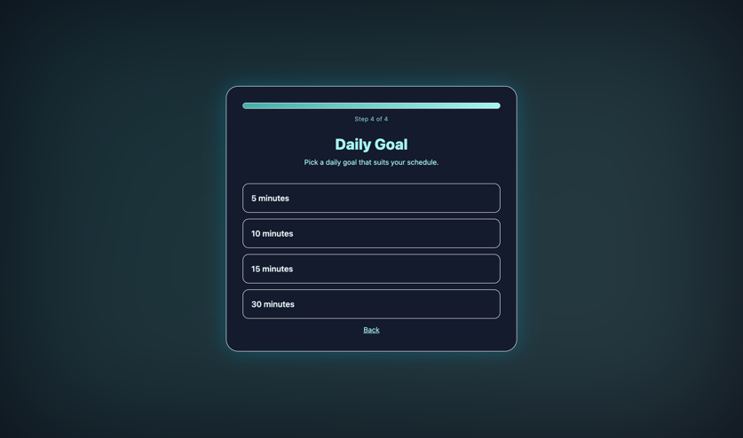
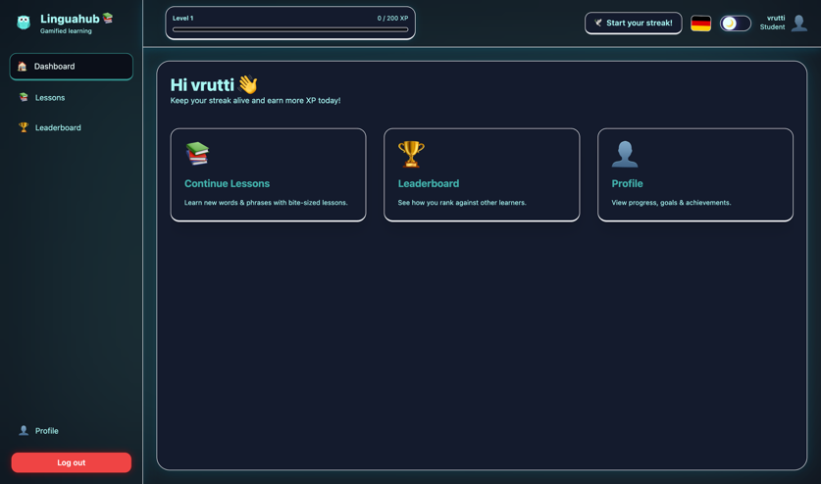 | 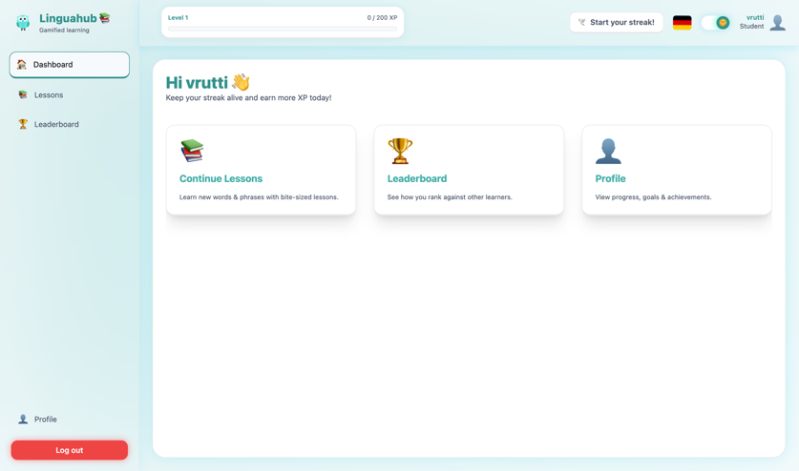
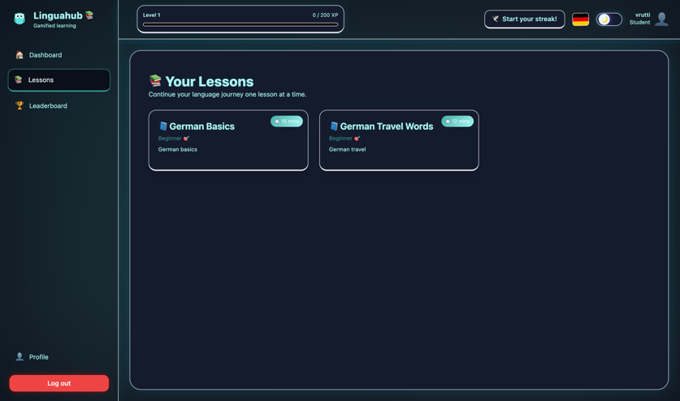 | 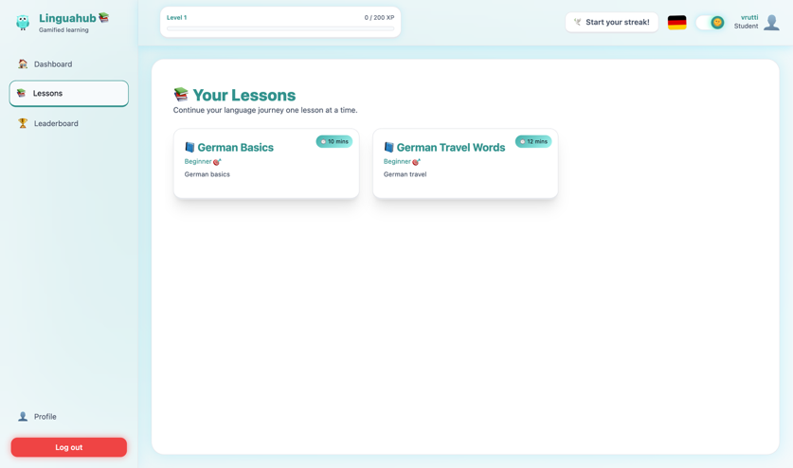
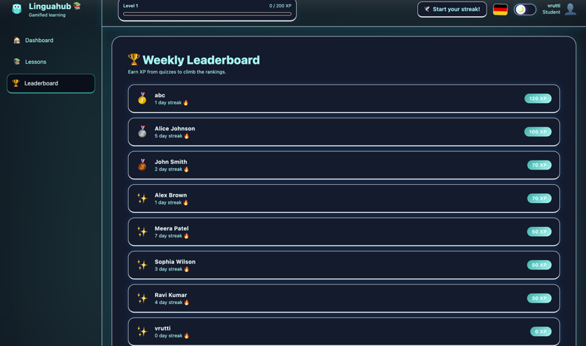 | 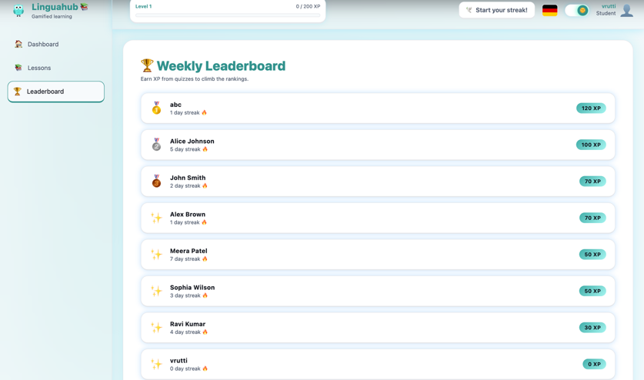
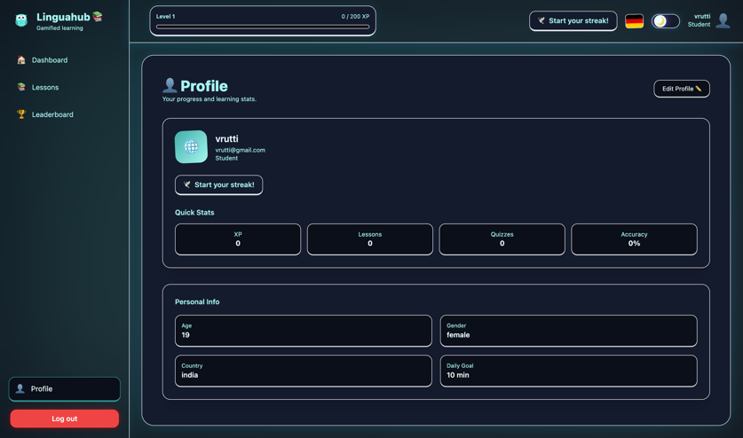 | 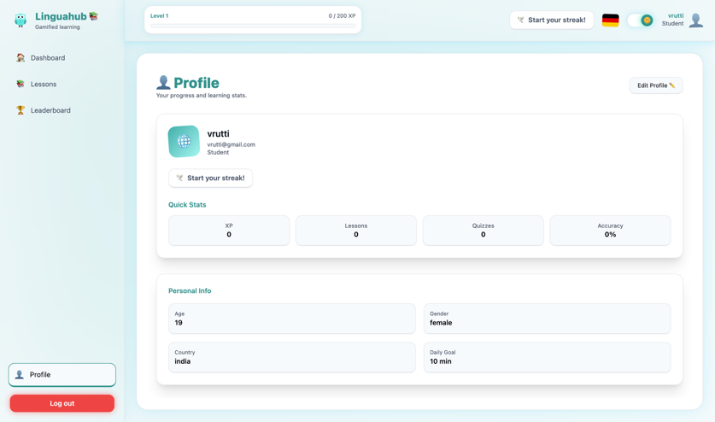
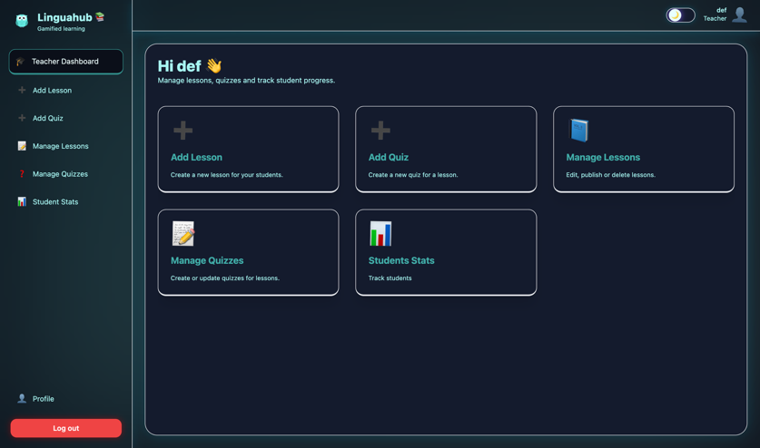 | 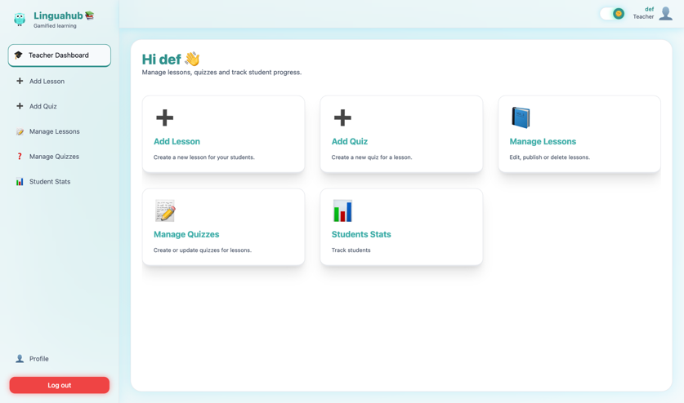
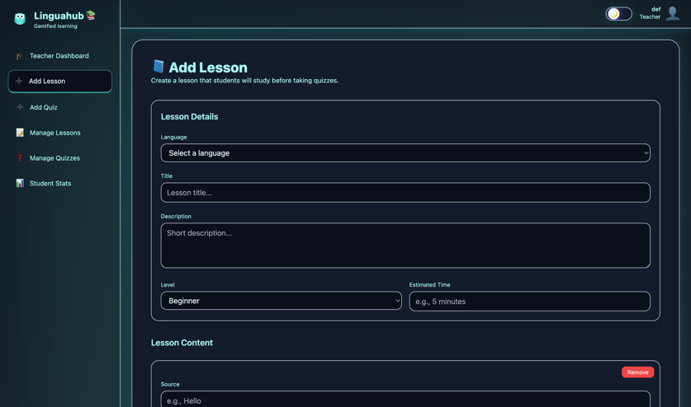 | 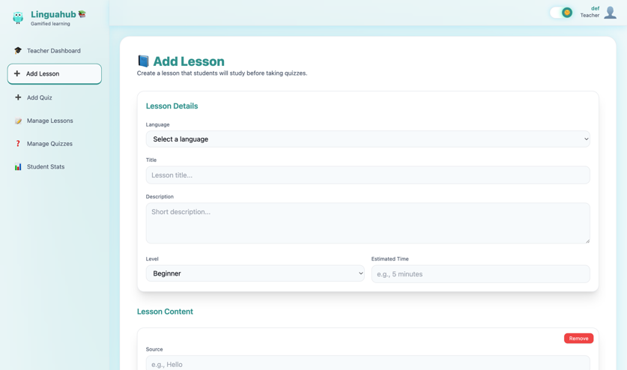
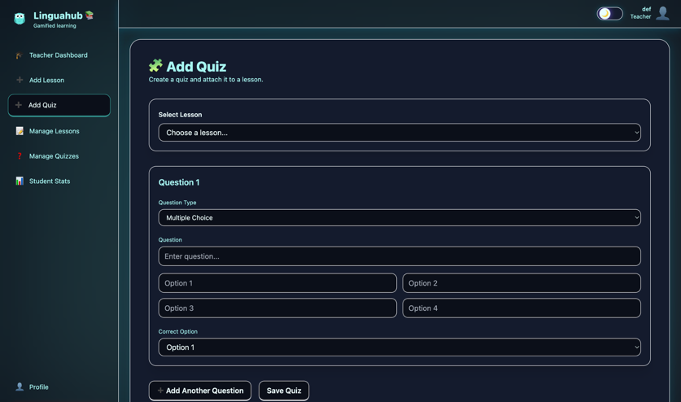 | 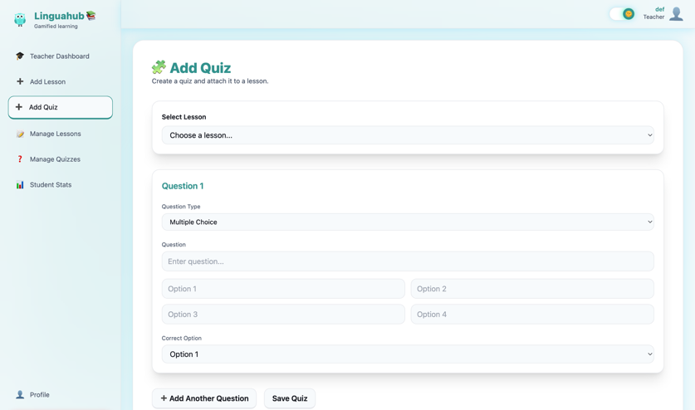
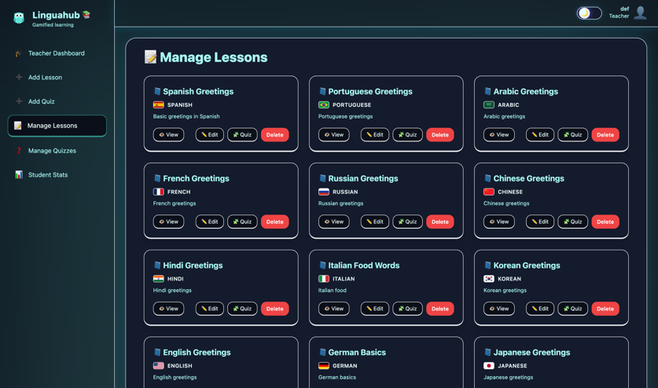 | 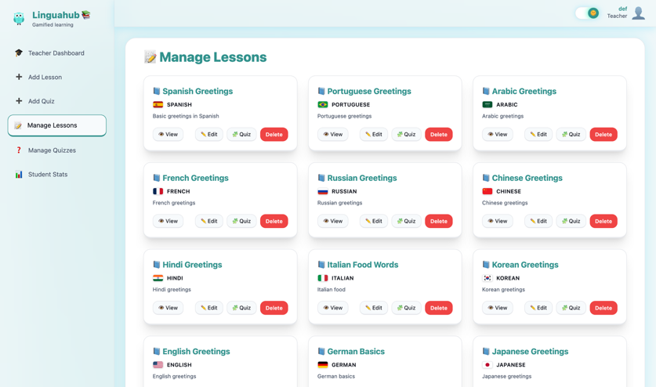
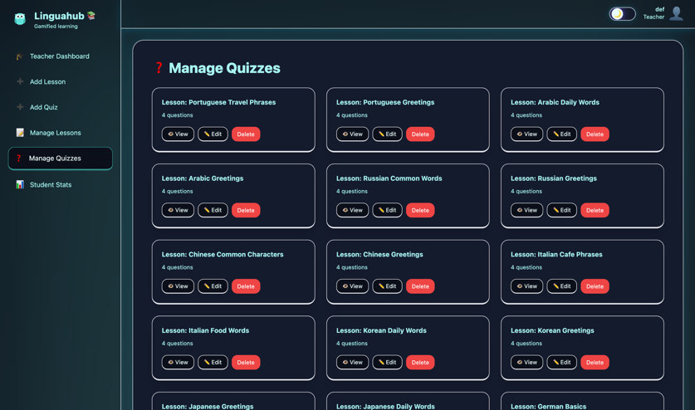 | 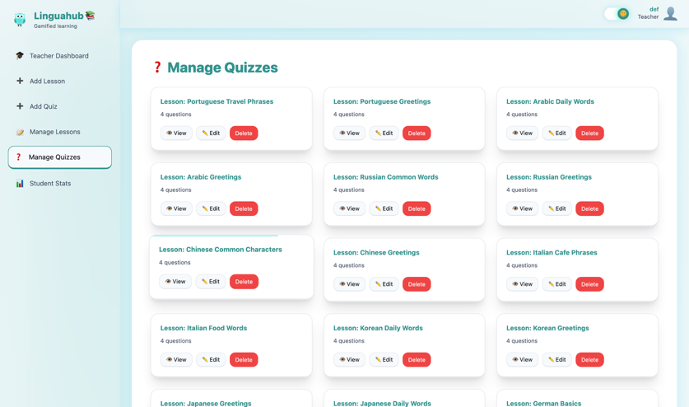
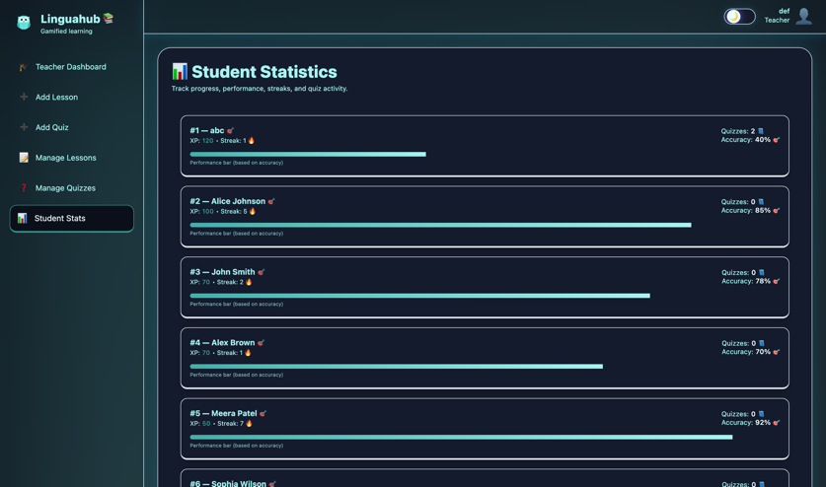 | 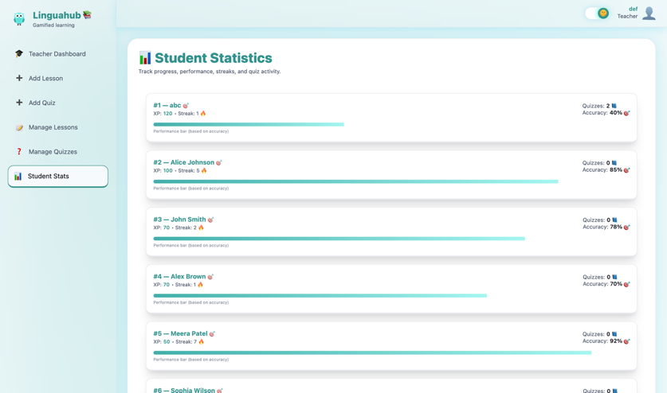
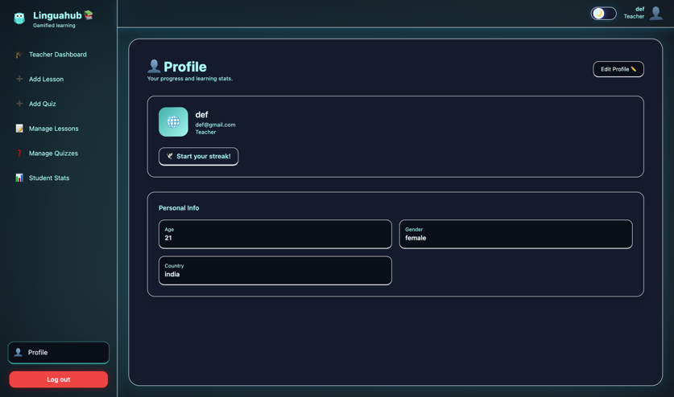 | 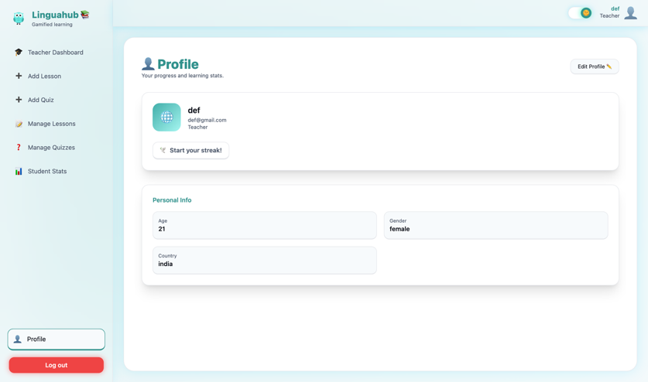
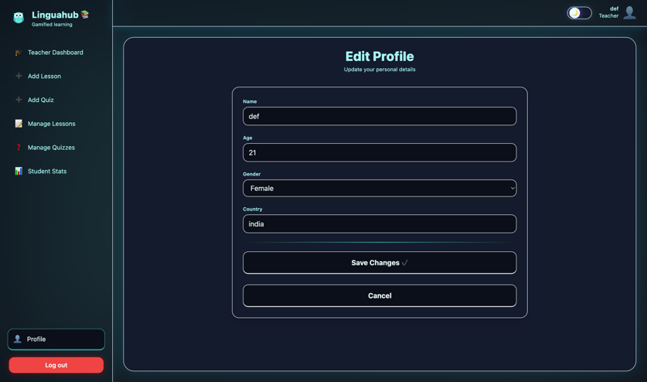 | 