**Міністерство освіти і науки України**

**Національний технічний університет України**

**«Київський політехнічний інститут імені Ігоря Сікорського»**

**Факультет інформатики та обчислювальної техніки**

**Кафедра обчислювальної техніки**

**Лабораторна робота №6**

з дисципліни

«Побудування програмної системи з множини об’єктів, керованих повідомленнями»

Виконав: Перевірив:

студент групи ІП-93 Порєв Віктор Миколайович

Домінський Валентин Олексійович

номер залікової книжки: 9311

Номер у списку: 9

Київ 2020

**Мета:**

Отримати вміння та навички використовувати засоби обміну інформацією та запрограмувати взаємодію незалежно працюючих програмних компонентів.

**Завдання:**

1. Створити у середовищі MS Visual Studio C++ проект Win32 з ім’ям Lab6.

2. Написати вихідні тексти усіх програм-компонентів згідно варіанту завдання.

3. Скомпілювати вихідні тексти і отримати виконувані файли програм.

4. Перевірити роботу програм. Налагодити взаємодію програм.

5. Проаналізувати та прокоментувати результати та вихідні тексти програм.

6. Оформити звіт.

**Варіанти завдань**

9 - Singleton Меєрса

Усе інше – з минулої роботи

**Вихідні тексти файлів:**

**Lab5.cpp:**

// Lab5.cpp : Defines the input point for the application.

//

// First Part

#include "framework.h"

#include "pch.h"

#include "Lab5.h"

#include "my_editor.h"

#include "toolbar.h"

#include "my_table.h"

#include "Resource.h"

#define MAX_LOADSTRING 100

#pragma region VariablesAndFunctions

// Global variables:

HINSTANCE hInst**;** // Current instance

WCHAR szTitle**[**MAX_LOADSTRING**];** // Header row text

WCHAR szWindowClass**[**MAX_LOADSTRING**];** // Class name of main window

LPCSTR currentShape**;**

const LPCSTR POINT_NAME **=** "Крапка"**;**

const LPCSTR LINE_NAME **=** "Лінія"**;**

const LPCSTR RECTANGLE_NAME **=** "Прямокутник"**;**

const LPCSTR ELLIPSE_NAME **=** "Овал"**;**

const LPCSTR LINEOO_NAME **=** "Лінія з кружочками на кінцях"**;**

const LPCSTR CUBE_NAME **=** "Куб"**;**

string detailsOfShape**;**

INT countForShapes **=** 0**;**

Toolbar toolbar**;**

MyEditor**&** ED **=** ED**.**getInstance**();**

MyTable**\*** table **=** **new** MyTable**;**

HWND hwnd **=** **NULL;**

// Send declarations of functions included in this code module:

ATOM MyRegisterClass**(**HINSTANCE hInstance**);**

BOOL InitInstance**(**HINSTANCE**,** int**);**

LRESULT CALLBACK WndProc**(**HWND**,** UINT**,** WPARAM**,** LPARAM**);**

INT_PTR CALLBACK About**(**HWND**,** UINT**,** WPARAM**,** LPARAM**);**

static void CallToolPoint**();**

static void CallToolLine**();**

static void CallToolRectangle**();**

static void CallToolEllipse**();**

static void CallToolLineOO**();**

static void CallToolCube**();**

static void CallLBUP**(**HWND hWnd**);**

static void CallTable**();**

static void OnWMCreateCall**(**HWND**);**

BOOL CALLBACK Table**(**HWND hWnd**,** UINT uMsg**,** WPARAM wParam**,** LPARAM lParam**);**

std**::**string shapeDetails **=** ""**;**

string pathForShapes **=** "objects.txt"**;**

static LPCSTR exceptionString **=** "Can't open a file or find a file"**;**

#pragma endregion VariablesAndFunctions

#pragma region DefaultFunctions

// Second Part

// Enter Point "wWinMain"

int APIENTRY wWinMain**(**_In_ HINSTANCE hInstance**,**

_In_opt_ HINSTANCE hPrevInstance**,**

_In_ LPWSTR lpCmdLine**,**

_In_ int nCmdShow**)**

**{**

UNREFERENCED_PARAMETER**(**hPrevInstance**);**

UNREFERENCED_PARAMETER**(**lpCmdLine**);**

InitCommonControls**();**

// TODO: Place the code here.

// Global line initialization

LoadStringW**(**hInstance**,** IDS_APP_TITLE**,** szTitle**,** MAX_LOADSTRING**);**

LoadStringW**(**hInstance**,** IDC_LAB3**,** szWindowClass**,** MAX_LOADSTRING**);**

MyRegisterClass**(**hInstance**);**

// Perform application initialization:

**if** **(!**InitInstance**(**hInstance**,** nCmdShow**))**

**{**

**return** FALSE**;**

**}**

HACCEL hAccelTable **=** LoadAccelerators**(**hInstance**,** MAKEINTRESOURCE**(**IDC_LAB3**));**

MSG msg**;**

// Main message cycle:

**while** **(**GetMessage**(&**msg**,** **nullptr,** 0**,** 0**))**

**{**

**if** **(!**TranslateAccelerator**(**msg**.**hwnd**,** hAccelTable**,** **&**msg**))**

**{**

TranslateMessage**(&**msg**);**

DispatchMessage**(&**msg**);**

**}**

**}**

**return** **(**int**)**msg**.**wParam**;**

**}**

//

// FUNCTION: MyRegisterClass()

//

// OBJECTIVE: To register the window class.

// Text of Function

/// <summary>

/// Register the window class.

/// </summary>

/// <param name="hInstance">The h instance.</param>

/// <returns></returns>

ATOM MyRegisterClass**(**HINSTANCE hInstance**)**

**{**

WNDCLASSEXW wcex**;**

wcex**.**cbSize **=** **sizeof(**WNDCLASSEX**);**

wcex**.**style **=** CS_HREDRAW **|** CS_VREDRAW**;**

wcex**.**lpfnWndProc **=** WndProc**;**

wcex**.**cbClsExtra **=** 0**;**

wcex**.**cbWndExtra **=** 0**;**

wcex**.**hInstance **=** hInstance**;**

wcex**.**hIcon **=** LoadIcon**(**hInstance**,** MAKEINTRESOURCE**(**IDI_LAB3**));**

wcex**.**hCursor **=** LoadCursor**(nullptr,** IDC_ARROW**);**

wcex**.**hbrBackground **=** **(**HBRUSH**)(**COLOR_WINDOW **+** 1**);**

wcex**.**lpszMenuName **=** MAKEINTRESOURCEW**(**IDC_LAB5**);**

wcex**.**lpszClassName **=** szWindowClass**;**

wcex**.**hIconSm **=** LoadIcon**(**wcex**.**hInstance**,** MAKEINTRESOURCE**(**IDI_SMALL**));**

**return** RegisterClassExW**(&**wcex**);**

**}**

//

// FUNCTION: InitInstance(HINSTANCE, int)

//

// OBJECTIVE: Saves the instance marker and creates the main window

//

// COMMENTARIES:

//

// In this function, the instance marker is saved in a global variable, and also

// the main program window is created and displayed.

//

/// <summary>

/// Saves the instance marker and creates the main window

/// </summary>

/// <param name="hInstance">The h instance.</param>

/// <param name="nCmdShow">The n command show.</param>

/// <returns></returns>

BOOL InitInstance**(**HINSTANCE hInstance**,** int nCmdShow**)**

**{**

hInst **=** hInstance**;** // Save instance marker in global variable

HWND hWnd **=** CreateWindowW**(**szWindowClass**,** szTitle**,** WS_OVERLAPPEDWINDOW **|** WS_CLIPCHILDREN**,**

CW_USEDEFAULT**,** 0**,** CW_USEDEFAULT**,** 0**,** **nullptr,** **nullptr,** hInstance**,** **nullptr);**

**if** **(!**hWnd**)**

**{**

**return** FALSE**;**

**}**

ShowWindow**(**hWnd**,** nCmdShow**);**

UpdateWindow**(**hWnd**);**

**return** TRUE**;**

**}**

/// <summary>

/// Message handler for "About" window.

/// </summary>

/// <param name="hDlg">The h dialog.</param>

/// <param name="message">The message.</param>

/// <param name="wParam">The w parameter.</param>

/// <param name="lParam">The l parameter.</param>

/// <returns></returns>

INT_PTR CALLBACK About**(**HWND hDlg**,** UINT message**,** WPARAM wParam**,** LPARAM lParam**)**

**{**

UNREFERENCED_PARAMETER**(**lParam**);**

**switch** **(**message**)**

**{**

**case** WM_INITDIALOG**:**

**return** **(**INT_PTR**)**TRUE**;**

**case** WM_COMMAND**:**

**if** **(**LOWORD**(**wParam**)** **==** IDOK **||** LOWORD**(**wParam**)** **==** IDCANCEL**)**

**{**

EndDialog**(**hDlg**,** LOWORD**(**wParam**));**

**return** **(**INT_PTR**)**TRUE**;**

**}**

**break;**

**}**

**return** **(**INT_PTR**)**FALSE**;**

**}**

#pragma endregion

#pragma region ModifiedFuntions

// Third Part

// FUNCTION: WndProc(HWND, UINT, WPARAM, LPARAM)

//

// OBJECTIVE: Processes messages in the main window.

//

// WM_COMMAND - Process the application menu

// WM_PAINT - Drawing of the main window

// WM_DESTROY - Send message about exit and return

//

//

/// <summary>

/// Processes messages in the main window.

/// </summary>

/// <param name="hWnd">The h WND.</param>

/// <param name="message">The message.</param>

/// <param name="wParam">The w parameter.</param>

/// <param name="lParam">The l parameter.</param>

/// <returns></returns>

LRESULT CALLBACK WndProc**(**HWND hWnd**,** UINT message**,** WPARAM wParam**,** LPARAM lParam**)**

**{**

**switch** **(**message**)**

**{**

**case** WM_CREATE**:**

OnWMCreateCall**(**hWnd**);**

**break;**

**case** WM_SIZE**:** // this message is sent if the window resizes

toolbar**.**OnSize**(**hWnd**);**

**break;**

**case** WM_NOTIFY**:** // message from the buttons

toolbar**.**OnNotify**(**hWnd**,** lParam**);**

**break;**

**case** WM_LBUTTONDOWN**:**

ED**.**OnLBdown**(**hWnd**);**

**break;**

**case** WM_LBUTTONUP**:**

CallLBUP**(**hWnd**);**

**break;**

**case** WM_MOUSEMOVE**:**

ED**.**OnMouseMove**(**hWnd**);**

**break;**

**case** WM_PAINT**:**

ED**.**OnPaint**(**hWnd**);**

**break;**

**case** WM_INITMENUPOPUP**:**

ED**.**OnInitMenuPopup**(**hWnd**,** wParam**);**

**break;**

**case** WM_COMMAND**:**

**{**

int wmId **=** LOWORD**(**wParam**);**

**switch** **(**wmId**)**

**{**

**case** IDD_TABLEINMENU**:**

CallTable**();**

**break;**

**case** ID_TOOL_POINT**:**

CallToolPoint**();**

**break;**

**case** ID_TOOL_LINE**:**

CallToolLine**();**

**break;**

**case** ID_TOOL_RECTANGLE**:**

CallToolRectangle**();**

**break;**

**case** ID_TOOL_ELLIPSE**:**

CallToolEllipse**();**

**break;**

**case** ID_TOOL_LINEOO**:**

CallToolLineOO**();**

**break;**

**case** ID_TOOL_CUBE**:**

CallToolCube**();**

**break;**

**case** IDM_ABOUT**:**

DialogBox**(**hInst**,** MAKEINTRESOURCE**(**IDD_ABOUTBOX**),** hWnd**,** About**);**

**break;**

**case** IDM_EXIT**:**

DestroyWindow**(**hWnd**);**

**break;**

**default:**

**return** DefWindowProcW**(**hWnd**,** message**,** wParam**,** lParam**);**

**}**

**}**

**break;**

**case** WM_DESTROY**:**

PostQuitMessage**(**0**);**

**break;**

**default:**

**return** DefWindowProcW**(**hWnd**,** message**,** wParam**,** lParam**);**

**}**

**return** 0**;**

**}**

/// <summary>

/// Do something when Point tool is used

/// </summary>

void CallTable**()**

**{**

hwnd **=** CreateDialog**(**hInst**,** MAKEINTRESOURCE**(**IDD_TABLE**),** 0**,** Table**);**

ShowWindow**(**hwnd**,** SW_SHOW**);**

SetWindowTextA**(**hwnd**,** "Таблиця"**);**

**}**

/// <summary>

/// Do something when Point tool is used

/// </summary>

void CallLBUP**(**HWND hWnd**)**

**{**

ED**.**OnLBup**(**hWnd**);**

shapeDetails **=** ED**.**GetDetails**();**

table**->**Add**(**hwnd**,** shapeDetails**);**

**}**

/// <summary>

/// Do something when WM_CREATE is called

/// </summary>

void OnWMCreateCall**(**HWND hWnd**)**

**{**

toolbar**.**OnCreate**(**hWnd**);** // here we will create Toolbar

CallToolPoint**();**

**if** **(**countForShapes **==** 0**)**

**{**

ifstream myTableFile**;**

myTableFile**.**open**(**pathForShapes**,** std**::**ofstream**::**out

**|** std**::**ofstream**::**trunc**);**

myTableFile**.**close**();**

**}**

**}**

/// <summary>

/// Do something when Point tool is used

/// </summary>

void CallToolPoint**()**

**{**

toolbar**.**OnToolPoint**();**

ED**.**Start**(new** PointShape**);**

**}**

/// <summary>

/// Do something when Line tool is used

/// </summary>

void CallToolLine**()**

**{**

toolbar**.**OnToolLine**();**

ED**.**Start**(new** LineShape**);**

**}**

/// <summary>

/// Do something when Rectangle tool is used

/// </summary>

void CallToolRectangle**()**

**{**

toolbar**.**OnToolRectangle**();**

ED**.**Start**(new** RectangleShape**);**

**}**

/// <summary>

/// Do something when Ellipse tool is used

/// </summary>

void CallToolEllipse**()**

**{**

toolbar**.**OnToolEllipse**();**

ED**.**Start**(new** EllipseShape**);**

**}**

/// <summary>

/// Do something when LineOO tool is used

/// </summary>

void CallToolLineOO**()**

**{**

toolbar**.**OnToolLineOO**();**

ED**.**Start**(new** LineOOShape**);**

**}**

/// <summary>

/// Do something when Cube tool is used

/// </summary>

void CallToolCube**()**

**{**

toolbar**.**OnToolCube**();**

ED**.**Start**(new** CubeShape**);**

**}**

/// <summary>

/// Do something with Table window

/// </summary>

/// <param name="hWnd"></param>

/// <param name="uMsg"></param>

/// <param name="wParam"></param>

/// <param name="lParam"></param>

/// <returns></returns>

BOOL CALLBACK Table**(**HWND hWnd**,** UINT uMsg**,** WPARAM wParam**,** LPARAM lParam**)**

**{**

ifstream myTableFile**;**

**switch** **(**uMsg**)**

**{**

**case** WM_INITDIALOG**:**

myTableFile**.**open**(**pathForShapes**);**

**if** **(**myTableFile**.**is_open**())**

**{**

string tempString **=** ""**;**

**while** **(!**myTableFile**.**eof**())**

**{**

getline**(**myTableFile**,** tempString**);**

**if** **(**tempString **!=** ""**)** SendDlgItemMessage**(**hWnd**,** IDC_LIST**,**

LB_ADDSTRING**,** 0**,** **(**LPARAM**)**tempString**.**c_str**());**

**}**

**}**

**else**

**{**

**throw** **new** exception**(**exceptionString**);**

**}**

countForShapes**++;**

myTableFile**.**close**();**

**return** **(**INT_PTR**)**TRUE**;**

**break;**

**case** WM_COMMAND**:**

**if** **(**LOWORD**(**wParam**)** **==** IDCANCEL**)**

**{**

DestroyWindow**(**hWnd**);**

**return** TRUE**;**

**}**

**if** **(**LOWORD**(**wParam**)** **==** IDC_EXIT**)**

**{**

DestroyWindow**(**hWnd**);**

**return** TRUE**;**

**}**

**}**

**return** **(**INT_PTR**)**FALSE**;**

**}**

#pragma endregion ModifiedFuntions

**My_Editor.cpp:**

#include "framework.h"

#include "pch.h"

#include "my_editor.h"

#include "toolbar.h"

#include <sstream>

#pragma region Variables

const int Size_Of_Array **=** 110**;**

Shape**\*** pcshape**[**Size_Of_Array**];**

int size **=** 0**;**

bool isPressed**;**

int const menuCount **=** 6**;**

int allMenus**[**menuCount**]** **=** **{** ID_TOOL_POINT**,** ID_TOOL_LINE**,**

ID_TOOL_RECTANGLE**,** ID_TOOL_ELLIPSE**,** ID_TOOL_LINEOO**,** ID_TOOL_CUBE**};**

#pragma endregion Variables

#pragma region Functions

/// <summary>

/// Destructor

/// </summary>

MyEditor**::~**MyEditor**()**

**{**

**for** **(**int i **=** 0**;** i **<** size**;** i**++)**

**{**

**delete** pcshape**[**i**];**

**}**

**delete** **\***pcshape**;**

**}**

/// <summary>

/// Starts new Shape

/// </summary>

/// <param name="shape"></param>

void MyEditor**::**Start**(**Shape**\*** shape**)**

**{**

pcshape**[**size**]** **=** shape**;**

**}**

/// <summary>

/// Do something, when LB is clicked

/// </summary>

/// <param name="hWnd"></param>

void MyEditor**::**OnLBdown**(**HWND hWnd**)**

**{**

POINT pt**;**

GetCursorPos**(&**pt**);**

ScreenToClient**(**hWnd**,** **&**pt**);**

X1 **=** X2 **=** pt**.**x**;**

Y1 **=** Y2 **=** pt**.**y**;**

isPressed **=** **true;**

**}**

/// <summary>

/// Do something, when LB is unclicked

/// </summary>

/// <param name="hWnd"></param>

void MyEditor**::**OnLBup**(**HWND hWnd**)**

**{**

POINT pt**;**

GetCursorPos**(&**pt**);**

ScreenToClient**(**hWnd**,** **&**pt**);**

X2 **=** pt**.**x**;**

Y2 **=** pt**.**y**;**

isPressed **=** **false;**

pcshape**[**size**]->**Set**(**X1**,** Y1**,** X2**,** Y2**);**

size**++;**

InvalidateRect**(**hWnd**,** **NULL,** TRUE**);**

pcshape**[**size**]** **=** pcshape**[**size **-** 1**]->**Duplicate**();**

**}**

/// <summary>

/// Do something, when mouse is moved

/// </summary>

/// <param name="hWnd"></param>

void MyEditor**::**OnMouseMove**(**HWND hWnd**)**

**{**

**if** **(**isPressed**)**

**{**

POINT pt**;**

HDC hdc **=** GetDC**(**hWnd**);**

SetROP2**(**hdc**,** R2_NOTXORPEN**);**

MoveToEx**(**hdc**,** X1**,** Y1**,** **NULL);**

pcshape**[**size**]->**Set**(**X1**,** Y1**,** X2**,** Y2**);**

pcshape**[**size**]->**Trail**(**hdc**);**

GetCursorPos**(&**pt**);**

ScreenToClient**(**hWnd**,** **&**pt**);**

X2 **=** pt**.**x**;**

Y2 **=** pt**.**y**;**

MoveToEx**(**hdc**,** X1**,** Y1**,** **NULL);**

pcshape**[**size**]->**Set**(**X1**,** Y1**,** X2**,** Y2**);**

pcshape**[**size**]->**Trail**(**hdc**);**

ReleaseDC**(**hWnd**,** hdc**);**

**}**

**}**

/// <summary>

/// Do something, when paint is called

/// </summary>

/// <param name="hWnd"></param>

void MyEditor**::**OnPaint**(**HWND hWnd**)**

**{**

PAINTSTRUCT ps**;**

HDC hdc**;**

hdc **=** BeginPaint**(**hWnd**,** **&**ps**);**

**for** **(**int i **=** 0**;** i **<** size**;** i**++)**

**{**

**if** **(**pcshape**[**i**])**

**{**

pcshape**[**i**]->**Show**(**hdc**);**

**}**

**}**

EndPaint**(**hWnd**,** **&**ps**);**

**}**

/// <summary>

/// Change InitMenuPopup

/// </summary>

/// <param name="hWnd"></param>

/// <param name="wParams"></param>

void MyEditor**::**OnInitMenuPopup**(**HWND hWnd**,** WPARAM wParams**)**

**{**

HMENU hMenu**,** hSubMenu**;**

hMenu **=** GetMenu**(**hWnd**);**

hSubMenu **=** GetSubMenu**(**hMenu**,** 1**);**

**if** **((**HMENU**)**wParams **==** hSubMenu**)**

**{**

**for** **(**auto**&** item **:** allMenus**)**

**{**

CheckMenuItem**(**hSubMenu**,** item**,** MF_UNCHECKED**);**

**}**

**switch** **(**pcshape**[**size**]->**InitMenuPopup**())**

**{**

**case** ID_TOOL_POINT**:**

CheckMenuItem**(**hSubMenu**,** IDM_POINT**,** MF_CHECKED**);**

**break;**

**case** ID_TOOL_LINE**:**

CheckMenuItem**(**hSubMenu**,** IDM_LINE**,** MF_CHECKED**);**

**break;**

**case** ID_TOOL_RECTANGLE**:**

CheckMenuItem**(**hSubMenu**,** IDM_RECTANGLE**,** MF_CHECKED**);**

**break;**

**case** ID_TOOL_ELLIPSE**:**

CheckMenuItem**(**hSubMenu**,** IDM_ELLIPSE**,** MF_CHECKED**);**

**break;**

**case** ID_TOOL_LINEOO**:**

CheckMenuItem**(**hSubMenu**,** IDM_LINEOO**,** MF_CHECKED**);**

**break;**

**case** ID_TOOL_CUBE**:**

CheckMenuItem**(**hSubMenu**,** IDM_CUBE**,** MF_CHECKED**);**

**break;**

**}**

**}**

**}**

/// <summary>

/// Get name and coords of the shape

/// </summary>

/// <returns></returns>

std**::**string MyEditor**::**GetDetails**()**

**{**

std**::**stringstream buffer**;**

buffer **<<** "Shape: "**;**

buffer **<<** pcshape**[**size**]->**GetShapeName**();**

buffer **<<** " - "**;**

buffer **<<** "x1: "**;**

buffer **<<** X1**;**

buffer **<<** " - "**;**

buffer **<<** "y1: "**;**

buffer **<<** Y1**;**

buffer **<<** " - "**;**

buffer **<<** "x2: "**;**

buffer **<<** X2**;**

buffer **<<** " - "**;**

buffer **<<** "y2: "**;**

buffer **<<** Y2**;**

buffer **<<** " - "**;**

std**::**string shapeString **=** buffer**.**str**();**

**return** shapeString**;**

**}**

#pragma endregion Functions

**My_Editor.h:**

#pragma once

#include "pch.h"

#include "Resource.h"

#include "shape.h"

#pragma region Editors

/// <summary>

/// Shape editor class for figures

/// </summary>

class MyEditor **{**

private**:**

MyEditor**()** **{};**

MyEditor**(**const MyEditor**&);**

MyEditor**&** **operator** **=** **(**MyEditor**&);**

public**:**

static MyEditor**&** getInstance**()**

**{**

static MyEditor instance**;**

**return** instance**;**

**}**

void Start**(**Shape**\*);**

void OnLBdown**(**HWND**);**

void OnLBup**(**HWND**);**

void OnMouseMove**(**HWND**);**

void OnPaint**(**HWND**);**

void OnInitMenuPopup**(**HWND**,** WPARAM**);**

**~**MyEditor**();**

long X1**,** Y1**,** X2**,** Y2**;**

std**::**string GetDetails**();**

**};**

#pragma endregion Editors

**Shape.cpp:**

#include "framework.h"

#include "pch.h"

#include "shape.h"

#include "colors.h"

#include "toolbar.h"

#pragma region Variables

int lineOOInt **=** 20**;**

int cubeInt **=** 50**;**

long X1**,** X2**,** Y1**,** Y2**;**

#pragma endregion Variables

#pragma region Functions

/// <summary>

/// Get coords of points

/// </summary>

/// <param name="X1">first point</param>

/// <param name="Y1">second point</param>

/// <param name="X2">third point</param>

/// <param name="Y2">fourth point</param>

void Shape**::**Set**(**long X1**,** long Y1**,** long X2**,** long Y2**)**

**{**

XS1 **=** X1**;**

YS1 **=** Y1**;**

XS2 **=** X2**;**

YS2 **=** Y2**;**

**}**

/// <summary>

/// Function for showing final shape

/// </summary>

/// <param name="hdc"></param>

void PointShape**::**Show**(**HDC hdc**)**

**{**

SetPixel**(**hdc**,** XS1**,** YS1**,** black**);**

**}**

/// <summary>

/// Trail for point

/// </summary>

/// <param name="hdc"></param>

void PointShape**::**Trail**(**HDC hdc**)** **{}**

/// <summary>

/// Function to get id for Menu

/// </summary>

/// <returns></returns>

int PointShape**::**InitMenuPopup**()**

**{**

**return** ID_TOOL_POINT**;**

**}**

/// <summary>

/// Function for duplicating

/// </summary>

/// <returns></returns>

Shape**\*** PointShape**::**Duplicate**()**

**{**

**return** **new** PointShape**();**

**}**

/// <summary>

/// Return name for table

/// </summary>

/// <returns></returns>

std**::**string PointShape**::**GetShapeName**()**

**{**

**return** "Point"**;**

**}**

/// <summary>

/// Function for showing final shape

/// </summary>

/// <param name="hdc"></param>

void LineShape**::**Show**(**HDC hdc**)**

**{**

HPEN hPen**,** hPenOld**;**

hPen **=** CreatePen**(**PS_SOLID**,** 1**,** black**);**

hPenOld **=** **(**HPEN**)**SelectObject**(**hdc**,** hPen**);**

MoveToEx**(**hdc**,** XS1**,** YS1**,** **NULL);**

LineTo**(**hdc**,** XS2**,** YS2**);**

SelectObject**(**hdc**,** hPenOld**);**

DeleteObject**(**hPen**);**

**}**

/// <summary>

/// Trail for line

/// </summary>

/// <param name="hdc"></param>

void LineShape**::**Trail**(**HDC hdc**)**

**{**

HPEN hPen**,** hPenOld**;**

hPen **=** CreatePen**(**PS_DOT**,** 1**,** black**);**

hPenOld **=** **(**HPEN**)**SelectObject**(**hdc**,** hPen**);**

MoveToEx**(**hdc**,** XS1**,** YS1**,** **NULL);**

LineTo**(**hdc**,** XS2**,** YS2**);**

SelectObject**(**hdc**,** hPenOld**);**

DeleteObject**(**hPen**);**

**}**

/// <summary>

/// Function to get id for Menu

/// </summary>

/// <returns></returns>

int LineShape**::**InitMenuPopup**()**

**{**

**return** ID_TOOL_LINE**;**

**}**

/// <summary>

/// Function for duplicating

/// </summary>

/// <returns></returns>

Shape**\*** LineShape**::**Duplicate**()**

**{**

**return** **new** LineShape**();**

**}**

/// <summary>

/// Return name for table

/// </summary>

/// <returns></returns>

std**::**string LineShape**::**GetShapeName**()**

**{**

**return** "Line"**;**

**}**

/// <summary>

/// Function for showing final shape

/// </summary>

/// <param name="hdc"></param>

void RectangleShape**::**Show**(**HDC hdc**)**

**{**

HPEN hPen**,** hPenOld**;**

HBRUSH hBrush**,** hBrushOld**;**

hPen **=** CreatePen**(**PS_SOLID**,** 1**,** black**);**

hPenOld **=** **(**HPEN**)**SelectObject**(**hdc**,** hPen**);**

hBrush **=** CreateSolidBrush**(**white**);**

hBrushOld **=** **(**HBRUSH**)**SelectObject**(**hdc**,** hBrush**);**

SelectObject**(**hdc**,** hBrush**);**

Rectangle**(**hdc**,** XS1**,** YS1**,** XS2**,** YS2**);**

SelectObject**(**hdc**,** hBrushOld**);**

DeleteObject**(**hBrush**);**

SelectObject**(**hdc**,** hPenOld**);**

DeleteObject**(**hPen**);**

**}**

/// <summary>

/// Trail for rectangle

/// </summary>

/// <param name="hdc"></param>

void RectangleShape**::**Trail**(**HDC hdc**)**

**{**

HPEN hPen**,** hPenOld**;**

hPen **=** CreatePen**(**PS_DOT**,** 1**,** black**);**

hPenOld **=** **(**HPEN**)**SelectObject**(**hdc**,** hPen**);**

MoveToEx**(**hdc**,** XS1**,** YS1**,** **NULL);**

LineTo**(**hdc**,** XS1**,** YS2**);**

LineTo**(**hdc**,** XS2**,** YS2**);**

LineTo**(**hdc**,** XS2**,** YS1**);**

LineTo**(**hdc**,** XS1**,** YS1**);**

SelectObject**(**hdc**,** hPenOld**);**

DeleteObject**(**hPen**);**

**}**

/// <summary>

/// Function to get id for Menu

/// </summary>

/// <returns></returns>

int RectangleShape**::**InitMenuPopup**()**

**{**

**return** ID_TOOL_RECTANGLE**;**

**}**

/// <summary>

/// Function for duplicating

/// </summary>

/// <returns></returns>

Shape**\*** RectangleShape**::**Duplicate**()**

**{**

**return** **new** RectangleShape**();**

**}**

/// <summary>

/// Return name for table

/// </summary>

/// <returns></returns>

std**::**string RectangleShape**::**GetShapeName**()**

**{**

**return** "Rectangle"**;**

**}**

/// <summary>

/// Function for showing final shape

/// </summary>

/// <param name="hdc"></param>

void EllipseShape**::**Show**(**HDC hdc**)**

**{**

HPEN hPen**,** hPenOld**;**

HBRUSH hBrush**,** hBrushOld**;**

hPen **=** CreatePen**(**PS_SOLID**,** 1**,** black**);**

hPenOld **=** **(**HPEN**)**SelectObject**(**hdc**,** hPen**);**

Arc**(**hdc**,** 2 **\*** XS1 **-** XS2**,** 2 **\*** YS1 **-** YS2**,** XS2**,** YS2**,** 0**,** 0**,** 0**,** 0**);**

SelectObject**(**hdc**,** hPenOld**);**

DeleteObject**(**hPen**);**

**};**

/// <summary>

/// Trail for ellipse

/// </summary>

/// <param name="hdc"></param>

void EllipseShape**::**Trail**(**HDC hdc**)**

**{**

HPEN hPen**,** hPenOld**;**

hPen **=** CreatePen**(**PS_DOT**,** 1**,** black**);**

hPenOld **=** **(**HPEN**)**SelectObject**(**hdc**,** hPen**);**

MoveToEx**(**hdc**,** XS1**,** YS1**,** **NULL);**

Arc**(**hdc**,** 2 **\*** XS1 **-** XS2**,** 2 **\*** YS1 **-** YS2**,** XS2**,** YS2**,** 0**,** 0**,** 0**,** 0**);**

SelectObject**(**hdc**,** hPenOld**);**

DeleteObject**(**hPen**);**

**}**

/// <summary>

/// Function to get id for Menu

/// </summary>

/// <returns></returns>

int EllipseShape**::**InitMenuPopup**()**

**{**

**return** ID_TOOL_ELLIPSE**;**

**}**

/// <summary>

/// Function for duplicating

/// </summary>

/// <returns></returns>

Shape**\*** EllipseShape**::**Duplicate**()**

**{**

**return** **new** EllipseShape**();**

**}**

/// <summary>

/// Return name for table

/// </summary>

/// <returns></returns>

std**::**string EllipseShape**::**GetShapeName**()**

**{**

**return** "Ellipse"**;**

**}**

/// <summary>

/// Function for showing final shape

/// </summary>

/// <param name="hdc"></param>

void LineOOShape**::**Show**(**HDC hdc**)**

**{**

X1 **=** XS1**;**

Y1 **=** YS1**;**

X2 **=** XS2**;**

Y2 **=** YS2**;**

LineShape**::**Set**(**X1**,** Y1**,** X2**,** Y2**);**

LineShape**::**Show**(**hdc**);**

EllipseShape**::**Set**(**X1**,** Y1**,**

X1 **-** lineOOInt**,** Y1 **-** lineOOInt**);**

EllipseShape**::**Show**(**hdc**);**

EllipseShape**::**Set**(**X2**,** Y2**,**

X2 **-** lineOOInt**,** Y2 **-** lineOOInt**);**

EllipseShape**::**Show**(**hdc**);**

LineShape**::**Set**(**X1**,** Y1**,** X2**,** Y2**);**

**}**

/// <summary>

/// Trail for lineOO

/// </summary>

/// <param name="hdc"></param>

void LineOOShape**::**Trail**(**HDC hdc**)**

**{**

X1 **=** XS1**;**

Y1 **=** YS1**;**

X2 **=** XS2**;**

Y2 **=** YS2**;**

LineShape**::**Set**(**X1**,** Y1**,** X2**,** Y2**);**

LineShape**::**Trail**(**hdc**);**

EllipseShape**::**Set**(**X1**,** Y1**,**

X1 **-** lineOOInt**,** Y1 **-** lineOOInt**);**

EllipseShape**::**Trail**(**hdc**);**

EllipseShape**::**Set**(**X2**,** Y2**,**

X2 **-** lineOOInt**,** Y2 **-** lineOOInt**);**

EllipseShape**::**Trail**(**hdc**);**

LineShape**::**Set**(**X1**,** Y1**,** X2**,** Y2**);**

**}**

/// <summary>

/// Function to get id for Menu

/// </summary>

/// <returns></returns>

int LineOOShape**::**InitMenuPopup**()**

**{**

**return** ID_TOOL_LINEOO**;**

**}**

/// <summary>

/// Function for duplicating

/// </summary>

/// <returns></returns>

Shape**\*** LineOOShape**::**Duplicate**()**

**{**

**return** **new** LineOOShape**();**

**}**

/// <summary>

/// Return name for table

/// </summary>

/// <returns></returns>

std**::**string LineOOShape**::**GetShapeName**()**

**{**

**return** "LineOO"**;**

**}**

/// <summary>

/// Function for showing final shape

/// </summary>

/// <param name="hdc"></param>

void CubeShape**::**Show**(**HDC hdc**)**

**{**

X1 **=** XS1**;** Y1 **=** YS1**;** X2 **=** XS2**;** Y2 **=** YS2**;**

RectangleShape**::**Set**(**X1 **-** cubeInt**,** Y1 **-** cubeInt**,**

X1 **+** cubeInt**,** Y1 **+** cubeInt**);**

RectangleShape**::**Show**(**hdc**);**

RectangleShape**::**Set**(**X2 **-** cubeInt**,** Y2 **-** cubeInt**,**

X2 **+** cubeInt**,** Y2 **+** cubeInt**);**

RectangleShape**::**Show**(**hdc**);**

LineShape**::**Set**(**X1 **-** cubeInt**,** Y1 **-** cubeInt**,**

X2 **-** cubeInt**,** Y2 **-** cubeInt**);**

LineShape**::**Show**(**hdc**);**

LineShape**::**Set**(**X1 **-** cubeInt**,** Y1 **+** cubeInt**,**

X2 **-** cubeInt**,** Y2 **+** cubeInt**);**

LineShape**::**Show**(**hdc**);**

LineShape**::**Set**(**X1 **+** cubeInt**,** Y1 **+** cubeInt**,**

X2 **+** cubeInt**,** Y2 **+** cubeInt**);**

LineShape**::**Show**(**hdc**);**

LineShape**::**Set**(**X1 **+** cubeInt**,** Y1 **-** cubeInt**,**

X2 **+** cubeInt**,** Y2 **-** cubeInt**);**

LineShape**::**Show**(**hdc**);**

LineShape**::**Set**(**X1**,** Y1**,** X2**,** Y2**);**

**}**

/// <summary>

/// Trail for cube

/// </summary>

/// <param name="hdc"></param>

void CubeShape**::**Trail**(**HDC hdc**)**

**{**

X1 **=** XS1**;** Y1 **=** YS1**;** X2 **=** XS2**;** Y2 **=** YS2**;**

RectangleShape**::**Set**(**X1 **-** cubeInt**,** Y1 **-** cubeInt**,**

X1 **+** cubeInt**,** Y1 **+** cubeInt**);**

RectangleShape**::**Trail**(**hdc**);**

RectangleShape**::**Set**(**X2 **-** cubeInt**,** Y2 **-** cubeInt**,**

X2 **+** cubeInt**,** Y2 **+** cubeInt**);**

RectangleShape**::**Trail**(**hdc**);**

LineShape**::**Set**(**X1 **-** cubeInt**,** Y1 **-** cubeInt**,**

X2 **-** cubeInt**,** Y2 **-** cubeInt**);**

LineShape**::**Trail**(**hdc**);**

LineShape**::**Set**(**X1 **-** cubeInt**,** Y1 **+** cubeInt**,**

X2 **-** cubeInt**,** Y2 **+** cubeInt**);**

LineShape**::**Trail**(**hdc**);**

LineShape**::**Set**(**X1 **+** cubeInt**,** Y1 **+** cubeInt**,**

X2 **+** cubeInt**,** Y2 **+** cubeInt**);**

LineShape**::**Trail**(**hdc**);**

LineShape**::**Set**(**X1 **+** cubeInt**,** Y1 **-** cubeInt**,**

X2 **+** cubeInt**,** Y2 **-** cubeInt**);**

LineShape**::**Trail**(**hdc**);**

LineShape**::**Set**(**X1**,** Y1**,** X2**,** Y2**);**

**}**

/// <summary>

/// Function to get id for Menu

/// </summary>

/// <returns></returns>

int CubeShape**::**InitMenuPopup**()**

**{**

**return** ID_TOOL_CUBE**;**

**}**

/// <summary>

/// Function for duplicating

/// </summary>

/// <returns></returns>

Shape**\*** CubeShape**::**Duplicate**()**

**{**

**return** **new** CubeShape**();**

**}**

/// <summary>

/// Return name for table

/// </summary>

/// <returns></returns>

std**::**string CubeShape**::**GetShapeName**()**

**{**

**return** "Cube"**;**

**}**

Shape**::~**Shape**()** **{};**

#pragma endregion Functions

**Shape.h:**

#include "pch.h"

/// <summary>

/// Main class for shapes

/// </summary>

class Shape

**{**

protected**:**

long XS1**,** YS1**,** XS2**,** YS2**;**

public**:**

void Set**(**long X1**,** long Y1**,** long X2**,** long Y2**);**

virtual void Show**(**HDC**)** **=** 0**;**

virtual void Trail**(**HDC**)** **=** 0**;**

virtual int InitMenuPopup**()** **=** 0**;**

virtual Shape**\*** Duplicate**()** **=** 0**;**

virtual std**::**string GetShapeName**()** **=** 0**;**

**~**Shape**();**

**};**

/// <summary>

/// Class for point

/// </summary>

class PointShape **:** public Shape

**{**

virtual void Show**(**HDC**);**

void Trail**(**HDC**);**

int InitMenuPopup**();**

virtual Shape**\*** Duplicate**();**

virtual std**::**string GetShapeName**();**

**};**

/// <summary>

/// Class for line

/// </summary>

class LineShape **:** public virtual Shape

**{**

public**:**

virtual void Show**(**HDC**);**

void Trail**(**HDC**);**

int InitMenuPopup**();**

virtual Shape**\*** Duplicate**();**

virtual std**::**string GetShapeName**();**

**};**

/// <summary>

/// Class for rectangle

/// </summary>

class RectangleShape **:** public virtual Shape

**{**

public**:**

virtual void Show**(**HDC**);**

void Trail**(**HDC**);**

int InitMenuPopup**();**

virtual Shape**\*** Duplicate**();**

virtual std**::**string GetShapeName**();**

**};**

/// <summary>

/// Class for ellipse

/// </summary>

class EllipseShape **:** public virtual Shape

**{**

public**:**

virtual void Show**(**HDC**);**

void Trail**(**HDC**);**

int InitMenuPopup**();**

virtual Shape**\*** Duplicate**();**

virtual std**::**string GetShapeName**();**

**};**

/// <summary>

/// Class for lineOO

/// </summary>

class LineOOShape **:** public LineShape**,** public EllipseShape

**{**

public**:**

void Show**(**HDC**);**

void Trail**(**HDC**);**

int InitMenuPopup**();**

virtual Shape**\*** Duplicate**();**

virtual std**::**string GetShapeName**();**

**};**

/// <summary>

/// Class for cube

/// </summary>

class CubeShape **:** public RectangleShape**,** public LineShape

**{**

public**:**

void Show**(**HDC**);**

void Trail**(**HDC**);**

int InitMenuPopup**();**

virtual Shape**\*** Duplicate**();**

virtual std**::**string GetShapeName**();**

**};**

**Toolbar.cpp:**

#include "framework.h"

#include "pch.h"

#include "lab5.h"

#include "toolbar.h"

#include "resource1.h"

#pragma region Variables

HWND hwndToolBar **=** **NULL;**

int point**,** line**,** rectangle**,** ellipse**,** lineOO**,** cube**,** buttonToChange **=** 0**;**

const int allShapes **=** 7**;**

int shapes**[**allShapes**]** **=** **{** point**,** line**,** rectangle**,** ellipse**,**

lineOO**,** cube**,** buttonToChange **};**

const LPCSTR pointName **=** "Крапка"**;**

const LPCSTR lineName **=** "Лінія"**;**

const LPCSTR rectangleName **=** "Прямокутник"**;**

const LPCSTR ellipseName **=** "Овал"**;**

const LPCSTR lineOOName **=** "Лінія з кружочками на кінцях"**;**

const LPCSTR cubeName **=** "Куб"**;**

const LPCSTR unnkownName **=** "Щось невідоме"**;**

#pragma endregion Variables

#pragma region Functions

/// <summary>

/// Creates toolbar

/// </summary>

/// <param name="hWnd"></param>

void Toolbar**::**OnCreate**(**HWND hWnd**)**

**{**

TBBUTTON tbb**[**7**];**

ZeroMemory**(**tbb**,** **sizeof(**tbb**));**

tbb**[**0**].**iBitmap **=** 0**;**

tbb**[**0**].**fsState **=** TBSTATE_ENABLED**;**

tbb**[**0**].**fsStyle **=** TBSTYLE_BUTTON**;**

tbb**[**0**].**idCommand **=** ID_TOOL_POINT**;**

tbb**[**1**].**iBitmap **=** 1**;**

tbb**[**1**].**fsState **=** TBSTATE_ENABLED**;**

tbb**[**1**].**fsStyle **=** TBSTYLE_BUTTON**;**

tbb**[**1**].**idCommand **=** ID_TOOL_LINE**;**

tbb**[**2**].**iBitmap **=** 2**;** // image index in BITMAP

tbb**[**2**].**fsState **=** TBSTATE_ENABLED**;**

tbb**[**2**].**fsStyle **=** TBSTYLE_BUTTON**;**

tbb**[**2**].**idCommand **=** ID_TOOL_RECTANGLE**;**

tbb**[**3**].**iBitmap **=** 3**;**

tbb**[**3**].**fsState **=** TBSTATE_ENABLED**;**

tbb**[**3**].**fsStyle **=** TBSTYLE_BUTTON**;**

tbb**[**3**].**idCommand **=** ID_TOOL_ELLIPSE**;**

tbb**[**4**].**iBitmap **=** 4**;**

tbb**[**4**].**fsState **=** TBSTATE_ENABLED**;**

tbb**[**4**].**fsStyle **=** TBSTYLE_BUTTON**;**

tbb**[**4**].**idCommand **=** ID_TOOL_LINEOO**;**

tbb**[**5**].**iBitmap **=** 5**;**

tbb**[**5**].**fsState **=** TBSTATE_ENABLED**;**

tbb**[**5**].**fsStyle **=** TBSTYLE_BUTTON**;**

tbb**[**5**].**idCommand **=** ID_TOOL_CUBE**;**

tbb**[**6**].**iBitmap **=** 6**;**

tbb**[**6**].**fsState **=** TBSTATE_ENABLED**;**

tbb**[**6**].**fsStyle **=** TBSTYLE_SEP**;** // separator of groups of buttons

tbb**[**6**].**idCommand **=** 0**;**

hwndToolBar **=** CreateToolbarEx**(**hWnd**,**

WS_CHILD **|** WS_VISIBLE **|** WS_BORDER **|** WS_CLIPSIBLINGS **|** CCS_TOP **|** TBSTYLE_TOOLTIPS**,**

IDC_MY_TOOLBAR**,**

6**,** // number of images in BITMAP

hInst**,**

IDB_BITMAP1**,** // BITMAP resource ID

tbb**,**

7**,** // number of buttons (with separator)

24**,** 24**,** 24**,** 24**,** // BITMAP button and image sizes

**sizeof(**TBBUTTON**));**

**}**

// --- message handler WM_SIZE ---

/// <summary>

/// Change size of toolbar

/// </summary>

/// <param name="hWnd"></param>

void Toolbar**::**OnSize**(**HWND hWnd**)**

**{**

RECT rc**,** rw**;**

**if** **(**hwndToolBar**)**

**{**

GetClientRect**(**hWnd**,** **&**rc**);** // new dimensions of the main window

GetWindowRect**(**hwndToolBar**,** **&**rw**);** // we need to know the height of the Toolbar

MoveWindow**(**hwndToolBar**,** 0**,** 0**,** rc**.**right **-** rc**.**left**,** rw**.**bottom **-** rw**.**top**,** FALSE**);**

**}**

**}**

/// <summary>

/// UnClick button and click button

/// </summary>

/// <param name="button"> button to unclick/click </param>

/// <param name="shape"> shape element </param>

void Toolbar**::**ChangeButton**(**int button**,** int shape**)**

**{**

SendMessage**(**hwndToolBar**,** TB_PRESSBUTTON**,** buttonToChange**,** 0**);**

buttonToChange **=** button**;**

SendMessage**(**hwndToolBar**,** TB_PRESSBUTTON**,** buttonToChange**,** shape**);**

**}**

/// <summary>

/// Set all elements to zero

/// </summary>

void Toolbar**::**SetToZeros**()**

**{**

**for** **(**auto**&** item **:** shapes**)**

**{**

item **=** 0**;**

**}**

**}**

/// <summary>

/// Sets value to opposite value

/// </summary>

/// <param name="value"></param>

void Toolbar**::**SetToOpposite**(**int value**)**

**{**

shapes**[**value**]** **=** **!**shapes**[**value**];**

**}**

/// <summary>

/// Function for drawing points with buttons animation

/// </summary>

void Toolbar**::**OnToolPoint**()**

**{**

SetToZeros**();**

SetToOpposite**(**0**);**

ChangeButton**(**ID_TOOL_POINT**,** shapes**[**0**]);**

**}**

/// <summary>

/// Function for drawing lines with buttons animation

/// </summary>

void Toolbar**::**OnToolLine**()**

**{**

SetToZeros**();**

SetToOpposite**(**1**);**

ChangeButton**(**ID_TOOL_LINE**,** shapes**[**1**]);**

**}**

/// <summary>

/// Function for drawing rectangles with buttons animation

/// </summary>

void Toolbar**::**OnToolRectangle**()**

**{**

SetToZeros**();**

SetToOpposite**(**2**);**

ChangeButton**(**ID_TOOL_RECTANGLE**,** shapes**[**2**]);**

**}**

/// <summary>

/// Function for drawing ellipses with buttons animation

/// </summary>

void Toolbar**::**OnToolEllipse**()**

**{**

SetToZeros**();**

SetToOpposite**(**3**);**

ChangeButton**(**ID_TOOL_ELLIPSE**,** shapes**[**3**]);**

**}**

/// <summary>

/// Function for drawing lines with ellipses with buttons animation

/// </summary>

void Toolbar**::**OnToolLineOO**()**

**{**

SetToZeros**();**

SetToOpposite**(**4**);**

ChangeButton**(**ID_TOOL_LINEOO**,** shapes**[**4**]);**

**}**

/// <summary>

/// Function for drawing cubes with buttons animation

/// </summary>

void Toolbar**::**OnToolCube**()**

**{**

SetToZeros**();**

SetToOpposite**(**5**);**

ChangeButton**(**ID_TOOL_CUBE**,** shapes**[**5**]);**

**}**

/// <summary>

/// Function for tooltips

/// </summary>

/// <param name="hWnd"></param>

/// <param name="lParam"></param>

void Toolbar**::**OnNotify**(**HWND hWnd**,** LPARAM lParam**)**

**{**

LPNMHDR pnmh **=** **(**LPNMHDR**)**lParam**;**

LPCSTR pText**;**

**if** **(**pnmh**->**code **==** TTN_NEEDTEXT**)**

**{**

LPTOOLTIPTEXT lpttt **=** **(**LPTOOLTIPTEXT**)**lParam**;**

**switch** **(**lpttt**->**hdr**.**idFrom**)**

**{**

**case** ID_TOOL_POINT**:**

pText **=** pointName**;**

**break;**

**case** ID_TOOL_LINE**:**

pText **=** lineName**;**

**break;**

**case** ID_TOOL_RECTANGLE**:**

pText **=** rectangleName**;**

**break;**

**case** ID_TOOL_ELLIPSE**:**

pText **=** ellipseName**;**

**break;**

**case** ID_TOOL_LINEOO**:**

pText **=** lineOOName**;**

**break;**

**case** ID_TOOL_CUBE**:**

pText **=** cubeName**;**

**break;**

**default:**

pText **=** unnkownName**;**

**break;**

**}**

lstrcpy**(**lpttt**->**szText**,** pText**);**

**}**

**}**

#pragma endregion Functions

**Toolbar.h:**

#pragma once

#define ID_TOOL_POINT 32805

#define ID_TOOL_LINE 32806

#define ID_TOOL_RECTANGLE 32807

#define ID_TOOL_ELLIPSE 32809

#define ID_TOOL_LINEOO 32824

#define ID_TOOL_CUBE 32825

#define IDC_MY_TOOLBAR 32811

/// <summary>

/// Toolbar class for creating toolbar

/// </summary>

class Toolbar

**{**

private**:**

static void SetToZeros**();**

static void SetToOpposite**(**int value**);**

static void ChangeButton**(**int button**,** int shape**);**

public**:**

void OnSize**(**HWND hWnd**);**

void OnCreate**(**HWND hWnd**);**

void OnNotify**(**HWND hWnd**,** LPARAM lParam**);**

void OnToolPoint**();**

void OnToolLine**();**

void OnToolRectangle**();**

void OnToolEllipse**();**

void OnToolLineOO**();**

void OnToolCube**();**

**};**

**My_Table.cpp:**

#include "framework.h"

#include "pch.h"

#include "my_table.h"

static string pathForShapes **=** "objects.txt"**;**

static LPCSTR exceptionString **=** "Can't open a file or find a file"**;**

/// <summary>

/// Add shape to table

/// </summary>

/// <param name="shapeDetails">name and coords</param>

void MyTable**::**Add**(**HWND hWndDlg**,** std**::**string shapeDetails**)**

**{**

ofstream myTableFile**;**

myTableFile**.**open**(**pathForShapes**,** ofstream**::**app**);**

**if** **(**myTableFile**.**is_open**())**

**{**

myTableFile **<<** shapeDetails **<<** endl**;**

**}**

**else**

**{**

**throw** **new** exception**(**exceptionString**);**

**}**

myTableFile**.**close**();**

SendDlgItemMessage**(**hWndDlg**,** IDC_LIST**,** LB_ADDSTRING**,**

0**,** **(**LPARAM**)**shapeDetails**.**c_str**());**

**}**

**My_Table.h:**

#pragma once

#include "resource2.h"

**using** **namespace** std**;**

/// <summary>

/// Class for table

/// </summary>

class MyTable

**{**

//якісь члени класу

public**:**

void Add**(**HWND**,** std**::**string**);** //функція додавання у таблицю нового рядка з описом об’єкту

//інші функції

**};**

**Діаграма класів**

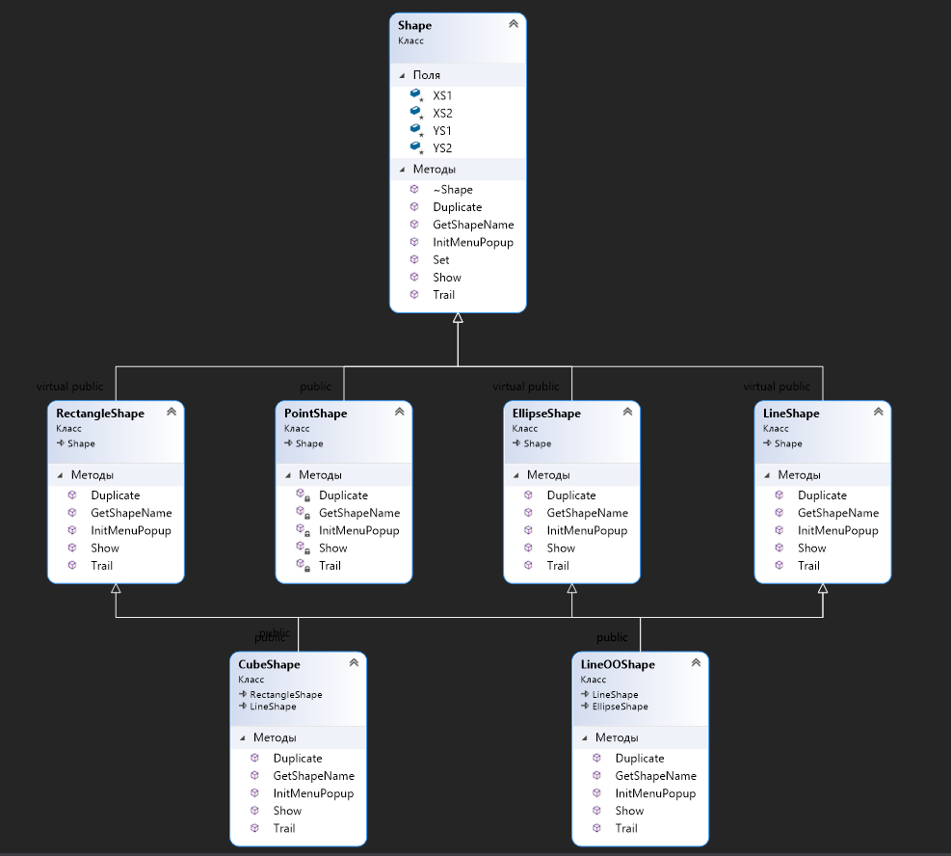

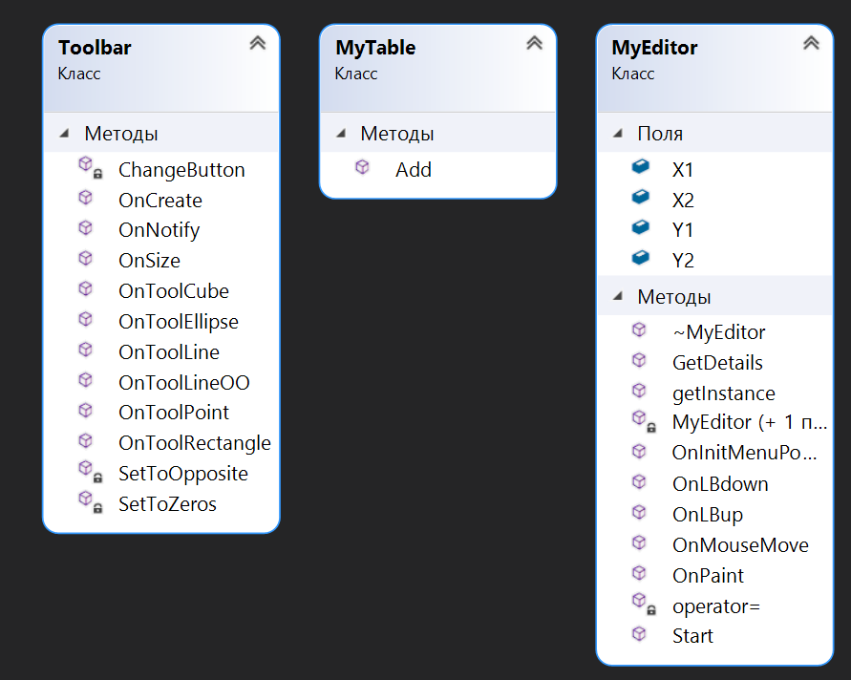

**Скріншоти програми:**

Також разом з іншими файлами є анімація (.gif) роботи програми

Бітмап:



Тулбар:

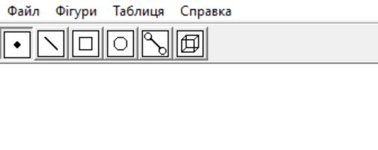

Вибір у меню:

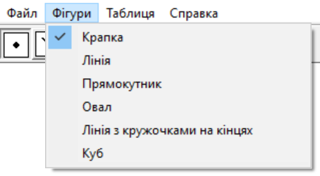

Крапки:



Лінії:

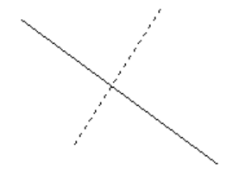

Квадрати:

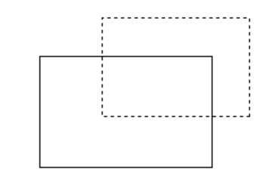

Овали:

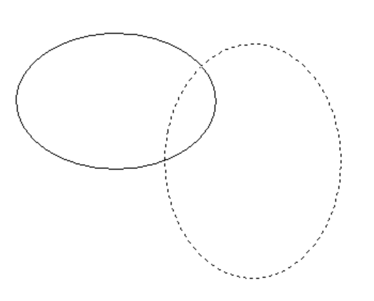

Лінії з кружечками:

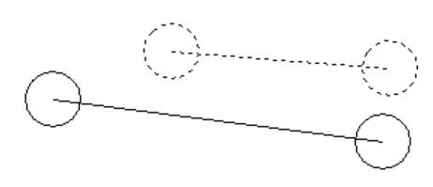

Куби:

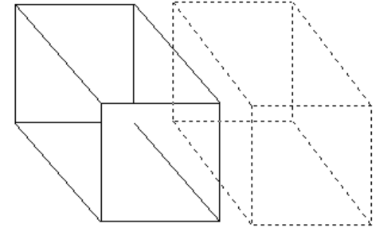

Таблиця:

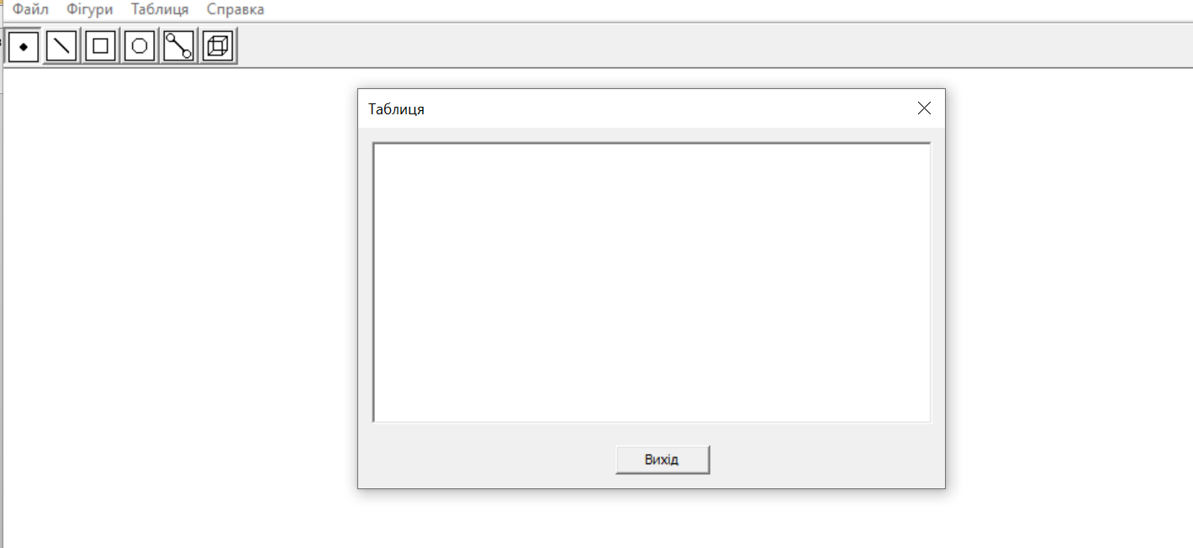

Таблиця з даними:

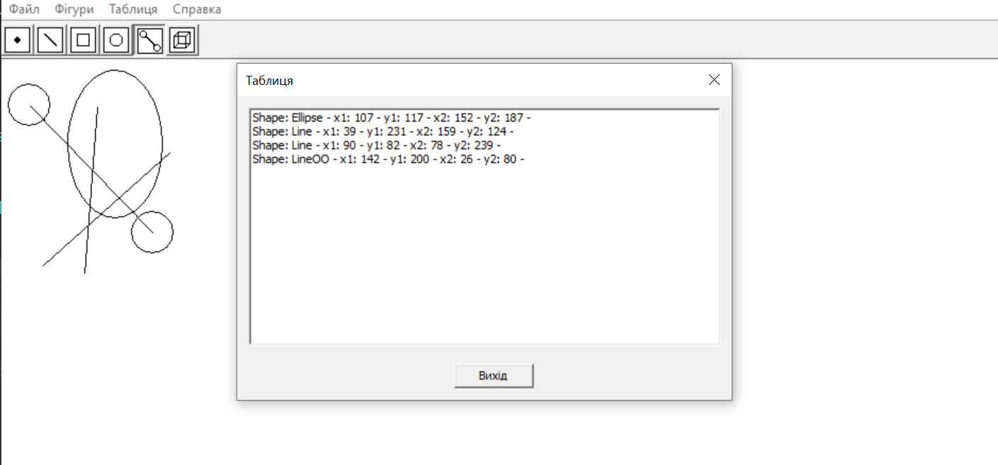

**Контрольні питання**

1. Що таке Singleton?

Клас, який забезпечує можливість створення тільки одного екземпляру об’єкта

2. Чим відрізняється класична реалізація Singleton від Singleton Меєрса?

У класичній реалізації є змінна “Instance” та код працює з нею, а в Singleton Меєрсаця змінна знаходиться у функції

3. Як запрограмувати немодальне діалогове вікно?

Потрібно мати ресурс-файл та створити в ньому вікно. Створити функцію, яка буде працювати з цим вікном. Коли користувач взаємодіє з пунктом у меню, то викликається функція, яка створює немодальне вікно

4. Як запрограмувати запис у файл об’єктів - геометричних форм?

Треба відкрити файл. Записати в нього наші дані за допомогою функцій побітового зсуву вліво. Закрити файл. Також в даному випадку можна використати “endl”, щоб закінчити введення на конкретному рядку.

5. Покажіть у програмі поліморфізм

My_editor може бути гарним прикладом поліморфізму, адже ми маємо «використання єдиного інтерфейсу для різнотипних сутностей або у використанні однакового символу для маніпуляцій над даними різного типу»

**Висновок:**

Навчився працювати з файлами. Записувати та видаляти з них дані. Дізнався про немодальні вікна, їх функції, як їх викликати та створювати.