**PROJECT DOCUMENTATION**

**ON**

**MOVIE BINGE**





**By:**

Vinamra Sareen



**CERTIFICATE**

**This is to certify that this report, titled MOVIE BINGE embodies the original work done by Vinamra Sareen in partial fulfillment of their course requirement at NIIT.**

**COORDINATOR**

**ACKNOWLEDGEMENT**

**I have benefitted a lot from the feedback and suggestions given to me by Mrs. Lopamudra Bera and other faculty members.**

**REQUIREMENTS OF PRODUCT**

**The software and hardware product requirements for Movie Binge:**

**Hardware specifications for running Movie Binge**

**There is no minimum requirement, you may use old hardware (like Pentium 2 or older), 128MB RAM will be enough and a 20GB HD will be big enough.**

**Software Details for running Movie Binge**

**Web Server (preferably Apache Tomcat)**

**H2 Database configuration**

**Technologies used:**

* **Bootstrap**
* **jQuery**
* **Font-Awesome**
* **HTML5**
* **CSS3**
* **JavaScript**
* **Google Fonts**
* **Spring MVC**
* **Hibernate**
* **Maven**

**And many jars i.e., dependencies.**

**PROJECT LIFE CYCLE MODEL**

**Initiation Phase**

**Introduction**

**This project is a web-based movie booking system. The project objective is to deliver the online booking application into web platform. Movie Tickets Booking is the process whereby consumers directly buy tickets from their device in real-time, without an intermediary service, over the Internet. It is a form of electronic commerce. This project is an attempt to provide the advantages of online booking system to customers. It helps buying the tickets for seats for any movie anywhere through internet by using browser. Thus, the customer will get the service of booking system and tickets for any favorite movie without having to stand in line.**

**Project Objective**

**The objective of the project is to make an application on web platform to purchase movie tickets for any playing show. To build such an application complete web support needs to be provided. A complete and efficient web application which can provide the best booking experience is the basic objective of the project.**

**Project Overview**

**The central concept of the application is to allow the customer to book virtually using the Internet and allow customers to buy the tickets of their desire. The information pertaining to the bookings are stored on an RDBMS at the server side (store). The application was designed into two modules first is for the customers who wish to buy the movie tickets. Second is for the admin who maintains and updates the information pertaining to the movies, show times and user booking. The end user of this product is a theatre where the application is hosted on the web and the administrator maintains the database. The application which is deployed at the customer database, the details of the movies are brought forward from the database for the customer view based on the selection and the database of all the movies are updated at the end of each transaction. Data entry into the application can be done through various screens designed for various levels of users. Once the authorized personnel feed the relevant data into the system, several reports could be generated as per the security.**

**Concept Development Phase**

**Project Scope**

**This system can be implemented to any theatre in the locality or to multinational theatres. The system recommends a facility to keep a check on database needs. If theatres are providing an online portal where their customers can enjoy easy booking on seats from anywhere and on any show, the theatres won’t be losing any more customers. Since the application is available in the Smartphone it is easily accessible and always available**

**VISION DOCUMENT**

**PROJECT PLAN**

**Project Name: Movie Binge**

|  |  |
| --- | --- |
|  | Milestone for Movie Binge |
| Milestone 1 | * **Created repository for Movie Binge on GitHub** * **Initialize this repo** * **Added Custom Controller for landing page** |
| Milestone 2 | * **Configure Hibernate and H2 database with Spring MVC** |
| Milestone 3 | * **Admin Panel performing CRUD operations for movies section** |
| Milestone 4 | * **Landing Page** * **Login and Booking Validations** |
| Milestone 5 | * **Booking Module** |

**Time Duration for Project Completion**

|  |  |  |  |  |
| --- | --- | --- | --- | --- |
| Milestones | Planned Start Date | Planned End Date | Actual Start Date | Actual End Date |
| Milestone 1 | **10 April** | **19 April** | **14 April** | **20 April** |
| Milestone 2 | **20 April** | **21 April** | **20 April** | **21 April** |
| Milestone 3 | **23 April** | **31 April** | **25 April** | **1 May** |
| Milestone 4 | **1 May** | **8 May** | **2 May** | **10 May** |
| Milestone 5 | **10 May** | **15 May** | **11 May** | **15 May** |

**WEEKLY STATUS REPORT**

1. **April – First Week** 
   1. **April 14** **- Created Repository for Movie Binge on GitHub**
   2. **April 18 – Initialized the repo**
   3. **April 19 - Added Custom Controller [Index Controller] for landing page**
2. **April – Second Week**
   1. **April 21 - Configured Hibernate and H2 database with Spring**
3. **April – May [End on April and Start of May]**
   1. **May 1 - Admin panel performing CRUD operations for movies section**
4. **May - Second Week**
   1. **May 7 - Landing page - [Partially Completed]**
   2. **May 9 – Login and Booking Validations**
5. **May – Third Week** 
   1. **May 15 – Booking Module Completed**

**WEEKLY STATUS REPORT**

|  |
| --- |
| **ACTIVITIES COMPLETED THIS WEEK** |

* **Created Repository for Movie Binge on GitHub**
* **Initialized the repo**
* **Added Custom Controller [Index Controller] for landing page**

|  |  |  |
| --- | --- | --- |
| **ACTIVITIES IN PROCESS** | **NEXT ACTION** | **DUE DATE** |
| Mapping URLs in Controller for other  requests | Database Configuration | 21 April |

|  |  |  |
| --- | --- | --- |
| **ACTIVITIES TO BE STARTED NEXT WEEK** | | |
| Hibernate and H2 Database Configuration | POJO for Movie, Movie  Details, Users, Show  and Trailers | Data Access  Objects for the  Same models. |
| Implement Dao to create queries and get  data |  |  |

|  |
| --- |
| **ISSUES FOR IMMEDIATE ATTENTION** |
| Not Yet |

**WEEKLY STATUS REPORT**

|  |
| --- |
| **ACTIVITIES COMPLETED THIS WEEK** |

* **Configured Hibernate and H2 database with Spring**

|  |  |  |
| --- | --- | --- |
| **ACTIVITIES IN PROCESS** | **NEXT ACTION** | **DUE DATE** |
| Creating queries to perform CRUD  operations | Create queries to  display data on  homepage | 1 May |

|  |  |  |
| --- | --- | --- |
| **ACTIVITIES TO BE STARTED NEXT WEEK** | | |
| Admin Panel performing CRUD operations |  |  |

|  |
| --- |
| **ISSUES FOR IMMEDIATE ATTENTION** |
| Handling exception in case of database connection error or other exceptions |

**WEEKLY STATUS REPORT**

|  |
| --- |
| **ACTIVITIES COMPLETED THIS WEEK** |

* Admin Panel performing CRUD operations

|  |  |  |
| --- | --- | --- |
| **ACTIVITIES IN PROCESS** | **NEXT ACTION** | **DUE DATE** |
| Landing Page | Booking Module | 9 May |

|  |  |  |
| --- | --- | --- |
| **ACTIVITIES TO BE STARTED NEXT WEEK** | | |
| Landing Page [ Homepage] | Booking and Validations |  |

|  |
| --- |
| **ISSUES FOR IMMEDIATE ATTENTION** |
| * Adding Custom Validations and implementing messages wherever required. * Login Security and session handling |

**WEEKLY STATUS REPORT**

|  |
| --- |
| **ACTIVITIES COMPLETED THIS WEEK** |

* **Landing page - [Partially Completed]**
* **Login and Booking Validations**

|  |  |  |
| --- | --- | --- |
| **ACTIVITIES IN PROCESS** | **NEXT ACTION** | **DUE DATE** |
| Service for seat booking | * Seat Booking Module * Get Seats based on date and time * Calculate Price in real time | 15 May |

|  |  |  |
| --- | --- | --- |
| **ACTIVITIES TO BE STARTED NEXT WEEK** | | |
|  |  |  |
|  |  |  |

|  |
| --- |
| **ISSUES FOR IMMEDIATE ATTENTION** |
| * Apply Transaction to book seats in case if more than one user tries to book the same seat then the first query proceeds. * In case on failure the transaction should be rolled back. * Errors should be handled carefully * Seats that are already booked must be shown by selection. |

**WEEKLY STATUS REPORT**

|  |
| --- |
| **ACTIVITIES COMPLETED THIS WEEK** |

* Booking Module Completed

**FUNCTIONAL REQUIREMENT DOCUMENT**

* **Customer can perform these functions:**
  + **Book movies**
  + **Seat Selection based on date and time**
  + **Cancel tickets**
  + **Browse to see all the movies currently playing**
  + **Browse to see all the upcoming movies**
  + **Verify the credentials at the time of login**
  + **Provide a mechanism to restrict access to administrative functions based on the fact whether the current user is admin or not.**
  + **Provide a mechanism to check for the current session, if session exist perform functions [sql queries].**
  + **Removes session after a long inactivity.**
* **Admin can perform these functions:**
  + **Add new movie**
  + **Update the movie details**
  + **View all movies**
  + **Delete movies**
  + **Add Show timings**
  + **Delete Show timings­­­**

**NON-FUNCTIONAL REQUIREMENT DOCUMENT**

**Usability**

* **Easy to navigate and tap buttons and navigation menu links.**

**Vision**

* **Appropriate messages should display wherever required. Most probable situations are successful logged in, signup.**

**Human Error**

* **Proper validations have been applied on forms.**

**Security**

* **According to industry best practices covered most of the security concerns.**

**Scalability**

* **Horizontal Scalability** 
  + **Movie Binge has been designed considering in the factor of database configuration. Hibernate allows easy adaption to different databases.**

**Maintainability**

* **Anyone who can understand documentation can make changes to code according to requirements.**

**Reliability**

* **Covered possible cases and it catches exceptions in case of failure.**

**UML: USE CASE DIAGRAM FOR USER & ADMIN**

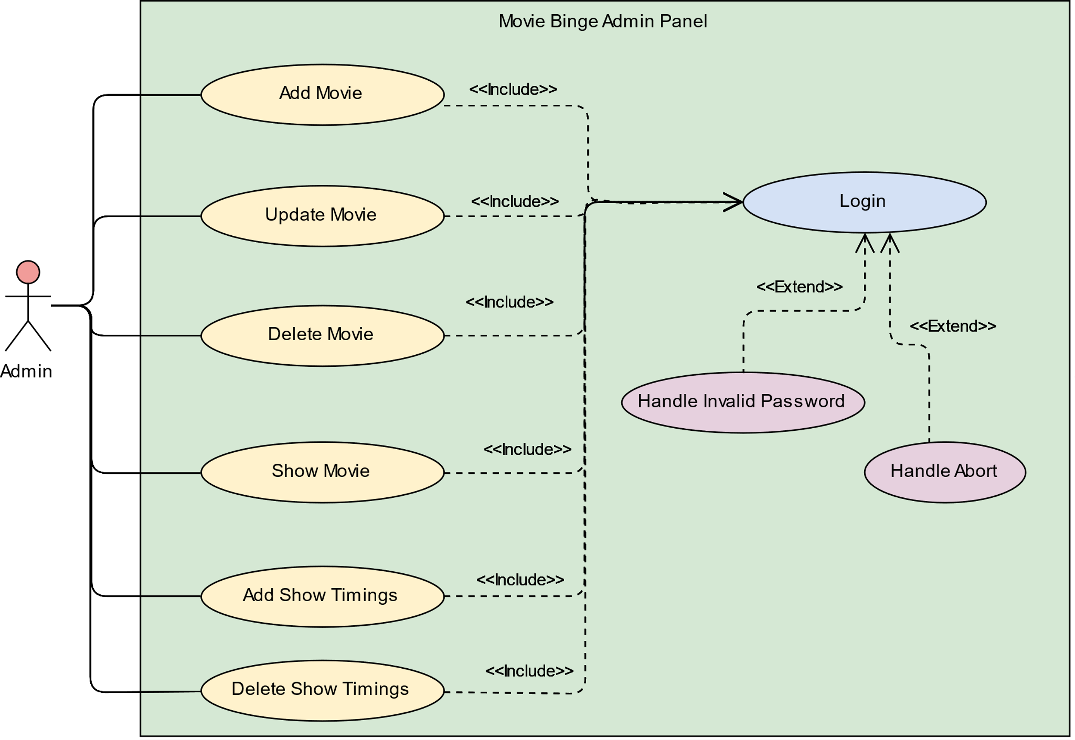

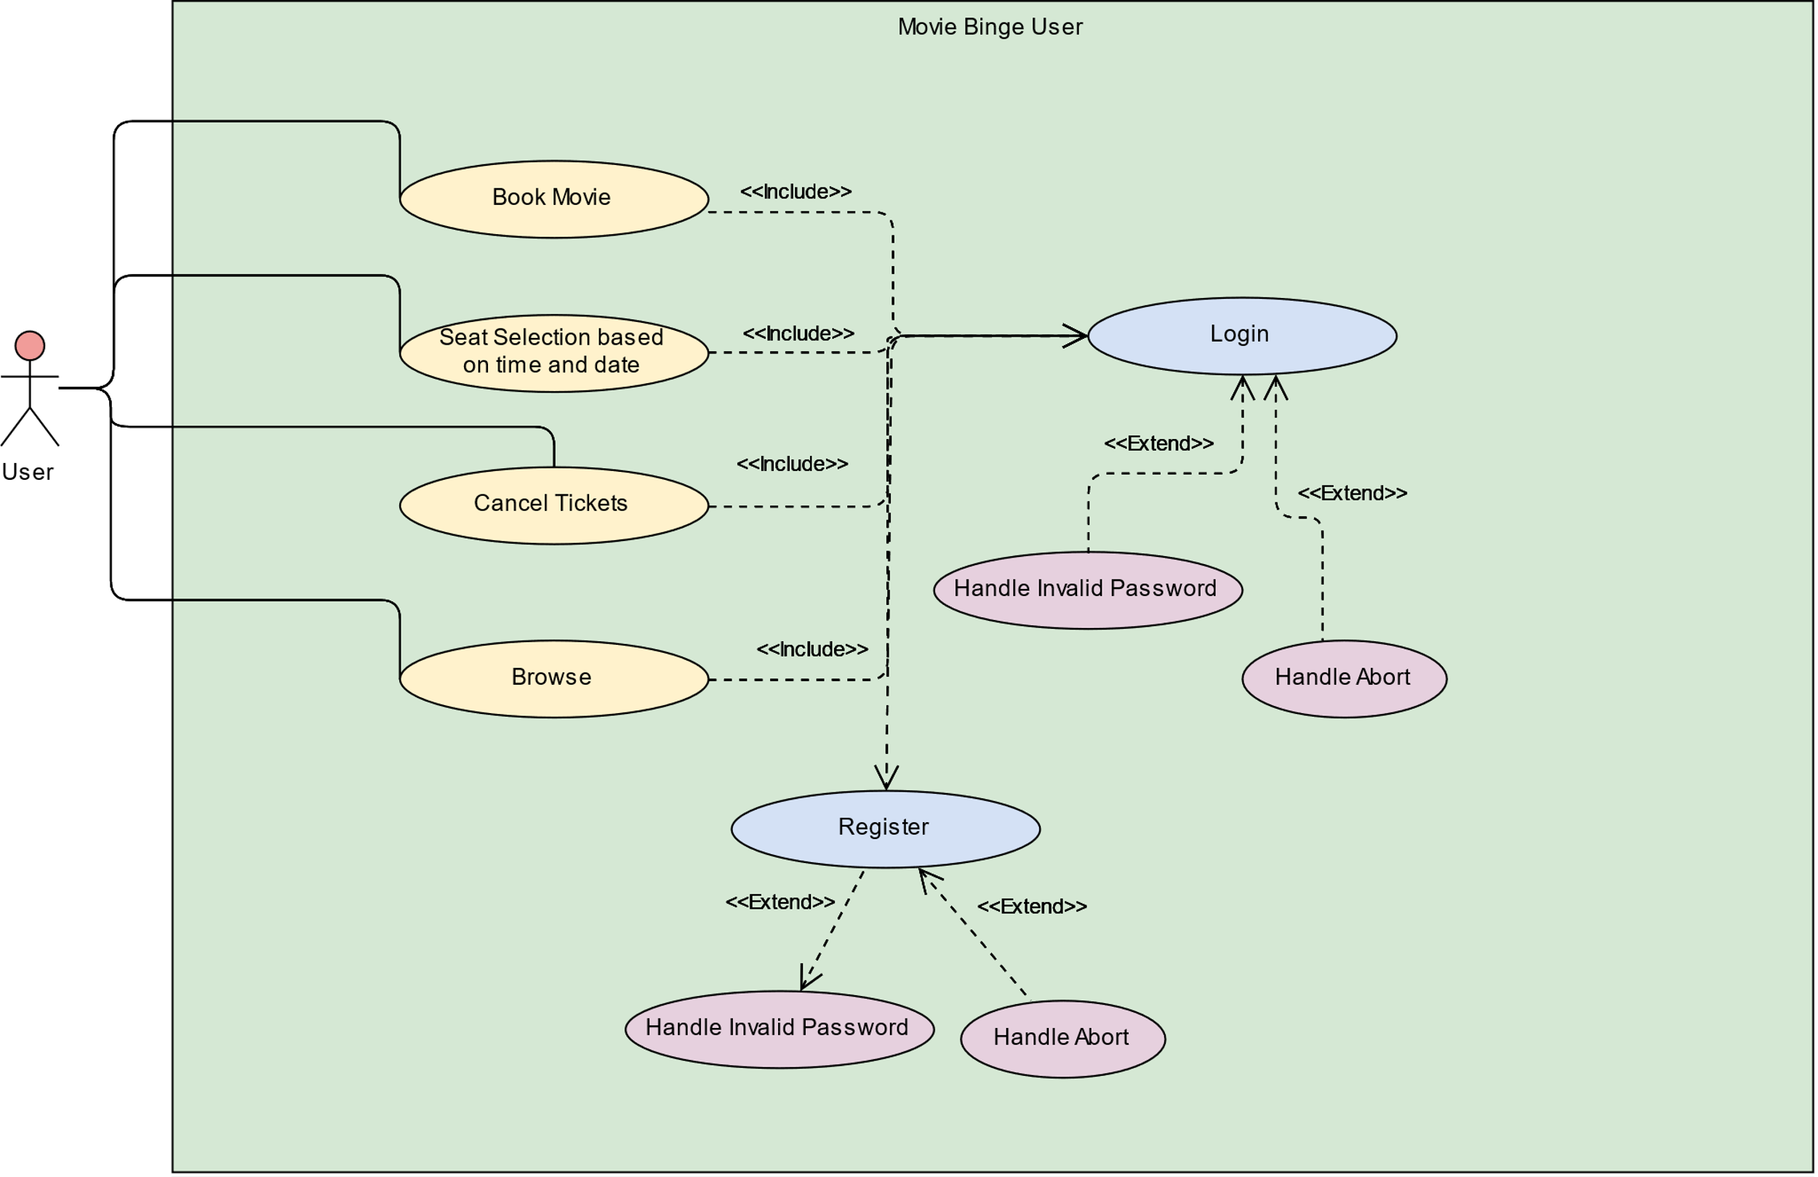

**USES CASES DETAIL**