Name :

Student ID:

Table of Contents

**Table of Figures2**

**Data Choice3**

**Background Information3**

**Data Description4**

**Data Processing7**

**Data Mining8**

**Discussion of Findings11**

**References11**

**Appendices12**

Table of Figures

Figure 1: Top cities based on numbers 4

Figure 2 : Bottom cities based on numbers 5

Figure 3 : Every Brand’s Transaction over a month 5

Figure 4 : Top 5 classes based on number of transactions 6

Figure 5 : Bottom 5 classes based on number of transactions 6

Figure 6 : Prominent brand in terms of frequency in many departments in various nations 7

Figure 7 : Month-by-Month transaction trend for all nations 7

Figure 8 : which brands of goods Americans prefer to buy at GRAND 8

Figure 9 : In Asia, each brand's market share fluctuated 8

Figure 10 : data trends at regular intervals 9

Figure 11 : comparisons across different categories 9

Figure 12 : a set of data series: connected data points 10

Figure 13 : Clustering produces a group of data objects 10

1. Data Choice

The data set RETAILDEMO 2 was chosen for this analytical report (Mike, 2021). There are a total of fifty seven column along with 2.3 million rows in this data set. The amount of data is enormous, and analyzing and filtering it with a normal relational-database is tough. In light of this, SAS Viya will be used for analyzing and visualizing in this report. We can derive some measures from either the provided data set, and we can further filter and sort the primary cluster data based on these measures. The primary cluster can be filtered, re-divided, and ordered based on a single measure in the real visualization study procedure. The primary cluster can also be joined, and first dataset could be taken as a foundation for categorizing data from another set. These activities can assist us in establishing the visual analysis that is required. We can generate required analytical reports naturally and rapidly by mixing the manifestations of numerous charts. Below following are the report's principal findings:

1. The firm should boost its involvement in large cities while decreasing its Investment in others.

2. Research how or when to prevent the sales decrease of other brands by focusing to the brand Maple, which total sales is increasing against the trend.

3. High-volume categories, including such bath body, should raise buy quantity to boost the amount of transactions while lowering the buy quantity of the segment with the greatest sales volume.

4. The Pines brand is the most popular in practically every country.

5. Each country's sales volume fluctuates over time.

6. The most popular way for Americans to purchase Pine brand products is through the GRAND chain of stores.

7. In Asia, Oak's market share has been dropping, while other brands' market share has been increasing.

1. Background Information

A data set (also known as a dataset) is a collection of data, usually in the form of a table. Each column corresponds to a different variable. Every corresponding to a query in the data set of a member. This lists the values for each variable as a random number, such as an object's length and weight. A data sheet is the name given to each value. The data set's data may have one or more members, depending on the number of rows. The collection and analysis of measurement data is used in a lot of scientific research. A fascinating trend may be observed here: data sets (often in conjunction using modeling and factors) are becoming increasingly essential. (2006, Dekker) An analytical report is a sort of business report that analyses and evaluates a business strategy or process using qualitative and quantitative firm data while encouraging workers to create info driven decisions based on facts and analytics and mined data (Greiner, 2011). "What would be an analysis report?" we posed the question. As a result, now is the time to think about the advantages of document analytics for business growth. Business intelligence is accessed through analysis reports (BI). And, as your company evolves smarter, you will gain an advantage over the competition. You will be able to make educated and accurate judgments by using analytical reports, as well as solve problems and react to new in a careful way.

This project is a data analysis of Business across all the different cites or countries across the world. The main idea of the project is an approach or instrument to help with business decision-making. As a result, it affects how the entire organization functions. Business analytics may therefore help a company become more profitable, grow its market share and revenue, and provide shareholders a higher return. It improves the ability to comprehend the primary and secondary data that is provided, which again affects the operational effectiveness of various departments. It gives businesses a competitive advantage. The information flow is nearly equal among all stakeholders in this digital era. The competitiveness of the firm is determined by how this information is used. Corporate analytics improves business choices by combining readily available data with several carefully considered models. It transforms readily available data into insightful knowledge. Any format that is necessary and convenient for the decision maker can be used to communicate this information. The data analysis of different datasets have magnitude of advantages which include:

* It aids businesses in obtaining accurate information.
* Compared to other data applications, it is a productive and affordable option.
* Businesses may adapt their operations and output in a lucrative way.
* Both modern and antiquated systems are used in data mining.
* It aids businesses in making wise selections.
* It aids in identifying fraud and credit concerns.
* It makes it simple for data scientists to swiftly evaluate massive volumes of data.
* The data may be used by data scientists to identify fraud, create risk models, and enhance product safety.
* It enables data scientists to swiftly launch automated behavioral and trend forecasts and find covert patterns.

1. Data Description
   1. Top 5 and Bottom 5 cities based on number of customers

The top five cities and the worst five cities are shown in figures 1 and 2, respectively. Therefore, we should focus more of our efforts on important cities like Shanghai and Mexico City while neglecting Del Mar and Chico.

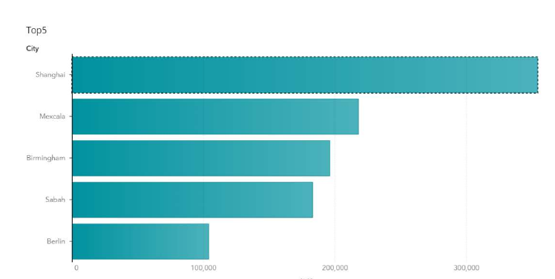

Figure : Top cities based on numbers

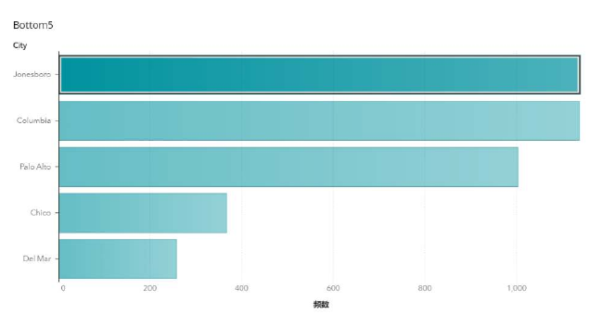

Figure : Bottom cities based on numbers

* 1. Every Brand’s Transaction over a month

Figure 3 shows three lines of varying colors, each of which symbolizes a brand. The spots on the lines indicate their transactions. The picture depicts Oak and Pine as being generally constant between August 2009 and November 2009 before rising and subsequently falling. However, Maple continues to rise.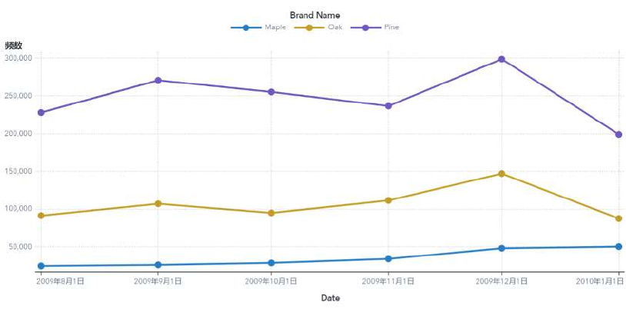

Figure : Every Brand’s Transaction over a month

* 1. Top 5 and Bottom 5 classes based on number of transactions

The top five classes and the worst five classes are shown in figures 4 and 5, respectively. This implies that we should spend more money on luxury categories like bath body and women's handbags and less on categories like women's swimsuits.

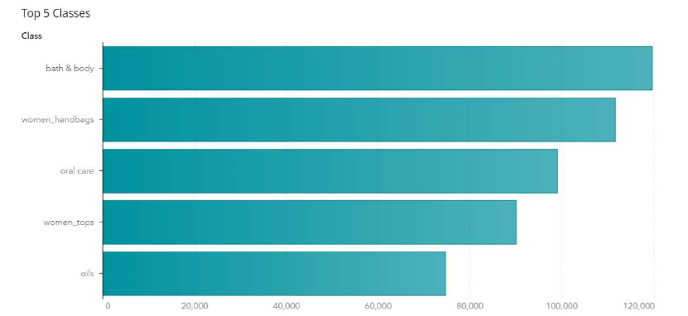

Figure : Top 5 classes based on number of transactions

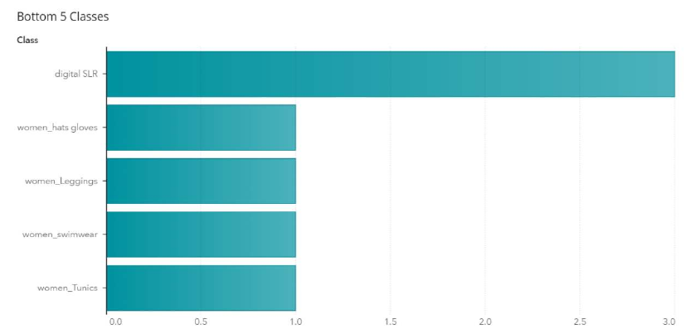

Figure : Bottom 5 classes based on number of transactions

* 1. Prominent brand in terms of frequency in many departments in various nations

The popularity of brands in relation to frequency in each department across several nations is depicted in this graphic. According to the diagram, Pine ruled the majority of courses and counties. However, Oak takes the majority of sales in several nations and in particular product categories.

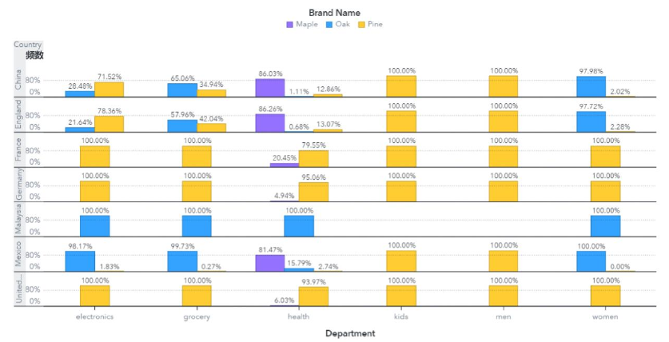

Figure : Prominent brand in terms of frequency in many departments in various nations

* 1. Month-by-Month transaction trend for all nations

This graphic shows the monthly transactions for each of the nations. The precise number of transactions is indicated by the number of dots above, and lines linking the dots are colored to reflect the various countries. The line graph with animations displays the monthly changes in the transaction number.

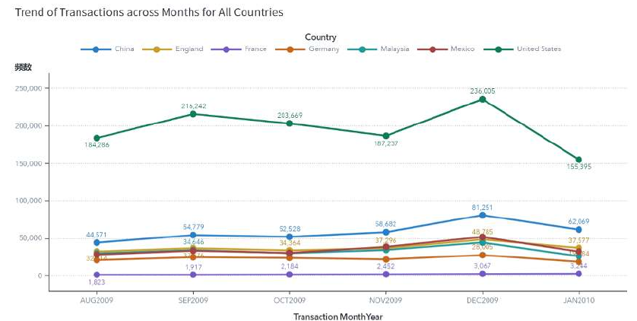

Figure : Month-by-Month transaction trend for all nations

1. Data Preprocessing
   1. Check to see which brands of goods Americans prefer to buy at GRAND. 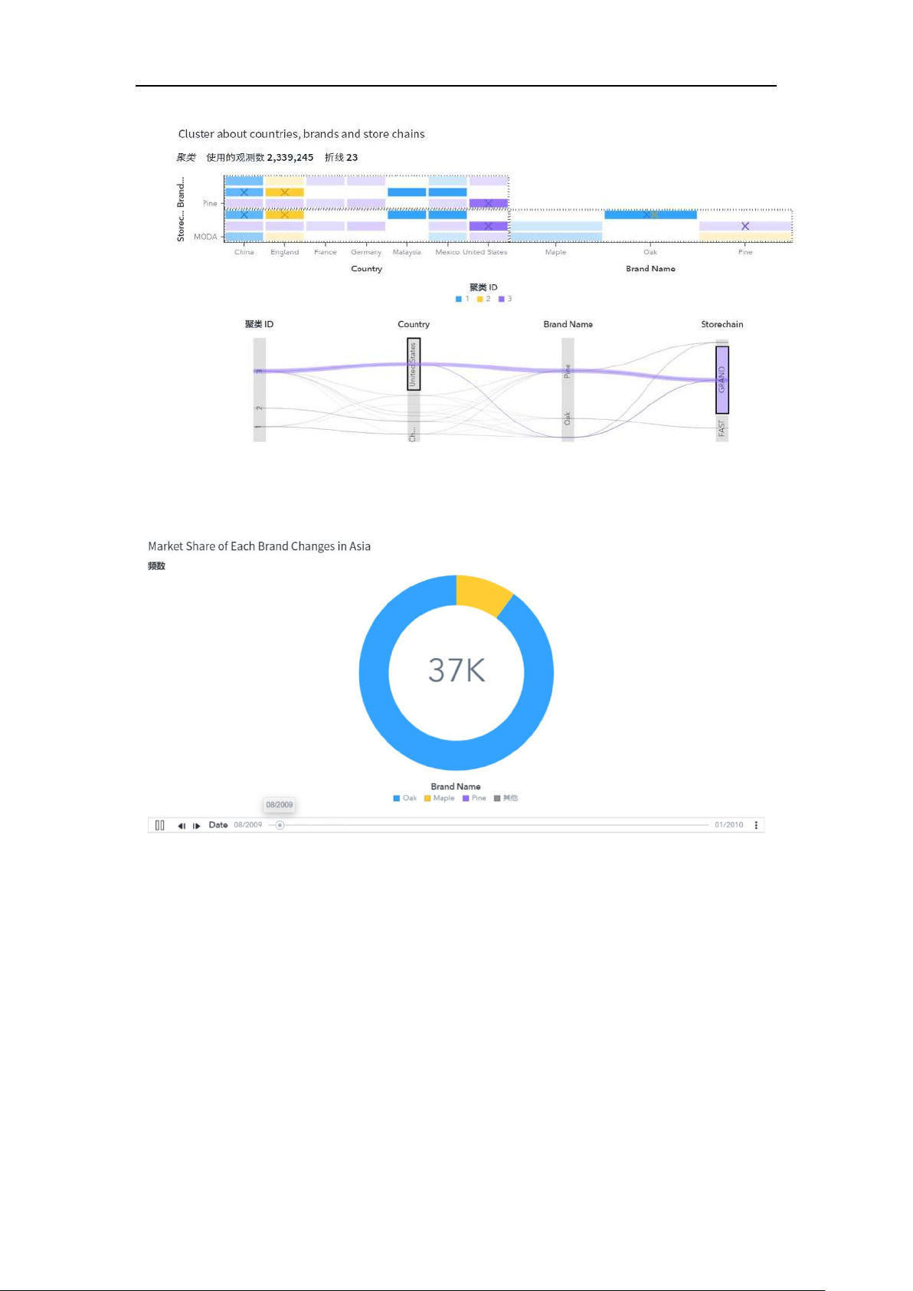

Figure : which brands of goods Americans prefer to buy at GRAND

* 1. In Asia, each brand's market share fluctuated.

Figure 9 : In Asia, each brand's market share fluctuated

1. Data Mining

Bar graphs are used because they may directly indicate the quantitative difference between elements which have to be evaluated. Furthermore, we can simply achieve other visualization tasks such as the most or least selection, as well as comparisons across different categories, by employing filtering and sorting tools.

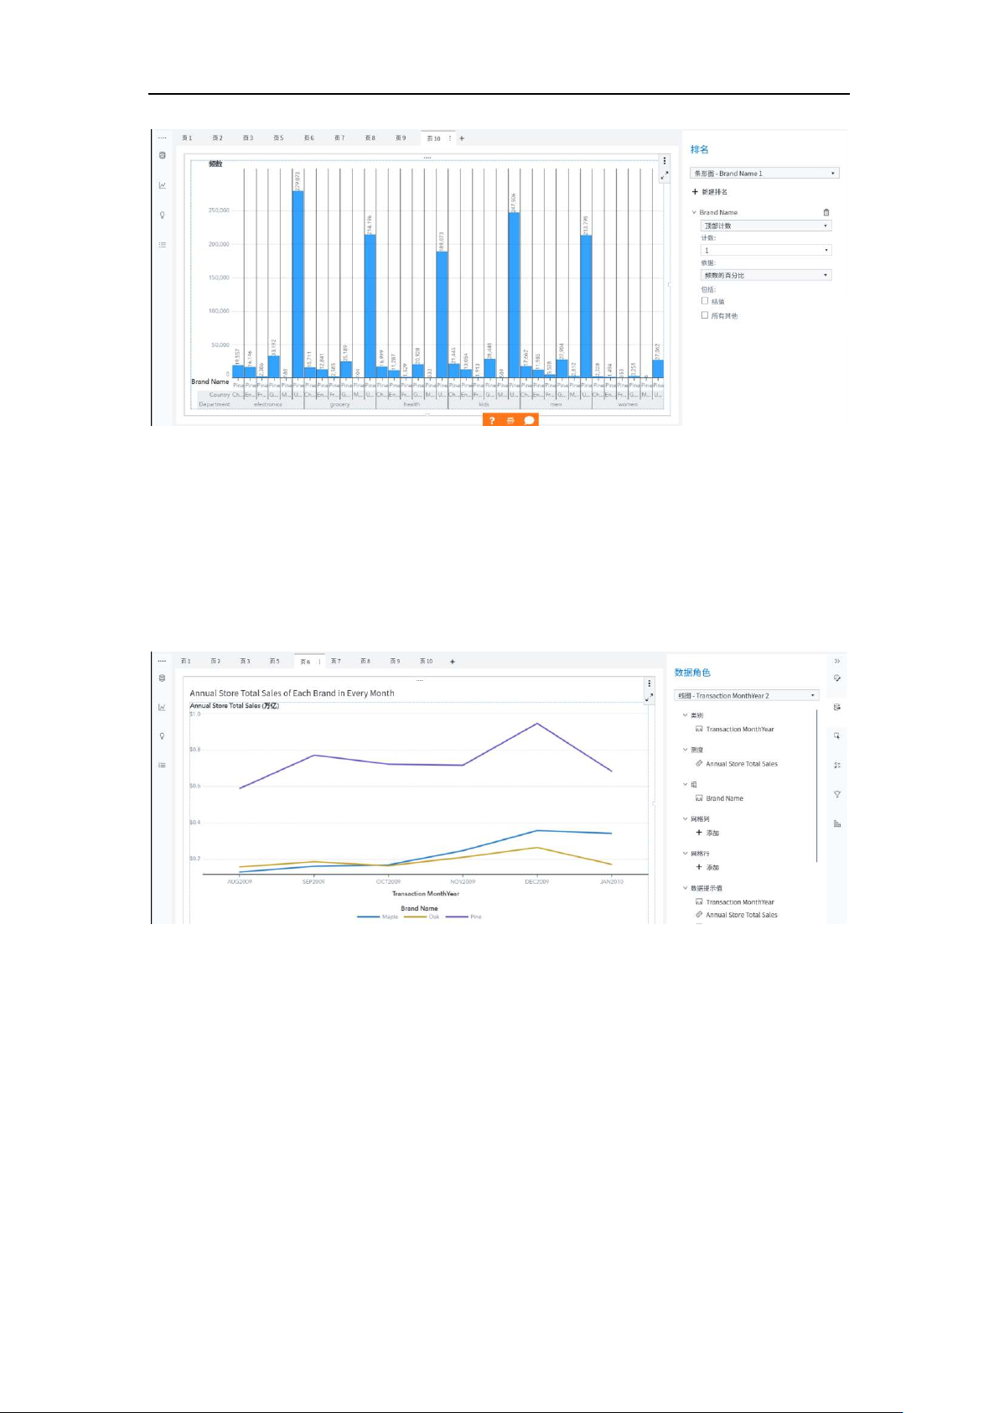

Figure 10 : data trends at regular intervals

Figure : comparisons across different categories

I've decided on a line chart. The data from the worksheet's columns or rows can be turned into a line chart. The line chart may show continuous data that varies over time, making it ideal for displaying data trends at regular intervals. A line chart has category data divided evenly all along horizontal axis as well as all value data distributed evenly all along vertical axis. As a result, it is ideal for activities such as demonstrating how something changed through time.

I utilize cluster for further visualization. Clustering is the technique of grouping a group of tangible or abstract objects into numerous classes made up of comparable elements. Clustering produces a group of data objects that are comparable to those in the single cluster but different from those in other clusters. "Things are categorized, and individuals are sorted into groups." There are numerous classification issues in both natural and social sciences. Cluster analysis is a statistical analytic method for examining classifications problems, often known as cluster analysis.

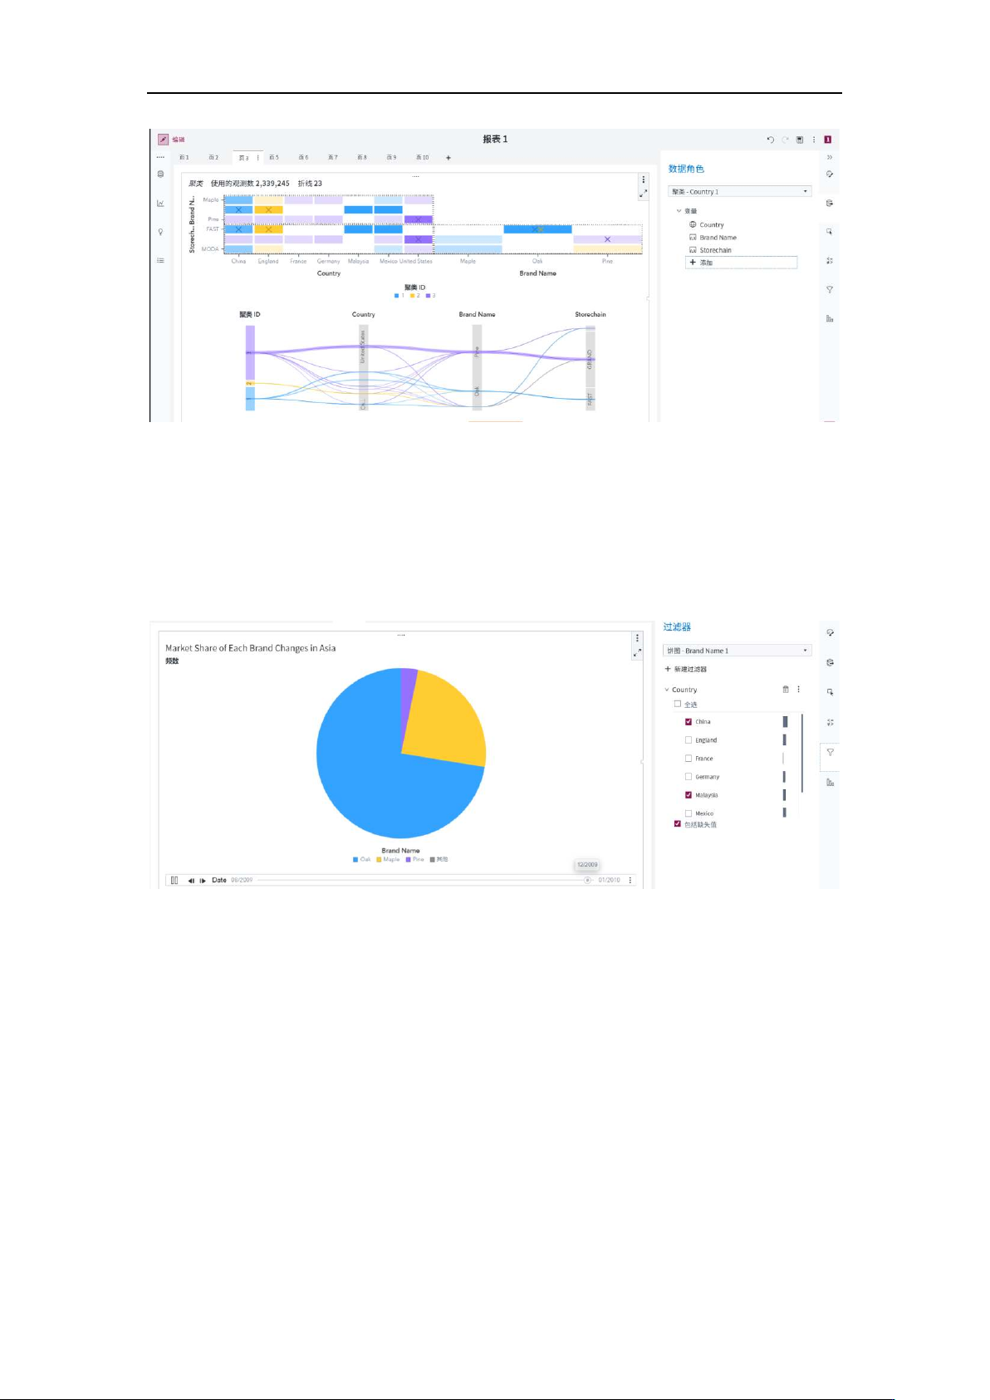I use a pie chart for further visualization. The pie chart depicts a set of data (data series: connected data points displayed inside this chart, those data are generated out from columns or rows of the data table). In the chart's legend, each data series has its own color or pattern. Represents the proportion of each item's size to the sum of all items in). The pie chart's data points are represented as a proportion of the overall pie chart.

Figure 12 : a set of data series: connected data points

Figure 13 : Clustering produces a group of data objects

The data mining algorithms have various applications such as:

Banks

By examining client financial data, purchase transactions, and card transactions, data mining enables banks to interact with credit ratings and anti-fraud systems. When creating a new marketing campaign, data mining also helps banks better understand the online behaviours and interests of their clients.

Healthcare

By combining each patient's medical history, results of the physical examination, drugs, and treatment patterns, healthcare data mining aids clinicians in making diagnoses that are more accurate. Additionally, mining promotes a more economical approach to managing health resources and aids in the battle against fraud and waste.

Marketing

If there was ever a field where data mining was advantageous, it's marketing! After all, the core of marketing is successfully targeting clients to achieve the best outcomes. Knowing as much as you can about your audience is, of course, the greatest approach to target them. To generate more successful tailored loyalty programs, data mining brings together information on age, gender, tastes, income level, geography, and purchasing patterns. Even which clients are more likely to unsubscribe from a mailing list or other connected service may be predicted using data marketing. With such knowledge, businesses may take action to keep those clients before they have a chance to go!

Retail

Although the worlds of marketing and retail are intertwined, the former nonetheless deserves to be included separately. Retail establishments and supermarkets can utilise purchase patterns to identify product linkages, choose which products to carry in the shop, and decide where to place them. Data mining also identifies the initiatives that receive the most reaction.

1. Discussion of Findings
   1. The top five cities and the worst five cities can be found in Figures 1-and 2. That means we should concentrate our efforts on high-profile cities such as Shanghai and Mescal, while reducing our efforts in Del Mar and Chico.
   2. Figure 3 shows three lines of varying colors, each representing a brand, and the point on the line denotes their transactions. The graph shows that Oaks and Pine were generally constant between August and November 2009, then rose and fell afterwards. However, Maple continues to rise.
   3. Figures 4 and 5 show the top and bottom of five classes. That suggests we should invest more in top classes like bath body and woman handbag, and less in woman swimwear and other similar categories.
   4. Diagram 6 depicts the attractiveness of brands in different countries based on the frequency of each section. The brand Pine controlled the majority of classes and counties, as seen in the diagram. However, in other regions and categories, Oak takes the crown of sales.
   5. Diagram 7 depicts the monthly transactions in those countries. The number above the dots reflects the total number of transactions, while lines connect the dots with colors that represent different countries. The line graph with animations depicts how the number of transactions evolved over time.
   6. The association between Country Brand name and Store chain is depicted in figure 8 as a cluster. By selecting the block we were familiar with, the line between them would appear automatically; by analyzing them, analysts would examine the association between them and deduce a clear clew. Whenever we select the United States, the diagram below depicts what happens.
   7. Figure 9 depicts the three brands' market share in Asia, with the amount in the center representing total sales for the brand names in Asia. This pie-chart is composed of three layers by different colors, each representing a brand, and the area of each section representing the portion of the market.
2. References

# References

Greiner, L. (2011, January 7). *dbta*. Retrieved from dbta: https://www.dbta.com/Editorial/Trends-and-Applications/What-is-Data-Analysis-and-Data-Mining-73503.aspx

Mike. (2021, January 26). *Whatagraph*. Retrieved from Whatagraph: https://whatagraph.com/blog/articles/analytical-report

1. Appendices
   1. Appendix A

According to a recent global analysis of ACI Worldwide (NASDAQ: ACIW) and Global Data, upwards of 70.3 billion real time transactions were conducted globally in 2020, up 41% from the previous year, as the COVID-19 epidemic drove trends away from cash and cheque and toward greater dependence on real-time and digital payments. The second edition of 'Prime-Time for Real-Time,' which was initially released in 2020, examines worldwide real time, account-to-account payments volumes and predictions in 48 global markets. It forecasts a 23.6 percent compound annual growth rate (CAGR) for real-time payments from 2020 to 2025.

* 1. Appendix B

"Real-time payments are still in their infancy around the world, with many countries focusing on the obvious use-case of P2P payments," said Samuel Mirant, Global Data’s lead analyst for payments. "However, the epidemic has created an opportunity to accelerate these instruments' growth trajectory." Consumers will naturally switch to using P2P payments for e-commerce over the slower and less comfortable procedure of using cards online as they become accustomed to the speed of real-time settlement. Once enough consumers recognize real-time payment brands and the user base is large enough to provide sufficient value to businesses, there is potential to go into in-store payments."