**Readme**

In order to perform this test, I used Selenium (I have repeatedly tried to test using Selenide, but still I'm more familiar with Selenium). I tried to run this test using Page Object.

**Test case**

|  |  |
| --- | --- |
| **Steps** | **Expected result** |
| 1. Open Google page  2. Search for "Test Automation"  3. Click on 7th link from the search results  4. Verify title contains "Automation" for the opened page | 1. A Google search page has opened 2. The page with the found result has opened. 3. Click on 7 - tab "What is Test Automation? Automated Testing 101 | SmartBear". 4. Checked to see if the title contains the word "Automated". |

**The test was performed on a computer with the following characteristics:**

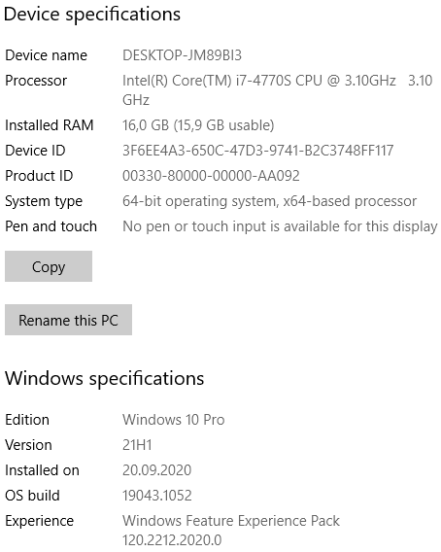

**Thank you for an interesting task) I'm waiting for an answer!)**