Retest AI Decision Quality
Executive Detail Report — AI Retest Recommendation Performance
Source: ATE_Retest_50_Devices_AI_Dataset.xlsx | 50 devices, 125 failure events | Prepared: August 17, 2026

1. Executive Summary
Across 125 retest-eligible failure events from 50 devices, the AI retest-recommendation model made the correct call — recommending RETEST only when a retest would actually recover the device, and DON'T RETEST only when the failure was persistent — in 88 cases (70.4% accuracy). The model recovers most of the value available: it correctly flags 58 of 70 truly beneficial retests (82.9% recall) and correctly waves off 30 of 55 truly persistent failures (54.5% specificity).
The two error types have different business consequences. Unnecessary retests (25 events, 20.0% of all events) cost 853.0 seconds of ATE time with no yield benefit — pure throughput loss. Missed opportunities (12 events, 9.6%) are more costly: these are devices the model told the line to scrap that a retest would have recovered, forfeiting 12 potentially good die.
Headline finding: the model's probability estimates are well-calibrated (Section 4), but its accuracy is not uniform — it applies what is effectively an all-or-nothing policy by test type. It recommends RETEST on 100% of Scan failures and DON'T RETEST on 100% of IDDQ and MBIST failures, rather than weighing each event individually within those categories (Section 5). This concentrates almost all missed opportunities in MBIST_03 (7 of 12) and most unnecessary retests in Scan (14 of 25).

2. Methodology
Each of the 125 failure events carries a ground-truth label (RETEST_BENEFICIAL or PERSISTENT_FAILURE) established by actually performing a retest and observing the outcome, independent of what the AI recommended. This allows every AI recommendation to be scored against a known-correct answer. Decisions were classified into a 2x2 outcome matrix (Section 3), and accuracy/precision/recall/specificity were computed directly from that matrix. Test time figures use the First_Test_Time_sec and Retest_Time_sec fields recorded per event; a Retest_Time_sec of 0 indicates no retest was actually performed for that event.

3. Decision Quality Breakdown
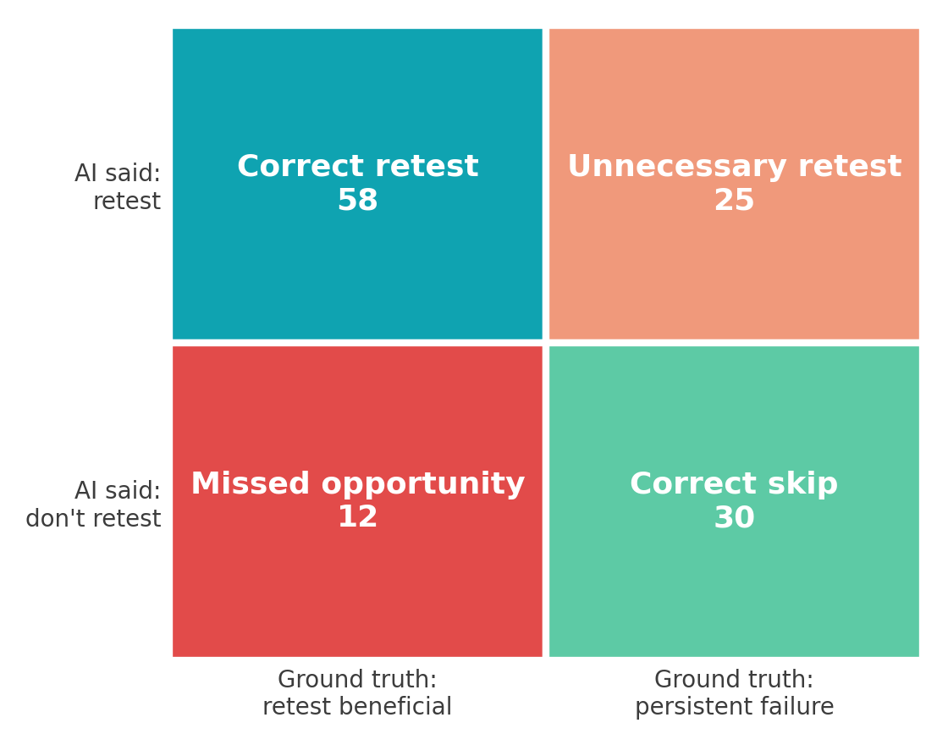
Figure 1 — AI recommendation vs. ground truth, all 125 events.
Metric | Value | Basis
AI decision accuracy | 70.4% | 88 of 125 events correctly classified
Precision | 69.9% | Of 83 RETEST calls, 58 recovered a device
Recall | 82.9% | Of 70 truly beneficial retests, AI caught 58
Specificity | 54.5% | Of 55 persistent failures, AI correctly skipped 30
Unnecessary retests | 25 events (20.0%) | 853.0 sec of retest time with no yield benefit
Missed opportunities | 12 events (9.6%) | 12 recoverable devices AI would have scrapped

AI Recommendation | Ground truth: Beneficial | Ground truth: Persistent
RETEST | 58 — Correct retest | 25 — Unnecessary retest
DON'T RETEST | 12 — Missed opportunity | 30 — Correct skip

4. Model Calibration
Before attributing the error pattern in Section 5 to a flaw in the underlying probability estimates, it's worth checking whether those estimates are trustworthy on their own terms. Grouping events by the AI's predicted retest-benefit probability and comparing to the actual observed beneficial-retest rate in each bucket shows the model is well-calibrated: events the model scored around 20-30% probability were beneficial about 30% of the time; events scored 80-100% were beneficial about 83% of the time.
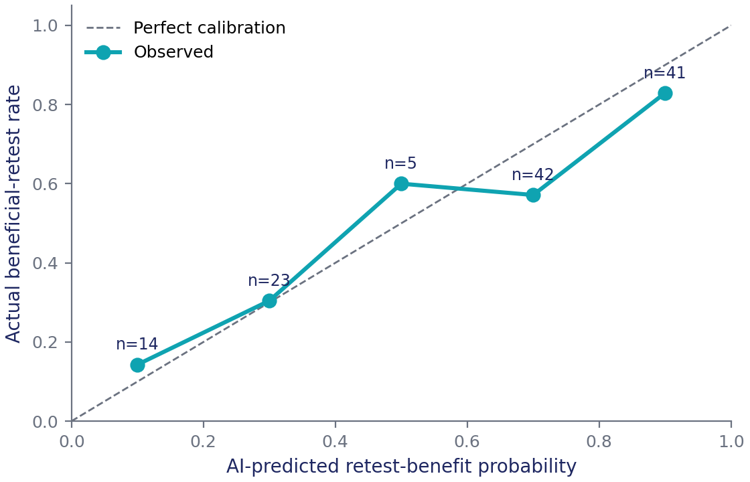
Figure 2 — Reliability diagram: predicted probability vs. observed outcome rate, in five buckets.
This matters for interpreting missed opportunities: a well-calibrated model operating at a 30% probability threshold will, by construction, still see roughly 30% of its "don't retest" calls in that bucket turn out beneficial purely by chance. Most of the 12 missed opportunities in Section 5 are this expected variance, not a scoring error — the model gave an honest low-but-nonzero probability and the coin landed the other way.

5. Where the Errors Concentrate
The confusion matrix in Section 3 shows overall accuracy, but the errors are not evenly spread. Breaking decisions out by Fail_Test reveals the AI is applying what functions as a fixed, test-type-level policy rather than an event-by-event judgment for three of the five test types:
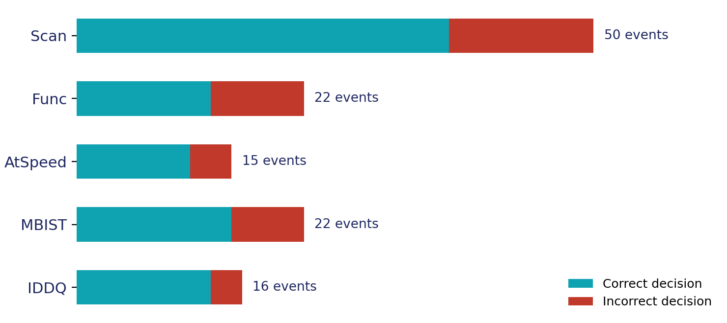
Figure 3 — Correct vs. incorrect decisions by failing test type.
Test type | Events | Correct calls | Accuracy | Behavior observed
Scan | 50 | 36 retest / 0 skip | 72.0% | AI recommends RETEST on 100% of Scan events
Func | 22 | 12 retest / 1 skip | 59.1% | Mixed recommendations; lowest accuracy of any test type
MBIST | 22 | 0 retest / 15 skip | 68.2% | AI recommends DON'T RETEST on 100% of MBIST events
IDDQ | 16 | 0 retest / 13 skip | 81.2% | AI recommends DON'T RETEST on 100% of IDDQ events
AtSpeed | 15 | 10 retest / 1 skip | 73.3% | Mixed recommendations

- Scan (50 events, 40% of all failures): the model recommends RETEST every single time. This is right 72% of the time but is the single largest source of unnecessary retests (14 of 25, 56%) — a Scan-specific probability threshold, rather than a blanket RETEST rule, would likely recover a meaningful share of that 853 seconds without giving up much recall.
- MBIST (22 events): the model recommends DON'T RETEST every single time, at a mean predicted probability of 25.4%. It is right 68% of the time, but this single test accounts for 7 of the 12 missed opportunities (58%) — the largest concentration of forfeited yield in the dataset.
- IDDQ (16 events): also a blanket DON'T RETEST policy, at a mean predicted probability of 17.4%, and the most accurate category overall (81.2%) — appropriate given how low the true recovery probability is for this test.
- Func and AtSpeed are the only two test types where the model actually splits its recommendation event-by-event rather than applying a fixed rule; Func has the lowest accuracy of any category (59.1%) and is worth a closer look independent of this report.

6. Variation by Wafer
Decision accuracy also varies materially by wafer, from 58.3% (W003) to 88.9% (W004) — a 30-point spread that is larger than the spread between any two test types. W004 stands out for having zero missed opportunities across 27 events; W003 has the highest concentration of unnecessary retests. This is consistent with wafer-to-wafer process variation shifting the true retest-recovery probability in ways the current model — which does not appear to use Wafer_ID or Voltage_V/Temperature_C as inputs — cannot see.
Wafer | Events | AI accuracy | Errors
W001 | 21 | 61.9% | 3 missed / 5 unnecessary
W002 | 23 | 73.9% | 3 missed / 3 unnecessary
W003 | 24 | 58.3% | 2 missed / 8 unnecessary
W004 | 27 | 88.9% | 0 missed / 3 unnecessary
W005 | 30 | 66.7% | 4 missed / 6 unnecessary

7. Economic Impact
Of the 4,421.0 seconds of retest time actually spent capturing ground truth for this dataset, 3,841.7 seconds went to the 83 events the AI recommended retesting (853.0 of which, 25 events, recovered nothing). The remaining 579.3 seconds were spent retesting the 12 events the AI had marked DON'T RETEST — time that would not have been spent under a strict AI-follows policy, but which is exactly what recovered those 12 otherwise-scrapped devices. In other words, the 12 missed opportunities represent forfeited die, not wasted time — the inverse of the unnecessary-retest cost.
- If unnecessary retests were eliminated (better Scan-specific thresholding): recovers up to 853.0 sec of ATE time across the sampled events, with no yield impact, since none of those 25 retests changed the final outcome.
- If missed opportunities were eliminated (better MBIST-specific thresholding): recovers up to 12 devices' worth of yield, at the cost of additional retest time on the currently-skipped MBIST/IDDQ population.
- These two levers trade against each other and should be tuned by test type rather than globally, since Section 5 shows the two failure modes are concentrated in different tests.

8. Recommendations
- Replace the effective blanket RETEST-on-Scan and DON'T-RETEST-on-MBIST/IDDQ policy with a continuous probability threshold applied uniformly across all test types — the model's own probability output is well-calibrated (Section 4) and is capable of finer-grained decisions than the current recommendation logic is using.
- Prioritize a threshold review specifically for MBIST_03 (Fail_Bin 45): it is the single largest source of missed opportunity (7 of 12 events) and the true recovery rate observed for this test (31.8%) is high enough that a modest threshold reduction would likely recover several of these devices for an acceptable increase in retest time.
- Investigate Wafer W003 and ATE_Site 5 (53.8% accuracy, the lowest of any site) as a process or fixture root-cause item, separate from the AI-model tuning above — the 30-point wafer-to-wafer accuracy spread suggests the model would benefit from wafer- or site-level context as an input feature.
- Revisit the Func test category (59.1% accuracy, the lowest of any test type) — it is the one test type already receiving mixed recommendations, suggesting the errors here are individual mis-scores rather than a systematic policy gap, and may need a feature-level fix rather than a threshold fix.

9. Caveats
This analysis covers 125 failure events from 50 devices in a single dataset snapshot; test-type and wafer breakdowns in Sections 5-6 involve subgroups as small as 15-30 events and should be treated as directional rather than statistically definitive until validated against a larger sample. Ground-truth labels rely on a single retest attempt per event; the underlying True_Retest_Pass_Probability field indicates recovery is genuinely probabilistic for several event categories (notably MBIST), so some fraction of both missed opportunities and correct skips reflects normal outcome variance rather than model error.

