STAT Login credential (Common credentials)
Username: LTISupport
Password: Terex123
RDP Machine:
Name: psmwtrxpvcs01.tcs.terex.com
Username: same Terex username
Password: same Terex account password
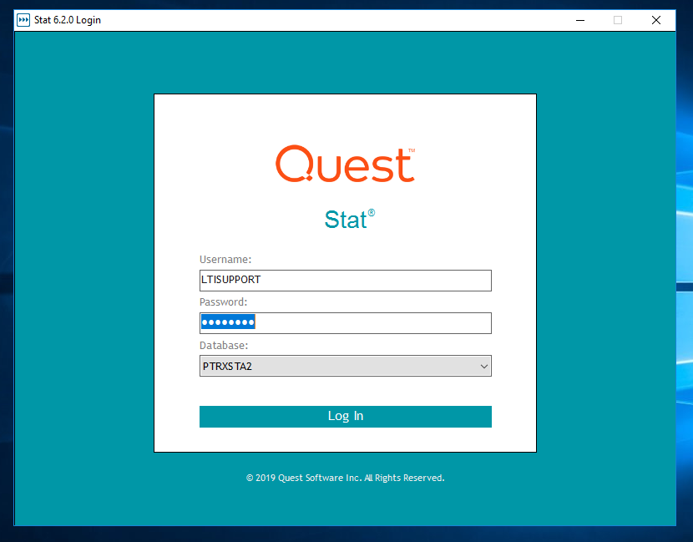

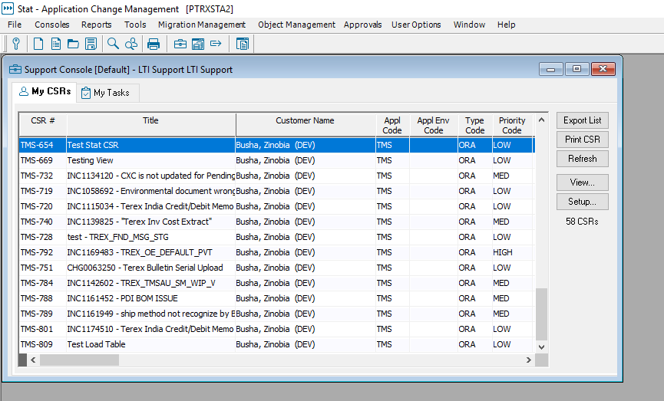

File -> New CSR from Blank - > TMS R12
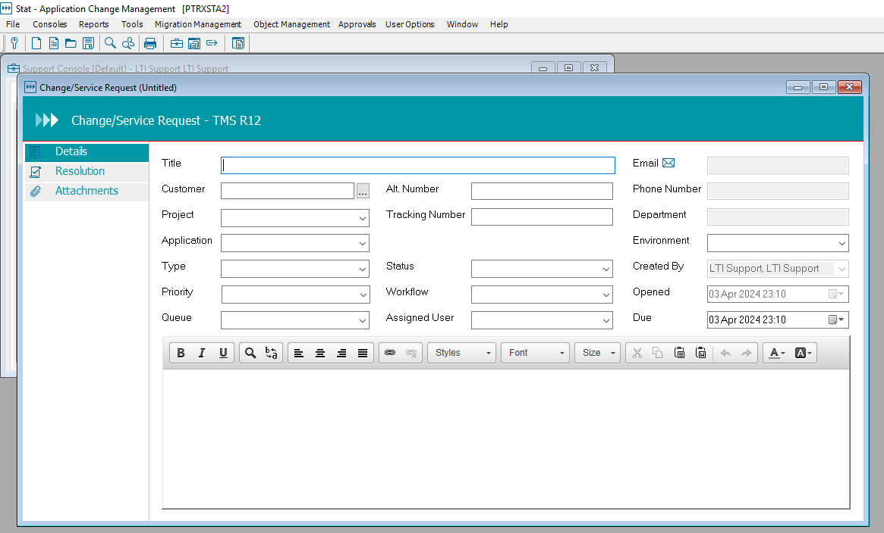

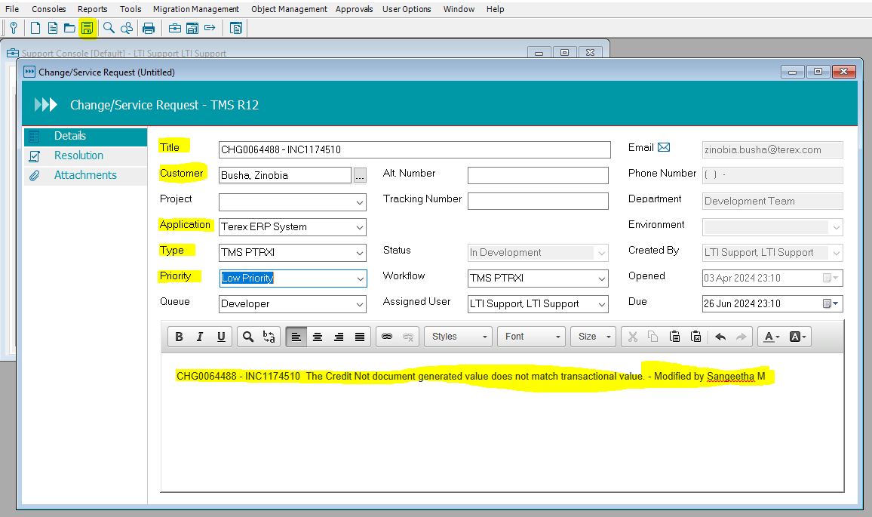

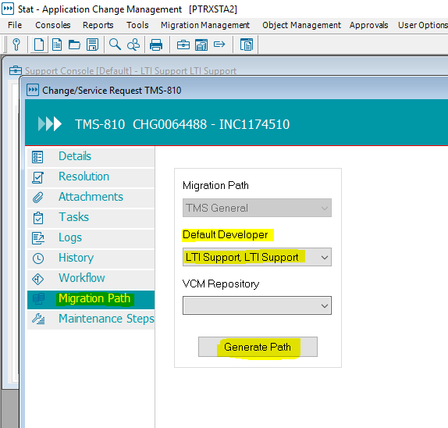
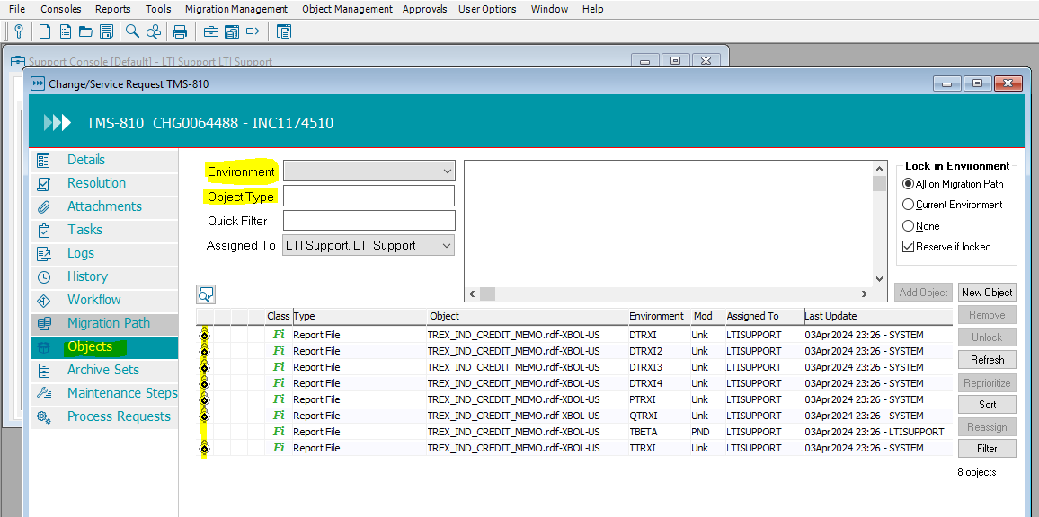

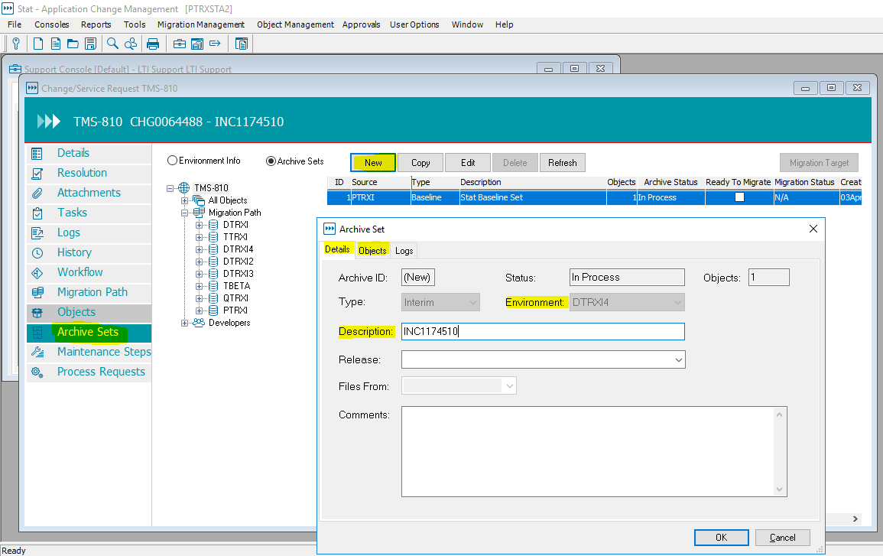

PVCS Link
http://psmwtrxpvcs01.tcs.terex.com:8080/TerexTMSRICE
User Name: PVCS user name
password: PVCS password
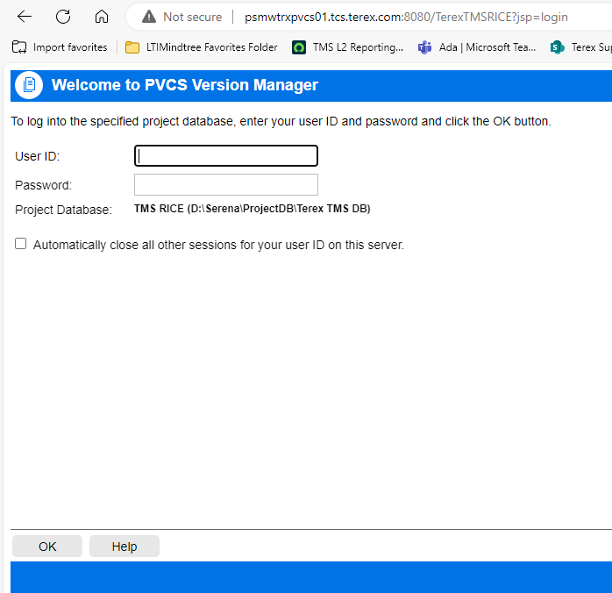

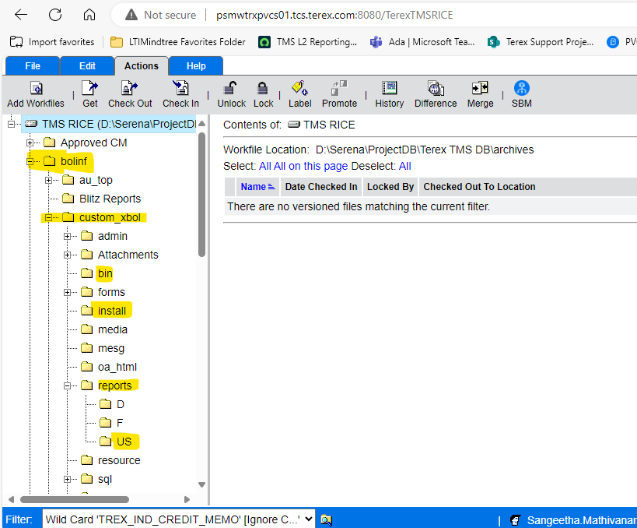

 | Code Review instructions:
1 | Lock the PVCS objects and release them after migration to production.
2 | In PVCS, kindly include the change request number in the Description or Label column.
3 | Ensure that the install instructions include the accurate PVCS version number
4 | Include the creator/modifier name in the Description column of the STAT CSR.
5 | Add the objects to STAT after they have been locked in PVCS.
6 | Include the PVCS version number in comments for modified code.
7 | For GUI objects such as forms and reports, please add detailed comments in the header level comments column.
8 | Create one set of installation instructions and one MD080 document for each change request.
9 | Close the STAT CSR after the code is migrated to PTRXI.

Reference Document

