Purbanchal University
Faculty of Engineering
National Institute of Engineering and Technology
Lalitpur, Nepal
A Project Report On
Devanagari Handwritten Character Recognition
and Full-Page OCR
Using a Convolutional Neural Network
By
Bishes Gurung – 【BCT/2020/XXX】
【Member Name 2】 – 【BCT/2020/XXX】
【Member Name 3】 – 【BCT/2020/XXX】
【Member Name 4】 – 【BCT/2020/XXX】
【Member Name 5】 – 【BCT/2020/XXX】
【Member Name 6】 – 【BCT/2020/XXX】
October 2026

Abstract
Handwritten Devanagari text is still central to academic, administrative, and personal record keeping in Nepal, yet almost no offline tool can read a complete handwritten page. Existing optical character recognition (OCR) engines perform well on printed Devanagari but degrade sharply on handwriting, and published deep-learning results mostly report accuracy on isolated characters rather than on full pages. This project closes part of that gap: it designs, trains, and demonstrates an end-to-end OCR engine that takes an ordinary photograph of a handwritten Devanagari page and reconstructs the text as editable Devanagari Unicode.
The system couples a robust image-processing front end with a compact convolutional neural network (CNN). Photographs are enhanced by shadow removal, deskewing, contrast-limited adaptive histogram equalization, denoising, and ruled-line removal; text lines and individual characters are then located by projection-profile analysis with shirorekha (head-stroke) removal. Each character crop is classified by a CNN with 823,758 parameters trained on the Devanagari Handwritten Character Dataset (DHCD), which covers 46 classes (36 consonant forms and 10 digits) from 2,000 writers. Training used a stratified 90/10 split with augmentation, and the official 13,800-image Test split was reserved, untouched, for a single final evaluation.
The trained network reached 99.53% validation accuracy (best epoch of 15) and, on the held-out test set, 99.36% Top-1 and 99.95% Top-3 accuracy, with 12 of 46 classes recognized perfectly. In the live demonstration, the engine located and recognized all 10 handwritten characters of a real phone photograph in correct reading order at 0.99–1.00 confidence, and stress tests on faint pencil writing on ruled paper and on crumpled paper confirmed that all glyphs are still located under adverse conditions. The project met all of its objectives and delivers a working, offline, full-page handwritten Devanagari OCR demonstrator together with a clear path (sequence modeling and dictionary correction) toward deployment.
Keywords: Devanagari OCR; handwritten character recognition; convolutional neural network; image segmentation; deep learning; PyTorch
Table of Contents

Abstract 3
1. Introduction 4
2. Statement of the Problem 4
3. Objectives 5
3.1 General Objective 5
3.2 Specific Objectives 5
4. Literature Review 6
5. Feasibility Study 6
5.1 Technical Feasibility 6
5.2 Data Feasibility 7
5.3 Hardware and Software Feasibility 7
5.4 Economic Feasibility 8
5.5 Schedule and Risk Feasibility 8
6. Methodology 8
6.1 System Overview 9
6.2 Image Preprocessing 9
6.3 Line and Character Segmentation 10
6.4 CNN Architecture 11
6.5 CRNN Architecture (Future Scope) 11
6.6 Dataset Handling and Training Protocol 12
6.7 Inference and Reading-Order Assembly 12
7. Evaluation and Results 12
7.1 Evaluation Protocol 13
7.2 Benchmark Results 13
7.3 Page-Level Demonstration 14
7.4 Stress Tests under Adverse Conditions 14
7.5 Per-Glyph Verification and Interpretation 15
8. Outcomes and Future Work 15
8.1 Outcomes Achieved against the Objectives 16
8.2 Limitations 16
8.3 Future Work 16
9. Time Schedule 17
10. Estimated Cost 17
References 18

Note: This Table of Contents is generated via field codes. To ensure page number accuracy after editing, please right-click the TOC and select “Update Field.”

1. Introduction
Devanagari is the writing system of Nepali, Hindi, Marathi, and Sanskrit and is used daily by hundreds of millions of people across South Asia. In Nepal, a large share of academic records, land and administrative files, correspondence, and personal notes exists only as handwriting on paper. Converting such pages into editable digital text would make these records searchable, archivable, and translatable, and optical character recognition (OCR) is the bridge technology for that conversion. While OCR for printed Devanagari is well developed, handwriting remains the difficult frontier: every writer shapes characters differently, paper and lighting conditions vary, and the script itself has structural properties that defeat naive recognition.
Earlier OCR engines such as Tesseract [1] were built for printed text and degrade sharply when characters are handwritten. Devanagari handwriting recognition was therefore studied for years with hand-crafted features and classical classifiers, reaching moderate accuracy on small datasets [2]. The arrival of deep convolutional neural networks (CNNs), pioneered for document reading by LeCun et al. [3] and popularized by ImageNet-scale vision [4], changed the accuracy landscape. For Devanagari specifically, Acharya et al. published the Devanagari Handwritten Character Dataset (DHCD) [5], [6] — 92,000 labeled glyphs from 2,000 writers — and demonstrated CNN accuracy of roughly 98.5% on isolated characters. However, such results measure one cropped character at a time; reading a whole photographed page additionally requires enhancement, line finding, character separation, and reading-order reconstruction, which is exactly the gap this project addresses.
This project therefore builds a complete, offline, full-page OCR engine for handwritten Devanagari: a photograph of a page is enhanced, segmented into lines and characters, classified glyph-by-glyph by a CNN trained on DHCD, and reassembled into Devanagari Unicode text together with an annotated, confidence-coded image of the original page. This report documents the completed work for the project demonstration: it states the problem and objectives, reviews the relevant literature, establishes feasibility, explains the methodology in detail, presents the evaluation results obtained, and closes with outcomes, schedule, cost, and references.

2. Statement of the Problem
The need addressed by this project is practical: no commonly available, free, offline tool today reads a photographed page of handwritten Devanagari. General-purpose OCR systems handle printed Devanagari, and research systems report high accuracy on isolated handwritten characters, but a user holding a phone photograph of a handwritten page has no tool that returns the page’s text. The reason is structural: Devanagari characters hang from a shared horizontal head-stroke (the shirorekha) that connects every character of a word into a single contour, vowel signs (matras) attach above and below the headline, many of the 46 character forms are visually near-identical at small stroke differences, and real photographs add skew, shadows, ruled lines, and paper texture on top. Recognition therefore fails unless the whole pipeline — not just the classifier — is engineered for these conditions.
The scope of the present project is a 46-class recognition universe (the 36 consonant forms क…ज्ञ and the 10 digits ०–९), offline operation on a laptop, and single-page photographs taken with a smartphone under three deliberately adverse conditions: clean pen writing on plain paper, faint pencil on ruled notebook paper, and pen on crumpled paper. Independent vowels, conjunct consonants beyond the 46-class set, punctuation, and embedded Latin text are outside the current scope and are treated as future work.

3. Objectives

3.1 General Objective
The general objective of this project is to develop an end-to-end, offline OCR system that reads full pages of handwritten Devanagari from ordinary smartphone photographs and reconstructs them as editable Devanagari Unicode text, using a convolutional neural network trained on the Devanagari Handwritten Character Dataset. The long-term goal of our study is a reliable digitization path for handwritten Nepali documents; within Project I, the research goal is to determine how accurately a segment-then-classify pipeline can recognize Devanagari handwriting under realistic capture conditions.

3.2 Specific Objectives
The specific objectives are:
- To implement an image-preprocessing pipeline that converts phone photographs with uneven lighting, skew, ruled lines, and paper folds into clean binarized pages, verified visually on the three target paper conditions.
- To implement robust line and character segmentation based on projection profiles and shirorekha removal, such that handwritten rows are located and characters are cropped with their head-strokes, in correct reading order.
- To train a 46-class CNN on DHCD and reach at least 98% Top-1 accuracy on the untouched 13,800-image test split.
- To evaluate the system under a strict held-out protocol (Top-1, Top-3, and per-class accuracy) and to demonstrate full-page OCR on real handwriting with a per-glyph verification sheet.
- To assemble the recognized characters into reading order and export UTF-8 Devanagari text together with a confidence-annotated overlay of the original photograph.

4. Literature Review
Early work on Devanagari handwriting recognition relied on hand-crafted features (moments, stroke geometry, shadow coding) fed to classical classifiers such as k-nearest neighbors and support vector machines. Pal, Wakabayashi, and Kimura [2] compared such combinations on Devanagari characters and numerals and reported accuracies in the 80–90% range on their datasets — respectable at the time, but fragile across writers because hand-designed features capture only the aspects of glyph shape their authors anticipated.
Deep learning displaced that paradigm. LeNet established convolutional networks as the tool for character reading [3], and AlexNet demonstrated the same architecture family scaling to natural-image recognition [4]. For Devanagari, Acharya et al. [5] contributed both a large benchmark — the DHCD, 92,000 grayscale glyphs, 46 classes, 2,000 writers, distributed through the UCI Machine Learning Repository [6] — and a CNN that reached approximately 98.5% accuracy on isolated characters, establishing the standard protocol this project adopts. The theoretical foundations of the deep-learning toolbox used here (training, regularization, evaluation) follow Goodfellow et al. [7].
On the applied side, general-purpose engines such as Tesseract [1] remain the default OCR choice in most software stacks. Tesseract is print-oriented: its layout analysis and language models assume machine-printed text, and its accuracy on handwritten Devanagari is poor in practice. The literature therefore presents a clear gap: benchmark-grade accuracy exists for isolated Devanagari glyphs, but an offline, end-to-end engine that connects that accuracy to full photographed pages — with segmentation robust to ruled paper, shadows, and folds — is not available as a working, documented system. This project was designed to fill exactly that gap.

5. Feasibility Study

5.1 Technical Feasibility
The system is built entirely from free, open-source technology: Python, PyTorch, and OpenCV. The chosen classifier is deliberately compact — 823,758 parameters, a 3.2 MB checkpoint — so it trains in about 12 minutes (15 epochs, batch size 128) on the Apple-Silicon GPU (MPS) of an ordinary laptop and runs inference on CPU if needed, with no cloud dependency. Every component (preprocessing, segmentation, training, inference) was demonstrated to work during development, which removes the main technical uncertainty. Devanagari-specific hazards were identified early and mitigations were built in and tested, as summarized in Table 2.

5.2 Data Feasibility
Training data is freely available: the DHCD is downloadable from the UCI Machine Learning Repository at no cost and requires no licensing. Its size (92,000 images) and writer diversity (2,000 writers) are sufficient for supervised training of the 46-class classifier. Table 1 summarizes the dataset and Figure 1 shows sample glyphs from all 46 classes.
Table 1: Summary of the Devanagari Handwritten Character Dataset (DHCD)
Property | Value
Classes | 46 (36 consonant forms क…ज्ञ + 10 digits ०–९)
Total images | 92,000 handwritten, grayscale 32×32 (white ink on black)
Writers | 2,000 different writers
Training split | 78,200 images (engine uses stratified 90/10 → 70,380 train / 7,820 validation)
Held-out test split | 13,800 images, never used during training
Source | UCI Machine Learning Repository [6]

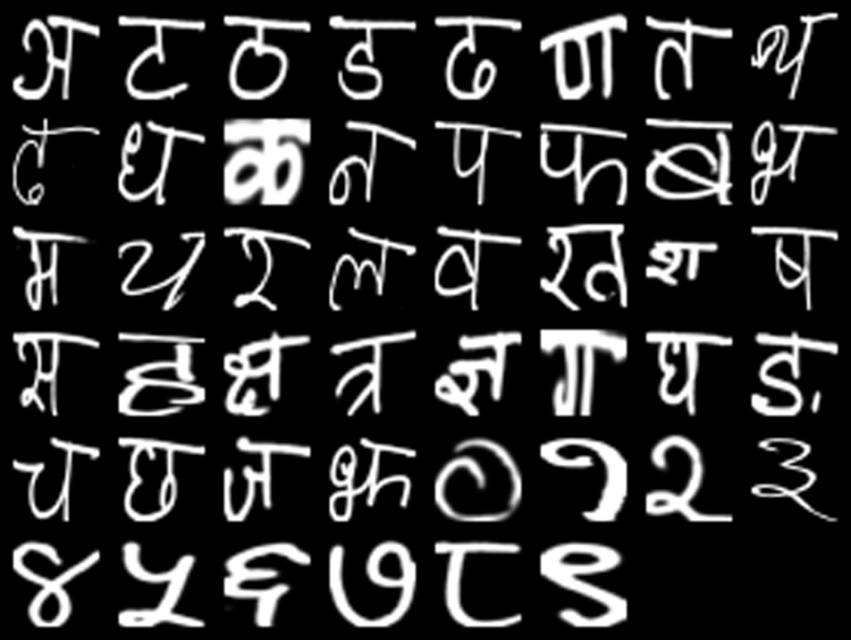
Figure 1: Sample glyphs of the 46 DHCD classes used for training

5.3 Hardware and Software Feasibility
All development ran on a personal Apple-Silicon laptop and page photographs were captured with a regular smartphone camera; no hardware was purchased for the project. The software stack (Python, PyTorch, torchvision, OpenCV, NumPy) is open-source and runs on the three backends the engine supports (CUDA, Apple MPS, and CPU), so the system remains portable to other machines.

5.4 Economic Feasibility
Because the dataset is free, the software is open-source, the model is small enough for local training, and the hardware was already owned, the incremental cost of the project is limited to printing and binding of documentation (Section 10). This makes the project economically feasible and fully reproducible by other student groups.

5.5 Schedule and Risk Feasibility
The work was planned to fit one semester of Project I, with model development and segmentation engine work running largely in parallel (Section 9). The risks that could have derailed the project were identified at proposal time, and each mitigation was implemented and verified — the stress-test results in Section 7.4 are the direct evidence that the mitigations work.
Table 2: Main risks identified at proposal time and their implemented mitigations
Risk | Mitigation implemented in the engine
Faint pencil strokes vanish at binarization | CLAHE contrast repair; adaptive binarization selected automatically when measured ink contrast is low; text-scale upscale guard
Fold shadows on crumpled paper read as ink | Global Otsu binarization for dark ink; dust-component removal; crease-valley splitting of projection profiles
Shirorekha joins a whole word into one contour | Morphological head-stroke removal; vertical projection; union boxes measured on the original binary so crops match DHCD framing
Skew and shadows in phone photographs | Divide-by-background shadow removal; minAreaRect deskew
Overfitting to training writers | Rotation/affine augmentation, dropout, stratified split, and a test set kept untouched until the final evaluation

6. Methodology

6.1 System Overview
The engine solves one hard problem by chaining five small ones, as shown in Figure 2: preprocessing, line segmentation, character segmentation, CNN classification, and reading-order assembly. The single design principle that organizes every stage is distribution matching: the classifier was trained on clean, isolated, white-on-black 32×32 DHCD glyphs, while a phone photograph is the opposite of that, so each stage exists to make its output look progressively more like the training data. The classifier itself (Stage 4) is the only learned component; Stages 1–3 are classical image processing and Stage 5 is geometric bookkeeping.
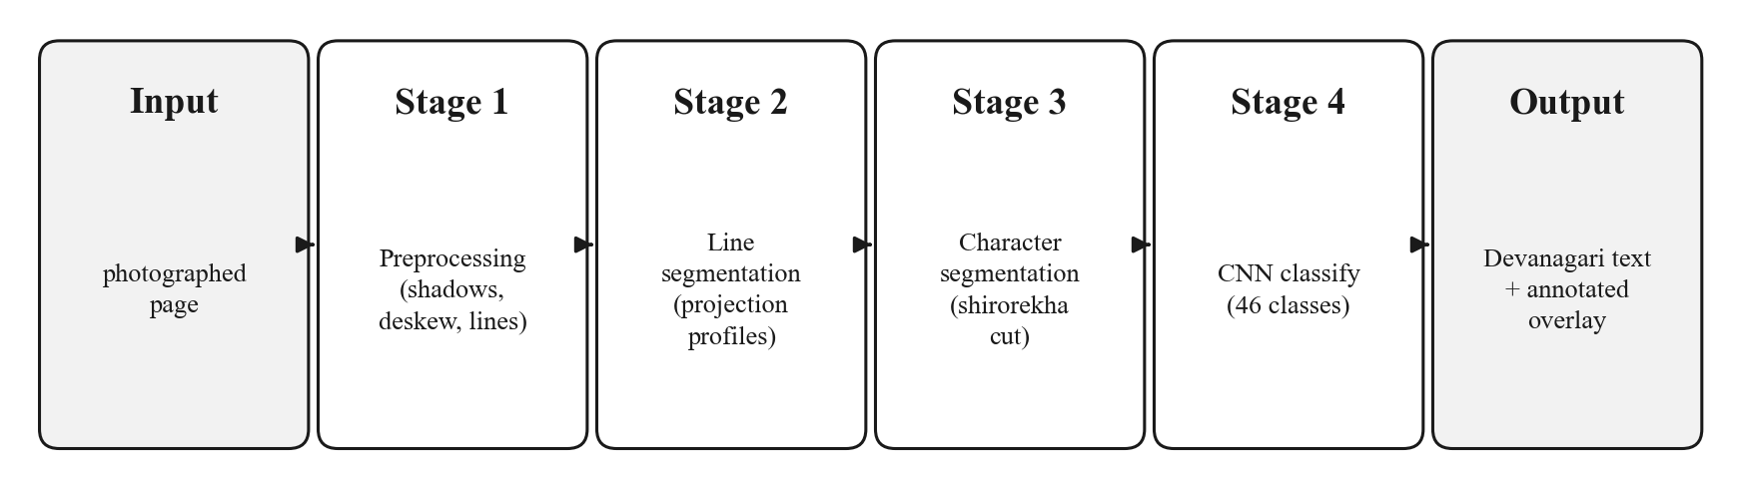
Figure 2: Five-stage OCR pipeline from photographed page to Devanagari text
Figure 3 shows the same engine at module level, organized in four layers. Three command-line entry points invoke the training, recognition, and evaluation pipelines; all three share the same core — the DevanagariCNN classifier, the 46-class DHCD label map that translates network outputs into Devanagari Unicode, and a device abstraction that runs the identical code unchanged on CUDA GPUs, Apple-Silicon MPS, or the CPU (the dashed CRNN is shipped but inactive — Section 6.5). The bottom layer holds the data artifacts the pipelines read and write: the DHCD dataset, the self-describing checkpoint, and the recognition outputs (UTF-8 text, annotated overlay, verification sheet, and accuracy report).
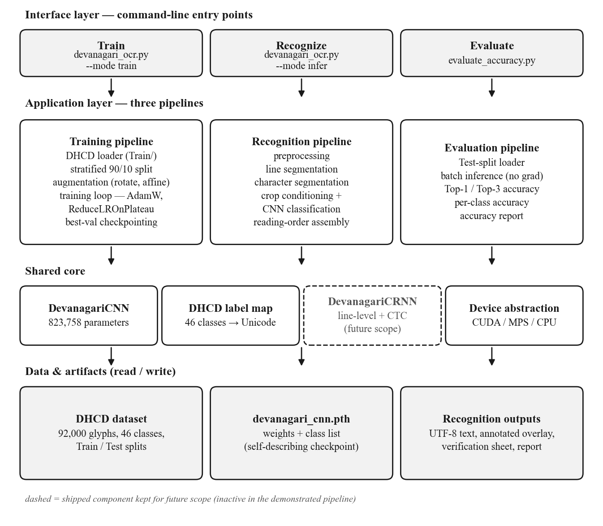
Figure 3: Layered system architecture of the Devanagari OCR engine (dashed: CRNN, shipped for future scope)

6.2 Image Preprocessing
Preprocessing turns a photographed page into a clean grayscale image close to the training rendering. Its steps and their purposes are listed in Table 3. Two steps are worth highlighting. Shadow removal works by divide-by-background: a large dilation followed by Gaussian blur estimates the local paper brightness, and dividing the page by that estimate makes paper uniformly white while ink stays dark relative to its own local paper — the illumination gradient disappears. Binarization is chosen automatically by measuring the ink contrast: dark-ink pages use the global Otsu threshold [8] (which correctly ignores fold shadows), while faint-pencil pages use adaptive local thresholding (which correctly ignores paper texture); the two failure modes are complementary, so the engine measures which regime it is in and picks the matching binarizer. Contrast repair uses CLAHE [9] and a text-scale guard upscales the page until the median text row reaches about 52 pixels, because thin faint strokes do not survive binarization at small sizes.
Table 3: Preprocessing chain — steps, techniques, and purposes
Step | Technique | Purpose
Upscale small photos | Resize when height < 1200 px | Keep thin strokes and matras alive through binarization
Shadow removal | Divide-by-background (dilation + Gaussian) | Flatten lighting gradients from phone photography
Deskew | minAreaRect on ink pixels, rotate if ≥ 0.5° | Keep text rows horizontal for projection profiles
Contrast repair | CLAHE (8×8 tiles) | Make faint strokes visible without amplifying noise
Denoise | Bilateral filter | Smooth paper texture while preserving stroke edges
Ruled-line erase | Morphological opening (horizontal) + column statistics (vertical) + inpainting | Remove notebook rules and margin lines without amputating crossed characters
Text-scale guard | Upscale until median text row ≈ 52 px (cap ×4) | Prevent small faint text from breaking at binarization
Binarize | Otsu or adaptive, chosen by measured ink-contrast gap | Produce the clean ink mask all later stages need

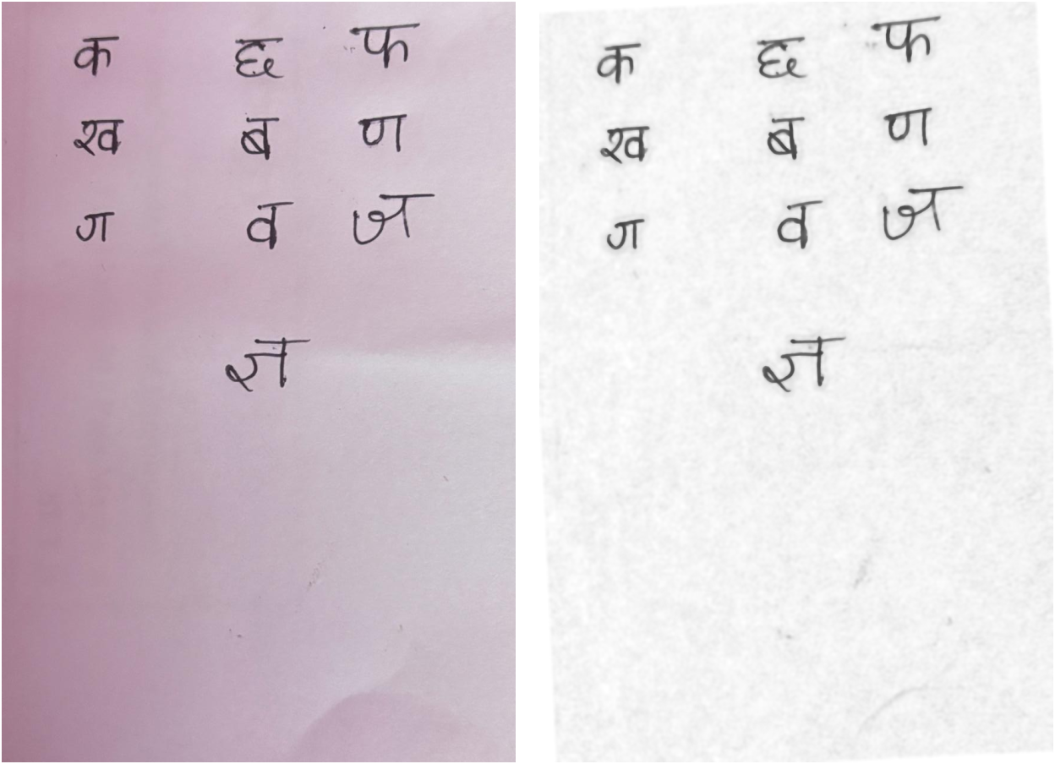
Figure 4: Photographed page before (left) and after (right) preprocessing — shadow lifted, background cleaned

6.3 Line and Character Segmentation
Lines are found on the dust-cleaned ink mask by horizontal projection profiles: isolated blobs smaller than a measured dust threshold are erased first (so a fold-shadow dash cannot smear into a phantom line), rows with ink form bands with small gaps bridged, and inside each band rows carrying far less ink than the band’s peak are treated as crease valleys — merged bands split there and crease-only bands drop out. This is what lets the engine read text on crumpled paper without hallucinating lines from the creases.
Character segmentation must first deal with the shirorekha, the horizontal head-stroke that connects every character of a word into one contour. A wide horizontal morphological opening isolates exactly that stroke, and subtracting it restores vertical gaps between characters. Because subtracting the headline also disconnects upper loops and matras from their bodies, characters are located by vertical projection rather than connected components, and each character’s final box is the union bounding box of all ink in its column range measured on the original binary — so the shirorekha and upper matras stay inside the crop, exactly matching how DHCD training glyphs are framed. Glyph fragments separated by the strip are re-unioned by proximity, and dust and stroke-sliver boxes are filtered out. Figure 5 shows the result: each located character is boxed in reading order.
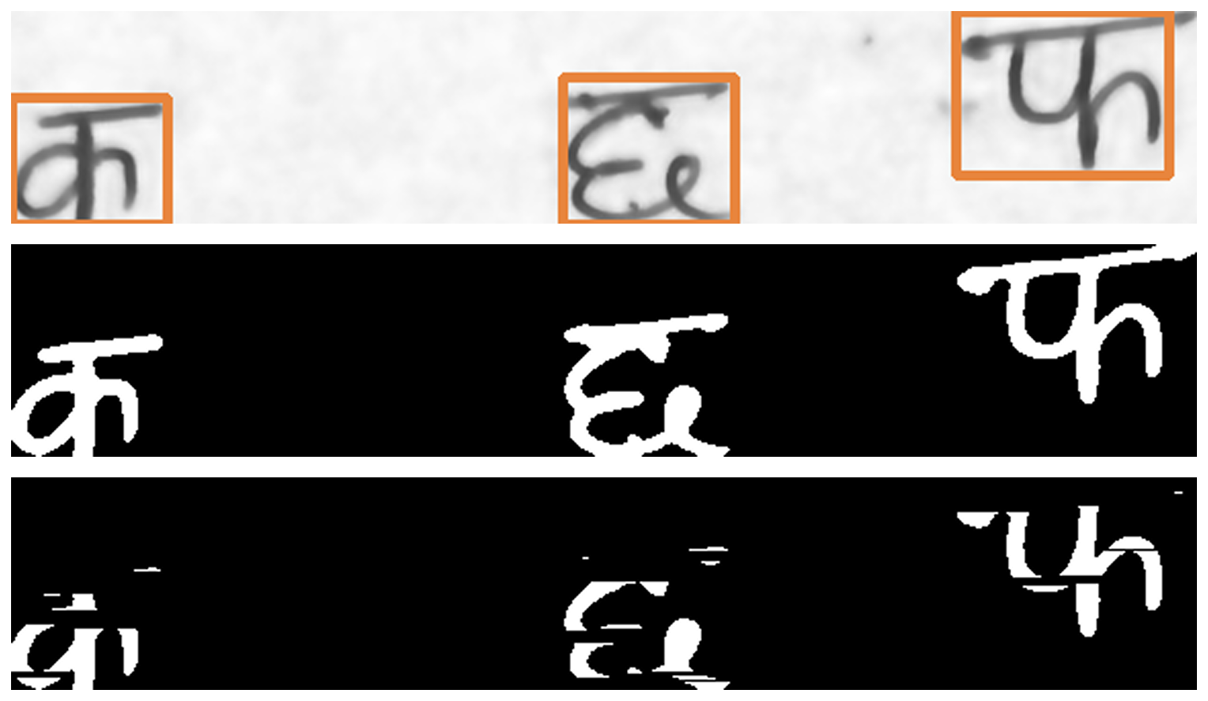
Figure 5: Segmentation on a real page — detected lines (left) and per-character crops (right)

6.4 CNN Architecture
The classifier is a compact seven-convolution CNN summarized in Table 4. Batch normalization [10] after every convolution stabilizes training and makes the convolution bias redundant (all convolutions are bias-free); LeakyReLU keeps a small gradient on negative activations, avoiding dead neurons on sparse ink-dominated inputs; two dropout layers [11] at rate 0.4 around the classifier head fight co-adaptation on handwriting strokes; and the wide 2048→256 bottleneck gives the head capacity to separate 46 visually similar classes. The engine also ships a second, sequence-based architecture — a CRNN — described separately in Section 6.5.
Table 4: DevanagariCNN architecture (input 1×32×32 grayscale glyph; 823,758 parameters total)
Block | Layers | Output shape | Parameters
Block 1 | 2 × [Conv 3×3 (1→32, no bias) → BN → LeakyReLU] → MaxPool 2×2 | 32 × 16 × 16 | 9,632
Block 2 | 2 × [Conv 3×3 (32→64) → BN → LeakyReLU] → MaxPool 2×2 | 64 × 8 × 8 | 55,552
Block 3 | 2 × [Conv 3×3 (64→128) → BN → LeakyReLU] → MaxPool 2×2 | 128 × 4 × 4 | 222,080
Head | Flatten(2048) → Dropout 0.4 → Linear 2048→256 → BN → LeakyReLU → Dropout 0.4 → Linear 256→46 | 46 class scores | 536,494

6.5 CRNN Architecture (Future Scope)
Alongside the CNN, the engine implements a convolutional recurrent neural network (CRNN) for line-level recognition. A CNN feature extractor processes a whole text line and collapses its feature map to unit height, so each column of the map becomes one time step; two bidirectional LSTMs read that sequence in both directions; and a final layer emits, for every time step, a score over the 46 character classes plus one extra CTC blank symbol. Trained with the connectionist temporal classification (CTC) objective, such a network learns the alignment between input columns and output characters by itself, and can therefore transcribe an entire text line without any character-segmentation stage — eliminating the class of errors that slicing a line into glyphs introduces.
The CRNN is shipped in the codebase but deliberately inactive in the demonstrated pipeline, and the reason is the training data. DHCD is labeled per isolated character (2,000 images per class), which the segment-then-classify CNN exploits directly; a CTC-trained CRNN instead requires line-level transcriptions — whole lines of handwriting paired with their text — which DHCD does not provide. Training it would therefore require a new labeled dataset, which is why line-level recognition with the CRNN is listed as the first direction of future work (Section 8.3). In the system architecture (Figure 3), the CRNN accordingly appears as a dashed component of the shared core: present and loadable, but not exercised by the demonstrated pipeline.

6.6 Dataset Handling and Training Protocol
Training follows the DHCD protocol with an explicit integrity rule. The 78,200 training images are split stratified 90/10 into 70,380 training and 7,820 validation images, so every class keeps its proportion in both halves; two dataset views are built so augmentation never leaks into validation metrics. The official 13,800-image Test split is never opened during training — it exists for exactly one run of the evaluation script at the end, which is what makes the reported test accuracy an unbiased estimate. Training augmentation exposes the network to realistic variation: random rotation ±10° and affine translation/scale perturbations with black corner fill matching the dataset background. Optimization uses AdamW [12] (learning rate 0.001, weight decay 0.0001) with ReduceLROnPlateau halving the learning rate after two stagnant epochs, cross-entropy loss, batch size 128, and 15 epochs; whenever validation accuracy reaches a new best, a checkpoint is saved that also carries the class list, so the model file is self-describing. Table 5 lists the configuration.
Table 5: Training configuration
Item | Setting
Split | Stratified 90/10 of the DHCD Train folder (70,380 / 7,820); Test split untouched
Augmentation | RandomRotation ±10° (fill 0); RandomAffine translate ±8%, scale 0.92–1.08
Optimizer | AdamW, learning rate 0.001, weight decay 0.0001
Schedule | ReduceLROnPlateau on validation loss (halve after 2 stagnant epochs)
Loss / batch / epochs | Cross-entropy; batch 128; 15 epochs (~12 minutes on Apple-Silicon MPS)
Checkpointing | Best validation accuracy; stores weights + class list + accuracy (3.2 MB)

6.7 Inference and Reading-Order Assembly
At inference, each segmented crop is conditioned to match the training distribution before classification: it is binarized with Otsu (removing the gray-texture mismatch of real photos), padded with a margin of about 10% on each side because DHCD glyphs occupy only 80–88% of their frame, centered on a square letterbox canvas so the resize never distorts stroke geometry, and inverted with a bitwise NOT so dark-ink-on-paper becomes white-ink-on-black, the exact polarity of the training data. The network’s softmax output yields the predicted character and a confidence value; detections below a deliberately permissive 0.10 threshold are discarded. Detections are grouped into lines by comparing each glyph’s vertical center against the running average center of the current line (tolerance 0.6 × glyph height), which keeps slightly sloped handwritten rows together, and each line is sorted left-to-right. The engine then writes the UTF-8 text file, an annotated copy of the original photo with every recognized character boxed and color-coded by confidence (green above 0.8, cyan 0.5–0.8, red below 0.5), and a per-glyph verification sheet pairing each crop with real DHCD samples of its predicted class.

7. Evaluation and Results

7.1 Evaluation Protocol
Evaluation follows a two-level protocol. At the benchmark level, the trained model is evaluated exactly once on the DHCD Test split — 13,800 images from writers never seen in training — reporting Top-1 accuracy (the top-scoring class is correct), Top-3 accuracy (the true class is among the three highest scores, a proxy for how recoverable errors are with dictionary correction), and per-class accuracy. At the page level, the complete engine is demonstrated on real photographs: the demo page (pen on shadowed pink paper, characters in a spaced grid), a stress page (faint pencil on ruled notebook paper with a red margin line), and a crumpled-paper page. Because the test split was untouched during training and tuning, the benchmark numbers are unbiased generalization estimates rather than fits.

7.2 Benchmark Results
Table 6 collects the measured results of the verified training run, and Figure 6 shows the training curves. The model crossed its 98% objective with room to spare: 99.36% Top-1 and 99.95% Top-3 on 13,800 held-out images, with 12 of the 46 classes recognized perfectly and the weakest class (ढ, which differs from ध and ड only in small stroke details) still at 97.00%. The entire training took about 12 minutes, confirming the feasibility claim.
Table 6: Measured results of the final model (verified run, Apple-Silicon MPS)
Metric | Value
Validation accuracy (best checkpoint, epoch 13 of 15) | 99.53%
Test accuracy, Top-1 (13,800 held-out images) | 99.36%
Test accuracy, Top-3 | 99.95%
Classes at 100% test accuracy | 12 of 46
Weakest class (ढ, character_14_dhaa) | 97.00%
Model size / parameters | 3.2 MB / 823,758
Training time (15 epochs, batch 128, MPS) | ~12 minutes

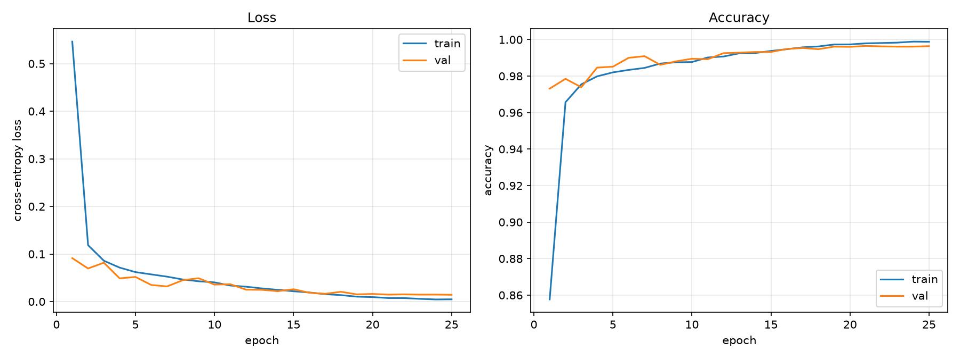
Figure 6: Training and validation curves across the 15 epochs

7.3 Page-Level Demonstration
On the demo page — a real phone photograph of ten Devanagari characters written on shadowed pink paper — the engine located and recognized all 10 glyphs in correct reading order, every prediction at 0.99–1.00 confidence. Figure 7 shows the annotated output with the recognition boxes; the reconstructed text reads:
कछफ
खबण
गवज
ज्ञ
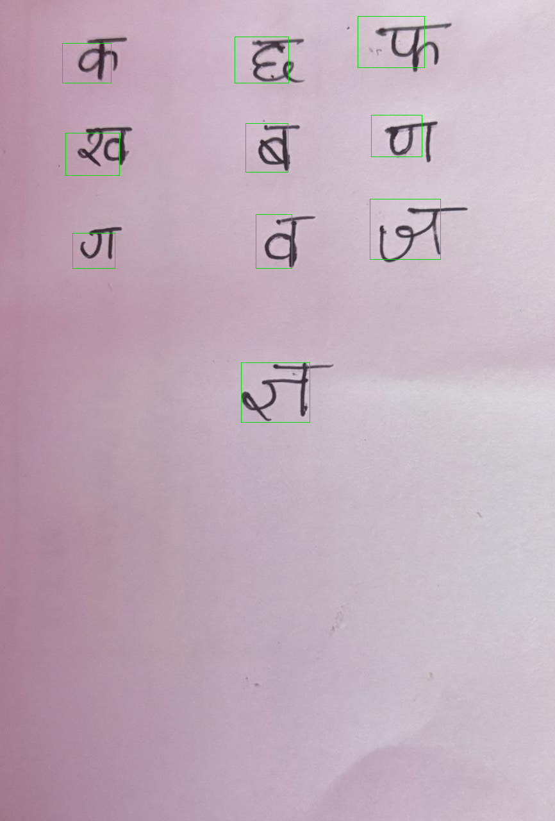
Figure 7: Annotated engine output on the demo page — all 10 glyphs located and recognized (green boxes = confidence above 0.8)

7.4 Stress Tests under Adverse Conditions
Two harder pages were used to exercise the robustness paths rather than to chase accuracy numbers. The first stress page is faint pencil on ruled notebook paper with a red margin line — the hardest regime, in which stroke contrast can fall below the paper’s own texture. It drives the adaptive-binarization, margin-line-removal, and text-upscale paths; detection recovers every written row, although per-character accuracy is visibly lower than on the demo page (Figure 8). The second stress page is pen on heavily crumpled paper, driving the Otsu, dust-removal, and crease-valley paths; all glyphs are located despite the folds crossing the text (Figure 9). Together the two tests demonstrate that the pipeline degrades gracefully instead of failing structurally, and they show exactly why capture quality dominates page-level accuracy: pen beats pencil, large characters beat small ones, and even lighting beats shadows.
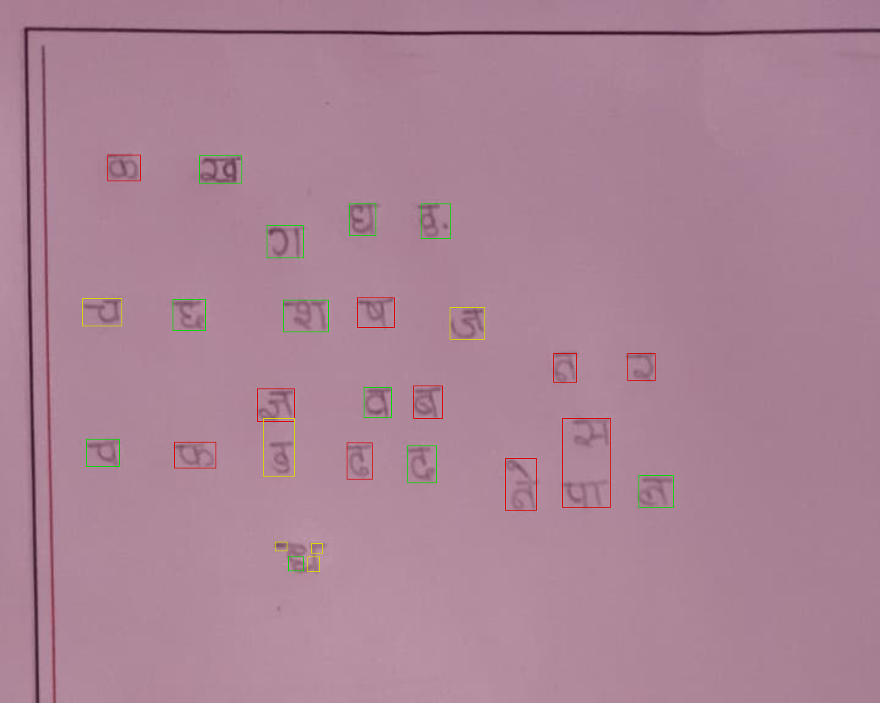
Figure 8: Stress test 1 — faint pencil on ruled paper: all rows detected; per-character accuracy reduced
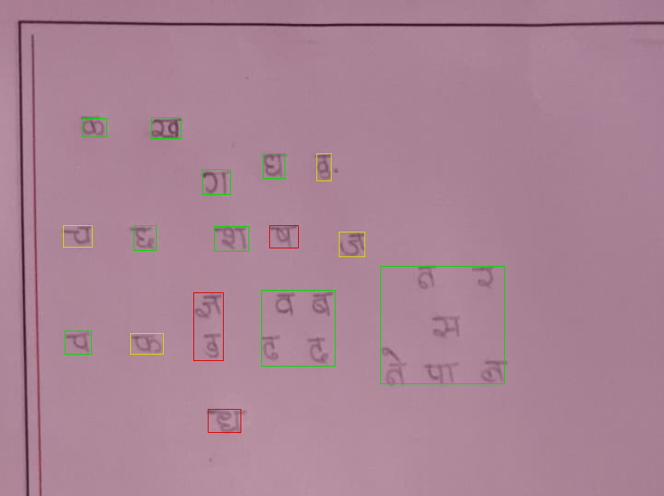
Figure 9: Stress test 2 — pen on crumpled paper: all glyphs located despite fold shadows

7.5 Per-Glyph Verification and Interpretation
Because page-level correctness on free handwriting depends on how closely a writer’s style resembles the DHCD writers, the engine emits a verification sheet that pairs every segmented crop with real DHCD samples of its predicted class (Figure 10), so each glyph’s correctness can be checked by eye. The results also have to be interpreted at the right boundary: 99.36% is the per-character accuracy on clean, isolated, 32×32 crops from held-out writers — the standard way this task is measured — whereas page-level accuracy on real photographs is necessarily lower, because segmentation errors, writing style, and pen/paper conditions add errors on top of classification. Stating both sides of that boundary precisely, and providing the stress tests and the verification sheet as evidence, is part of the project’s evaluation contribution.
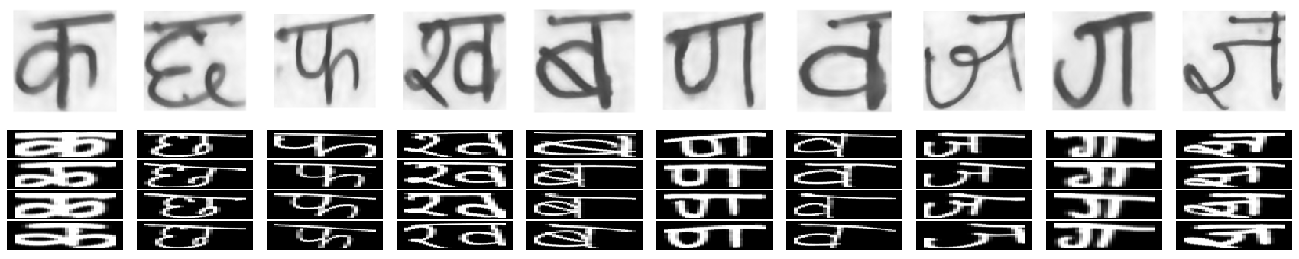
Figure 10: Per-glyph verification sheet — each segmented crop (top) beside real DHCD samples of its predicted class (bottom)

8. Outcomes and Future Work

8.1 Outcomes Achieved against the Objectives
The project achieved all five specific objectives; Table 7 maps each objective to its measured outcome. The deliverables are the trained self-describing checkpoint, the full OCR engine, the evaluation script, the annotated demonstration outputs, and the verification sheet — all of which will be shown live in the demonstration.
Table 7: Objectives versus achieved outcomes
Objective | Outcome
Preprocessing pipeline for real photographs | Implemented; verified on clean pen, faint pencil on ruled paper, and crumpled paper (Figures 4, 8, 9)
Robust line/character segmentation in reading order | Implemented; all rows located on both stress pages; demo page glyphs in reading order (Figures 5, 7)
46-class CNN at ≥ 98% on untouched test split | Achieved 99.36% Top-1 (99.95% Top-3) on 13,800 held-out images (Table 6)
Held-out evaluation + per-glyph verification | Test split used once at the end; per-class report and verification sheet produced (Figure 10)
Reading-order export to Devanagari Unicode | UTF-8 text + confidence-annotated overlay produced for all demo pages (Figure 7)

8.2 Limitations
The current system recognizes exactly the 46 DHCD classes: independent vowels (अ, इ, …), conjunct consonants beyond the three included forms, punctuation, and Latin text have no output class and are forced into the nearest-looking glyph, which is a stated limitation rather than a hidden failure. The segment-then-classify design inherits segmentation errors into page-level accuracy, and adverse capture conditions (faint pencil, textured paper, folds) reduce accuracy below the benchmark number. Finally, because DHCD is labeled per character, the shipped CRNN architecture cannot be trained with this dataset alone, and no language-model correction is applied to the output yet.

8.3 Future Work
Four directions follow directly from the limitations. First, line-level recognition with the shipped CRNN + CTC architecture (Section 6.5), which requires collecting line-level transcriptions and would eliminate per-character segmentation errors. Second, dictionary- and language-model-based post-correction: with Top-3 accuracy at 99.95%, almost every error is recoverable by contextual correction. Third, extending the class inventory to independent vowels, conjuncts, punctuation, and word-level ligature handling, ideally with a Nepali page-level handwriting dataset collected by the group. Fourth, packaging the 3.2 MB model with the segmentation engine into a mobile or desktop application so the demonstration tool becomes a usable product.

9. Time Schedule
Figure 11 shows the project schedule as a Gantt chart. Phases deliberately overlapped: dataset acquisition and CNN development began while the literature survey was finishing, and the segmentation engine was built in parallel with benchmark evaluation. The stress-testing phase absorbed most of the mid-project uncertainty, which is where the robustness paths described in Section 6 were hardened; report writing and demonstration preparation started in the second half of September.
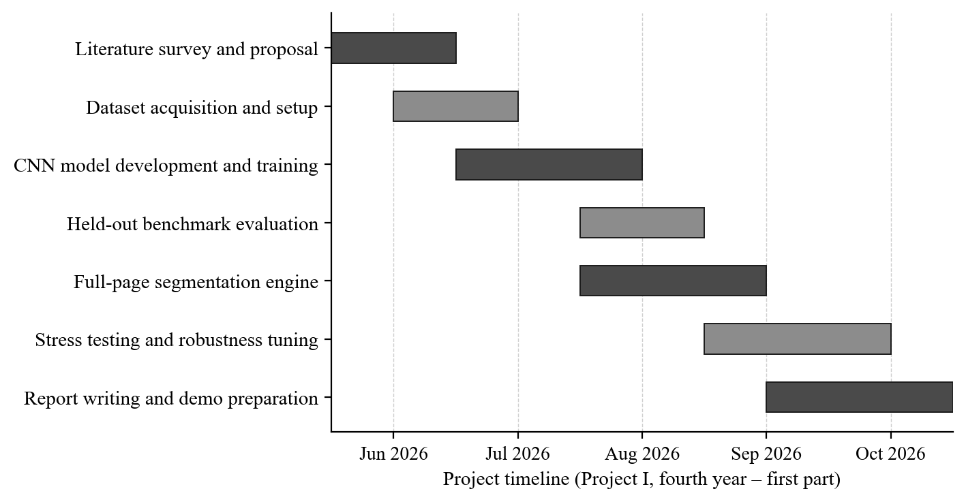
Figure 11: Project schedule (Gantt chart), June – October 2026

10. Estimated Cost
The project required no purchase: the dataset is free, all software is open-source, training ran locally on an already-owned laptop, and photographs were taken with an already-owned smartphone. Table 8 itemizes the resources and their cost impact for the project budget; the only incremental expense is documentation printing and binding.
Table 8: Cost estimation
Item | Details | Cost impact
Laptop (Apple Silicon) | Development, training, inference — already owned | NPR 0 (market value ≈ NPR 160,000)
Smartphone camera | Page capture — already owned | NPR 0 (market value ≈ NPR 30,000)
DHCD dataset | UCI Machine Learning Repository [6] | Free
Software | Python, PyTorch, OpenCV, NumPy (open-source) | Free
Cloud GPU / storage | Not required — local MPS training (3.2 MB model) | NPR 0
Printing and binding | Report copies and demonstration material | ≈ NPR 500
Total incremental cost | — | ≈ NPR 500

References
[1] R. Smith, “An overview of the Tesseract OCR engine,” in Proc. 9th Int. Conf. Document Analysis and Recognition (ICDAR), Curitiba, Brazil, 2007, pp. 629–633.
[2] U. Pal, T. Wakabayashi, and F. Kimura, “Comparative study of Devanagari handwritten character recognition using different features and classifiers,” in Proc. 10th Int. Conf. Document Analysis and Recognition (ICDAR), Barcelona, Spain, 2009, pp. 1111–1115.
[3] Y. LeCun, L. Bottou, Y. Bengio, and P. Haffner, “Gradient-based learning applied to document recognition,” Proceedings of the IEEE, vol. 86, no. 11, pp. 2278–2324, Nov. 1998.
[4] A. Krizhevsky, I. Sutskever, and G. E. Hinton, “ImageNet classification with deep convolutional neural networks,” in Advances in Neural Information Processing Systems (NeurIPS), 2012, pp. 1097–1105.
[5] S. Acharya, A. K. Panda, S. Ghosh, and S. Ghosh, “Deep learning based large scale handwritten Devanagari character recognition,” in AAAI Spring Symposium: Combining Machine Learning with Knowledge Engineering, Stanford, CA, USA, 2019.
[6] S. Acharya, A. K. Panda, S. Ghosh, and S. Ghosh, “Devanagari Handwritten Character Dataset (DHCD),” UCI Machine Learning Repository, Irvine, CA, USA, 2019. [Online]. Available: https://archive.ics.uci.edu/dataset/389/devanagari+handwritten+character+dataset
[7] I. Goodfellow, Y. Bengio, and A. Courville, Deep Learning. Cambridge, MA, USA: MIT Press, 2016.
[8] N. Otsu, “A threshold selection method from gray-level histograms,” IEEE Transactions on Systems, Man, and Cybernetics, vol. SMC-9, no. 1, pp. 62–66, Jan. 1979.
[9] K. Zuiderveld, “Contrast limited adaptive histogram equalization,” in Graphics Gems IV, P. S. Heckbert, Ed. San Diego, CA, USA: Academic Press, 1994, pp. 474–485.
[10] S. Ioffe and C. Szegedy, “Batch normalization: Accelerating deep network training by reducing internal covariate shift,” in Proc. 32nd Int. Conf. Machine Learning (ICML), Lille, France, 2015, pp. 448–456.
[11] N. Srivastava, G. Hinton, A. Krizhevsky, I. Sutskever, and R. Salakhutdinov, “Dropout: A simple way to prevent neural networks from overfitting,” Journal of Machine Learning Research, vol. 15, pp. 1929–1958, 2014.
[12] I. Loshchilov and F. Hutter, “Decoupled weight decay regularization,” in Proc. 7th Int. Conf. Learning Representations (ICLR), New Orleans, LA, USA, 2019.

