***JAVASCRIPT ASSIGNMENT – 3***

1.) Write a function that prints the multiplication table for a given number up to 10.

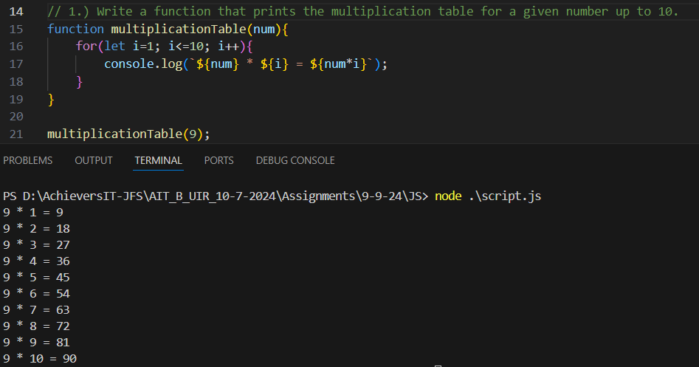

2.) Write a function to reverse an array without using the built-in reverse method.

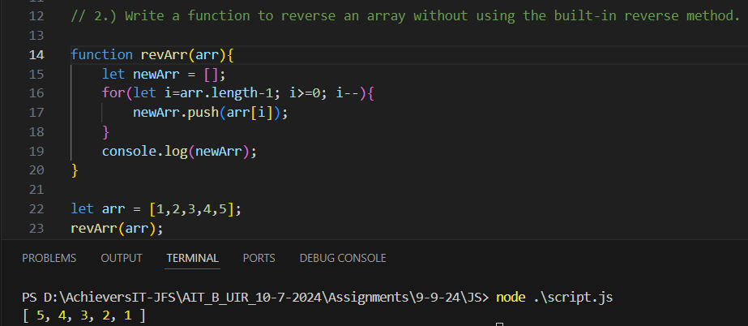

3.) Write a function that prints all prime numbers up to a given number N.

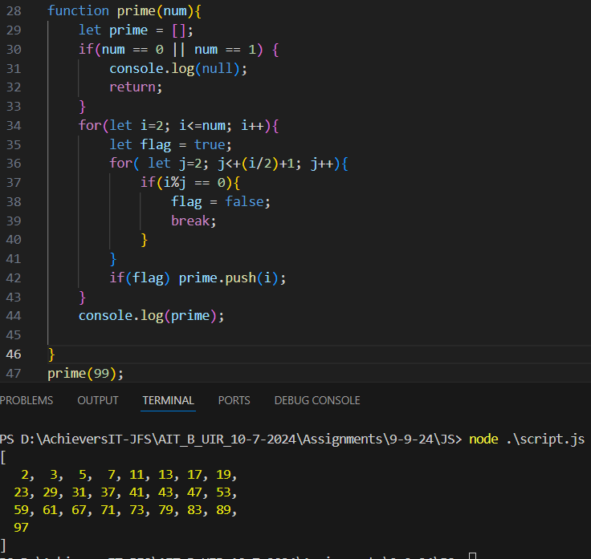

4.) Write a function to calculate the factorial of a given number using a loop.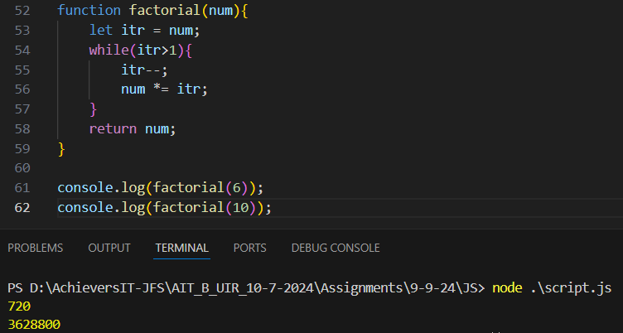

5.) Write a function that prints numbers from 1 to 100. For multiples of 3, print "Fizz", for multiples of 5 print "Buzz", and for multiples of both 3 and 5, print "FizzBuzz".

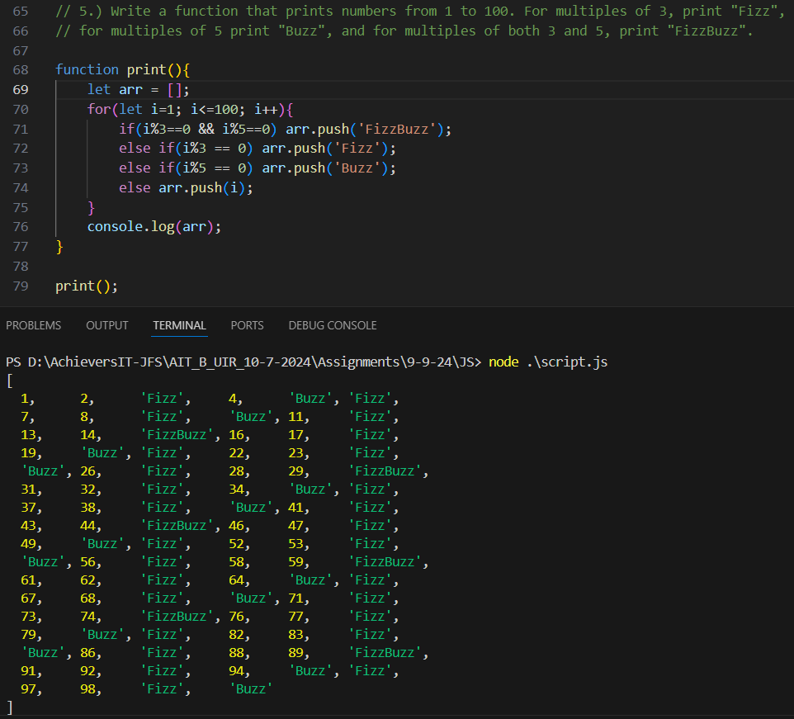

6.) Write a function that performs basic arithmetic operations (add, subtract, multiply, divide) based on user input.

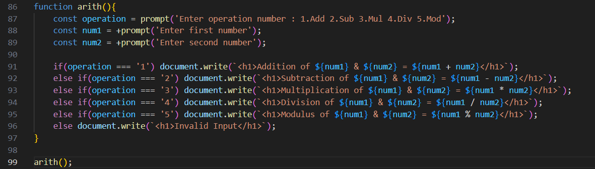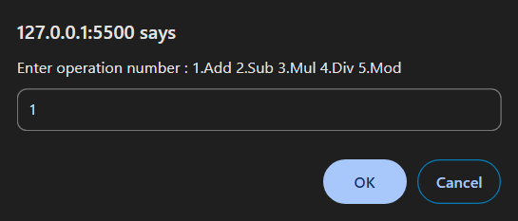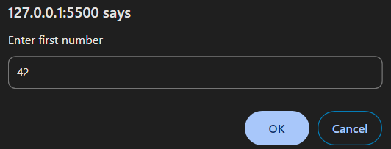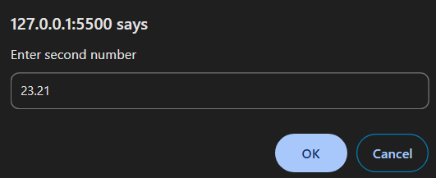

7.) Write a function to count the number of vowels in a given string

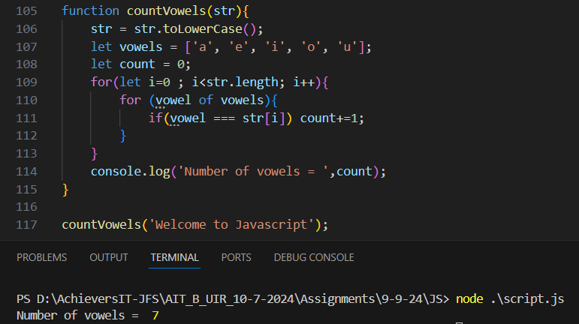

8.) Write a function to split an array into chunks of a specified size.

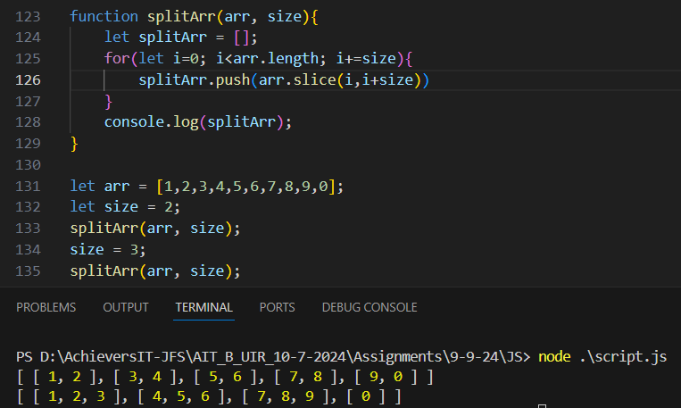

9.) Write a function to check if two strings are anagrams of each other.

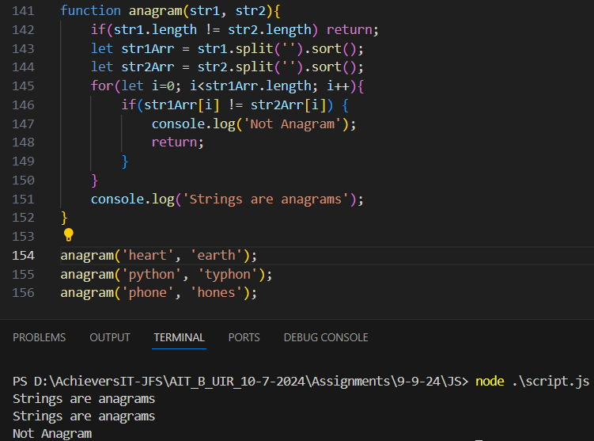

10.) Write a function to find the longest word in a given sentence.

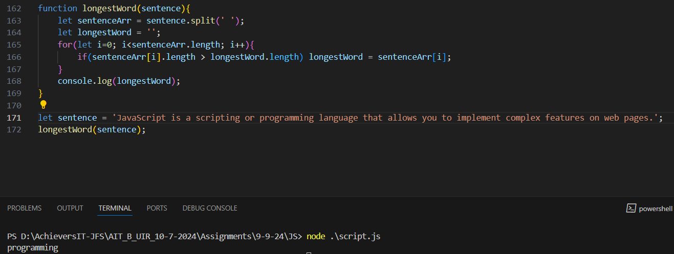

11.) Difference between Event bubbling and Event capturing? Write an example.

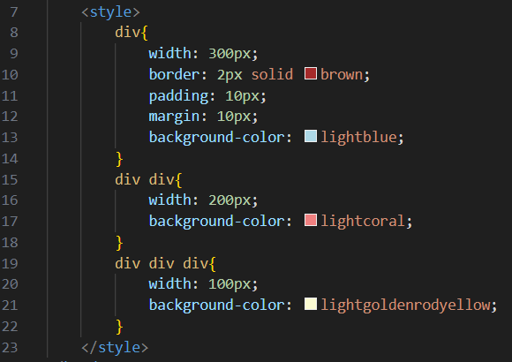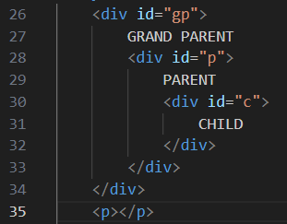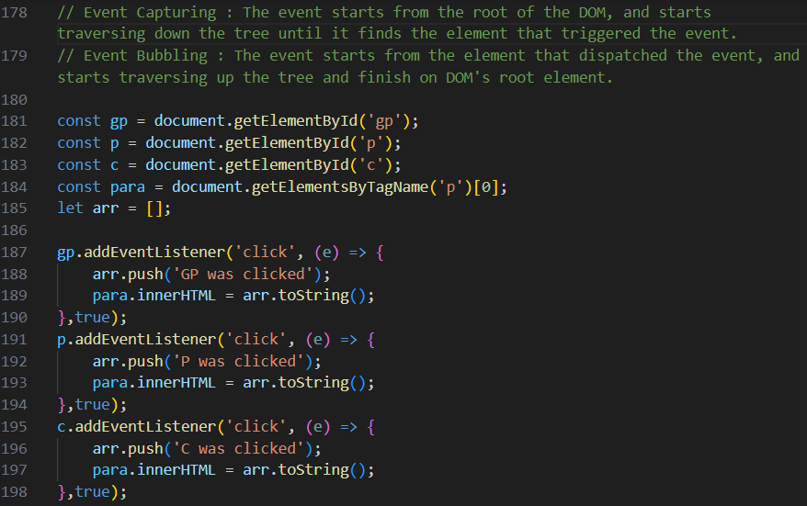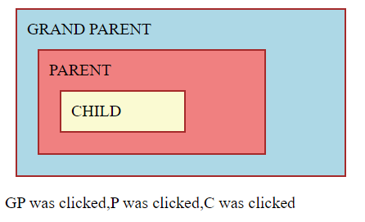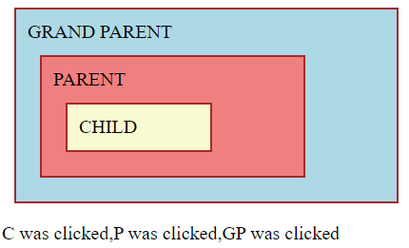

Capturing Bubbling

12.) How do you create and remove an element in dom?

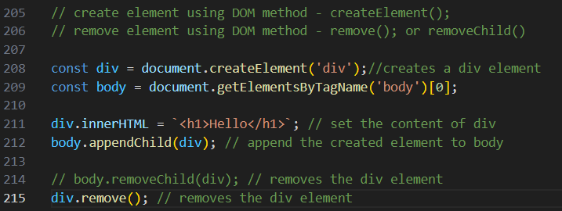

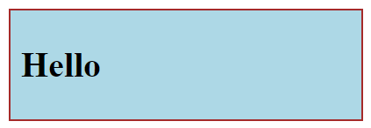 

13.) Create a button that counts the number of times it has been clicked. Display the counter in a <span> element.

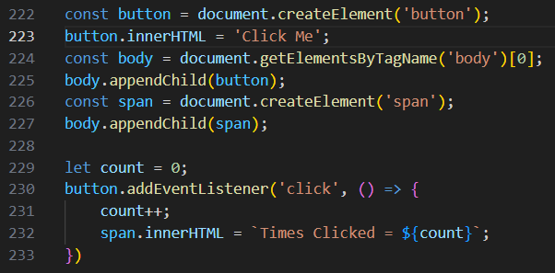

14.) Detect and display the key that the user presses on the keyboard.

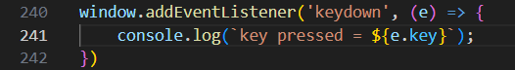

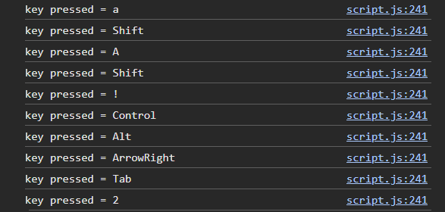

15.) Track and display the mouse's current X and Y coordinates as the user moves the mouse over a <div>.

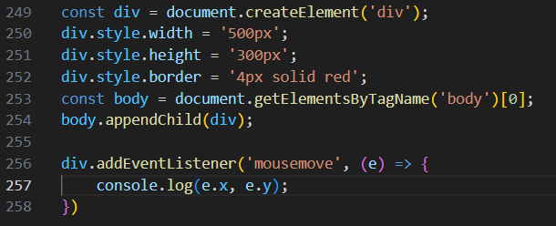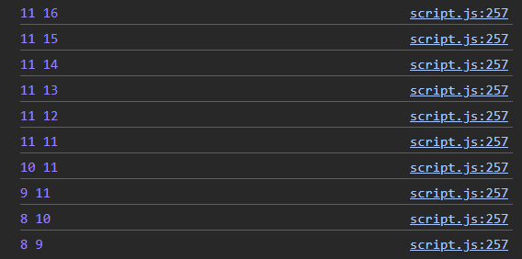

16.) Change the background color of a <div> when it's double-clicked.

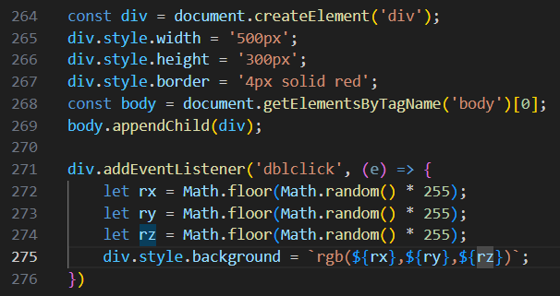



17.) When the user hovers over a <div>, display some hidden text. Hide the text when the user stops hovering.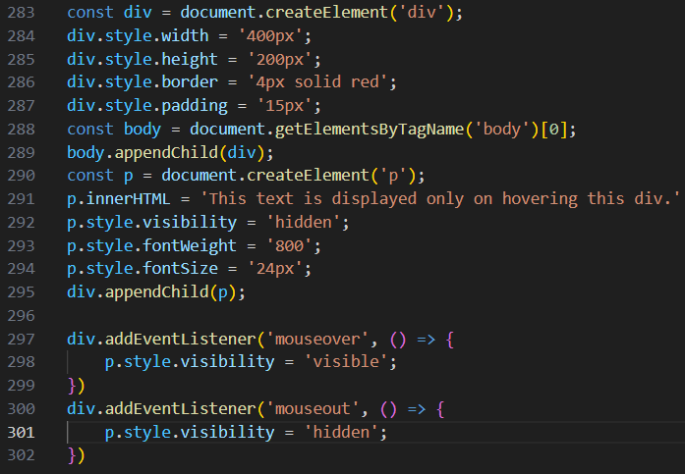

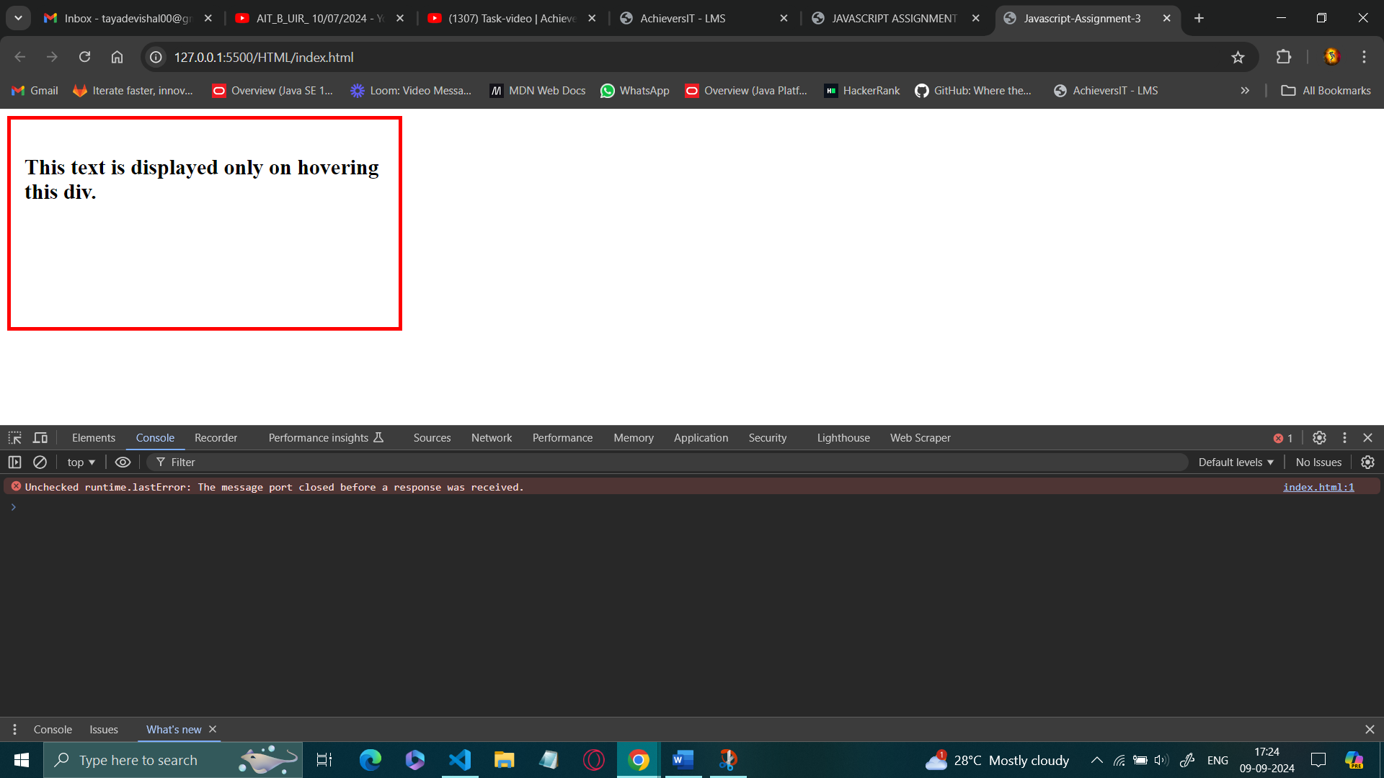

18.) Create an input field that displays how many characters the user has typed.

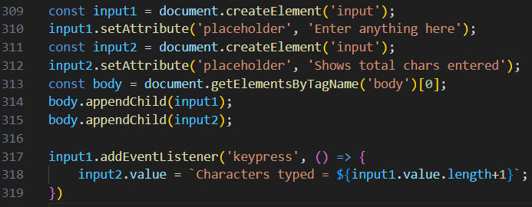

19.) When the user clicks on a <div>, change the text inside it.

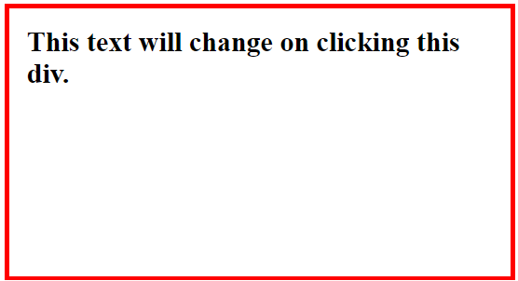 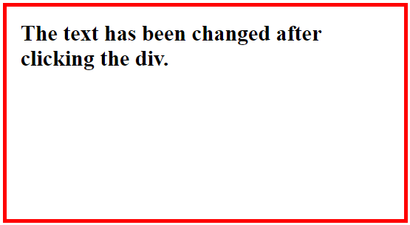

20.) When the user types in an input field, automatically convert the text to uppercase.

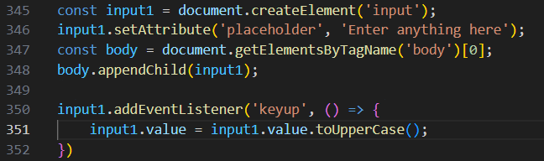

21.) Change an image to another when the user hovers over it and revert to the original image when the user stops hovering.

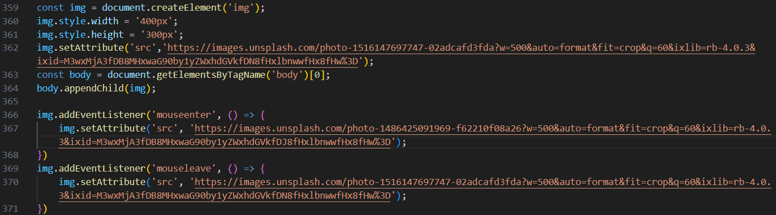

 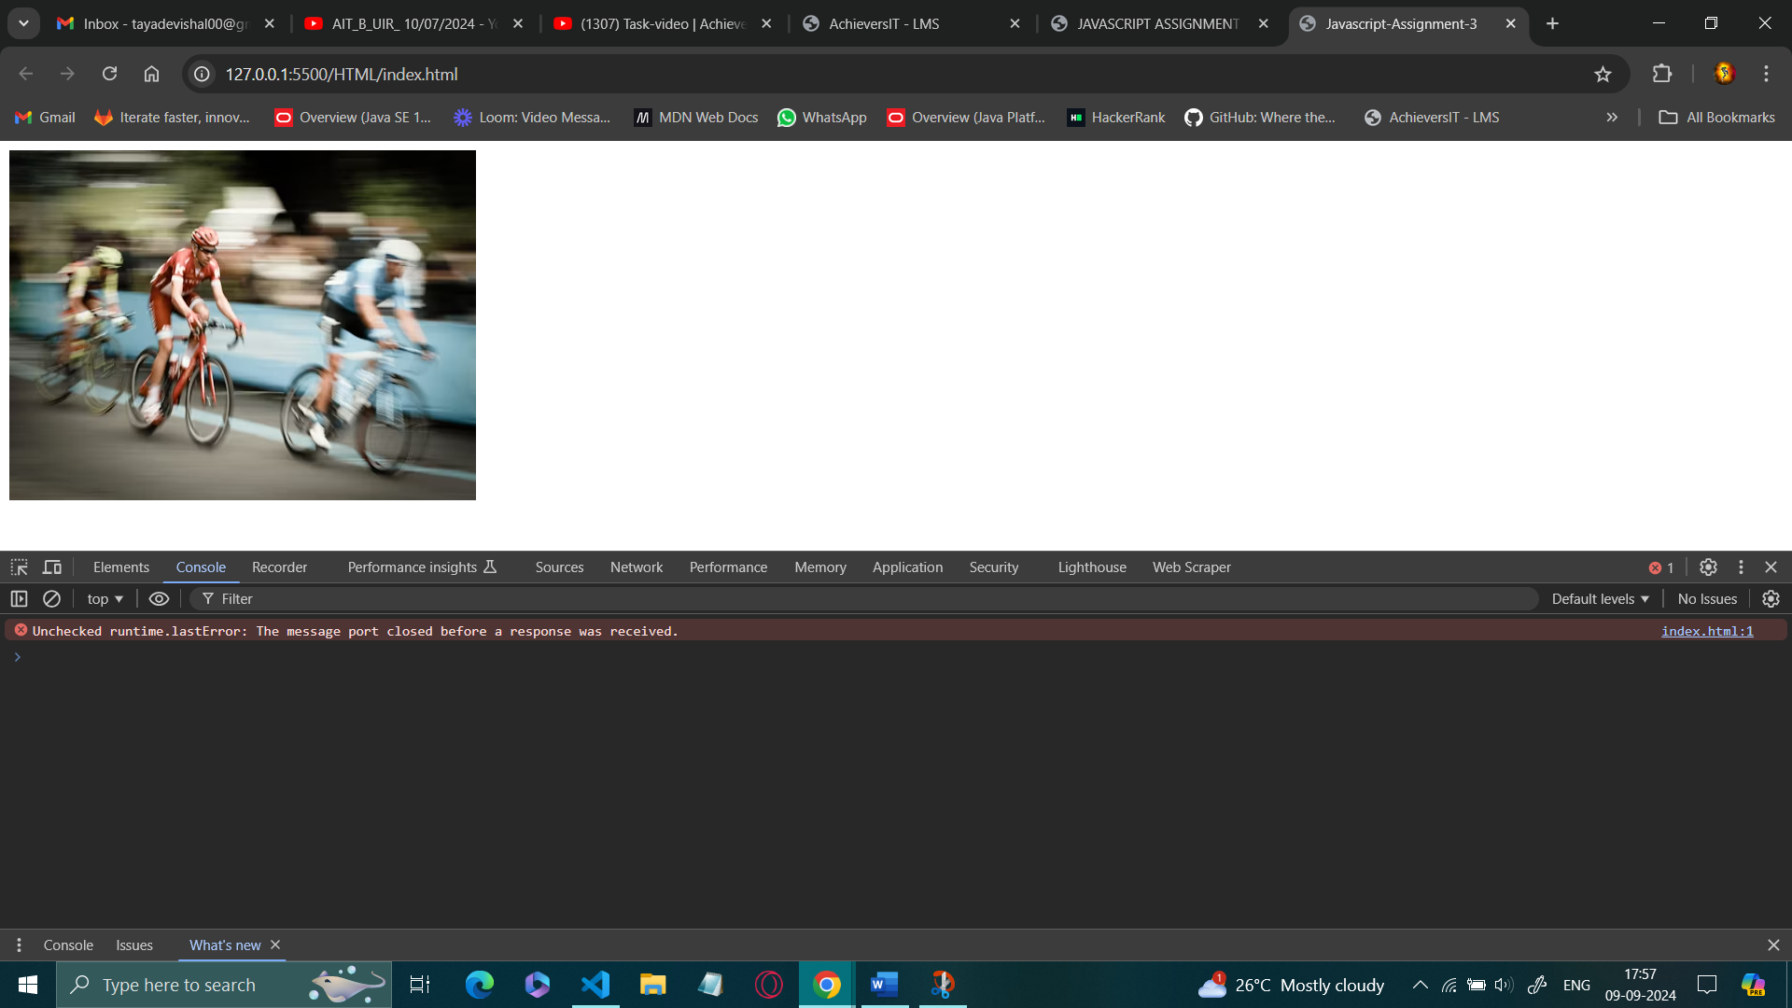

22.) Change the background color of the page when the user scrolls past a certain point.

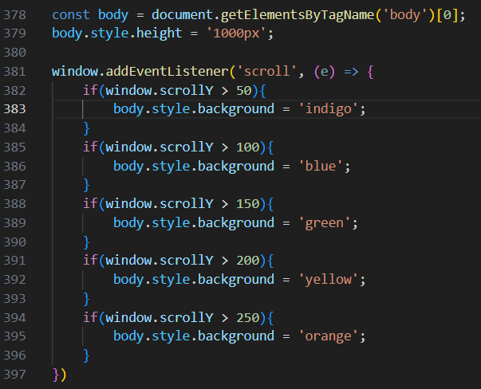



23.) Create a button that, when the button is clicked, Add a new list item to an unordered list.

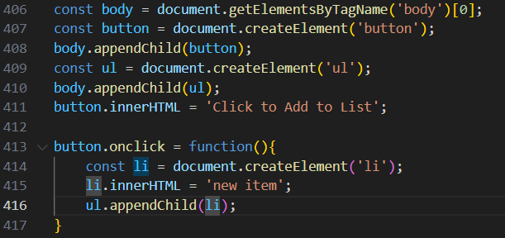

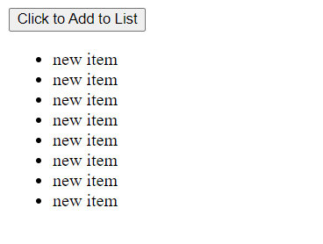

24.) Once the user clicks a button, disable it and display a message that the button has been clicked.

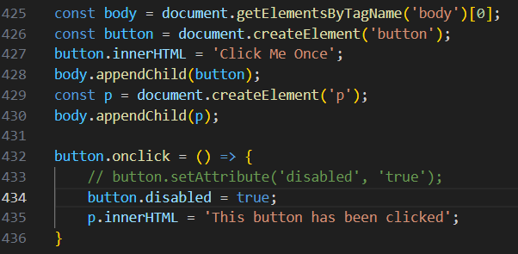

 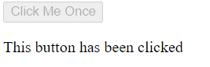

25.) Write a program that detects when the user copies text from a <textArea> and displays a message.

