EXECUTIVE ANALYSIS:

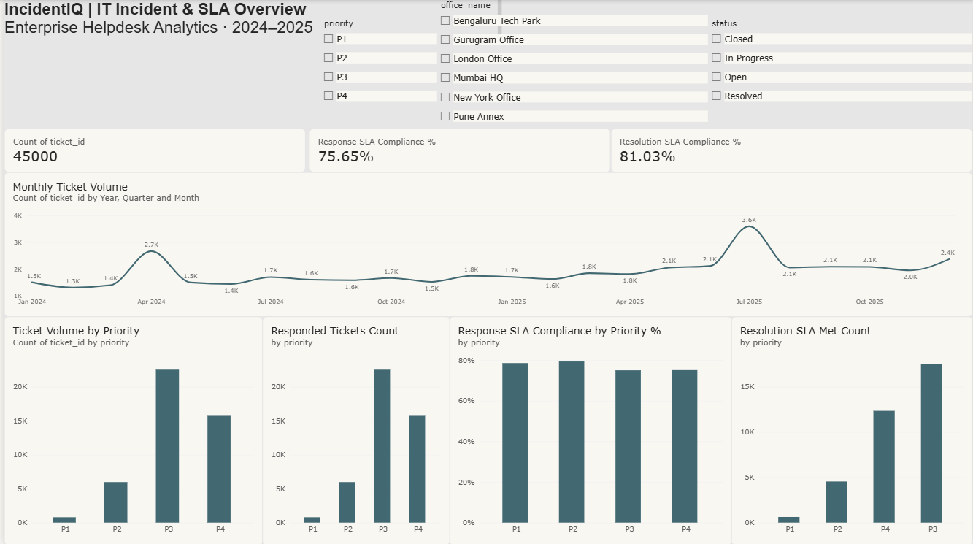

SLA ANALYSIS:
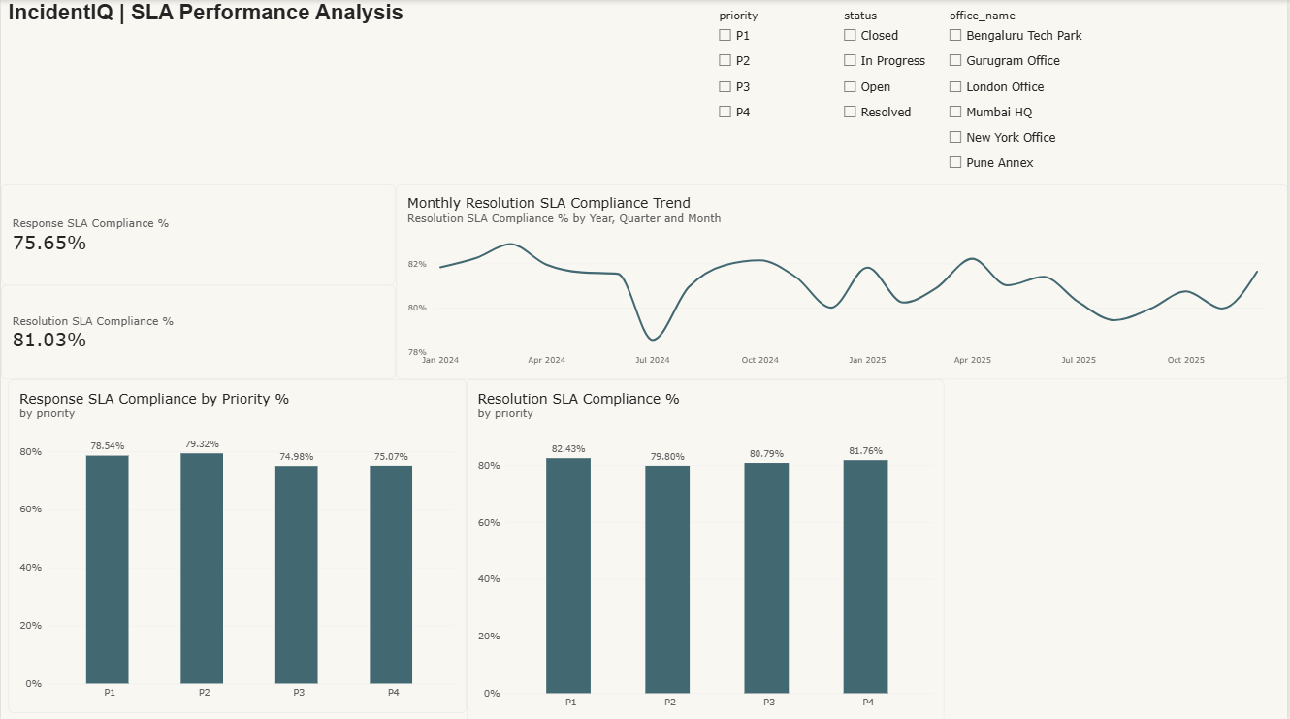

TEAM AND OFFICE PERFORMANCE:

