INCIDENTIQ
Enterprise IT Incident & SLA Analytics
Power BI Dashboard Portfolio
Built with MySQL, Power BI, and DAX
PROJECT SNAPSHOTS
This portfolio presents three report pages covering executive KPIs, SLA compliance, and support-team and office performance. All results are based on a synthetic dataset.

01 | EXECUTIVE OVERVIEW
Ticket volume and SLA KPIs, with priority breakdowns and interactive filters.
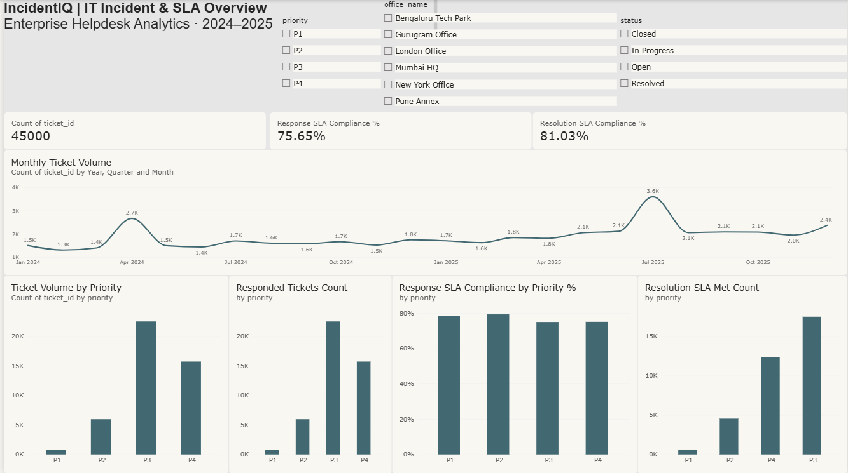

02 | SLA ANALYSIS
Response and resolution SLA compliance by priority, plus the monthly resolution compliance trend.
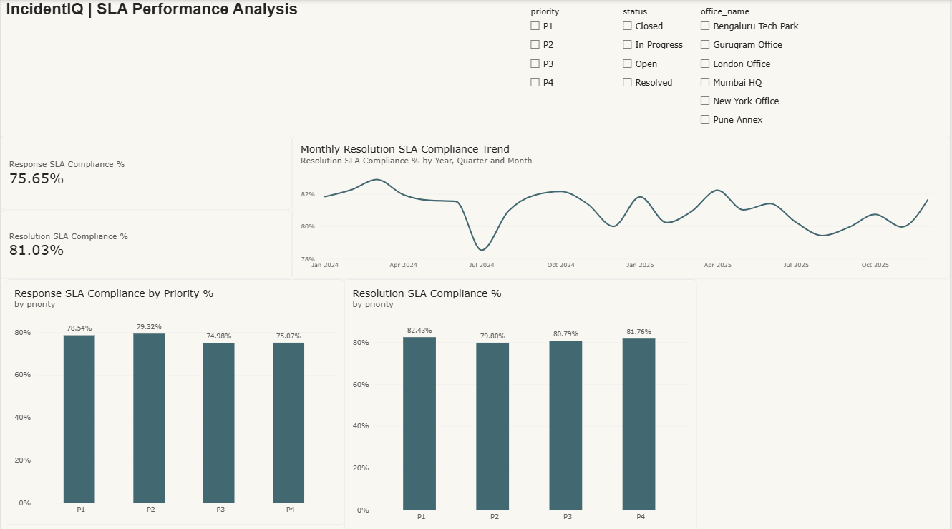

03 | TEAM & OFFICE PERFORMANCE
Support-team resolution compliance, ticket workload distribution, and response SLA breach rates by office.
