**DATE:31/10/2023**

**Project _Id :Proj_223331_Team_1**

**Project Name : smart water fountains (phase 5)**

**IOT :**

**Documentation :**

***OBJECTIVE***

The main objectives of a smart water fountain project are to:

* **Improve water quality:** Smart water fountains can use sensors to monitor water quality parameters such as temperature, pH, and turbidity. This data can be used to identify and address potential water quality problems early on, before they have a chance to impact human health.
* **Reduce water waste:** Smart water fountains can use sensors to detect water leaks and automatically shut off the water supply. They can also be programmed to dispense water only when needed, which can help to reduce water waste.
* **Improve convenience for users:** Smart water fountains can be connected to the internet and controlled remotely using a smartphone app. This allows users t**o** check the water level, water quality, and other status information from anywhere. Users can also use the app to start and stop the water fountain, or to program it to dispense water at specific times.

In addition to these general objectives, specific smart water fountain projects may have additional objectives, such as:

* **Reduce maintenance costs:**
* **Improve data collection and analysis:**
* **Promote public health:**

Here are some specific examples of how smart water fountain projects can be used to achieve these objectives:

* **Improving water quality**
* **Reducing water waste**
* **Improving convenience for users**
* **Reducing maintenance costs**
* **Collecting data and improving data analysis**
* **Promoting public health**

Overall, smart water fountain projects have the potential to improve water quality, reduce water waste, improve convenience for users, reduce maintenance costs, collect data and improve data analysis, and promote public health.

***IOT device setup***

The IoT device setup for a smart water fountain typically consists of the following components:

* **Sensors:** Smart water fountains use a variety of sensors to collect data about their operation and the water they dispense.

Common sensors include:

* + Water level sensors to monitor the water level in the fountain
  + Water quality sensors to monitor parameters such as temperature, pH, and turbidity
  + Flow sensors to measure the rate of water flow
  + Leak sensors to detect water leaks
* **Microcontroller**: The microcontroller is the central processing unit of the smart water fountain. It collects data from the sensors, controls the fountain’s operation, and communicates with the cloud.
* **Communication module:** The communication module allows the smart water fountain to connect to the cloud and send and receive data. Common communication modules include Wi-Fi, cellular, and Ethernet.
* **Power supply:** The power supply provides power to the microcontroller, sensors, and other components of the smart water fountain.

The specific IoT device setup for a smart water fountain will vary depending on the specific features and functionality of the fountain. For example, a smart water fountain with advanced water quality monitoring capabilities may require additional sensors and processing power.

Here Is a diagram of a typical IoT device setup for a smart water fountain:

[Sensors] -> [Microcontroller] -> [Communication module] -> [Cloud]

The sensors collect data about the water fountain and send it to the microcontroller. The microcontroller processes the data and uses it to control the operation of the water fountain.

The microcontroller also communicates with the cloud to send data and receive instructions . The cloud platform allows the smart water fountain to be monitored and managed remotely.

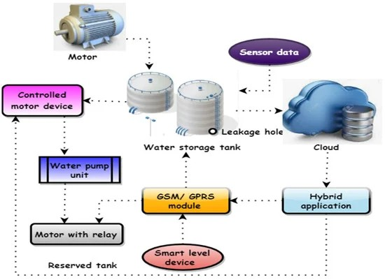

***Platform development***

The development of an IoT platform for smart water fountains typically involves the following steps:

* **Requirements gathering:** The first step is to gather requirements from the stakeholders, such as the water fountain manufacturer, the water utility, and the end users. These requirements will define the features and functionality of the IoT platform.
* **System design:** Once the requirements have been gathered, the next step is to design the system architecture of the IoT platform. This includes defining the components of the platform, such as the cloud platform, the edge devices, and the communication network.
* **Hardware development:** If necessary, new hardware may need to be developed for the IoT platform. This may involve developing new sensors, microcontrollers, or communication modules.
* **Software development:** The software for the IoT platform needs to be developed to collect data from the sensors, control the operation of the water fountains, and communicate with the cloud.
* **System integration:** The next step is to integrate the hardware and software components of the IoT platform. This includes configuring the sensors, microcontrollers, and communication modules to work together.
* **Deployment and testing:** Once the IoT platform has been integrated, it needs to be deployed and tested in a real-world environment. This involves installing the hardware and software at the water fountains and testing the system to ensure that it is working as expected.
* **Maintenance and support:** Once the IoT platform is deployed, it needs to be maintained and supported to ensure that it continues to operate reliably. This may involve providing software updates, fixing bugs, and providing technical support to the users of the platform.

The following are some of the key considerations for developing an IoT platform for smart water fountains:

* **Security**
* **Scalability**
* **Reliability**
* **Ease of use**

Here are some examples of the features that can be included in an IoT platform for smart water fountains:

* Real-time monitoring
* Alerting:
* Remote control
* Data analytics

Overall, an IoT platform for smart water fountains can help to improve the water quality, reduce water waste, improve convenience for users, and reduce maintenance cost.

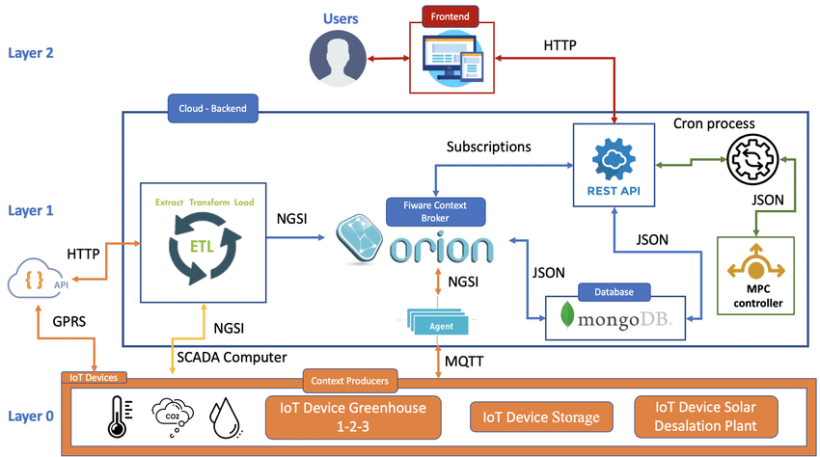

***Code implementation***

The IoT code implementation for the smart water fountain is responsible for the following tasks:

* Collecting data from the sensors
* Controlling the operation of the water fountain
* Communicating with the IoT platform

**Python**

**Import time**

**Import board**

**Import adafruit_dht**

**Import esp8266**

**# Connect to the water level sensor**

**Water_level_sensor = adafruit_dht.DHT22(board.D4)**

**# Connect to the ESP8266 Wi-Fi module**

**Esp8266.connect_wifi(ssid=”MY_SSID”, password=”MY_PASSWORD”)**

**# Create a function to send data to the IoT platform**

**Def Send_data(water_level):**

**Esp8266.post_data(**[**https://example.com/api/water-fountain**](https://example.com/api/water-fountain)**, {“water_level”: water_level})**

**# Start the data collection loop**

**While True:**

**# Read the water level from the sensor**

**Water_level = water_level_sensor.water_level**

**# Send the data to the IoT platform**

**Send_data(water_level)**

**# Wait 10 seconds before sending the next data point**

**Time.sleep(10)**

This code will continuously read the water level from the sensor and send it to the IoT platform every 10 seconds. The IoT platform can then use this data to monitor the water level and send alerts if the water level falls below a certain threshold.

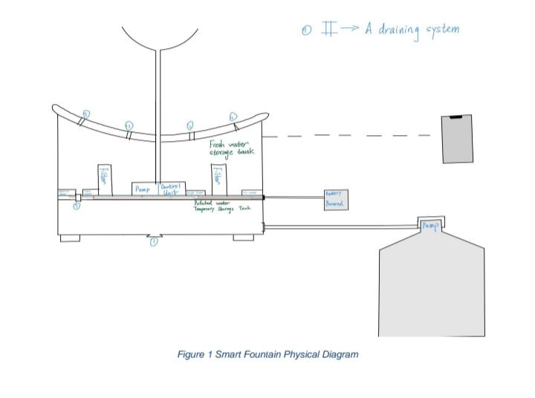***Smart water fountains physical Diagram.***

This diagram shows a high-level overview of the smart water fountain system architecture**.** The system consists of the following components

* Water fountain
* Microcontroller
* Communication module
* IoT platform

*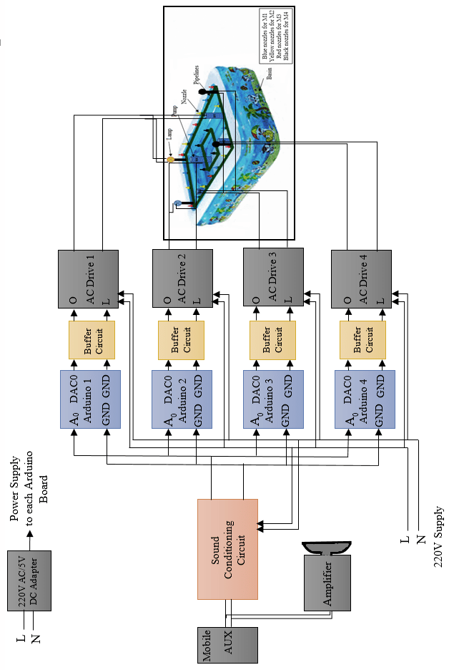****Schematic:***

***Screenshots***

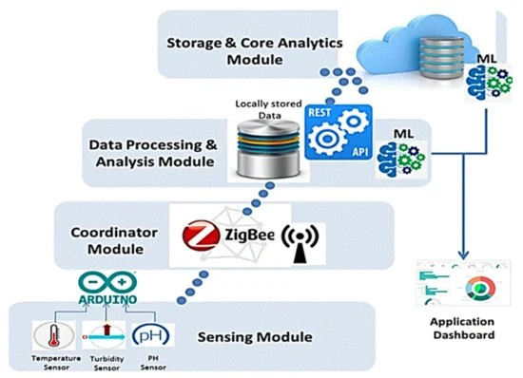**IoT-WQMS proposed**

***Conclusion***

Smart water fountains offer a number of benefits, including improved water quality, reduced water waste, improved convenience for users, and reduced maintenance costs. By using IoT technology, smart water fountains can be monitored and controlled remotely, and data can be collected to identify areas for improvement.