DATE: **17/10/2023**

PROJECT ID: **Proj_223331_Team_1**

PROJECT NAME: **SMART WATER FOUNTAINS**

**AI& ADS**

Artificial intelligence (AI) and artificial data science (ADS) are rapidly transforming many industries, including the water sector. One area where AI and ADS are having a major impact is in the development of smart water fountains.

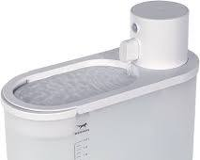Smart water fountains use a variety of sensors and technologies to collect data on water usage, temperature, and quality. This data is then analyzed using AI and ADS to identify patterns and trends. This information can then be used to improve the efficiency and effectiveness of water fountains, as well as to detect and prevent problems.

Here are some specific examples of how AI and ADS are being used in smart water fountains:

* **Predicting water usage:** AI can be used to predict water usage patterns based on historical data. This information can then be used to optimize the operation of water fountains, such as by adjusting the flow rate or turning off the fountain when it is not in use.
* **Preventing leaks:** AI can be used to detect leaks in water fountains by analyzing data from sensors that monitor water flow and pressure. This early detection can help to minimize water waste and damage.
* **Improving water quality:** AI can be used to monitor water quality in water fountains by analyzing data from sensors that measure temperature, pH, and other parameters. This information can then be used to take corrective action, such as adding filters or disinfectants.
* **Providing personalized recommendations:** AI can be used to provide personalized recommendations to users of water fountains, such as recommending the optimal water temperature or suggesting drinks based on the user’s health and fitness goals.

**DAC**

A digital-to-analog converter (DAC) is an electronic device that converts a digital signal into an analog signal. DACs are used in a variety of applications, including audio, video, and control systems.

In smart water fountains, DACs are used to control the flow rate and pressure of water. For example, a DAC can be used to control a solenoid valve that turns the water on and off. The DAC can also be used to control the speed of a pump that circulates the water.

By using a DAC, smart water fountains can be precisely controlled to deliver the desired amount of water at the desired pressure. This can help to improve water efficiency and reduce waste.

**Here is an example of how a DAC is used in a smart water fountain:**

1. A sensor detects that a user is approaching the water fountain.
2. The sensor sends a signal to the microcontroller that controls the water fountain.
3. The microcontroller uses the DAC to control the flow rate and pressure of the water.
4. The water fountain delivers the desired amount of water at the desired pressure.

DACs for smart water fountains are typically small and lightweight, making them easy to install and maintain. They are also relatively inexpensive, making them a cost-effective solution for improving the water efficiency of water fountains.

**Here are some of the benefits of using a DAC in a smart water fountain:**

1. **Improved water efficiency:** DACs can be used to precisely control the flow rate and pressure of water, which can help to improve water efficiency and reduce waste.
2. **Reduced maintenance costs:** DACs are typically reliable and require little maintenance.
3. **Increased user satisfaction:** DACs can be used to create a more consistent and enjoyable water fountain experience for use

**IoT**

To begin building a smart water fountain project using IoT devices and Python scripts, I would first deploy the IoT devices. This would involve placing the devices in the appropriate locations and connecting them to the power supply and network.

Once the IoT devices are deployed, I would develop a Python script to run on the devices. This script would be responsible for collecting data from the sensors on the IoT devices, processing the data, and taking appropriate actions.

Here is an example of a simple Python script for a smart water fountain:

import time

import board

import pwmio

# Define the pins for the water pump and solenoid valve

pump_pin = board.D18

solenoid_pin = board.D17

# Create a PWM object to control the water pump

pump_pwm = pwmio.PWMOut(pump_pin, frequency=50)

# Create a digital output object to control the solenoid valve

solenoid_out = digitalio.DigitalInOut(solenoid_pin)

# Set the initial state of the water pump and solenoid valve

pump_pwm.duty_cycle = 0

solenoid_out.value = False

# Start the main loop

while True:

# Read the water level sensor

water_level = read_water_level_sensor()

# If the water level is low, turn on the water pump

if water_level < 0.5:

pump_pwm.duty_cycle = 100

# Otherwise, turn off the water pump

else:

pump_pwm.duty_cycle = 0

# Open the solenoid valve to dispense water

solenoid_out.value = True

# Wait for 1 second

time.sleep(1)

# Close the solenoid valve

solenoid_out.value = False

# Wait for 1 second

time.sleep(1)

This script would continuously read the water level sensor and turn on the water pump if the water level is low. It would also open the solenoid valve to dispense water for 1 second before closing it again.

The Python script could be modified to implement more complex features, such as Predicting water usage and adjusting the water pump speed accordingly

1. Detecting leaks and turning off the water pump
2. Monitoring water quality and taking corrective action if necessary
3. Providing personalized recommendations to users

By using IoT devices and Python scripts, it is possible to create smart water fountains that are more efficient, effective, and user-friendly

**CAD**

Here is an example of a smart water fountain solution that can be built using IBM Cloud Foundry:

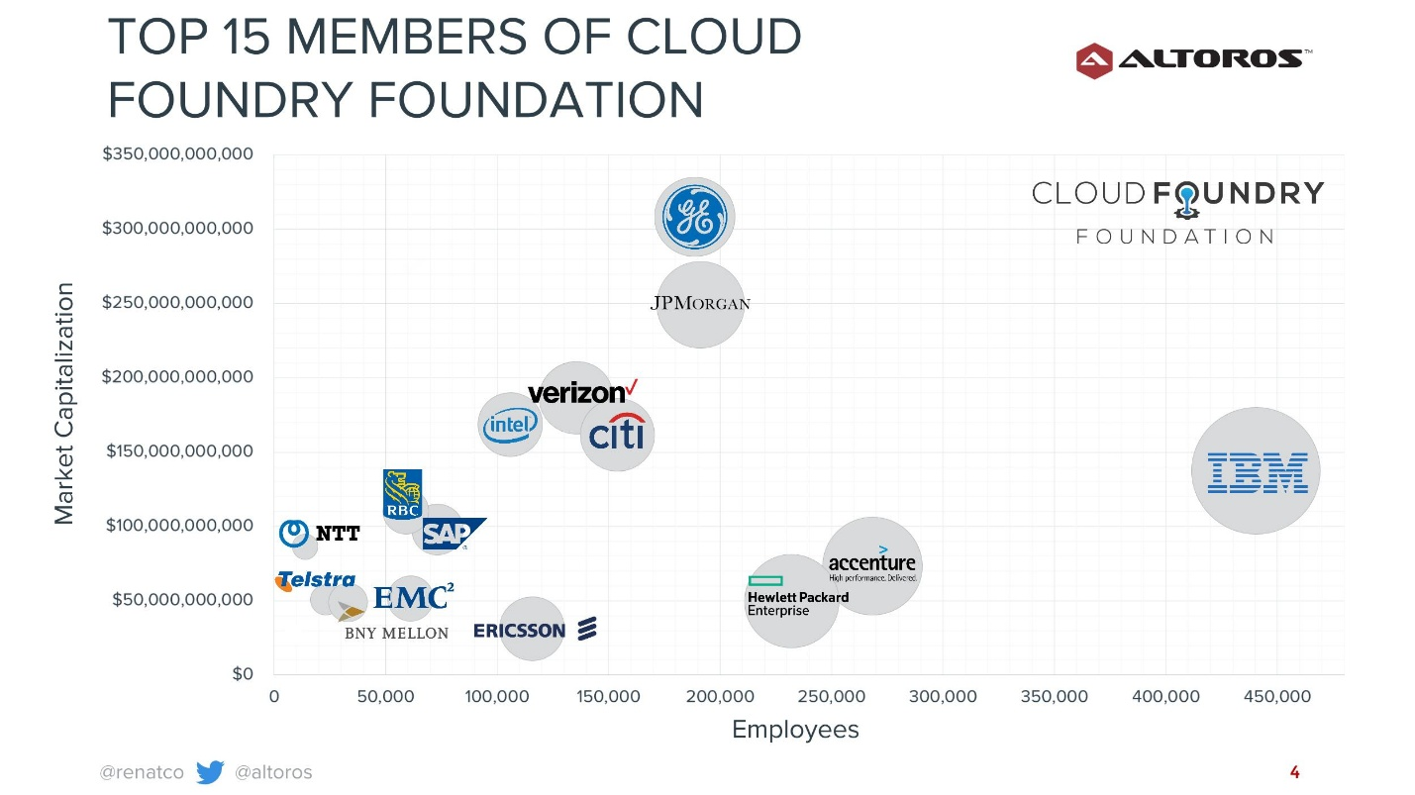

IBM Cloud Foundry is an open-source platform that provides a cloud-native environment for deploying, running, and managing applications. It is a popular choice for developing and deploying smart water fountain solutions, as it offers a number of advantages, including:

* **Scalability:** IBM Cloud Foundry can be scaled up or down to meet the needs of the application, making it ideal for smart water fountains that need to be able to handle fluctuating demand.
* **Security:** IBM Cloud Foundry provides a number of security features to protect applications from unauthorized access and attack.
* **Reliability:** IBM Cloud Foundry is a highly reliable platform that offers a 99.99% uptime SLA.
* **Ease of use:** IBM Cloud Foundry is easy to use and provides a number of tools and services to help developers build and deploy applications.

Once the IBM Cloud Foundry platform is deployed, I would need to develop an application that can be deployed to the platform. This application would be responsible for collecting data from the IoT devices, processing the data, and taking appropriate actions.

The application could be developed using any programming language that is supported by IBM Cloud Foundry. For example, I could develop the application using Python, Java, or Node.js.

Once the application is developed, I would need to deploy it to the IBM Cloud Foundry platform. This can be done using the IBM Cloud Foundry documentation.

Once the application is deployed, I would need to configure it to connect to the IoT devices and to perform the desired actions. This can be done by setting the configuration parameters of the application.

For example, I could configure the application to connect to the IoT devices using the MQTT protocol. I could also configure the application to send a notification to the user if the water level in the fountain is low.

Here are some specific examples of functions that I could implement in an IBM Cloud Foundry application for a smart water fountain:

* **Predicting water usage:** I could use machine learning to train a model to predict water usage patterns based on historical data. This model could then be used to optimize the operation of the water fountain, such as by adjusting the flow rate or turning off the fountain when it is not in use.
* **Preventing leaks:** I could use machine learning to train a model to detect leaks in the water fountain by analyzing data from sensors that monitor water flow and pressure. This early detection could help to minimize water waste and damage.
* **Improving water quality:** I could use machine learning to train a model to monitor water quality in the water fountain by analyzing data from sensors that measure temperature, pH, and other parameters. This information could then be used to take corrective action, such as adding filters or disinfectants.
* **Providing personalized recommendations:** I could use machine learning to train a model to provide personalized recommendations to users of the water fountain, such as recommending the optimal water temperature or suggesting drinks based on the user's health and fitness goals.

By developing an application using IBM Cloud Foundry, I could create a smart water fountain solution that is scalable, secure, reliable, and easy to use