Assignment 1

Vishwas Siravara
UIN: 623009600

Transcripts for BFS,DFS and GBFS
source = [1,1] , destination = [20, 20]
BFS:-
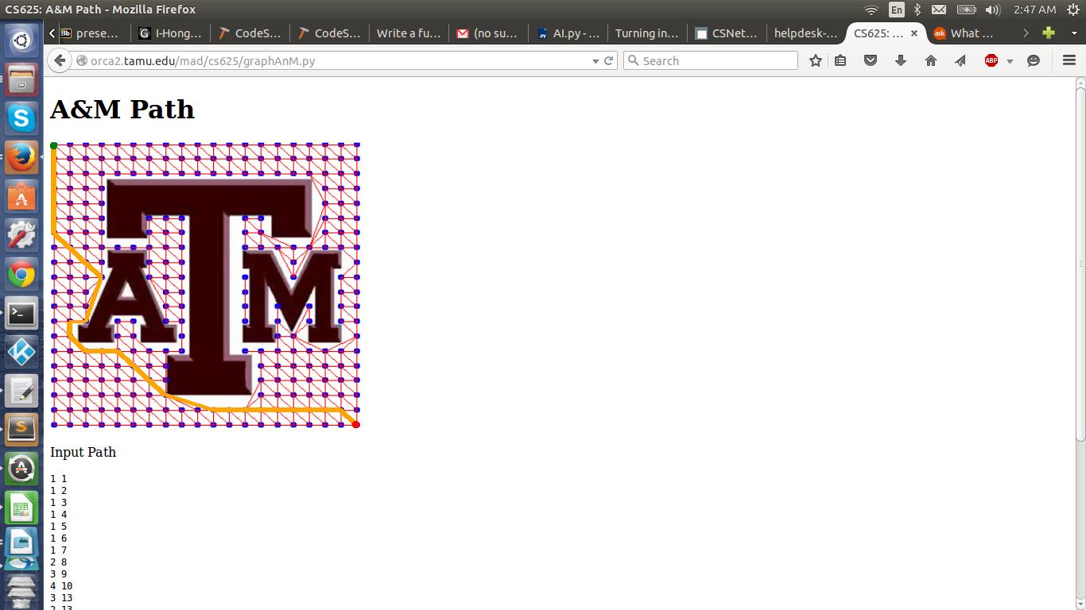

--------BFS--------------
lenght of visited is 263
max frontier size is 21
Iterations is 252
Time taken bfs
0.0141408443451
Path for bfs is:
0
1
2
3
4
5
6
27
48
68
52
32
33
53
69
81
94
109
127
153
158
171
183
196
209
221
235
253
274
Path with coordinates
[1, 1]
[1, 2]
[1, 3]
[1, 4]
[1, 5]
[1, 6]
[1, 7]
[2, 8]
[3, 9]
[4, 10]
[3, 13]
[2, 13]
[2, 14]
[3, 15]
[4, 15]
[5, 15]
[6, 16]
[7, 17]
[8, 18]
[11, 19]
[12, 19]
[13, 19]
[14, 19]
[15, 19]
[16, 19]
[17, 19]
[18, 19]
[19, 19]
[20, 20]
Path length 29

DFS:
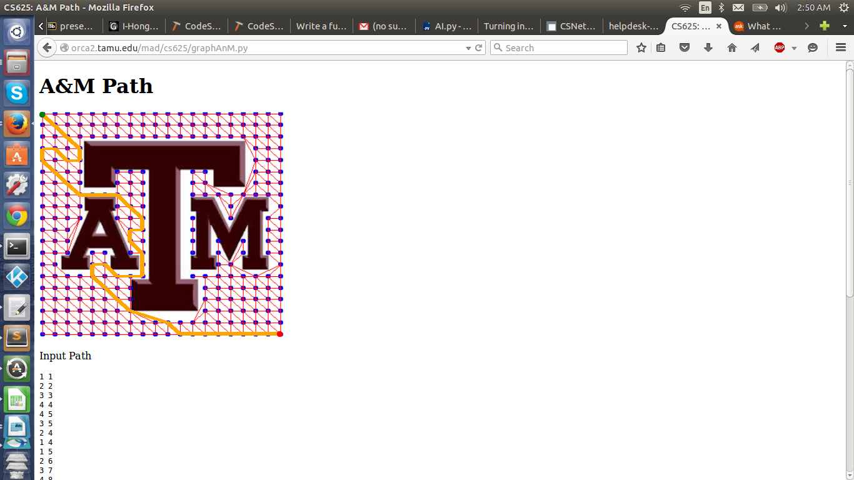

------------DFS-------------
lenght of visited is 86
max lenght of frontier is 43
Iterations is 44
Time taken for dfs
0.00253510475159
Path for dfs is:
0
21
42
62
63
44
23
3
4
25
46
66
78
90
104
119
137
138
121
122
140
141
142
124
107
92
80
81
94
109
127
153
159
172
184
197
210
222
236
254
274
Path with coordinates
[1, 1]
[2, 2]
[3, 3]
[4, 4]
[4, 5]
[3, 5]
[2, 4]
[1, 4]
[1, 5]
[2, 6]
[3, 7]
[4, 8]
[5, 8]
[6, 8]
[7, 8]
[8, 9]
[9, 10]
[9, 11]
[8, 11]
[8, 12]
[9, 13]
[9, 14]
[9, 15]
[8, 15]
[7, 15]
[6, 14]
[5, 14]
[5, 15]
[6, 16]
[7, 17]
[8, 18]
[11, 19]
[12, 20]
[13, 20]
[14, 20]
[15, 20]
[16, 20]
[17, 20]
[18, 20]
[19, 20]
[20, 20]
Path length 41

GBFS:
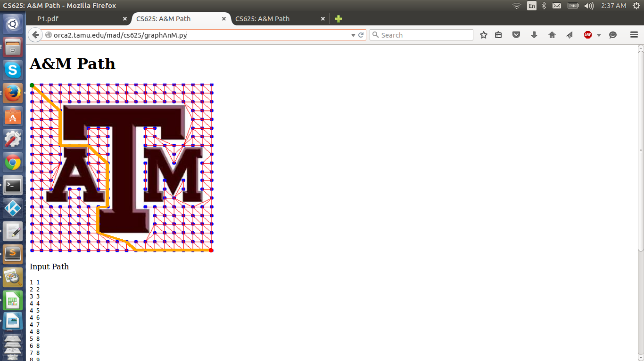

------------GBFS---------------
lenght of visited is 66
lenght of frontier is 35
Iterations is 31
Time taken for gbfs
0.00197601318359
Path for gbfs is:
0
21
42
62
63
64
65
66
78
90
104
119
137
138
139
140
141
142
124
125
126
127
153
159
172
184
197
210
222
236
254
274
Path with coordinates
[1, 1]
[2, 2]
[3, 3]
[4, 4]
[4, 5]
[4, 6]
[4, 7]
[4, 8]
[5, 8]
[6, 8]
[7, 8]
[8, 9]
[9, 10]
[9, 11]
[9, 12]
[9, 13]
[9, 14]
[9, 15]
[8, 15]
[8, 16]
[8, 17]
[8, 18]
[11, 19]
[12, 20]
[13, 20]
[14, 20]
[15, 20]
[16, 20]
[17, 20]
[18, 20]
[19, 20]
[20, 20]
Path length 32

