Vishwas Siravara
UIN: 623009600

Program Traces:

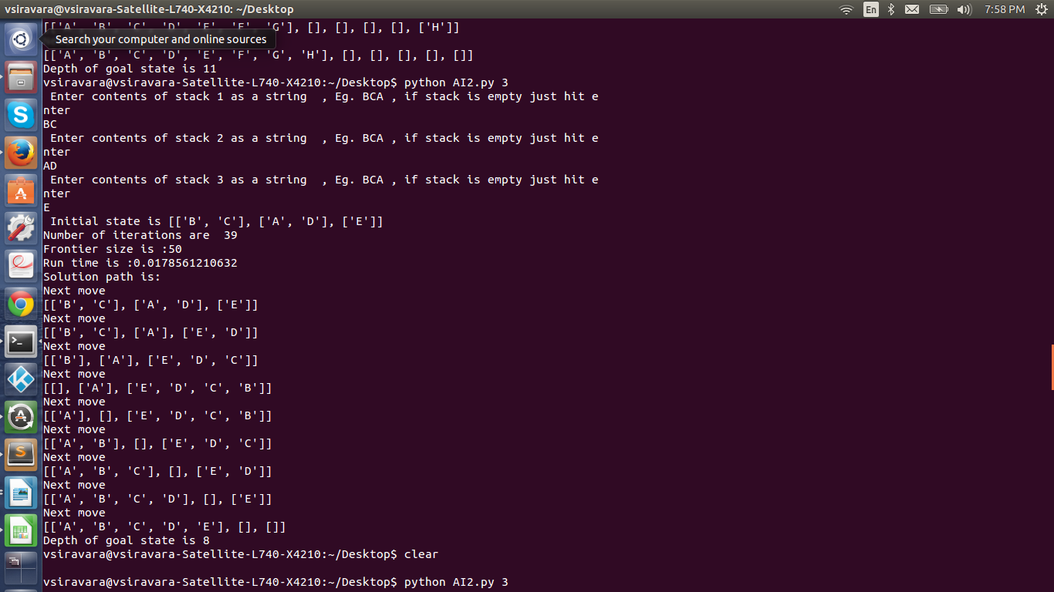

Running instructions:

Python version used : Python 2.7.6

to run the code from command line :
> python <filename> < number of stacks>
Eg.
>python AI2.py 3

Once this command is run , the program asks the user to enter elements of each stack. Enter the elements as a string with each letter capitalized . If the stack has to be left empty just hit enter and move on to the next stack. Make sure that the alphabets are continuous starting from A . The program will not work for random alphabets like AX1. It has to be continuous starting from A.

The program terminates after 10000 iterations if the goal state is not found.

