RE56 Labs
Specification document model – DELIVER 10 pages AT MAXIMUM

STUDENTS
TREHIOU PAUL
SENE VICTOR
WANG SIYU
GLANGINE GEOFFREY

Code division multiplexing in UMTS

XU

DOCUMENT VERSION
Date: (28/04/17) Modify Chapter: all
Date: (11/05/17) Modify Chapter: 1

TEACHER COMMENTS
Date:
Comments:

---------------------------------------

1. PURPOSE OF THE SYSTEM FUNCTION (10 lines)

The main program will be able to simulate a basic UMTS downlink communication with a large number of mobile phone and one antenna.
The antena and the mobile will be autonomous and the antena. The mobile phones and the antena, will use an OVSF code in order to simulate a communication.
We will implement the simulation of interference and retrieving the messages from this signal.
The others mobiles will receive random messages. After we decrypt the message in the global signal.
We also will see the mean throughput of cellphones. And the error rate due to interferences.

2. INPUT DATA AND PARAMETERS
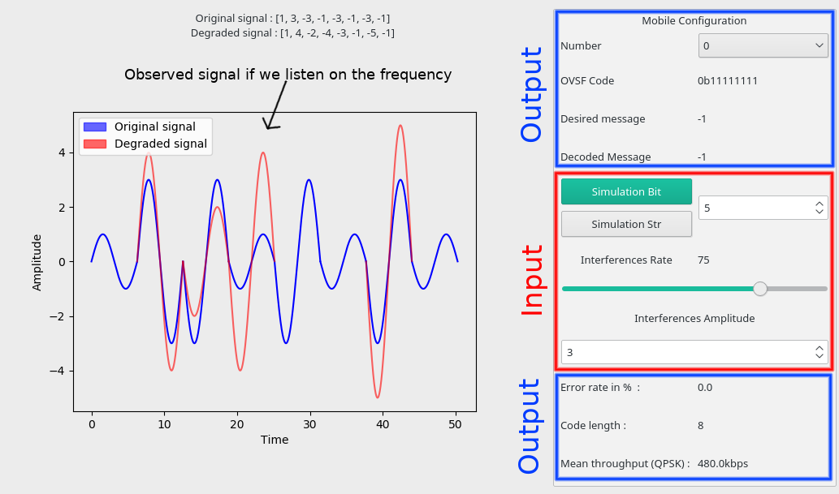
Our program has two way of simulation. We can simulate the sending of 1 bit from the antenna to a mobile or the sending of a string like “hello”. So we propose 2 buttons and one text entry to enter the number of mobile we want to simulate.
Or goal is to understand how interferences modify a signal. That’s why we have a rate and amplification which user can modify to have an idea of the modification that’s occurred.

3. DESCRIPTION OF FORMULA AND ALGORITHM

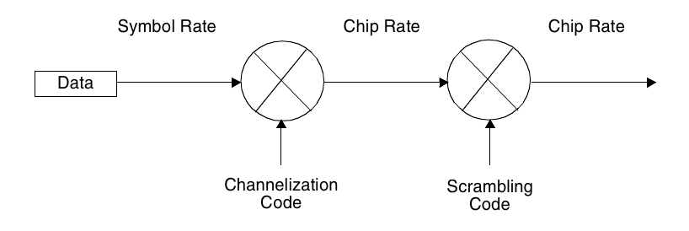

First of all, we worked on the OVSF tree creation. To do this we created a Tree structure who is making a binary tree with all of the codes. After we wanted to makes this tree “intelligent” in order to give the right code size to mobile so we could have mobiles with high througput and mobiles with high data redundancy. But after discussion, we discover that this feature is implemented by an other project and we didn’t have to implement this. So we abandoned the idea to use the Tree data structure because to use a code we needed to implement a breadth first search algorithm and it’s not as trivial as just have codes in a table. So we change this tree to a table of codes of the right size for a determined number of phones. To make this we use this algorithm :
Input : DepthOfTree
Output : OvsfTree
OVSFTree = [1] //The first code in the tree is 1
for i←0 to i=DepthOfTree:
newOVSFList=[]
Xornumber= (2*2)^{i}-1 //create a binary number of size equal to the size of the code for this depth of the tree and containing just 1
for j in OVSFTree : //parsing the previous codes
Code = concat(j,j)
Add code in NewOVSFList
code=j + (j^xornumber) //generate the second code by duplicating the previous code and inverting all bits of it
Add code in NewOVSFList
endFor
OVSFTree=NewOVSFList
endFor
return column

After we apply algorithm saw in TD for generate a signal and demodulate the data in the signal with the channelization codes.

After all of that we implemented the feature of adding pseudo random noises in the signal to saw the channelization code protection in function of this code length.

To do so, we made a function which is taking two arguments, the percentage rate of interference and the amplitude of the interference.

So there is the algorithm :
Input : Signal, rate, amlplitude
Output : NewSignal

for I in Signal :
if(random(0,100)<rate):
I+=random(-amplitude,amplitude)
return Signal

4. OUTPUT DATA

For this Project, we choosed to display the annalogical signal (in black on the figure below) But we display the signal in numeric version too (in blue on the figure)
The too displaying types of signal display the true, perfect signal and the signal with interferences when we add some interferences. Note that simultaion str doesn’t display the signals, because in simultaion str mode, many signals are generated and we can’t displays. It doesn’t make sense to display just one signal in a simulation which use more than 10 signals.

The program displays the OVSF code by mobile and the sent message to a mobile and the received message by this mobile, you just add to choose an mobile in the drop down box. All this stuff is framed in green on the picture. The received messages could be character if the simmulation mode is “Simulation str” or just bits (- 1= 0 and 1 = 1) if the simulation mode is simulation bit.

Finally, for all simulations we display the error rate of receiving bits, the code length used by this simulation and the mean throughput of the simulation.

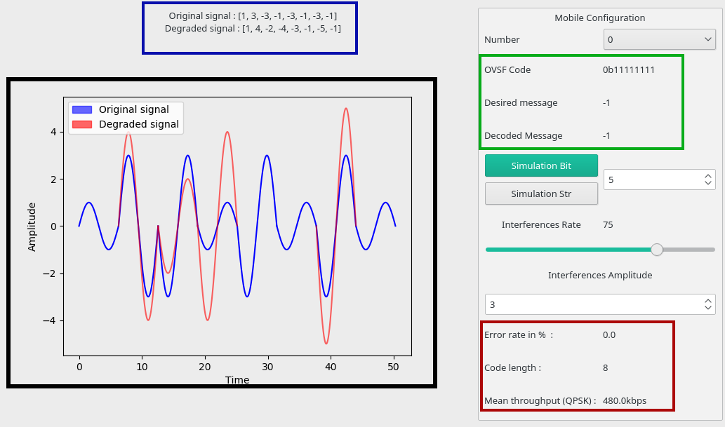

5. VALIDATION ON ONE EXAMPLE
(Describe one hand-made example of the algorithm steps. The purpose of this exercise is to verify the accuracy of your work. Take a reduced set of data to describe the inputs, the calculations made, and the outputs obtained.)

6. BIBLIOGRAPHY USED
(Describe the list all the references you found to your project: title, author, year of publication, website, etc.)
What is UMTS ? : http://www-igm.univ-mlv.fr/~dr/XPOSE2006/eric_meurisse/umts.php
https://www.youtube.com/watch?v=XJ81CuujwYE&feature=youtu.be

http://thebestwirelessinternet.com/umts.html

https://en.wikipedia.org/wiki/CDMA2000

http://wifinotes.com/mobile-communication-technologies/what-is-cdma.html

Jukka Lempiäinen, Matti Manninen (2007) : https://books.google.fr/books?id=9frZBwAAQBAJ&dq=SF+management+umts&hl=fr&source=gbs_navlinks_s

7. Software Developement
We implement all this software with python. For the graphical user interface, we used QT because we thought that it’s the best tool for displaying things like button and text field. It offers a tool named Qtdesigner which permit to create an xml fil wich is containing the interface. For displaying the graph (Annalogical signal we used mathplotlib)
We choosed python because we knew that it’s a good tool for doing simulations and mathematics. We wanted to use binary representation, but python isn’t the tool for that because it’s using the “complement a deux” representation for it’s integers so when we try to use xor funtion on int python returned something we didn’t want.

The whole program is about 637 line codes.

The files goldCode.py and goldCode.java are the same, just transpiled from an external tool, we tried to implement it but it was useless for this project, so we abandoned this feature.

Gui.py is the graphicall interface file, it’s the main of our program too, in this file you’ll find some function which are linking the simulation motor to the interface.

Gui.ui is a file that contain the GUI in xml format, used by gui.py

Mobile.py is a class which is representing a mobile.

OVSFGenerator.py is the file which is creating the table of ovsf codes used by initializeCommunication.py

OVSFTree.py is the first OVSFGenerator what we implemented, It’s a Tree structure, containing all OVSF code existing. But we prefer to use the table made by OVSFGenerator.py, it’s easier to use.

Signalplot.py is all the code used to display the signals in a graph.

And Finally, innitializeCommunications.oy is the core of our software, it contains all the functions needed by the simulation. It’s the simulation motor.

Our application is totally MVC compliant, Actually, some of us worked on the simulation motor and the others worked on the interface. When the simulation motor was finished, we just call the functions in the graphical interface bloc and the function worked well.

The program worked well on linux just by lauching in python3 gui.py :
python3 gui.py

In the software, the more important, for us, is the interference plugin. Actually, it allow us to understand well the importance of having a long OVSF code. In deed, when we add interferences, and we have a small code, the devices are unable to demodulate well the signal, but is the code is very long, the throughput is decreasing, but all mobile are able to receive the good datas.

