Maconomy to CaseWare Cloud Integration

Contents
- Integration scope and field coverage
- Maconomy fields in scope
- Scope boundaries
- Integration workflow and behavior
- How the integration starts
- How jobs are selected
- Maconomy data used in CaseWare Cloud
- How the integration decides what to do
- New job or missing CaseWare entity
- Existing CaseWare entity
- Maconomy updates
- Authentication and reliability
- Status and troubleshooting
- Support sequence

Integration scope and field coverage
This delivery synchronizes open Maconomy jobs with their corresponding CaseWare Cloud client entity and one business address. It supports scheduled processing of recently created or changed jobs and a manual, single-job retry. Maconomy is the source of truth; the local database only controls service activation and stores execution status for support.

Maconomy fields in scope
Maconomy field | Purpose in the integration
`jobnumber` | Finds the CaseWare entity using `VSKY-{jobnumber}`.
`jobname` | Sets the CaseWare entity name and operating name.
`name1` | Sets the address name.
`name2`, `name3`, `name4` | Set address lines 1, 2, and 3.
`postaldistrict` | Sets the address city.
`country` | Sets the address country.
`template`, `closed` | Exclude template and closed jobs.
`createddate`, `changeddate` | Select recent jobs for the scheduled run.
`versionnumber` | Determines whether CaseWare needs a newer version.
`text19` | Stores CaseWare IDs, numbers, synchronized version, and UTC timestamp.

The integration applies the following standard CaseWare values: entity owner `Client`, entity type `A`, organization type `Corporation`, entity country code `US`, and address category `Business`.

Scope boundaries
This delivery includes entity creation and updates, creation or updates of the single associated business address, Maconomy `text19` write-back, scheduled and manual triggers, version checks, token reuse, rate-limit handling, and status logging. It does not include other Maconomy record types, additional CaseWare modules or related records such as contacts, phones, emails, documents, workflow, or billing, changes to unrelated Maconomy business data, or changes to CaseWare screens. Any additional data or process can be assessed separately so that it receives clear requirements and delivery timing.

Integration workflow and behavior
This section explains how an in-scope Maconomy job is synchronized with CaseWare Cloud, how the two systems remain connected, and what happens when a job is created or changed.
The integration uses Maconomy as the source of truth. Maconomy owns the job information and stores the CaseWare entity and address identifiers in the job's `text19` field. The local integration database controls whether the service is active and stores execution history for support and troubleshooting. It is not used to decide whether a job needs synchronization.
The CaseWare Cloud system is accessed through APIs, so this guide explains its requests and responses using endpoint examples rather than CaseWare screen images.
The scheduled batch endpoint is:
POST /api/v1/maconomy-caseware-cloud/sync-jobs

For a one-off synchronization, an authorized caller can use the separate job-number endpoint:
POST /api/v1/maconomy-caseware-cloud/sync-job
{
"jobnumber": "10105"
}

This endpoint is intended for manual checking and recovery when a scheduled run reports a failed job. It reads and processes only the supplied Maconomy job; it does not process the rest of the job list. It applies the same create, map, update, address, checkpoint, version, and logging rules as the scheduled batch endpoint.
Support can use it to retry a failed job after correcting the underlying data or service issue. A successful response shows the final action and the updated `text19` checkpoint. A missing Maconomy job returns HTTP 404. A processing failure returns the job with `syncAction: "FAILED"` and a `syncError` message, and the attempt is recorded in the request log for follow-up. If the job is already synchronized according to its version checkpoint, the response action is `ALREADY_SYNCED` and no CaseWare update is required.

How integration starts
The integration runs automatically from the scheduler every five minutes when the service is active. It can also be called manually by an authorized caller.
Before any synchronization begins, the integration checks the service status in the database. If the service is inactive, no Maconomy or CaseWare operation is performed.
The service status is controlled by the `integration_service` database record described in the scheduler and service configuration section above.

How jobs are selected
The integration asks Maconomy for jobs that meet all of these conditions:
- The job is not a template.
- The job is not closed.
- The job was created or changed today or yesterday.
The response includes the job details needed to update CaseWare, including the job name, address fields, Maconomy version, and `text19`.
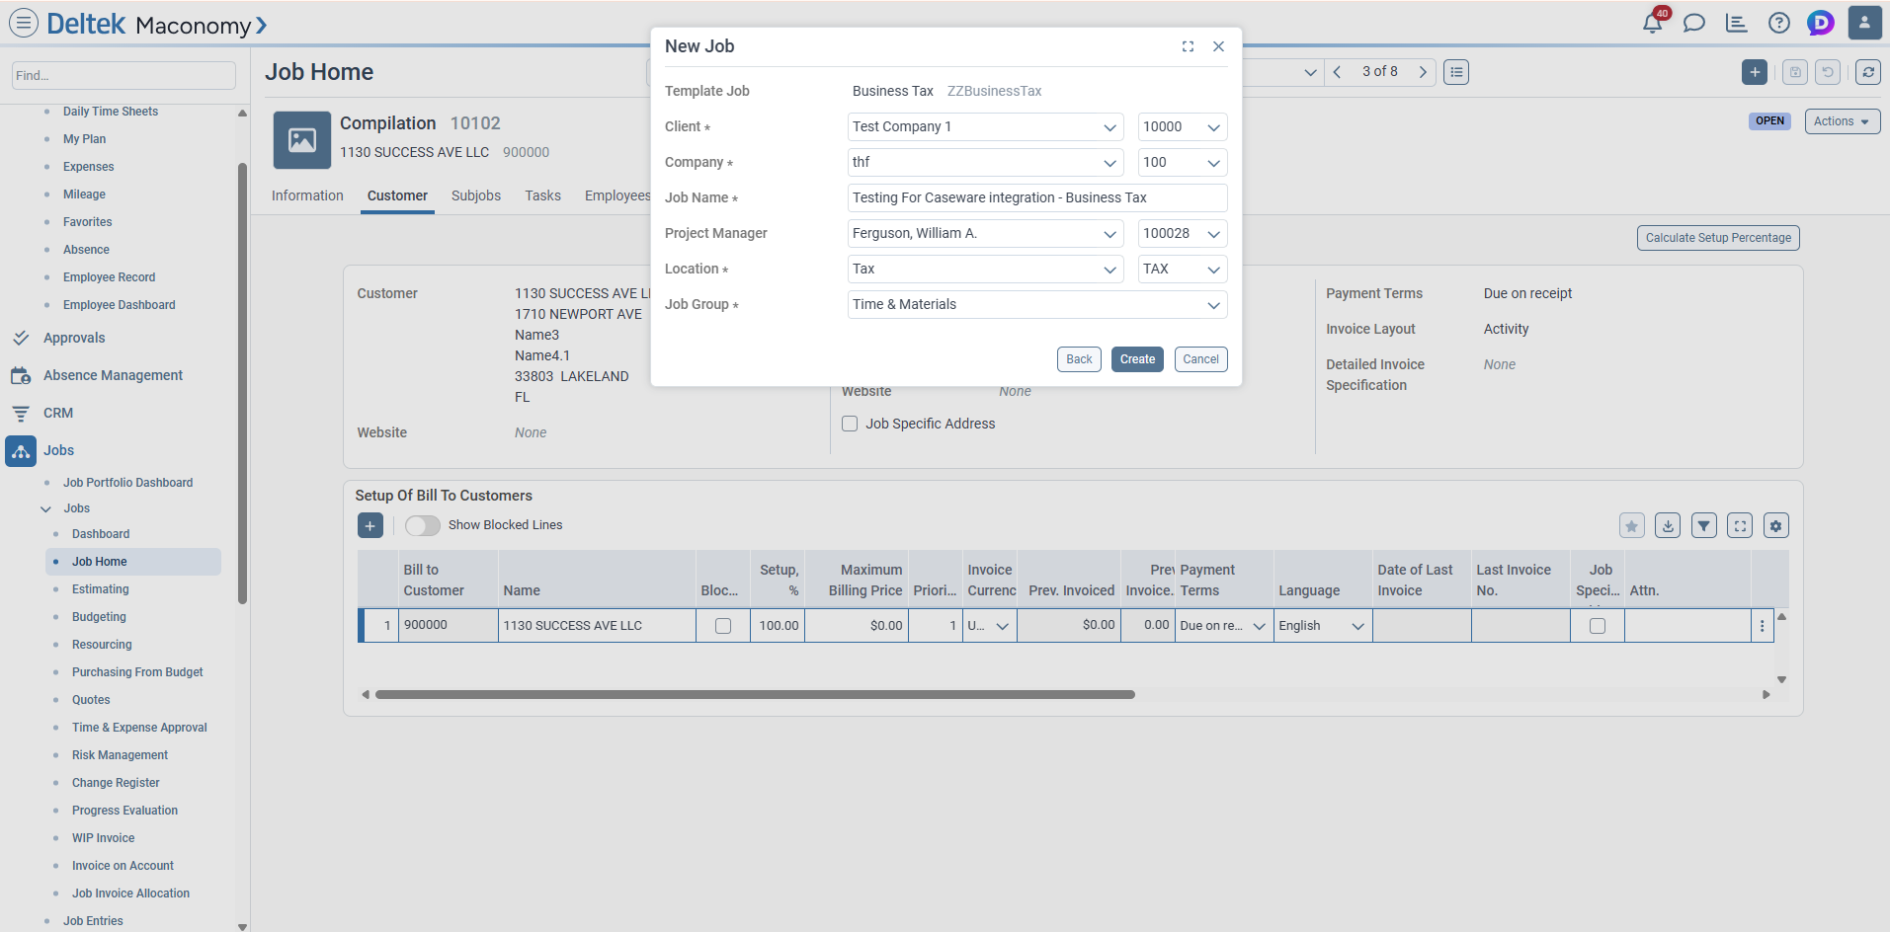
Filled Maconomy New Job form
The job is created in Maconomy from the completed New Job form. The job name, client, company, project manager, location, and job group are captured before the integration can process the job.
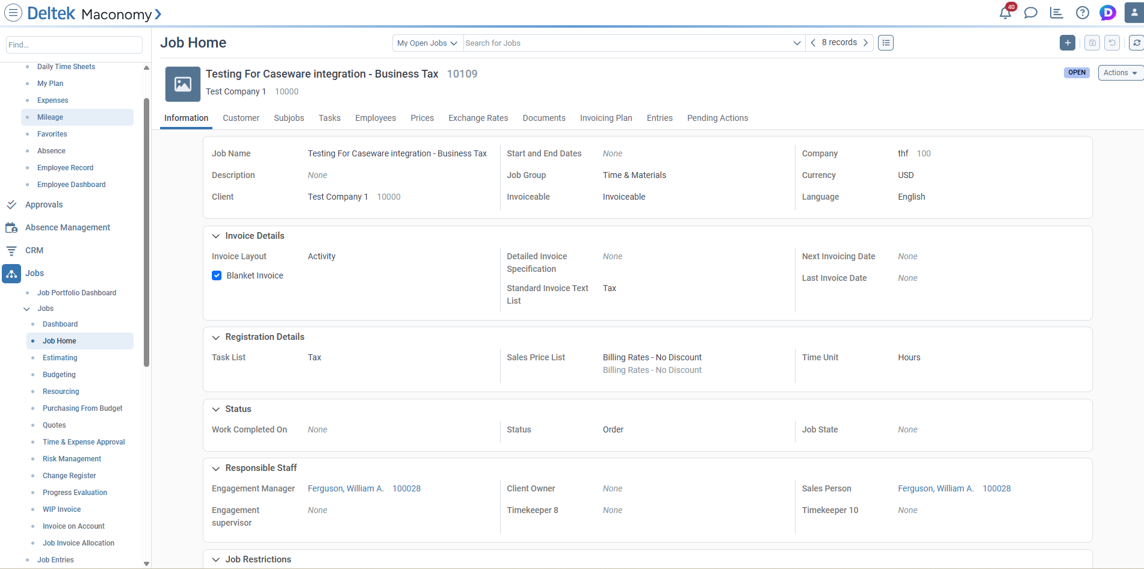
Maconomy job Information tab after creation
The new job is then available in Maconomy's Job Home. The Information tab shows the created job number, job name, client, company, and other job details used by the integration.
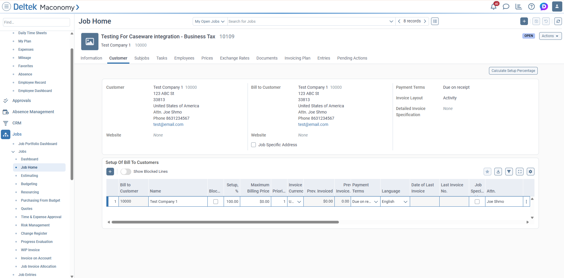
Maconomy job Customer tab after creation
The Customer tab provides the customer and address data used to create or update the CaseWare address record.

Maconomy data used in CaseWare Cloud
The integration reads information from the Maconomy job and sends it to two functional areas in CaseWare Cloud: the entity record and the entity address. The same values are used when an entity is created and when it is updated.

CaseWare entity
The entity is the organization or client record in CaseWare Cloud.
Maconomy information | CaseWare entity field | Functional meaning
Job Name (`jobname`) | `Name` | The name displayed for the client or organization.
Job Name (`jobname`) | `OperatingName` | The operating or trading name used by the entity.
Job Number (`jobnumber`) | `EntityNo` as `VSKY-{jobnumber}` | The unique reference used to find the same entity later.
— | `OwnerType = Client` | Identifies the CaseWare entity as a client.
— | `Type = A` | Sets the CaseWare entity type required by the integration.
— | `OrganizationType = Corporation` | Sets the standard organization classification during creation.
— | `CountryCode = US` | Sets the standard country code during entity creation.

The job number is the link between the two systems. For example, Maconomy job `10105` is searched in CaseWare as entity number `VSKY-10105`.

CaseWare Entity Address
The address is stored below the CaseWare entity and represents the customer address shown on the Maconomy Customer tab.
Maconomy information | CaseWare address field | Functional meaning
Customer name (`name1`) | `Name` | The name shown for the address or customer location.
Address line 1 (`name2`) | `Address1` | The first street or address line.
Address line 2 (`name3`) | `Address2` | The second address line, when provided.
Address line 3 (`name4`) | `Address3` | The third address line, when provided.
City or postal district (`postaldistrict`) | `City` | The city or locality.
Country (`country`) | `Country` | The country value from Maconomy.
— | `AddressCategory = Business` | Identifies the address as a business address.

When an address is created, CaseWare returns an address number (`Id`) and a unique address identifier (`CWGuid`). Both are saved in Maconomy `text19` so the same address can be updated later. If the job has no CaseWare address yet, the integration creates one using the values above. If an address is already mapped, the integration updates that address.

Synchronization and control information
These Maconomy values control when the integration works on a job. They are not business data sent to the visible CaseWare entity or address fields.
Maconomy information | How it is used
`template` | Template jobs are excluded.
`closed` | Closed jobs are excluded.
`createddate` | A newly created job is considered during the current two-day window.
`changeddate` | A changed job is considered during the current two-day window.
`versionnumber` | Compared with `text19.syncedVersion` to identify newer Maconomy data.
`text19` | Stores the CaseWare entity/address mapping and synchronized version.

The integration does not copy the internal `versionnumber` into a CaseWare business field. It uses that value only to know whether CaseWare needs the latest Maconomy information.
The Maconomy customer number, job dates, template flag, closed flag, and version are used for selection and synchronization control. They are not written into the visible CaseWare entity or address business fields.

How integration decides what to do
The decision is based on `text19` and the Maconomy version.
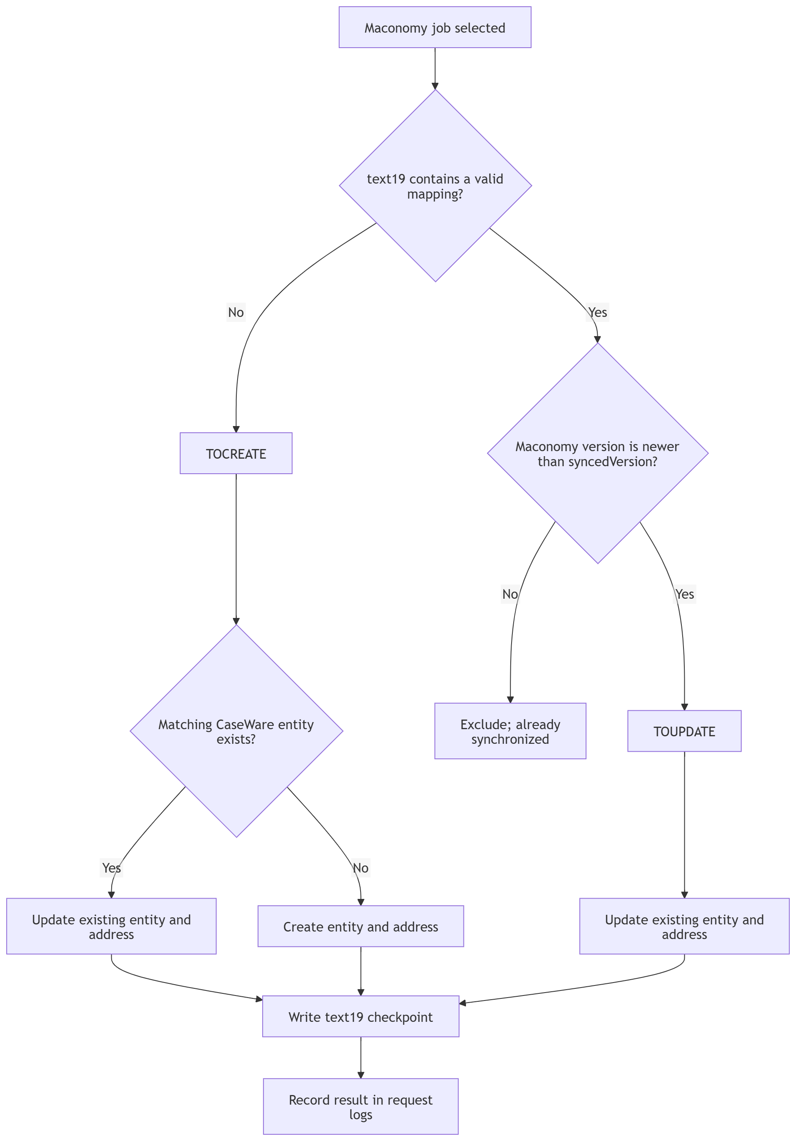

New job or missing CaseWare entity
For a `TOCREATE` job, the integration searches CaseWare using the job number:
EntityNo = VSKY-{Maconomy job number}

If no matching entity exists, the integration creates the CaseWare entity and its first address. The address is then read back so both the numeric address number and address `CWGuid` can be saved in Maconomy.
The entity uses the Maconomy job name and standard integration values. The address uses the Maconomy name, street, city, country, and postal information.
After successful creation, the Maconomy `text19` field contains the mapping:
{
"entityId": "CaseWare entity CWGuid",
"entityNo": "VSKY-job number",
"syncedVersion": "Maconomy version after text19 write",
"addressId": "CaseWare address CWGuid",
"addressNo": "CaseWare address Id",
"lastUpdateOnUTC": "UTC timestamp"
}

The response action is `CREATED`.

Existing CaseWare entity
If the CaseWare entity already exists, the integration does not create a duplicate. It immediately updates the CaseWare entity with the latest Maconomy job data. It then updates the existing address or creates an address when the entity has none.
The entity and address identifiers are written to Maconomy only after the CaseWare data is current. The response action is `TOUPDATE`, identifying the update workflow that was completed.
CaseWare Cloud is accessed through its entity and address APIs; no CaseWare Cloud user-interface screenshot is required for this integration.

Maconomy updates
When `text19` already contains a mapping and the Maconomy version is newer than `syncedVersion`, the integration updates the mapped CaseWare entity and address.
The Maconomy version is checked again immediately before writing `text19`. This prevents a newer Maconomy change from being overwritten. The checkpoint is stored as a stringified JSON value because `text19` is a string field.
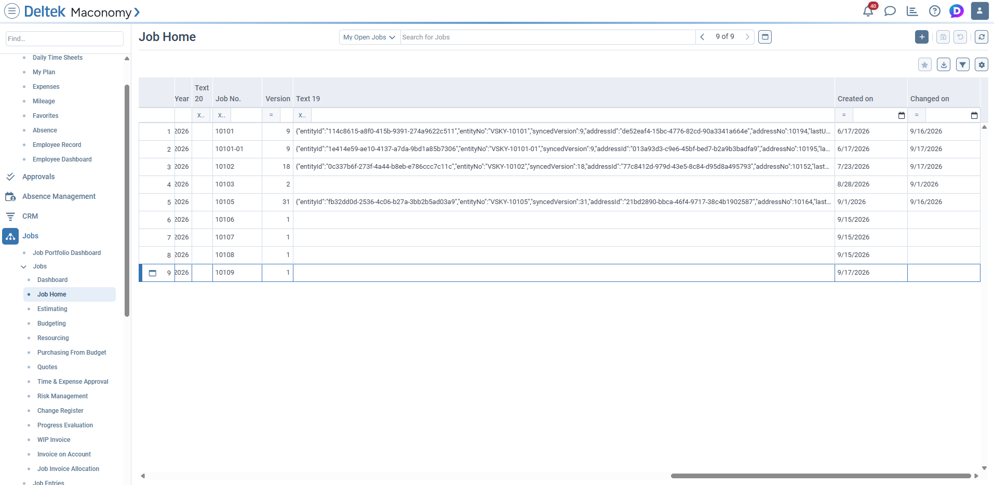
Maconomy jobs list showing text19 mappings
After CaseWare synchronization, the Maconomy jobs list shows the stringified JSON checkpoint in the `Text 19` column. This contains the CaseWare entity and address identifiers used by later update runs.
Writing `text19` increases the Maconomy version by one. The integration stores the corresponding synchronized version so the next scheduler run can exclude the job until Maconomy reports another change.

Authentication and reliability
Maconomy and CaseWare authentication tokens are reused for up to 29 minutes, within their 30-minute lifetime. This avoids logging in separately for every job.
CaseWare rate-limit responses are retried using the server's `Retry-After` value, or a bounded 2, 4, and 8 second backoff when that value is unavailable. Each job is processed independently. If one job fails, its error is returned and recorded while the remaining jobs continue.

Status and troubleshooting
At the end of a synchronization request, the integration records:
- One status row for each processed job.
- One summary row for the complete request.
- The request ID, job number, action, status, message, Maconomy version, and
checkpoint details.
Typical outcomes are:
Outcome | Meaning
`CREATED` | CaseWare entity and address were created and mapped.
`TOUPDATE` | CaseWare data was updated using the Maconomy job.
`FAILED` | The job could not complete; review the error and request log.

The logs are used for support and troubleshooting only. They do not control whether a job is synchronized.

Support sequence
When investigating a job, support can review the following in order:
- Confirm the integration service is active.
- Check the Maconomy job's `versionnumber` and `text19`.
- Check the CaseWare entity using `entityId` or `entityNo`.
- Check the CaseWare address using `addressId` or `addressNo`.
- Review the request and job status logs using the request ID.

