Red LED

Green LED

3 Dials to enter password

Password switch

*Figure 1 Front view*

Flap to access the arming interface

power source

Figure 2 Side view

The intrusion alarm system uses the 3-digits password system using dials and hidden control interface to provide additional security. The system will start the alarm whenever the lid is opened, or the box is lifted from the surface without the correct password entered. When the alarm is started the red will flash on and off and the system will make a sound to indicate that someone has tried to access the alarm.

Please use provided USB cable to connect intrusion alarm to a power source.

**Activating the alarm:** To activate the alarm system, lift the flap (side of the box) and push the switch labelled as “Activate” for 2 seconds. (Please make sure that password switch is off) After 2 seconds, the activate button will slide up inside the box (you will not be able to see the buttons) The green LED should light up indicating that the system is activated.

**Opening the box:** To open the box, and disable the alarm, please enter the password 224 using the dials, and turn on the password switch. (match the digits on the dials with the indicator)

To enter number 2

* If the wrong password is entered, the red LED will light up.
* If the correct password is entered, the system will be disabled, and all LEDs will turn off.
* If the box is opened or lifted while the password switch is off or wrong password is entered, the alarm will activate.

**To disable the intrusion alarm**, please enter the correct password using dial and make sure that password switch is on. When the correct password is entered, the motor inside the system, will bring back the “Activate” and “disable” buttons in the initial place. After that, please open the flap and push the “disable” button for 3 seconds. When the button is placed, the system should turn off all LEDs, and there will be no sound coming out of the speaker.

Intrusion Alarm: Part List

|  |  |
| --- | --- |
| Main Components | Pin Label |
| PICAXE 20M2+ | Not applicable |
| Red LED | c.1 |
| Green LED | B.3 |
| Lever switch | C.6 |
| Normally closed push button switch | C.2 |
| Push button switch (activate alarm) | B.4 |
| Push button switch (disable alarm) | B.6 |
| Speaker | C.4 |
| Toggle switch | C.0 |
| Potentiometer x 3 | B.0, B.1, B.2 |
| Servo | B.5 |
| 22kΩ resistor | Not applicable |
| 10kΩ resistor x 6 | Not applicable |
| 330Ω resistor x 3 | Not applicable |
| Breadboard, USB cable, masking tape, wire, breadboard power module, etc. | Not applicable |

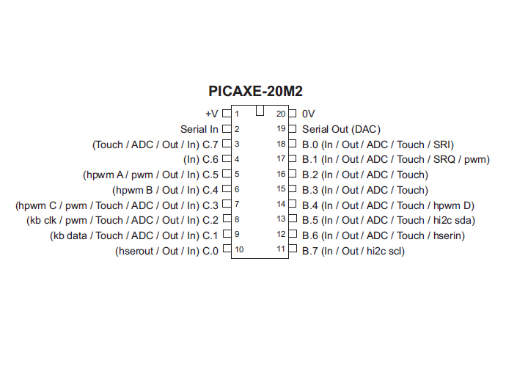

Figure 4: Datasheet for PICAXE -20M2 Microcontroller

Project #1 Building an Intrusion Alarm

Vrajang Parikh

TEJ4M1

Mr. Boehm

31 May 2019