RAPIDFIRE: TERMINAL OVERLAY
AND UNIFIED DEVELOPER
ENVIRONMENT FOR STACK
SCAFFOLDING AND DEVOPS
AUTOMATION
PROJECT SYNOPSIS
OF MINI PROJECT
BACHELOR OF TECHNOLOGY
Computer Science & Engineering

SUBMITTED BY  Vedansh Shrivastava (Roll No. 321)  Vaishnavi Sahu (Roll No. 319)  Tanwi Gupta (Roll No. 311)  Tanmay Mittal (Roll No. 309) | UNDER THE SUPERVISION OF  Ms. Ruchika  Assistant Professor / Project Guide  Department of Computer Science & Engineering
Class: CSE-2A | Batch: 2025–2029 | Second Year (3rd Semester)
Greater Noida Institute of Technology, Greater Noida
Dr. A.P.J. Abdul Kalam Technical University, Lucknow
October 2026

TABLE OF CONTENTS
Section | Title / Topic | Page
— | Title Page | 1
— | Table of Contents | 2
— | Notations and Nomenclature | 2
1.0 | INTRODUCTION | 3
1.1 | Background, Context and Motivation | 3
1.2 | Problem Definition: Setup Latency and Credential Exposure | 3
1.3 | Persistent PTY Shell Overlay and Command Routing | 4
1.4 | Deterministic Scaffolding and Offline Recipes | 4
1.5 | DevSecOps Guardrails: Pre-Push Secret Interception | 5
1.6 | In-Terminal AI Assistance and Workspace Presets | 5
1.7 | Technical Terms and Nomenclature | 5
2.0 | LITERATURE REVIEW | 6
2.1 | Review of Contemporary Developer Tools | 6
2.2 | Credential Protection and AI Assistance | 6
2.3 | Comparative Evaluation of Developer Toolchains | 7
2.4 | Identified Research Gaps | 7
3.0 | OBJECTIVES OF THE PROJECT | 8
3.1 | Primary Technical Objectives | 8
3.2 | Engineering and Usability Objectives | 8
3.3 | Scope and Project Boundaries | 8
4.0 | METHODOLOGY / PLANNING OF WORK | 9
4.1 | System Architecture and Data Flow Pipeline | 9
4.2 | Phased Development and Planning of Work | 9
4.3 | Verification and Quality Assurance | 9
5.0 | REFERENCES | 10
NOTATIONS AND NOMENCLATURE
PTY — Pseudoterminal; REPL — Read-Eval-Print Loop; CORS — Cross-Origin Resource Sharing; LLM — Large Language Model; API — Application Programming Interface.
1.0 INTRODUCTION
1.1 Background, Context and Motivation
Setting up a full-stack app means more than writing frontend and backend code. Developers also have to set up package managers, virtual environments, CORS, Git repositories, and arrange for hosting and deployment, often across various terminals and services, so that even a small app can take time to set up. This effort builds on foundations provided by UNIX process interfaces [1] and component-oriented software design [2].
RapidFire CLI brings these tasks into the terminal developers already use. It keeps access to the native shell while adding connected project scaffolding, Git and GitHub operations, pre-push credential checks, AI assistance, and reusable workspace presets. The aim is to make setup and daily development less repetitive without replacing the familiar shell.
1.2 Problem Definition: Setup Latency and Credential Exposure
Rushing through project setup can lead to security mistakes. A full-stack app may use API keys, database connection strings, or access tokens, often stored in environment files. If too many files are staged at once, sensitive information could be pushed to a shared repository by mistake. Secure-coding guidance [3], studies of public GitHub data [4], and research on exposed secrets [5] show why reviewing changes before a push matters.
Credentials are not the only setup problem. Developers may also encounter occupied ports, CORS mismatches, or dependencies installed in the wrong environment. Fixing these issues often requires switching between terminal commands, documentation, and AI tools. RapidFire combines scaffolding and native shell access with installation prompts that require user approval. Gitleaks provides the secret-scanning component of this workflow [6].
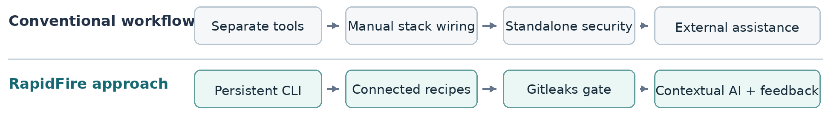
Figure 1. Comparison of fragmented setup tasks with the RapidFire integrated workflow.

1.3 Persistent PTY Shell Overlay and Command Routing
Unlike project generators that create the initial files and then exit, RapidFire remains open as a shell-passthrough REPL. Its node-pty bridge connects to the host shell, including Bash, Zsh, PowerShell, or Command Prompt. The design draws on established work in continuous delivery [7], Node.js concurrency [8], and Unix system architecture [9].
RapidFire routes built-in operations such as setup, ask, suggest, push, preset, and deploy through its own command handler. Other commands, including cd, npm test, and Python scripts, are passed to the native shell. This allows developers to use both types of commands in one session while retaining interactive terminal behaviour and the current working directory.
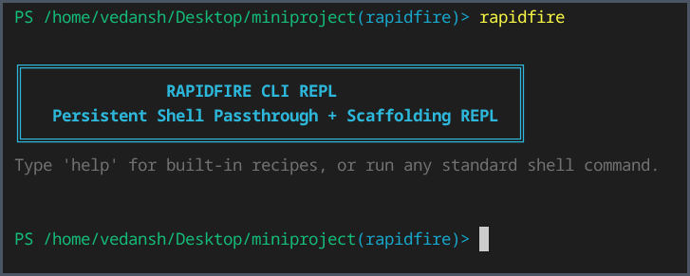
Figure 2. Actual RapidFire CLI REPL launch in a terminal session.
1.4 Deterministic Scaffolding and Offline Recipes
RapidFire currently offers thirteen scaffolding recipes: eight connected frontend-backend combinations, three standalone frontends, and two standalone backends. Supported technologies include React, Vue, Svelte, FastAPI, Django, Flask, and Express.js. For example, setup react+fastapi prepares a React/Vite frontend alongside a FastAPI backend.
Recipes configure ports, CORS and produce a project manifest named .rapidfire.json. Recipes that run with Python may set up a separate virtual environment. Local fallback templates may generate project files without pulling a remote template, though the process of installing dependencies may require an internet connection or a cached dependency.

1.5 DevSecOps Guardrails: Pre-Push Secret Interception
RapidFire adds Gitleaks checks [6] to the local Git workflow. During scaffolding, it can initialise a repository and install a pre-push hook. Its push operation brings together staging, commit preparation, secret scanning, and GitHub synchronisation. If Gitleaks finds a possible credential, the push is stopped so the developer can investigate. Otherwise, GitHub CLI can help connect a remote repository and push the changes. This adds a safeguard against accidentally sharing credentials.
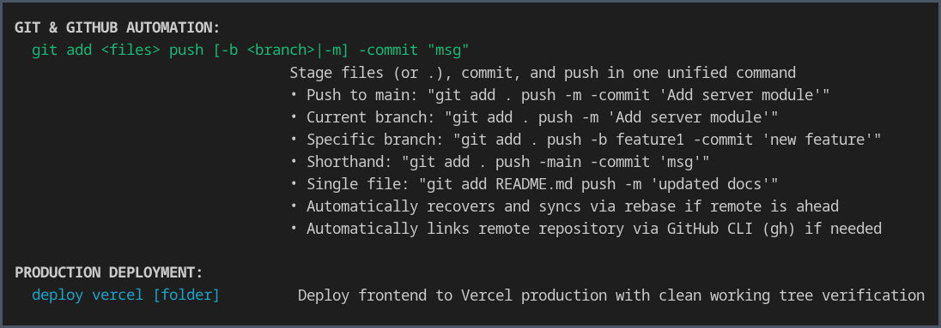
Figure 3. Actual CLI help showing Git and GitHub automation and Vercel deployment.
1.6 In-Terminal AI Assistance and Workspace Presets
RapidFire provides ask, suggest, explain, and tell commands to help with coding questions related to the active project. When using Gemini, Groq, or a local Ollama model, it can provide context from recent terminal errors, package manifests, and .rapidfire.json. Proposed dependency-installation commands are checked and require user approval before execution. Research on language models trained for code [10] informs this feature, although generated suggestions still need review.
With preset save and preset load, developers can store a project's basic structure and restore it later. Presets keep selected files and metadata but leave out large or temporary directories such as node_modules, Python virtual environments, and .git. This makes it easier to recreate a workspace or share its structure with a team.
1.7 Technical Terms and Nomenclature
A PTY is the pseudoterminal bridge between RapidFire and the native shell.
A REPL is the interactive session where users enter commands and see results.
CORS controls cross-origin web requests; DevSecOps adds security checks.
Gitleaks scans repositories for possible exposed credentials.
The .rapidfire.json manifest stores generated project settings.
Other abbreviations appear in Notations and Nomenclature on page 2.

2.0 LITERATURE REVIEW
2.1 Review of Contemporary Developer Tools
Developer tools help at different stages of application setup. Yeoman and Cookiecutter offer reusable project templates, while Vite helps create frontend projects. These tools save time, but developers may still need to connect a backend, configure CORS, choose ports, and prepare other services themselves. Coordination becomes harder as more components are added. Research on useful code-review feedback [11] also highlights the importance of giving developers information they can act on.
Tools such as tmux and GNU screen keep terminal sessions running and help manage several processes. However, they are not intended to connect frontend and backend services or scan Git changes for secrets. Other terminal utilities focus on prompts, command discovery, and interaction. RapidFire builds on a persistent shell session by adding project setup and development tasks. Its Git workflows follow practices described in Pro Git [12].
2.2 Credential Protection and AI Assistance
Secret-scanning tools such as Gitleaks [6] and TruffleHog can flag possible credentials in source files and repository history. These checks can run through Git hooks or continuous-integration pipelines, but they need to be configured and maintained. RapidFire aims to add a pre-push hook during scaffolding so that secret checking becomes part of the normal workflow rather than an extra step to remember.
AI command-line assistants can explain errors and suggest commands, but developers still need to decide whether the advice is safe and relevant. RapidFire uses current terminal context to provide help and pairs it with a dependency installer that asks for confirmation before running supported commands. This is intended to make assistance practical while keeping the developer in control.
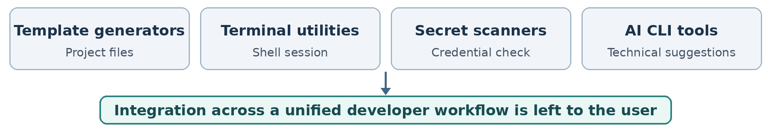
Figure 4. Tool categories reviewed in the literature and their integration gap.

2.3 Comparative Evaluation of Developer Toolchains
Table 1. Qualitative comparison of developer workflow tools
Tool / category | Established contribution | Remaining integration requirement
Yeoman, Cookiecutter and Vite | Automate generation of individual project templates. | Connecting frontend and backend services and configuring CORS may require extra steps.
tmux and GNU screen | Maintain multiple shell sessions and terminal processes. | Do not provide connected scaffolding or integrated secret scanning.
Gitleaks and Git hooks | Identify potential credentials before or during code sharing. | Protection depends on the developer configuring and maintaining the checks.
AI command-line assistants | Provide contextual explanations and suggested development commands. | Validation, package installation and project-state handling may require other tools.
2.4 Identified Research Gaps
The tools reviewed above leave a practical gap between generating a project and continuing development. Project generators usually stop after creating the template, while terminal utilities, security scanners, and AI assistants run separately. Developers must still connect application components, configure checks, and move information between tools. REST architectural principles [13] help explain how networked parts of an application can communicate.
RapidFire aims to reduce this separation by combining native shell access, connected scaffolding, pre-push checks, and contextual AI support in one session. This is a qualitative comparison of workflows, not a claim that RapidFire outperforms every existing tool.
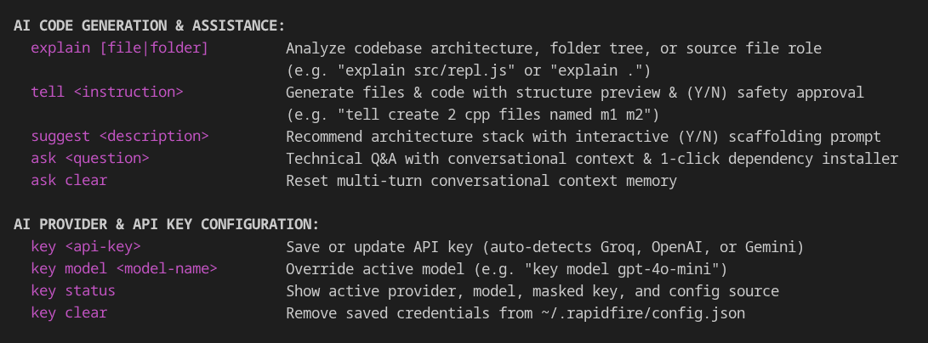
Figure 5. Actual CLI help showing AI assistance commands and provider configuration.
3.0 OBJECTIVES OF THE PROJECT
The goal of RapidFire is to make common full-stack development tasks easier to manage from one local terminal. It focuses on reducing repeated setup work, preserving everyday shell use, and adding safeguards to repository operations.
3.1 Primary Technical Objectives
• Persistent terminal overlay: Develop a node-pty-based REPL that handles RapidFire commands while preserving native shell use, interactive output, and the working directory.
• Connected scaffolding engine: Provide thirteen frontend, backend, and combined recipes with suitable ports, CORS configuration, and Python environments where needed.
• Pre-push security inspection: Use Gitleaks in the local Git workflow to flag suspected credentials and stop a push before sensitive information is shared.
• Contextual AI dependency assistance: Use terminal errors and project files to inform AI suggestions, check installation commands, and ask for approval before execution.
3.2 Engineering and Usability Objectives
• Git and GitHub automation: Simplify staging, commits, branch selection, remote repository linking, and pushing through Git and GitHub CLI.
• Workspace reproducibility: Store project settings in .rapidfire.json and provide JSON presets to save and restore project structures.
• Provider flexibility: Allow users to choose supported cloud AI providers or a local model according to the available runtime.
3.3 Scope and Project Boundaries
RapidFire focuses on local development tasks such as scaffolding, native shell commands, controlled package installation, Git-related security checks, and optional frontend deployment through Vercel CLI. Cloud AI requests need internet access and send selected project context to the provider. Using a local Ollama model can avoid sending that context to an external service. Generated applications may still require dependency downloads, further testing, and production hardening.
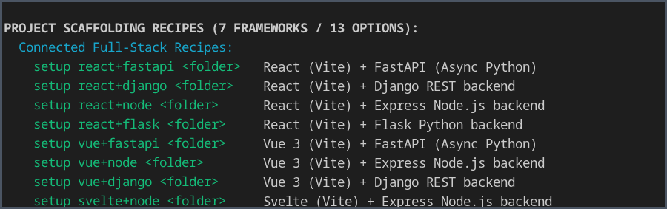
Figure 6. Actual help output showing the connected project-scaffolding recipes.

4.0 METHODOLOGY / PLANNING OF WORK
4.1 System Architecture and Data Flow Pipeline
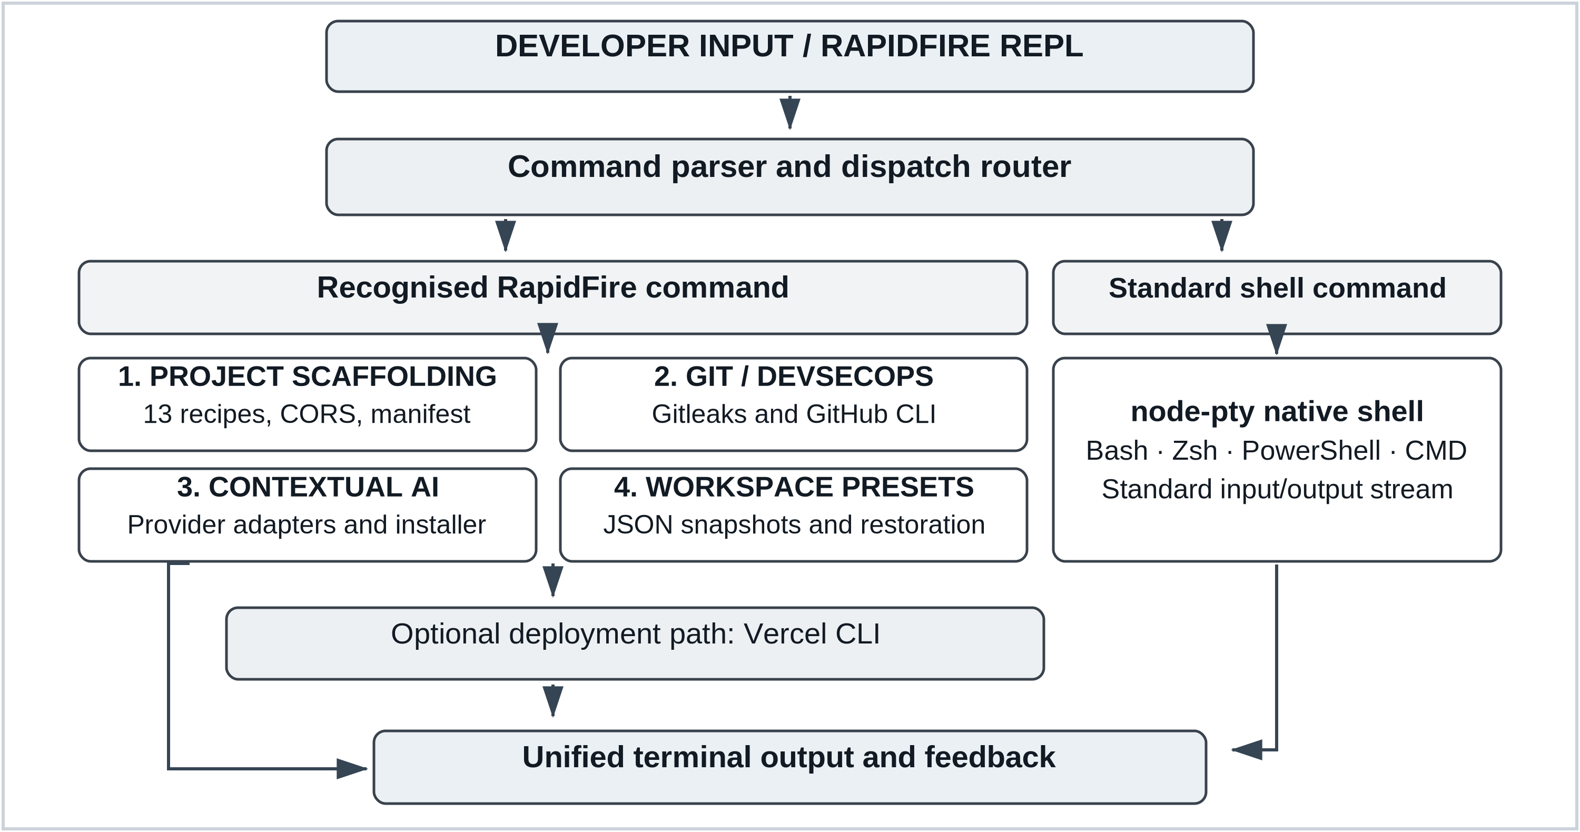
Figure 7. RapidFire CLI execution architecture, four core engines and optional Vercel deployment.
4.2 Phased Development and Planning of Work
Table 2. Work Breakdown Structure and Development Milestone Schedule
Phase | Milestone | Key technical deliverables | Duration
Phase 1 | Core terminal | Literature review, node-pty integration and REPL shell passthrough. | Weeks 1–3
Phase 2 | Project recipes | Thirteen scaffolds, CORS defaults, manifests and Python environments. | Weeks 4–7
Phase 3 | Git and security | Gitleaks pre-push checks, GitHub CLI and push recovery. | Weeks 8–10
Phase 4 | AI and presets | Provider adapters, approved dependency installation and JSON presets. | Weeks 11–13
Phase 5 | Validation | Recipe, shell and security tests; cross-platform checks and release. | Weeks 14–16
4.3 Verification and Quality Assurance
Verification will check whether standard commands pass through to the native shell and whether all thirteen scaffolding recipes create projects with appropriate ports and CORS settings. It will also test how the tool responds to sample credentials, restores workspaces, handles Vercel CLI deployment, and operates on supported host systems. The testing plan follows ISO/IEC/IEEE 29119-2:2021 [14].

5.0 REFERENCES
[1] W. R. Stevens and S. A. Rago, Advanced Programming in the UNIX Environment, 3rd ed. Boston, MA, USA: Addison-Wesley, 2013.
[2] E. Gamma, R. Helm, R. Johnson, and J. Vlissides, Design Patterns: Elements of Reusable Object-Oriented Software. Reading, MA, USA: Addison-Wesley, 1994.
[3] M. Howard and D. LeBlanc, Writing Secure Code, 2nd ed. Redmond, WA, USA: Microsoft Press, 2003.
[4] E. Kalliamvakou, G. Gousios, K. Blincoe, L. Singer, D. M. German, and D. Damian, “The promises and perils of mining GitHub,” in Proc. 11th Working Conf. Mining Software Repositories (MSR), Hyderabad, India, 2014, pp. 92–101, doi: 10.1145/2597073.2597074.
[5] M. Meli, M. R. McNiece, and B. Reaves, “How Bad Can It Git? Characterizing Secret Leakage in Public GitHub Repositories,” in Proc. 26th Annu. Netw. Distrib. Syst. Secur. Symp. (NDSS), San Diego, CA, USA, 2019, doi: 10.14722/ndss.2019.23418.
[6] Gitleaks, “Gitleaks: Detect and prevent hardcoded secrets,” GitHub repository. [Online]. Available: https://github.com/gitleaks/gitleaks
[7] J. Humble and D. Farley, Continuous Delivery: Reliable Software Releases through Build, Test, and Deployment Automation. Boston, MA, USA: Addison-Wesley, 2010.
[8] S. Tilkov and S. Vinoski, “Node.js: Using JavaScript to build high-performance network programs,” IEEE Internet Comput., vol. 14, no. 6, pp. 80–83, Nov.–Dec. 2010, doi: 10.1109/MIC.2010.145.
[9] D. Spinellis and P. Avgeriou, “Evolution of the Unix System Architecture: An Exploratory Case Study,” IEEE Trans. Softw. Eng., vol. 47, no. 6, pp. 1134–1163, Jun. 2021, doi: 10.1109/TSE.2019.2892149.
[10] M. Chen et al., “Evaluating large language models trained on code,” arXiv:2107.03374, 2021.
[11] A. Bosu, M. Greiler, and C. Bird, “Characteristics of Useful Code Reviews: An Empirical Study at Microsoft,” in Proc. IEEE/ACM 12th Working Conf. Mining Software Repositories (MSR), Florence, Italy, 2015, pp. 146–156, doi: 10.1109/MSR.2015.21.
[12] S. Chacon and B. Straub, Pro Git, 2nd ed. New York, NY, USA: Apress, 2014.
[13] R. T. Fielding, “Architectural styles and the design of network-based software architectures,” Ph.D. dissertation, Univ. of California, Irvine, CA, USA, 2000.
[14] ISO/IEC/IEEE 29119-2:2021, Software and systems engineering — Software testing — Part 2: Test processes, 2nd ed., Oct. 2021.

