RAPIDFIRE: TERMINAL OVERLAY
AND UNIFIED DEVELOPER
ENVIRONMENT FOR STACK
SCAFFOLDING AND DEVOPS
AUTOMATION
PROJECT SYNOPSIS
OF MINI PROJECT
BACHELOR OF TECHNOLOGY
Computer Science & Engineering

SUBMITTED BY  Vedansh Shrivastava (Roll No. 321)  Vaishnavi Sahu (Roll No. 319)  Tanwi Gupta (Roll No. 311)  Tanmay Mittal (Roll No. 309) | UNDER THE SUPERVISION OF  Ms. Ruchika  Assistant Professor / Project Guide  Department of Computer Science & Engineering
Class: CSE-2A | Batch: 2025–2029 | Second Year (3rd Semester)
Greater Noida Institute of Technology, Greater Noida
Dr. A.P.J. Abdul Kalam Technical University, Lucknow
October 2026

TABLE OF CONTENTS
Section | Title / Topic | Page
— | Title Page | 1
— | Table of Contents | 2
— | Notations and Nomenclature | 2
1.0 | INTRODUCTION | 3
1.1 | Background, Context and Motivation | 3
1.2 | Problem Definition: Setup Latency and Credential Exposure | 3
1.3 | Persistent PTY Shell Overlay and Command Routing | 4
1.4 | Deterministic Scaffolding and Offline Recipes | 4
1.5 | DevSecOps Guardrails: Pre-Push Secret Interception | 5
1.6 | In-Terminal AI Assistance and Workspace Presets | 5
1.7 | Technical Terms and Nomenclature | 5
2.0 | LITERATURE REVIEW | 6
2.1 | Review of Contemporary Developer Tools | 6
2.2 | Credential Protection and AI Assistance | 6
2.3 | Comparative Evaluation of Developer Toolchains | 7
2.4 | Identified Research Gaps | 7
3.0 | OBJECTIVES OF THE PROJECT | 8
3.1 | Primary Technical Objectives | 8
3.2 | Engineering and Usability Objectives | 8
3.3 | Scope and Project Boundaries | 8
4.0 | METHODOLOGY / PLANNING OF WORK | 9
4.1 | System Architecture and Data Flow Pipeline | 9
4.2 | Phased Development and Planning of Work | 9
4.3 | Verification and Quality Assurance | 9
5.0 | REFERENCES | 10
NOTATIONS AND NOMENCLATURE
PTY — Pseudoterminal; REPL — Read-Eval-Print Loop; CORS — Cross-Origin Resource Sharing; LLM — Large Language Model; API — Application Programming Interface.
1.0 INTRODUCTION
1.1 Background, Context and Motivation
Starting a full-stack project takes more work than simply writing a frontend and a backend. Before the first feature can be tested, a developer may have to install packages, create a Python environment, set up Git, choose ports and make sure the browser can communicate with the server. Deployment adds another set of steps. It is easy to lose time moving between terminals and setup guides, especially when building a small project. UNIX process handling [1] and modular software design [2] offer a useful starting point for organising these tasks.
RapidFire CLI is our attempt to bring the most common of these steps into one place. It works inside a normal terminal instead of replacing it with an unfamiliar interface. Alongside regular shell commands, it offers project templates, Git and GitHub support, checks for exposed credentials, AI-based help and saved workspace presets. The goal is straightforward: spend less time repeating setup commands and more time working on the application itself.
1.2 Problem Definition: Setup Latency and Credential Exposure
Speed is not the only concern during setup. Projects often contain API keys, database URLs and access tokens, usually kept in environment files. A developer who runs a broad Git staging command might accidentally include one of these files in a commit. Once a secret reaches a shared repository, removing the file alone may not be enough. Secure-coding recommendations [3] and studies of GitHub repositories [4], [5] make a strong case for checking files before they are pushed.
There are also everyday configuration problems. For example, the frontend may call the wrong backend port, CORS rules may block a request, or a Python package may be installed outside the project's virtual environment. Solving each issue separately means switching between commands, documentation and support tools. RapidFire tries to keep those tasks together without taking away normal shell access. It also asks for approval before running suggested installation commands, while Gitleaks [6] checks for possible secrets in the Git workflow.
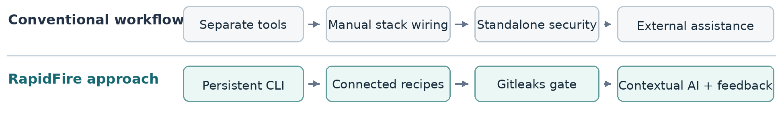
Figure 1. Comparison of fragmented setup tasks with the RapidFire integrated workflow.

1.3 Persistent PTY Shell Overlay and Command Routing
A typical scaffolding tool finishes after creating the project folder. RapidFire takes a different approach: the terminal session stays open, so the developer can carry on working immediately. It uses node-pty to connect its REPL to the system shell, including Bash, Zsh, PowerShell or Command Prompt, depending on the computer. This design is consistent with ideas from continuous delivery [7], Node.js programming [8] and the UNIX system architecture [9].
The command router first checks whether an instruction belongs to RapidFire. Commands such as setup, ask, suggest, push, preset and deploy are handled by its own features. Everything else, including cd, npm test or a Python command, is passed to the underlying shell. In practice, a developer can create an application and then run normal commands in the same window, with the working directory and interactive output kept intact.
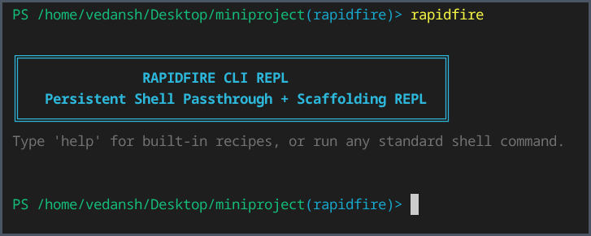
Figure 2. Actual RapidFire CLI REPL launch in a terminal session.
1.4 Deterministic Scaffolding and Offline Recipes
RapidFire offers thirteen project recipes at present: eight full-stack combinations, three frontend-only options and two backend-only options. They cover React, Vue, Svelte, FastAPI, Django, Flask and Express.js. A command such as setup react+fastapi, for example, creates a React frontend using Vite and a FastAPI backend. This avoids having to assemble the two parts separately every time.
The templates also handle some of the configuration that is easy to forget. They assign suitable ports, prepare CORS settings and save project details in a .rapidfire.json file. Python-based setups get their own virtual environment. RapidFire includes local fallback templates, so the basic folder structure can be created without downloading a template. However, installing new packages may still need an internet connection unless those packages are already cached.

1.5 DevSecOps Guardrails: Pre-Push Secret Interception
Accidentally sharing credentials is a risk even in a small project. RapidFire can initialise Git and add a Gitleaks pre-push hook during setup. Its push command groups staging, commit preparation, secret scanning and GitHub synchronisation. If Gitleaks detects a suspected token or password, the push stops until the user checks it. Otherwise, GitHub CLI can help link the remote repository and upload the changes. The scan is not a replacement for reviewing code, but it adds one more check before a mistake becomes public.
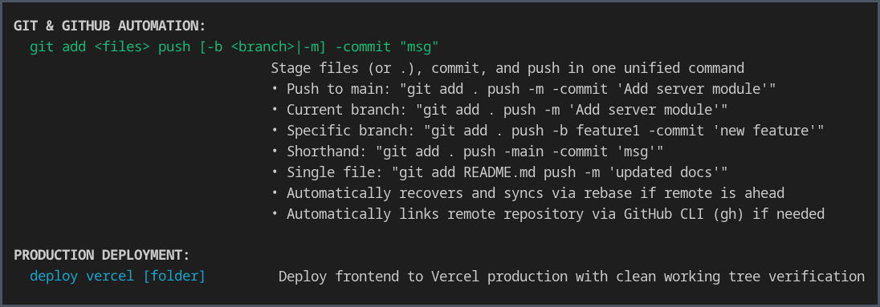
Figure 3. Actual CLI help showing Git and GitHub automation and Vercel deployment.
1.6 In-Terminal AI Assistance and Workspace Presets
The commands ask, suggest, explain and tell offer help while the developer is coding. For context, RapidFire can include terminal errors, package details and information from .rapidfire.json in requests to Gemini, Groq or a local Ollama model. If the response suggests installing a package, the tool checks that command and asks the user to approve it. Research on language models for code [10] informs this approach, but an AI suggestion still needs to be checked rather than followed blindly.
The preset commands help when a similar project is needed again. preset save stores the basic file structure and metadata, and preset load restores them. Large or temporary directories such as node_modules, .git and Python virtual environments are excluded. This keeps presets small enough to reuse or share without copying installed dependencies.
1.7 Technical Terms and Nomenclature
PTY means pseudoterminal. RapidFire uses it to communicate with the computer's real shell.
REPL is the command loop that stays open, accepts input and shows the result.
CORS controls requests between different web origins. DevSecOps means adding security checks during development, not only at the end.
Gitleaks scans files and Git changes for strings that may contain credentials.
The .rapidfire.json file records configuration details for a RapidFire project.
The other abbreviations are explained in Notations and Nomenclature on page 2.

2.0 LITERATURE REVIEW
2.1 Review of Contemporary Developer Tools
There is no shortage of tools for beginning a software project, but they solve different parts of the problem. Yeoman and Cookiecutter create projects from reusable templates, and Vite provides a quick way to start a frontend. After that, the developer may still need to add a backend, connect the two services, configure CORS and decide which ports to use. That extra work becomes more noticeable as a project grows. Research on code reviews [11] also suggests that developers benefit most from feedback they can turn into clear actions.
Terminal utilities cover another part of the workflow. tmux and GNU screen are useful for keeping sessions running and managing processes, but they do not create a connected application or inspect Git changes for passwords and keys. Some newer command-line tools make prompts and commands easier to use, yet setup and security remain separate tasks. RapidFire combines a persistent shell with project-specific operations, using Git practices discussed in Pro Git [12].
2.2 Credential Protection and AI Assistance
Security tools address a different risk. Gitleaks and TruffleHog look for strings that may be passwords, tokens or other secrets in files and repository history. A team can connect these scanners to Git hooks or a CI pipeline, but someone must set up and maintain those checks. RapidFire is designed to add a Gitleaks pre-push hook during scaffolding, so checking for credentials becomes part of the usual push process rather than something to remember separately.
AI assistants can be helpful when a command fails, but their suggestions are not automatically safe to run. An installation instruction may be unnecessary or unsuitable for the current project. RapidFire uses information from the active terminal session to make the response more relevant. It then checks supported dependency commands and asks for confirmation before executing them. This gives the user help at the point where a problem occurs, while leaving the final decision with the developer.
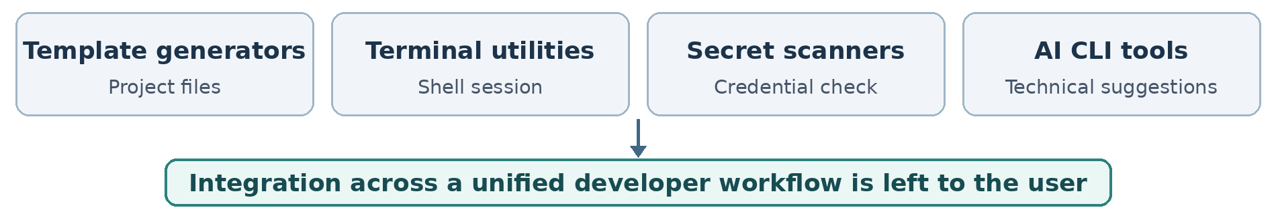
Figure 4. Tool categories reviewed in the literature and their integration gap.

2.3 Comparative Evaluation of Developer Toolchains
Table 1. Qualitative comparison of developer workflow tools
Tool / category | Established contribution | Remaining integration requirement
Yeoman, Cookiecutter and Vite | Create starter projects from reusable templates. | A separate backend, CORS settings and service connections may still need manual work.
tmux and GNU screen | Keep terminal sessions and multiple processes running. | Do not create connected stacks or scan Git changes for secrets.
Gitleaks and Git hooks | Check Git files or changes for possible exposed credentials. | Hooks and scanning rules still have to be set up and maintained.
AI command-line assistants | Explain errors and suggest commands using available context. | Users still need to check suggestions and manage installations and project state.
2.4 Identified Research Gaps
The comparison shows a gap between creating a project and continuing to work on it. Template generators are good at producing starter files, whereas session managers, secret scanners and AI helpers are usually separate tools. The developer is left to connect the application, remember security checks and repeat project details across different interfaces. For applications with frontend and backend services, REST principles [13] are also relevant to how those parts communicate.
RapidFire is aimed at this practical gap. It brings connected templates, standard shell commands, pre-push scanning and project-aware assistance into one terminal session. The comparison is about reducing the number of separate setup steps; it is not evidence that RapidFire is faster or better than every alternative. That would require direct testing.
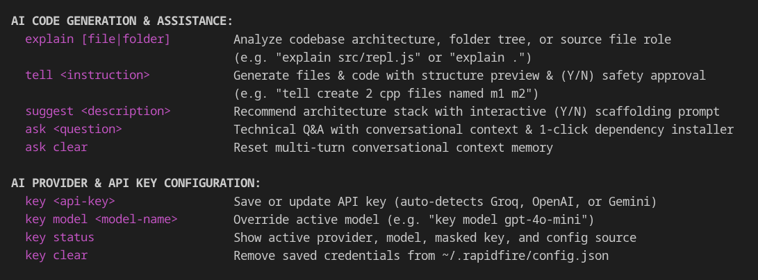
Figure 5. Actual CLI help showing AI assistance commands and provider configuration.
3.0 OBJECTIVES OF THE PROJECT
The aim is to make routine full-stack work easier in one terminal. A developer should be able to create a project, keep using normal shell commands and work with Git without repeatedly switching tools.
3.1 Primary Technical Objectives
• Persistent terminal overlay: Build a node-pty REPL that stays open for RapidFire commands but still lets users run ordinary shell commands, see interactive output and keep their current directory.
• Connected scaffolding engine: Provide thirteen ready-to-use templates for frontend, backend and full-stack projects, including port configuration, CORS settings and Python environments when required.
• Pre-push security inspection: Connect Gitleaks to the Git push process so a suspected API key or other credential is flagged before changes are uploaded.
• Contextual AI dependency assistance: Use recent terminal errors and project files to improve AI suggestions, and require the developer's approval before a suggested package-installation command runs.
3.2 Engineering and Usability Objectives
• Git and GitHub automation: Bring common Git tasks—staging, committing, choosing a branch, connecting a remote and pushing—into a simpler workflow supported by GitHub CLI.
• Workspace reproducibility: Keep generated settings in .rapidfire.json and let users save or reload lightweight JSON presets instead of rebuilding the same workspace from scratch.
• Provider flexibility: Support cloud AI services as well as a local model, so the user can choose a provider that suits the available setup.
3.3 Scope and Project Boundaries
RapidFire mainly covers local development: creating project files, using the native shell, installing approved dependencies, checking Git changes and optionally deploying a frontend with Vercel CLI. Cloud AI services require internet access and receive the project context selected for the request. A local Ollama model can process that context without sending it to a cloud provider. The tool is not a replacement for deployment infrastructure or production checks; generated projects still need dependencies, testing and security review.
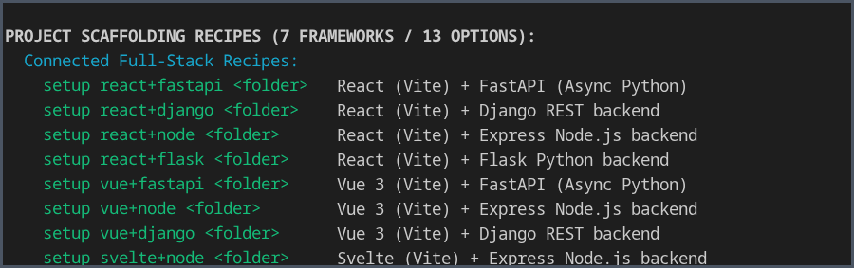
Figure 6. Actual help output showing the connected project-scaffolding recipes.

4.0 METHODOLOGY / PLANNING OF WORK
4.1 System Architecture and Data Flow Pipeline
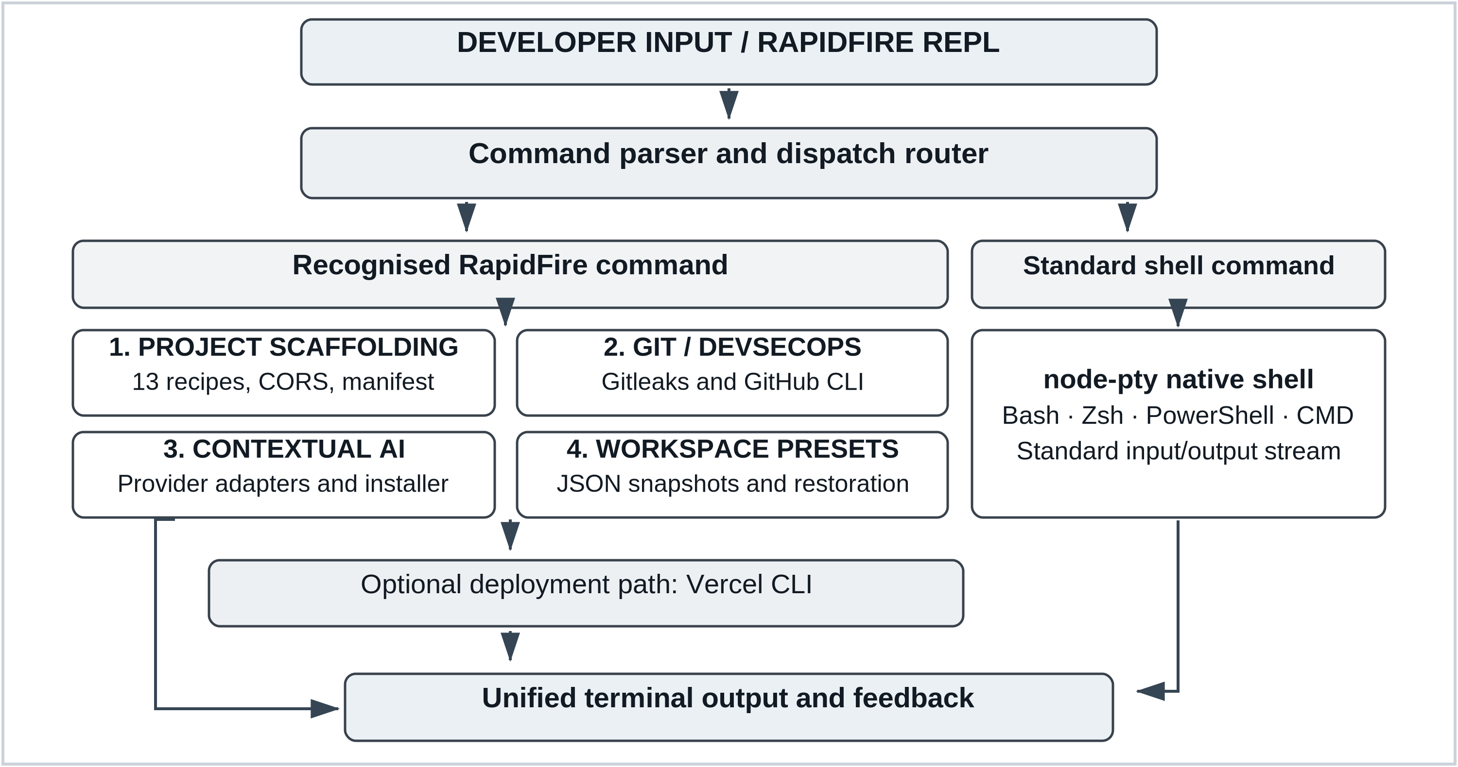
Figure 7. RapidFire CLI execution architecture, four core engines and optional Vercel deployment.
4.2 Phased Development and Planning of Work
Table 2. Work Breakdown Structure and Development Milestone Schedule
Phase | Milestone | Key technical deliverables | Duration
Phase 1 | Core terminal | Literature review, node-pty integration and REPL shell passthrough. | Weeks 1–3
Phase 2 | Project recipes | Thirteen scaffolds, CORS defaults, manifests and Python environments. | Weeks 4–7
Phase 3 | Git and security | Gitleaks pre-push checks, GitHub CLI and push recovery. | Weeks 8–10
Phase 4 | AI and presets | Provider adapters, approved dependency installation and JSON presets. | Weeks 11–13
Phase 5 | Validation | Recipe, shell and security tests; cross-platform checks and release. | Weeks 14–16
4.3 Verification and Quality Assurance
Testing will start with basic terminal behaviour: ordinary shell commands should still run correctly inside RapidFire. Each of the thirteen recipes will then be checked for its folder structure, ports, CORS settings and, where needed, Python environment. We will also test the response to sample credentials, saving and restoring presets, the Vercel CLI path and behaviour on supported operating systems. The test plan will be organised using the process guidance in ISO/IEC/IEEE 29119-2:2021 [14].

5.0 REFERENCES
[1] W. R. Stevens and S. A. Rago, Advanced Programming in the UNIX Environment, 3rd ed. Boston, MA, USA: Addison-Wesley, 2013.
[2] E. Gamma, R. Helm, R. Johnson, and J. Vlissides, Design Patterns: Elements of Reusable Object-Oriented Software. Reading, MA, USA: Addison-Wesley, 1994.
[3] M. Howard and D. LeBlanc, Writing Secure Code, 2nd ed. Redmond, WA, USA: Microsoft Press, 2003.
[4] E. Kalliamvakou, G. Gousios, K. Blincoe, L. Singer, D. M. German, and D. Damian, “The promises and perils of mining GitHub,” in Proc. 11th Working Conf. Mining Software Repositories (MSR), Hyderabad, India, 2014, pp. 92–101, doi: 10.1145/2597073.2597074.
[5] M. Meli, M. R. McNiece, and B. Reaves, “How Bad Can It Git? Characterizing Secret Leakage in Public GitHub Repositories,” in Proc. 26th Annu. Netw. Distrib. Syst. Secur. Symp. (NDSS), San Diego, CA, USA, 2019, doi: 10.14722/ndss.2019.23418.
[6] Gitleaks, “Gitleaks: Detect and prevent hardcoded secrets,” GitHub repository. [Online]. Available: https://github.com/gitleaks/gitleaks
[7] J. Humble and D. Farley, Continuous Delivery: Reliable Software Releases through Build, Test, and Deployment Automation. Boston, MA, USA: Addison-Wesley, 2010.
[8] S. Tilkov and S. Vinoski, “Node.js: Using JavaScript to build high-performance network programs,” IEEE Internet Comput., vol. 14, no. 6, pp. 80–83, Nov.–Dec. 2010, doi: 10.1109/MIC.2010.145.
[9] D. Spinellis and P. Avgeriou, “Evolution of the Unix System Architecture: An Exploratory Case Study,” IEEE Trans. Softw. Eng., vol. 47, no. 6, pp. 1134–1163, Jun. 2021, doi: 10.1109/TSE.2019.2892149.
[10] M. Chen et al., “Evaluating large language models trained on code,” arXiv:2107.03374, 2021.
[11] A. Bosu, M. Greiler, and C. Bird, “Characteristics of Useful Code Reviews: An Empirical Study at Microsoft,” in Proc. IEEE/ACM 12th Working Conf. Mining Software Repositories (MSR), Florence, Italy, 2015, pp. 146–156, doi: 10.1109/MSR.2015.21.
[12] S. Chacon and B. Straub, Pro Git, 2nd ed. New York, NY, USA: Apress, 2014.
[13] R. T. Fielding, “Architectural styles and the design of network-based software architectures,” Ph.D. dissertation, Univ. of California, Irvine, CA, USA, 2000.
[14] ISO/IEC/IEEE 29119-2:2021, Software and systems engineering — Software testing — Part 2: Test processes, 2nd ed., Oct. 2021.

