RAPIDFIRE: TERMINAL OVERLAY
AND UNIFIED DEVELOPER
ENVIRONMENT FOR STACK
SCAFFOLDING AND DEVOPS
AUTOMATION
PROJECT SYNOPSIS
OF MINI PROJECT
BACHELOR OF TECHNOLOGY
Computer Science & Engineering

SUBMITTED BY  Vedansh Shrivastava (Roll No. 321)  Vaishnavi Sahu (Roll No. 319)  Tanwi Gupta (Roll No. 311)  Tanmay Mittal (Roll No. 309) | UNDER THE SUPERVISION OF  Ms. Ruchika  Assistant Professor / Project Guide  Department of Computer Science & Engineering
Class: CSE-2A | Batch: 2025–2029 | Second Year (3rd Semester)
Greater Noida Institute of Technology, Greater Noida
Dr. A.P.J. Abdul Kalam Technical University, Lucknow
October 2026

TABLE OF CONTENTS
Section | Title / Topic | Page
— | Title Page | 1
— | Table of Contents | 2
— | Notations and Nomenclature | 2
1.0 | INTRODUCTION | 3
1.1 | Background, Context and Motivation | 3
1.2 | Problem Definition: Setup Latency and Credential Exposure | 3
1.3 | Persistent PTY Shell Overlay and Command Routing | 4
1.4 | Deterministic Scaffolding and Offline Recipes | 4
1.5 | DevSecOps Guardrails: Pre-Push Secret Interception | 5
1.6 | In-Terminal AI Assistance and Workspace Presets | 5
1.7 | Technical Terms and Nomenclature | 5
2.0 | LITERATURE REVIEW | 6
2.1 | Review of Contemporary Developer Tools | 6
2.2 | Credential Protection and AI Assistance | 6
2.3 | Comparative Evaluation of Developer Toolchains | 7
2.4 | Identified Research Gaps | 7
3.0 | OBJECTIVES OF THE PROJECT | 8
3.1 | Primary Technical Objectives | 8
3.2 | Engineering and Usability Objectives | 8
3.3 | Scope and Project Boundaries | 8
4.0 | METHODOLOGY / PLANNING OF WORK | 9
4.1 | System Architecture and Data Flow Pipeline | 9
4.2 | Phased Development and Planning of Work | 9
4.3 | Verification and Quality Assurance | 9
5.0 | REFERENCES | 10
NOTATIONS AND NOMENCLATURE
PTY — Pseudoterminal; REPL — Read-Eval-Print Loop; CORS — Cross-Origin Resource Sharing; LLM — Large Language Model; API — Application Programming Interface.
1.0 INTRODUCTION
1.1 Background, Context and Motivation
Full stack app setup, however, involves setting up package managers, virtual environments, CORS policies, organizing git repositories, hosting, and deploying. All of those activities often require multiple terminals, services and interactions between those services – even for small projects, setup time can be significant. UNIX process interfaces [1] and component-oriented software design [2] will hopefully inform general principles of abstractions for integrating some of these activities.
Rapid Fire CLI will unify those activities into the terminal you are already used to working with: it will create connected scaffolding, github/git operations, prepush credential verification, AI support, and re-usable workspace presets while maintaining the native shell access. We also hope to take some of the tedium out of the process – setup time and daily routine tasks may be minimized without forcing you out of your familiar environment.
1.2 Problem Definition: Setup Latency and Credential Exposure
Manual environment orchestration introduces substantial cognitive overhead and creates severe security vulnerabilities. When developers rapidly assemble full-stack prototypes, environment files frequently accumulate live database connection strings, JWT signing keys, and cloud API tokens. Staging code using blanket commands like "git add ." risks committing these credentials directly into public version control. Automated scraping networks inspect public GitHub commits in under sixty seconds [4, 5].
Environmental friction extends well beyond leaked credentials. Port collisions, unactivated virtual environments, and missing CORS headers routinely stall development. Finding and fixing these mismatches forces developers to navigate StackOverflow, documentation pages, and external tools. RapidFire eliminates this friction by scaffolding synchronized frontend and backend pairs with pre-configured ports and CORS middleware, while installing pre-push hooks that intercept secrets locally [6].
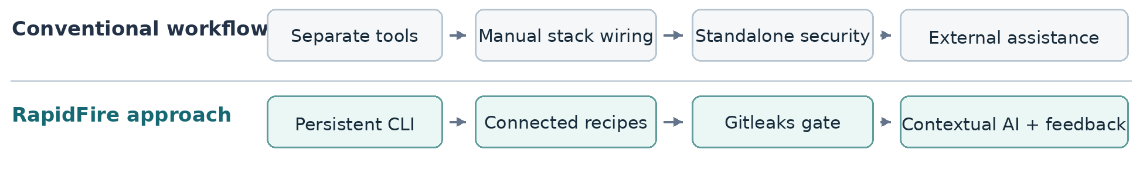
Figure 1. Comparison of fragmented setup tasks with the RapidFire integrated workflow.

1.3 Persistent PTY Shell Overlay and Command Routing
Unlike traditional scaffolding scripts that shut down after generating directory trees, RapidFire persists as an interactive terminal wrapper. Using a node-pty pseudoterminal layer, it binds directly to the user's host shell, supporting Bash, Zsh, PowerShell, or Command Prompt. This architecture builds upon classic principles of continuous delivery pipelines [7], event-driven JavaScript I/O [8], and Unix process control [9].
The built-in command dispatcher intercepts project actions such as setup, ask, suggest, push, preset, and deploy. Any command outside this set—such as directory changes via cd, compilation flags, or local runtime tests—falls through seamlessly to the underlying shell. This ensures developers retain full terminal responsiveness, interactive process input, and current working directory tracking without quitting the session.
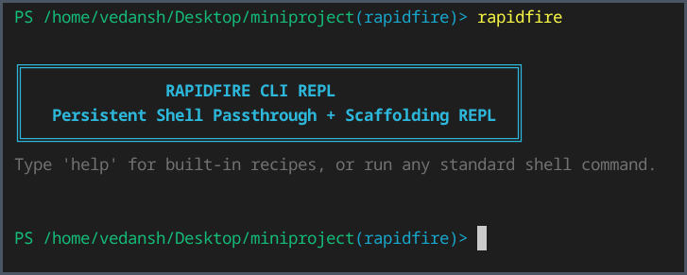
Figure 2. Actual RapidFire CLI REPL launch in a terminal session.
1.4 Deterministic Scaffolding and Offline Recipes
RapidFire provides thirteen deterministic scaffolding templates: eight dual-tier frontend-backend pairings, three client-only setups, and two backend services. Supported frameworks span React, Vue, Svelte, FastAPI, Django, Flask, and Express.js. For instance, invoking setup react+fastapi initializes a Vite React interface paired with an asynchronous FastAPI server.
Every recipe configures non-conflicting port bindings, injects cross-origin CORS headers, and writes a local .rapidfire.json tracking manifest. Python-backed architectures automatically spawn an isolated virtual environment. Offline template fallbacks ensure files generate reliably without active network connections, although third-party dependency installation still relies on package registries or local cache.

1.5 DevSecOps Guardrails: Pre-Push Secret Interception
RapidFire embeds Gitleaks validation directly into local development checkpoints. During stack creation, it configures a Git repository and writes a pre-push hook script. The integrated push routine coordinates file staging, commit generation, secret pattern matching, and GitHub synchronization. If Gitleaks spots an uncommitted token or private key, the push aborts immediately to protect sensitive credentials. If clean, GitHub CLI coordinates remote repository synchronization smoothly.
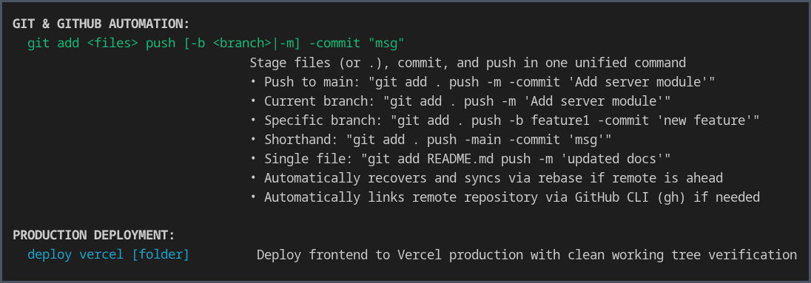
Figure 3. Actual CLI help showing Git and GitHub automation and Vercel deployment.
1.6 In-Terminal AI Assistance and Workspace Presets
RapidFire provides in-terminal AI utilities via ask, suggest, explain, and tell commands to debug errors without leaving the console. To keep prompts relevant, the system extracts recent terminal error lines, dependency manifests, and .rapidfire.json metadata, routing requests to Gemini, Groq, or local Ollama instances. Proposed terminal commands pass through a security validator requiring manual user confirmation ([Y/N]) before execution, aligning with empirical research on code generation safety [10].
Using preset save and preset load, developers can export complete project configurations into lightweight JSON schemas. These blueprints preserve key files and directory hierarchies while excluding bloated artifacts such as node_modules, Python virtual environments, and .git trees. This provides an efficient mechanism for reproducing local workspaces across developer teams.
1.7 Technical Terms and Nomenclature
A PTY represents the pseudoterminal interface linking RapidFire to the host operating system.
A REPL provides an interactive read-eval-print loop where developer commands run continuously.
CORS controls cross-domain browser requests, while DevSecOps embeds automated security checks into local coding workflows.
Gitleaks is a regex scanner detecting hardcoded secrets and API keys within source files.
The .rapidfire.json manifest records selected stack parameters and environment ports for the active workspace.
Additional definitions and abbreviations appear in the Notations and Nomenclature section on page 2.

2.0 LITERATURE REVIEW
2.1 Review of Contemporary Developer Tools
Contemporary software development relies on specialized tools that address isolated segments of the application lifecycle. Project generators such as Yeoman, Cookiecutter, and create-vite automate file generation from template blueprints, significantly reducing initial boilerplate for standalone services. However, these tools terminate immediately after writing files to disk. They leave cross-tier connectivity, runtime dependency isolation, and version control configuration to manual developer intervention [7, 8].
Applications like tmux and GNU screen, are very useful for keeping shell sessions alive and for managing several processes at once. They are not intended to connect frontend and backend services or to scan Git repositories for hidden information. The other developments in terminal capabilities focus on improvements to prompts, command exploration and user interaction. Rapid Fire extends a persistent shell session with project configuration and development activities. Its Git workflows follow Pro Git [12] recommendations.
2.2 Credential Protection and AI Assistance
Secret-scanning tools, including Gitleaks and Truffle Hog, are able to scan for potential credentials in source files and the repository history. These can be run via git hooks or CI pipelines; but they require setup, ongoing review, and adjustment to them to be effective. Rapid Fire is interested in adding a pre-push hook at initial scaffolding time to the project, which suggests secret checking may be an integral part of the project's workflow rather than a one-time task that developers have to remember to perform.
The AI command-line tool can inform on errors, and provide commands to run in response, but it is ultimately up to the developer to decide whether or not the commands are safe or relevant, and in the case of Rapid Fire using the context of the current terminal, and the included dependency installer which asks for confirmation before proceeding with commands it supports.
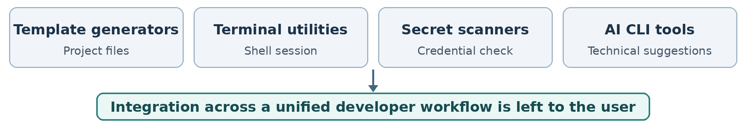
Figure 4. Tool categories reviewed in the literature and their integration gap.

2.3 Comparative Evaluation of Developer Toolchains
Table 1. Qualitative comparison of developer workflow tools
Tool / category | Established contribution | Remaining integration requirement
Yeoman, Cookiecutter and Vite | Generates isolated starter templates for single client or server stacks. | Leaves inter-service port coordination, CORS routing, and Git setup to manual steps.
tmux and GNU screen | Multiplexes terminal sessions and preserves long-running background processes. | Lacks project manifest tracking, multi-tier templates, and secret scanning hooks.
Gitleaks and Git hooks | Scans commits against pattern signatures to catch hardcoded authentication keys. | Requires manual setup per repository; CI scans run only after push.
AI command-line assistants | Offers terminal command advice and conversational error explanations via remote LLMs. | Lacks local file context; can hallucinate risky commands without confirmation.
2.4 Identified Research Gaps
The tools reviewed above leave a practical gap between generating a project and working on it afterwards. A generator often stops when the template has been created, while terminal utilities, security scanners and AI assistants work separately. As a result, developers must still connect application components, set up checks and carry information between tools. REST architectural principles [13] are useful when deciding how networked parts of an application should communicate.
RapidFire is intended to reduce this separation by keeping native shell access, connected scaffolding, pre-push checks and contextual AI support in one session. This is a qualitative comparison of the workflows involved, not a claim that RapidFire performs better than every existing tool
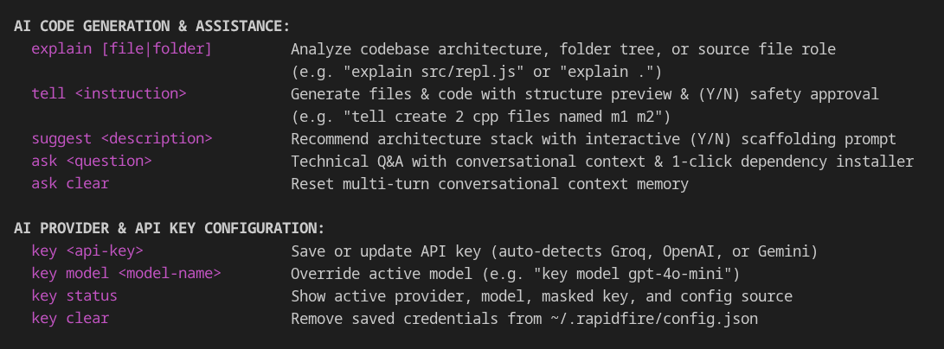
Figure 5. Actual CLI help showing AI assistance commands and provider configuration.
3.0 OBJECTIVES OF THE PROJECT
The primary goal is to enable the execution of typical full-stack development tasks through one unified, locally managed terminal. Rapid Fire focuses on the reduction of setup steps, the preservation of existing shell usage, and the bolstering of repository security.
3.1 Primary Technical Objectives
• The node-pty based REPL is recommended to be developed to enable native shell features, interactive output, and retain current working directory, aside from handling Rapid Fire commands.
• Connected Scaffolding Engine is planned to deliver thirteen frontend, backend and mixed recipes with ports, CORS, and Python environment specified appropriately.
• Pre-push Security Inspection is designed to utilize Gitleaks on the local Git workflow to find and mark potential credentials and prevent malicious exposure.
• Contextual AI Dependency Assistance is designed to utilize terminal errors and project files as evidence for AI responses, validate suggested installation commands and ask permission before executing them.
3.2 Engineering and Usability Objectives
• Git and GitHub automation: The command line and GitHub CLI will probably make it possible to easily stage, commit, select branch, connect remote repo, and push the changes.
• Workspace reproducibility: It is expected that workspace reproducibility will be achieved by storing the generated project setting in a.rapidfire.json file and providing JSON presets for saving and restoring project structure.
• Provider flexibility: The provider flexibility can be seen in the ability to select the supported cloud AI providers or a local model depending on the available runtime.
3.3 Scope and Project Boundaries
Local development work, like scaffolding and native shell commands, controlled package installation, Git security testing, and the option to deploy the frontend with Vercel CLI, is at the core of Rapid Fire. Cloud AI requests also require an internet connection and send the project context to the provider. Using a local Ollama model might not have to send that context elsewhere. However, apps built out with either solution will need more dependencies installed, more testing, and production hardening.
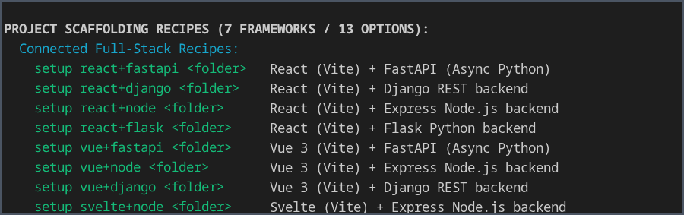
Figure 6. Actual help output showing the connected project-scaffolding recipes.
4.0 METHODOLOGY / PLANNING OF WORK
4.1 System Architecture and Data Flow Pipeline
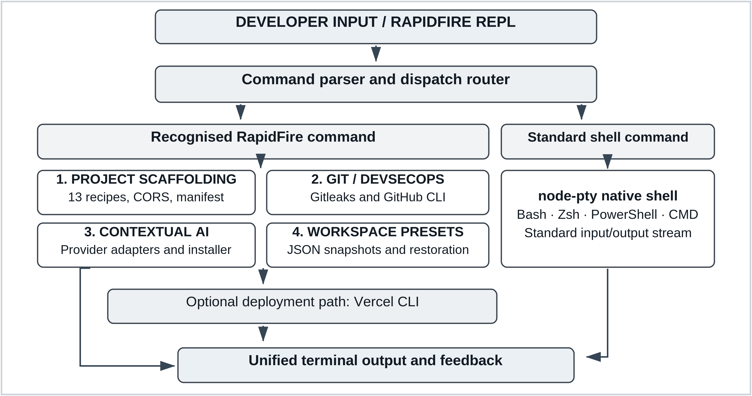
Figure 7. RapidFire CLI execution architecture, four core engines and optional Vercel deployment.
4.2 Phased Development and Planning of Work
Table 2. Work Breakdown Structure and Development Milestone Schedule
Phase | Milestone | Key technical deliverables | Duration
Phase 1 | Core terminal | Literature review, node-pty integration and REPL shell passthrough. | Weeks 1–3
Phase 2 | Project recipes | Thirteen scaffolds, CORS defaults, manifests and Python environments. | Weeks 4–7
Phase 3 | Git and security | Gitleaks pre-push checks, GitHub CLI and push recovery. | Weeks 8–10
Phase 4 | AI and presets | Provider adapters, approved dependency installation and JSON presets. | Weeks 11–13
Phase 5 | Validation | Recipe, shell and security tests; cross-platform checks and release. | Weeks 14–16
4.3 Verification and Quality Assurance
Verification seeks to evaluate how well the commands listed are piped through the "native" shell as well as the other thirteen scaffolding recipes to produce the projects with correct ports and CORS settings. The suite also covers test credential responses, workspace recovery, Vercel CLI deploy, and behavior within supported host systems. The strategy for testing is based on the procedures delineated in ISO/IEC/IEEE 291192:2021 [14].

5.0 REFERENCES
[1] W. R. Stevens and S. A. Rago, Advanced Programming in the UNIX Environment, 3rd ed. Boston, MA, USA: Addison-Wesley, 2013.
[2] E. Gamma, R. Helm, R. Johnson, and J. Vlissides, Design Patterns: Elements of Reusable Object-Oriented Software. Reading, MA, USA: Addison-Wesley, 1994.
[3] M. Howard and D. LeBlanc, Writing Secure Code, 2nd ed. Redmond, WA, USA: Microsoft Press, 2003.
[4] E. Kalliamvakou, G. Gousios, K. Blincoe, L. Singer, D. M. German, and D. Damian, “The promises and perils of mining GitHub,” in Proc. 11th Working Conf. Mining Software Repositories (MSR), Hyderabad, India, 2014, pp. 92–101, doi: 10.1145/2597073.2597074.
[5] M. Meli, M. R. McNiece, and B. Reaves, “How Bad Can It Git? Characterizing Secret Leakage in Public GitHub Repositories,” in Proc. 26th Annu. Netw. Distrib. Syst. Secur. Symp. (NDSS), San Diego, CA, USA, 2019, doi: 10.14722/ndss.2019.23418.
[6] Gitleaks, “Gitleaks: Detect and prevent hardcoded secrets,” GitHub repository. [Online]. Available: https://github.com/gitleaks/gitleaks
[7] J. Humble and D. Farley, Continuous Delivery: Reliable Software Releases through Build, Test, and Deployment Automation. Boston, MA, USA: Addison-Wesley, 2010.
[8] S. Tilkov and S. Vinoski, “Node.js: Using JavaScript to build high-performance network programs,” IEEE Internet Comput., vol. 14, no. 6, pp. 80–83, Nov.–Dec. 2010, doi: 10.1109/MIC.2010.145.
[9] D. Spinellis and P. Avgeriou, “Evolution of the Unix System Architecture: An Exploratory Case Study,” IEEE Trans. Softw. Eng., vol. 47, no. 6, pp. 1134–1163, Jun. 2021, doi: 10.1109/TSE.2019.2892149.
[10] M. Chen et al., “Evaluating large language models trained on code,” arXiv:2107.03374, 2021.
[11] A. Bosu, M. Greiler, and C. Bird, “Characteristics of Useful Code Reviews: An Empirical Study at Microsoft,” in Proc. IEEE/ACM 12th Working Conf. Mining Software Repositories (MSR), Florence, Italy, 2015, pp. 146–156, doi: 10.1109/MSR.2015.21.
[12] S. Chacon and B. Straub, Pro Git, 2nd ed. New York, NY, USA: Apress, 2014.
[13] R. T. Fielding, “Architectural styles and the design of network-based software architectures,” Ph.D. dissertation, Univ. of California, Irvine, CA, USA, 2000.
[14] ISO/IEC/IEEE 29119-2:2021, Software and systems engineering — Software testing — Part 2: Test processes, 2nd ed., Oct. 2021.

