RAPIDFIRE: TERMINAL OVERLAY
AND UNIFIED DEVELOPER
ENVIRONMENT FOR STACK
SCAFFOLDING AND DEVOPS
AUTOMATION
PROJECT SYNOPSIS
OF MINI PROJECT
BACHELOR OF TECHNOLOGY
Computer Science & Engineering

SUBMITTED BY  Vedansh Shrivastava (Roll No. 321)  Vaishnavi Sahu (Roll No. 319)  Tanwi Gupta (Roll No. 311)  Tanmay Mittal (Roll No. 309) | UNDER THE SUPERVISION OF  Ms. Ruchika  Assistant Professor / Project Guide  Department of Computer Science & Engineering
Class: CSE-2A | Batch: 2025–2029 | Second Year (3rd Semester)
Greater Noida Institute of Technology, Greater Noida
Dr. A.P.J. Abdul Kalam Technical University, Lucknow
October 2026

TABLE OF CONTENTS
Section | Title / Topic | Page
— | Title Page | 1
— | Table of Contents | 2
— | Notations and Nomenclature | 2
1.0 | INTRODUCTION | 3
1.1 | Background, Context and Motivation | 3
1.2 | Problem Definition: Setup Latency and Credential Exposure | 3
1.3 | Persistent PTY Shell Overlay and Command Routing | 4
1.4 | Deterministic Scaffolding and Offline Recipes | 4
1.5 | DevSecOps Guardrails: Pre-Push Secret Interception | 5
1.6 | In-Terminal AI Assistance and Workspace Presets | 5
1.7 | Technical Terms and Nomenclature | 5
2.0 | LITERATURE REVIEW | 6
2.1 | Review of Contemporary Developer Tools | 6
2.2 | Credential Protection and AI Assistance | 6
2.3 | Comparative Evaluation of Developer Toolchains | 7
2.4 | Identified Research Gaps | 7
3.0 | OBJECTIVES OF THE PROJECT | 8
3.1 | Primary Technical Objectives | 8
3.2 | Engineering and Usability Objectives | 8
3.3 | Scope and Project Boundaries | 8
4.0 | METHODOLOGY / PLANNING OF WORK | 9
4.1 | System Architecture and Data Flow Pipeline | 9
4.2 | Phased Development and Planning of Work | 9
4.3 | Verification and Quality Assurance | 9
5.0 | REFERENCES | 10
NOTATIONS AND NOMENCLATURE
PTY — Pseudoterminal; REPL — Read-Eval-Print Loop; CORS — Cross-Origin Resource Sharing; LLM — Large Language Model; API — Application Programming Interface.
1.0 INTRODUCTION
1.1 Background, Context and Motivation
Modern full-stack web engineering forces developers to spend hours configuring boilerplate before writing functional domain code. Initializing a React client alongside an asynchronous FastAPI or Express backend requires coordinating distinct package managers, isolating Python virtual environments, resolving Cross-Origin Resource Sharing (CORS) header rejections between port 5173 and port 8000, and linking remote repositories. POSIX process abstractions [1] and modular component architectures [2] provide a foundation for system integration.
RapidFire CLI rethinks this setup lifecycle by embedding project scaffolding, pre-push security hooks, and contextual AI directly into a persistent terminal overlay. Rather than replacing the native shell, RapidFire wraps node-pty to preserve active working directories, environment variables, and shell history while providing fast commands for cross-tier framework generation and automated GitHub repository creation.
1.2 Problem Definition: Setup Latency and Credential Exposure
Manual environment orchestration introduces substantial cognitive overhead and creates severe security vulnerabilities. When developers rapidly assemble full-stack prototypes, environment files frequently accumulate live database connection strings, JWT signing keys, and cloud API tokens. Staging code using blanket commands like "git add ." risks committing these credentials directly into public version control. Automated scraping networks inspect public GitHub commits in under sixty seconds [4, 5].
Environmental friction extends well beyond leaked credentials. Port collisions, unactivated virtual environments, and missing CORS headers routinely stall development. Finding and fixing these mismatches forces developers to navigate StackOverflow, documentation pages, and external tools. RapidFire eliminates this friction by scaffolding synchronized frontend and backend pairs with pre-configured ports and CORS middleware, while installing pre-push hooks that intercept secrets locally [6].
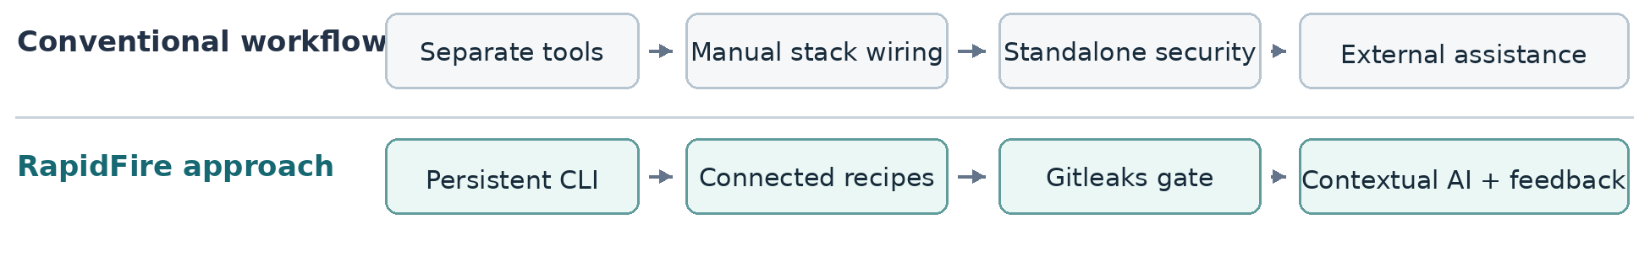
Figure 1. Comparison of fragmented setup tasks with the RapidFire integrated workflow.

1.3 Persistent PTY Shell Overlay and Command Routing
Unlike traditional scaffolding scripts that shut down after generating directory trees, RapidFire persists as an interactive terminal wrapper. Using a node-pty pseudoterminal layer, it binds directly to the user's host shell, supporting Bash, Zsh, PowerShell, or Command Prompt. This architecture builds upon classic principles of continuous delivery pipelines [7], event-driven JavaScript I/O [8], and Unix process control [9].
The built-in command dispatcher intercepts project actions such as setup, ask, suggest, push, preset, and deploy. Any command outside this set—such as directory changes via cd, compilation flags, or local runtime tests—falls through seamlessly to the underlying shell. This ensures developers retain full terminal responsiveness, interactive process input, and current working directory tracking without quitting the session.
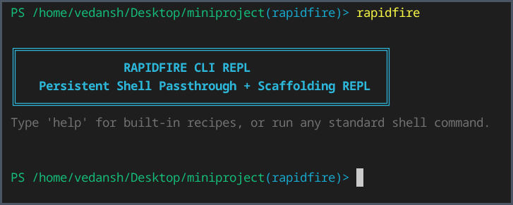
Figure 2. Actual RapidFire CLI REPL launch in a terminal session.
1.4 Deterministic Scaffolding and Offline Recipes
RapidFire provides thirteen deterministic scaffolding templates: eight dual-tier frontend-backend pairings, three client-only setups, and two backend services. Supported frameworks span React, Vue, Svelte, FastAPI, Django, Flask, and Express.js. For instance, invoking setup react+fastapi initializes a Vite React interface paired with an asynchronous FastAPI server.
Every recipe configures non-conflicting port bindings, injects cross-origin CORS headers, and writes a local .rapidfire.json tracking manifest. Python-backed architectures automatically spawn an isolated virtual environment. Offline template fallbacks ensure files generate reliably without active network connections, although third-party dependency installation still relies on package registries or local cache.

1.5 DevSecOps Guardrails: Pre-Push Secret Interception
RapidFire embeds Gitleaks validation directly into local development checkpoints. During stack creation, it configures a Git repository and writes a pre-push hook script. The integrated push routine coordinates file staging, commit generation, secret pattern matching, and GitHub synchronization. If Gitleaks spots an uncommitted token or private key, the push aborts immediately to protect sensitive credentials. If clean, GitHub CLI coordinates remote repository synchronization smoothly.
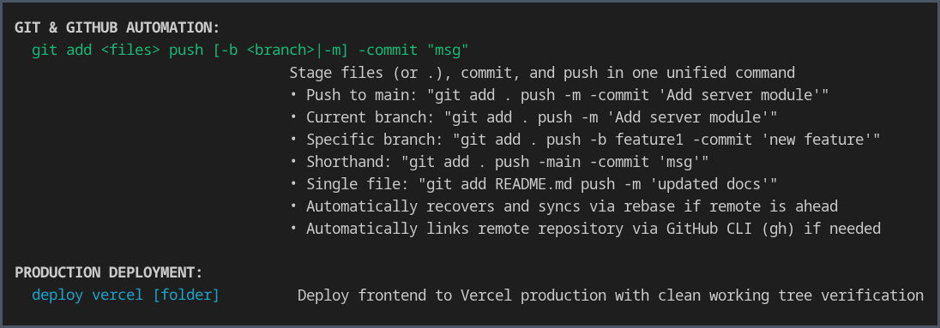
Figure 3. Actual CLI help showing Git and GitHub automation and Vercel deployment.
1.6 In-Terminal AI Assistance and Workspace Presets
RapidFire provides in-terminal AI utilities via ask, suggest, explain, and tell commands to debug errors without leaving the console. To keep prompts relevant, the system extracts recent terminal error lines, dependency manifests, and .rapidfire.json metadata, routing requests to Gemini, Groq, or local Ollama instances. Proposed terminal commands pass through a security validator requiring manual user confirmation ([Y/N]) before execution, aligning with empirical research on code generation safety [10].
Using preset save and load, developers export stack architecture into compact JSON schemas. These blueprints preserve directory structures while omitting heavy folders like node_modules, Python virtual environments, and .git trees, enabling fast environment replication across teams.
1.7 Technical Terms and Nomenclature
A PTY is the pseudoterminal layer connecting RapidFire with the host shell.
A REPL is the interactive loop where developer commands run continuously.
CORS governs cross-domain web calls; DevSecOps embeds local security checks.
Gitleaks inspects repository diffs for exposed credentials and private tokens.
The .rapidfire.json manifest records stack settings for the local workspace.
Other abbreviations appear in the Notations and Nomenclature section on page 2.

2.0 LITERATURE REVIEW
2.1 Review of Contemporary Developer Tools
Contemporary software development relies on specialized tools that address isolated segments of the application lifecycle. Project generators such as Yeoman, Cookiecutter, and create-vite automate file generation from template blueprints, significantly reducing initial boilerplate for standalone services. However, these tools terminate immediately after writing files to disk. They leave cross-tier connectivity, runtime dependency isolation, and version control configuration to manual developer intervention [7, 8].
Terminal multiplexers like tmux and GNU screen preserve active shell sessions across multiple processes, yet they operate in complete isolation from application architecture, manifest lifecycles, and security hygiene [9]. Standard command-line interfaces provide no built-in guardrails against credential leakage or broken monorepo submodules. RapidFire bridges these disjointed utilities by embedding multi-stack scaffolding, session continuity, and Git automation into an interactive terminal environment grounded in Pro Git practices [12].
2.2 Credential Protection and AI Assistance
Static secret-scanning engines, notably Gitleaks and TruffleHog, inspect codebases for high-entropy tokens, private SSH keys, and cloud credentials. While highly effective, their deployment traditionally depends on explicit developer configuration or continuous integration pipelines hosted on remote servers [3, 6]. Because CI scanners execute asynchronously after commits are published to remote branches, compromised tokens are already exposed. RapidFire installs an automated pre-push hook during scaffolding, intercepting commits on the host machine prior to network transmission.
General-purpose AI terminal tools frequently offer code suggestions and error explanations, but their output is disconnected from the developer's local project state. Unrestricted AI assistants introduce risks of executing hallucinated or destructive commands [10, 11]. RapidFire overcomes this risk by capturing recent terminal error streams to ground AI responses, while routing all proposed shell commands through a strict regex sanitizer requiring interactive confirmation ([Y/N]) before execution.
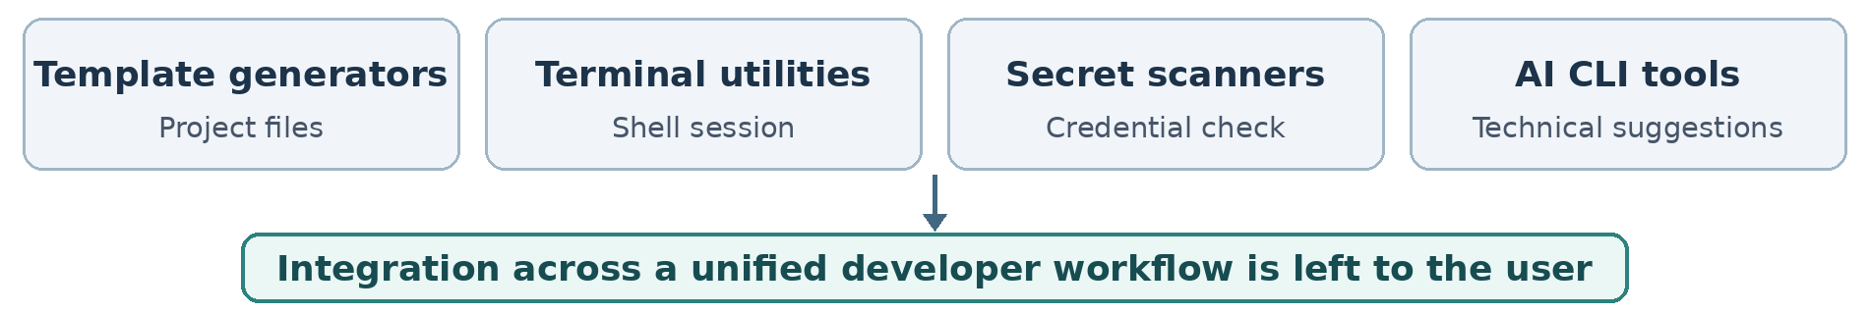
Figure 4. Tool categories reviewed in the literature and their integration gap.

2.3 Comparative Evaluation of Developer Toolchains
Table 1. Qualitative comparison of developer workflow tools
Tool / category | Established contribution | Remaining integration requirement
Yeoman, Cookiecutter and Vite | Generates isolated starter templates for single client or server stacks. | Leaves inter-service port coordination, CORS routing, and Git setup to manual steps.
tmux and GNU screen | Multiplexes terminal sessions and preserves long-running background processes. | Lacks project manifest tracking, multi-tier templates, and secret scanning hooks.
Gitleaks and Git hooks | Scans commits against pattern signatures to catch hardcoded authentication keys. | Requires manual setup per repository; CI scans run only after push.
AI command-line assistants | Offers terminal command advice and conversational error explanations via remote LLMs. | Lacks local file context; can hallucinate risky commands without confirmation.
2.4 Identified Research Gaps
The literature demonstrates a clear workflow disconnect across modern developer tools. Generators finish once directories are written, whereas terminal multiplexers, secret scanners, and AI assistants operate as disconnected utilities. Consequently, engineers still spend manual effort wiring ports, fixing CORS rejections, configuring pre-push checks, and relaying terminal logs between programs. Building distributed full-stack systems following REST architectural principles [13] demands coordinated interface contracts that isolated template scripts do not provide.
RapidFire bridges this divide by uniting native shell passthrough, coupled two-tier scaffolding, in-flight pre-push secret checks, and contextual AI into a single local console. This architectural synthesis streamlines everyday developer routines while acknowledging the specialized strengths of existing standalone command-line tools.
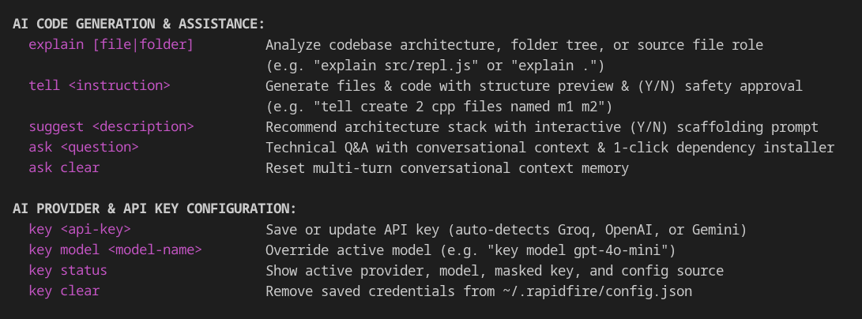
Figure 5. Actual CLI help showing AI assistance commands and provider configuration.
3.0 OBJECTIVES OF THE PROJECT
The primary aim of RapidFire is to eliminate setup friction by integrating multi-tier project scaffolding, persistent shell passthrough, and local secret scanning into a unified terminal console while preserving complete shell state.
3.1 Primary Technical Objectives
• Persistent terminal overlay: Build a node-pty terminal wrapper running custom commands while preserving native shell state, directory context, and stream history.
• Connected scaffolding engine: Provide thirteen zero-dependency project recipes with coordinated ports (5173, 8000), CORS headers, and Python environments.
• Pre-push security inspection: Embed Gitleaks in a local pre-push hook to intercept hardcoded API keys before commits leave the developer workstation.
• Contextual AI dependency assistance: Pass terminal error streams into AI prompts for targeted fixes, with an interactive confirmation prompt before execution.
3.2 Engineering and Usability Objectives
• Git and GitHub automation: Automate local staging, commits, branch setup, and GitHub repository creation via Git and GitHub CLI.
• Workspace reproducibility: Store project parameters in .rapidfire.json schemas and provide JSON presets to replicate full directory layouts.
• Provider flexibility: Support cloud and local Ollama models, sanitize Windows ConPTY escape codes, and provide scriptable CLI flags.
3.3 Scope and Project Boundaries
RapidFire concentrates on local developer tasks: project scaffolding, persistent terminal passthrough, dependency verification gates, pre-push secret scanning, and optional frontend deployment via Vercel CLI. Cloud AI queries transmit selected error snippets across HTTPS, whereas local Ollama models run fully offline on the host machine. The tool operates as a developer workstation overlay; it does not replace remote CI/CD pipelines or cloud infrastructure.
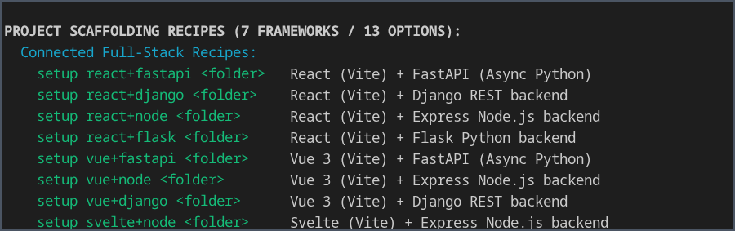
Figure 6. Actual help output showing the connected project-scaffolding recipes.

4.0 METHODOLOGY / PLANNING OF WORK
4.1 System Architecture and Data Flow Pipeline
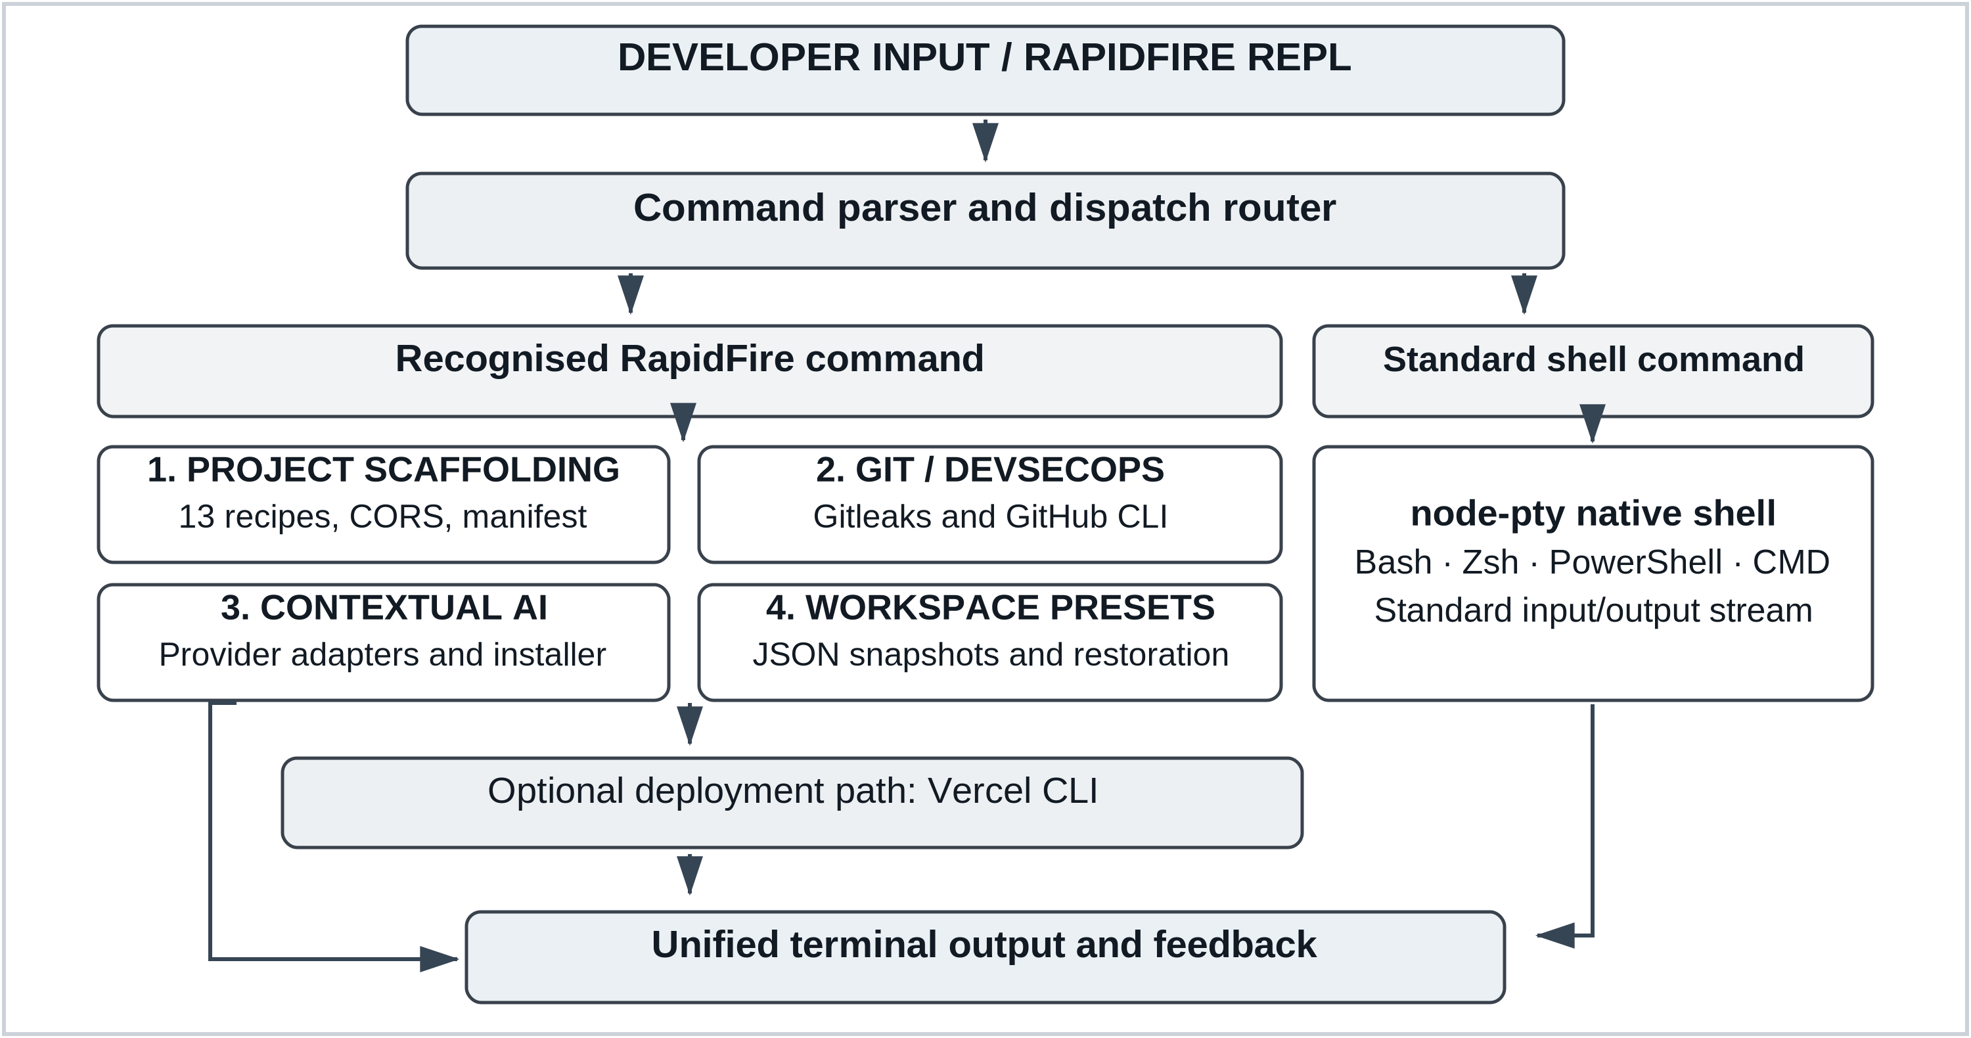
Figure 7. RapidFire CLI execution architecture, four core engines and optional Vercel deployment.
4.2 Phased Development and Planning of Work
Table 2. Work Breakdown Structure and Development Milestone Schedule
Phase | Milestone | Key technical deliverables | Duration
Phase 1 | Core terminal | Literature review, node-pty integration and REPL shell passthrough. | Weeks 1–3
Phase 2 | Project recipes | Thirteen scaffolds, CORS defaults, manifests and Python environments. | Weeks 4–7
Phase 3 | Git and security | Gitleaks pre-push checks, GitHub CLI and push recovery. | Weeks 8–10
Phase 4 | AI and presets | Provider adapters, approved dependency installation and JSON presets. | Weeks 11–13
Phase 5 | Validation | Recipe, shell and security tests; cross-platform checks and release. | Weeks 14–16
4.3 Verification and Quality Assurance
System validation relies on 26 automated test suites executing across the codebase to verify pseudo-terminal stream stability, thirteen scaffolding configurations, port alignment, and CORS headers. Additional test cases evaluate simulated Gitleaks secret interception, workspace manifest restoration, Windows ConPTY filtering, and optional Vercel deployment. Our verification approach follows standard test engineering guidelines detailed in ISO/IEC/IEEE 29119-2:2021 [14].

5.0 REFERENCES
[1] W. R. Stevens and S. A. Rago, Advanced Programming in the UNIX Environment, 3rd ed. Boston, MA, USA: Addison-Wesley, 2013.
[2] E. Gamma, R. Helm, R. Johnson, and J. Vlissides, Design Patterns: Elements of Reusable Object-Oriented Software. Reading, MA, USA: Addison-Wesley, 1994.
[3] M. Howard and D. LeBlanc, Writing Secure Code, 2nd ed. Redmond, WA, USA: Microsoft Press, 2003.
[4] E. Kalliamvakou, G. Gousios, K. Blincoe, L. Singer, D. M. German, and D. Damian, “The promises and perils of mining GitHub,” in Proc. 11th Working Conf. Mining Software Repositories (MSR), Hyderabad, India, 2014, pp. 92–101, doi: 10.1145/2597073.2597074.
[5] M. Meli, M. R. McNiece, and B. Reaves, “How Bad Can It Git? Characterizing Secret Leakage in Public GitHub Repositories,” in Proc. 26th Annu. Netw. Distrib. Syst. Secur. Symp. (NDSS), San Diego, CA, USA, 2019, doi: 10.14722/ndss.2019.23418.
[6] Gitleaks, “Gitleaks: Detect and prevent hardcoded secrets,” GitHub repository. [Online]. Available: https://github.com/gitleaks/gitleaks
[7] J. Humble and D. Farley, Continuous Delivery: Reliable Software Releases through Build, Test, and Deployment Automation. Boston, MA, USA: Addison-Wesley, 2010.
[8] S. Tilkov and S. Vinoski, “Node.js: Using JavaScript to build high-performance network programs,” IEEE Internet Comput., vol. 14, no. 6, pp. 80–83, Nov.–Dec. 2010, doi: 10.1109/MIC.2010.145.
[9] D. Spinellis and P. Avgeriou, “Evolution of the Unix System Architecture: An Exploratory Case Study,” IEEE Trans. Softw. Eng., vol. 47, no. 6, pp. 1134–1163, Jun. 2021, doi: 10.1109/TSE.2019.2892149.
[10] M. Chen et al., “Evaluating large language models trained on code,” arXiv:2107.03374, 2021.
[11] A. Bosu, M. Greiler, and C. Bird, “Characteristics of Useful Code Reviews: An Empirical Study at Microsoft,” in Proc. IEEE/ACM 12th Working Conf. Mining Software Repositories (MSR), Florence, Italy, 2015, pp. 146–156, doi: 10.1109/MSR.2015.21.
[12] S. Chacon and B. Straub, Pro Git, 2nd ed. New York, NY, USA: Apress, 2014.
[13] R. T. Fielding, “Architectural styles and the design of network-based software architectures,” Ph.D. dissertation, Univ. of California, Irvine, CA, USA, 2000.
[14] ISO/IEC/IEEE 29119-2:2021, Software and systems engineering — Software testing — Part 2: Test processes, 2nd ed., Oct. 2021.

