RAPIDFIRE: TERMINAL OVERLAY
AND UNIFIED DEVELOPER
ENVIRONMENT FOR STACK
SCAFFOLDING AND DEVOPS
AUTOMATION
PROJECT SYNOPSIS
OF MINI PROJECT
BACHELOR OF TECHNOLOGY
Computer Science & Engineering

SUBMITTED BY  Vedansh Shrivastava (Roll No. 321)  Vaishnavi Sahu (Roll No. 319)  Tanwi Gupta (Roll No. 311)  Tanmay Mittal (Roll No. 309) | UNDER THE SUPERVISION OF  Ms. Ruchika  Assistant Professor / Project Guide  Department of Computer Science & Engineering
Class: CSE-2A | Batch: 2025–2029 | Second Year (3rd Semester)
Greater Noida Institute of Technology, Greater Noida
Dr. A.P.J. Abdul Kalam Technical University, Lucknow
October 2026

TABLE OF CONTENTS
Section | Title / Topic | Page
— | Title Page | 1
— | Table of Contents | 2
— | Notations and Nomenclature | 2
1.0 | INTRODUCTION | 3
1.1 | Background, Context and Motivation | 3
1.2 | Problem Definition: Setup Latency and Credential Exposure | 3
1.3 | Persistent PTY Shell Overlay and Command Routing | 4
1.4 | Deterministic Scaffolding and Offline Recipes | 4
1.5 | DevSecOps Guardrails: Pre-Push Secret Interception | 5
1.6 | In-Terminal AI Assistance and Workspace Presets | 5
1.7 | Technical Terms and Nomenclature | 5
2.0 | LITERATURE REVIEW | 6
2.1 | Review of Contemporary Developer Tools | 6
2.2 | Credential Protection and AI Assistance | 6
2.3 | Comparative Evaluation of Developer Toolchains | 7
2.4 | Identified Research Gaps | 7
3.0 | OBJECTIVES OF THE PROJECT | 8
3.1 | Primary Technical Objectives | 8
3.2 | Engineering and Usability Objectives | 8
3.3 | Scope and Project Boundaries | 8
4.0 | METHODOLOGY / PLANNING OF WORK | 9
4.1 | System Architecture and Data Flow Pipeline | 9
4.2 | Phased Development and Planning of Work | 9
4.3 | Verification and Quality Assurance | 9
5.0 | REFERENCES | 10
NOTATIONS AND NOMENCLATURE
PTY — Pseudoterminal; REPL — Read-Eval-Print Loop; CORS — Cross-Origin Resource Sharing; LLM — Large Language Model; API — Application Programming Interface.
1.0 INTRODUCTION
1.1 Background, Context and Motivation
Setting up a full-stack application involves more than writing the frontend and backend code. Developers also need to prepare package managers, virtual environments, CORS settings, Git repositories, hosting and deployment. These tasks often involve several terminals and services, so even a small project can take time to get ready. UNIX process interfaces [1] and component-oriented software design [2] provide useful foundations for bringing this work together.
RapidFire CLI brings these activities into the terminal developers already use. It keeps the native shell available while adding connected project scaffolding, Git and GitHub operations, pre-push credential checks, AI assistance and reusable workspace presets. The intention is to make setup and day-to-day development less repetitive without asking users to give up their familiar shell.
1.2 Problem Definition: Setup Latency and Credential Exposure
Rushed project setup can also lead to security mistakes. A full-stack application may contain API keys, database connection strings or access tokens, often stored in environment files. When a developer stages many files at once, sensitive information can be included by mistake and pushed to a shared repository. Secure-coding guidance [3], studies of public GitHub data [4] and research on exposed secrets [5] show why checking changes before a push matters.
Credentials are not the only source of difficulty. Developers may run into occupied ports, CORS mismatches or dependencies installed in the wrong environment. Finding and fixing these problems often means moving between terminal commands, documentation and AI tools. RapidFire combines scaffolding, native shell access and installation prompts that require approval. Gitleaks [6] supplies the secret-scanning component of this workflow.
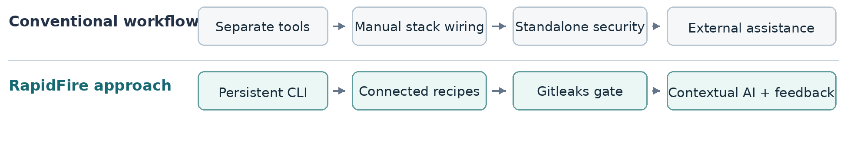
Figure 1. Comparison of fragmented setup tasks with the RapidFire integrated workflow.

1.3 Persistent PTY Shell Overlay and Command Routing
Most project generators create the initial files and then exit. RapidFire instead remains open as a shell-passthrough REPL, allowing developers to continue working in the same session. Its node-pty bridge connects to the host shell, whether that is Bash, Zsh, PowerShell or Command Prompt. The design draws on established work in continuous delivery [7], Node.js concurrency [8] and Unix system architecture [9].
RapidFire's command router handles recognised operations such as setup, ask, suggest, push, preset and deploy. Commands it does not recognise, including cd, npm test and Python scripts, go to the native shell. This lets users move between RapidFire features and ordinary shell commands while retaining terminal output, interactive behaviour and the current working directory.
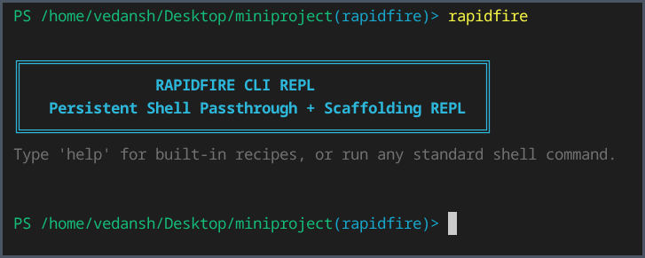
Figure 2. Actual RapidFire CLI REPL launch in a terminal session.
1.4 Deterministic Scaffolding and Offline Recipes
RapidFire currently provides thirteen scaffolding recipes: eight connected frontend–backend combinations, three standalone frontends and two standalone backends. The available technologies include React, Vue, Svelte, FastAPI, Django, Flask and Express.js. For instance, setup react+fastapi prepares a React/Vite frontend alongside a FastAPI backend.
Each recipe sets up appropriate ports and CORS configuration and creates a .rapidfire.json project manifest. Recipes that use Python also prepare a separate virtual environment. Local fallback templates make it possible to generate project files without retrieving a remote template, although installing dependencies may still require internet access or cached packages.

1.5 DevSecOps Guardrails: Pre-Push Secret Interception
RapidFire adds Gitleaks checks to the local Git workflow. During scaffolding, it can initialise a repository and install a pre-push hook. Its unified push operation brings together staging, commit preparation, secret scanning and GitHub synchronisation. If Gitleaks flags a possible credential, the push is stopped so the developer can investigate. Otherwise, GitHub CLI can assist with linking the remote repository and pushing the changes. This adds a safeguard against sharing credentials by accident.
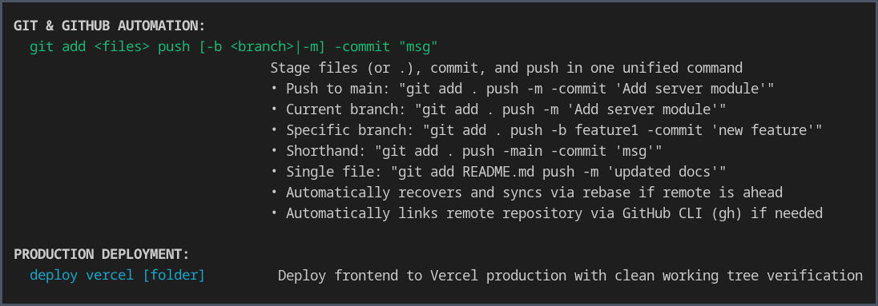
Figure 3. Actual CLI help showing Git and GitHub automation and Vercel deployment.
1.6 In-Terminal AI Assistance and Workspace Presets
RapidFire also provides ask, suggest, explain and tell commands for coding questions and help related to the active project. To give the selected AI provider useful context, it can include recent terminal errors, package manifests and information from .rapidfire.json when using Gemini, Groq or a local Ollama model. Proposed dependency-installation commands are checked and require the user's approval before they run. Research on language models trained for code [10] informs this feature, although generated suggestions still need to be reviewed.
With preset save and preset load, developers can save a project's basic structure and restore it later. Presets include selected project files and metadata but leave out large or temporary directories such as node_modules, Python virtual environments and .git. This makes it easier to recreate a workspace or share its structure with another team member.
1.7 Technical Terms and Nomenclature
A PTY is the pseudoterminal bridge connecting RapidFire with the native shell.
A REPL is the persistent interface in which users enter commands and see the results.
CORS manages cross-origin web requests, while DevSecOps brings security checks into development work.
Gitleaks checks repository files and Git changes for possible exposed credentials.
The .rapidfire.json manifest stores configuration details for a generated project.
Other abbreviations are listed in the Notations and Nomenclature section on page 3.

2.0 LITERATURE REVIEW
2.1 Review of Contemporary Developer Tools
Developer tools help at different stages of setting up an application. Yeoman and Cookiecutter provide starting points through reusable templates, while Vite helps create frontend projects. These tools can save time, but developers may still need to connect a backend, configure CORS, select ports and prepare other services themselves. The amount of coordination grows when a project has several parts. Research into useful code-review feedback [11] also highlights the importance of giving developers information they can act on.
Tools such as tmux and GNU screen can keep shell sessions running and help manage several processes, but they are not designed to connect frontend and backend services or scan Git changes for secrets. Other terminal improvements focus on prompts, command discovery and interaction. RapidFire builds on a persistent shell session while adding project setup and development tasks. Its Git-related workflows follow practices described in Pro Git [12].
2.2 Credential Protection and AI Assistance
Secret-scanning tools such as Gitleaks and TruffleHog can identify suspected credentials in source files and repository history. These checks may run through Git hooks or continuous-integration pipelines, but they depend on being configured and maintained. RapidFire aims to add a pre-push hook during project scaffolding so that secret checking becomes a normal part of the workflow rather than an extra step developers have to remember.
AI command-line assistants can explain errors and suggest commands, but developers still need to decide whether those suggestions are safe and relevant. RapidFire uses the current terminal context to provide help and pairs that assistance with a dependency installer that asks for confirmation before running supported commands. The aim is to offer practical help while keeping execution under the user's control.
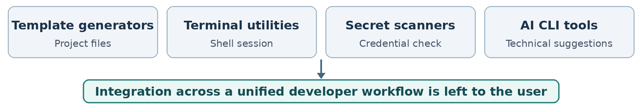
Figure 4. Tool categories reviewed in the literature and their integration gap.

2.3 Comparative Evaluation of Developer Toolchains
Table 1. Qualitative comparison of developer workflow tools
Tool / category | Established contribution | Remaining integration requirement
Yeoman, Cookiecutter and Vite | Automate generation of individual project templates. | Connecting frontend and backend services and configuring CORS may require extra steps.
tmux and GNU screen | Maintain multiple shell sessions and terminal processes. | Do not provide connected scaffolding or integrated secret scanning.
Gitleaks and Git hooks | Identify potential credentials before or during code sharing. | Protection depends on the developer configuring and maintaining the checks.
AI command-line assistants | Provide contextual explanations and suggested development commands. | Validation, package installation and project-state handling may require other tools.
2.4 Identified Research Gaps
The tools reviewed above leave a practical gap between generating a project and working on it afterwards. A generator often stops when the template has been created, while terminal utilities, security scanners and AI assistants work separately. As a result, developers must still connect application components, set up checks and carry information between tools. REST architectural principles [13] are useful when deciding how networked parts of an application should communicate.
RapidFire is intended to reduce this separation by keeping native shell access, connected scaffolding, pre-push checks and contextual AI support in one session. This is a qualitative comparison of the workflows involved, not a claim that RapidFire performs better than every existing tool.
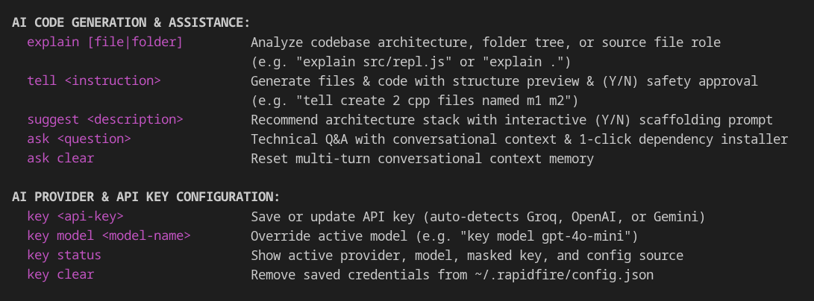
Figure 5. Actual CLI help showing AI assistance commands and provider configuration.
3.0 OBJECTIVES OF THE PROJECT
The main objective is to make common full-stack development tasks easier to handle from one locally run terminal. RapidFire focuses on reducing setup work, preserving everyday shell use and making repository operations safer.
3.1 Primary Technical Objectives
• Persistent terminal overlay: Build a node-pty-based REPL that handles RapidFire commands while preserving native shell use, interactive output and working-directory state.
• Connected scaffolding engine: Provide thirteen frontend, backend and combined recipes with suitable ports, CORS settings and Python environments where needed.
• Pre-push security inspection: Use Gitleaks within the local Git workflow to flag suspected credentials and stop a push before sensitive information is shared.
• Contextual AI dependency assistance: Use terminal errors and project files to inform AI responses, check proposed installation commands and ask for approval before execution.
3.2 Engineering and Usability Objectives
• Git and GitHub automation: Simplify staging, commits, branch selection, remote repository linking and pushing through Git and GitHub CLI.
• Workspace reproducibility: Store generated project settings in .rapidfire.json and provide JSON presets that can save and restore project structures.
• Provider flexibility: Allow the user to select supported cloud AI providers or a local model according to the available runtime.
3.3 Scope and Project Boundaries
RapidFire focuses on local development tasks, including scaffolding, native shell commands, controlled package installation, Git-related security checks and optional frontend deployment through Vercel CLI. Cloud AI requests need an internet connection and send the chosen project context to the provider. Using a local Ollama model can avoid sending that context to an external service. Generated applications may still need dependency downloads, additional testing and production hardening.
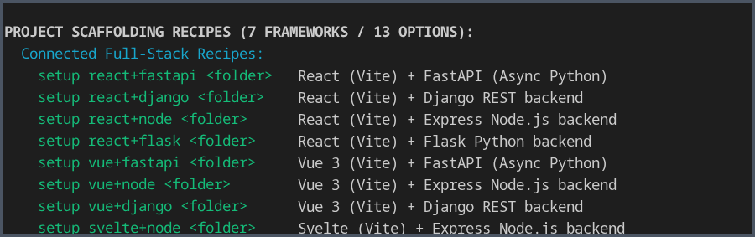
Figure 6. Actual help output showing the connected project-scaffolding recipes.

4.0 METHODOLOGY / PLANNING OF WORK
4.1 System Architecture and Data Flow Pipeline
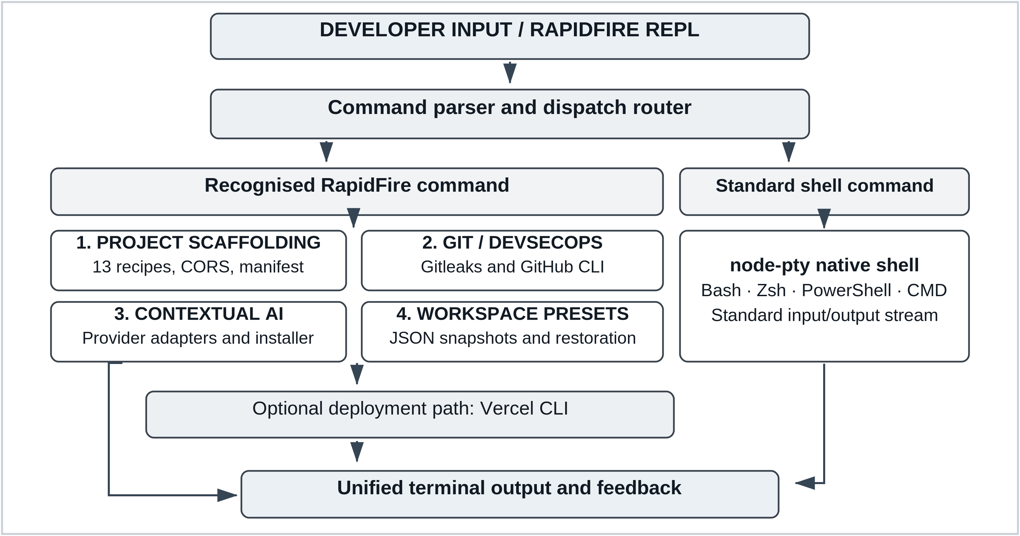
Figure 7. RapidFire CLI execution architecture, four core engines and optional Vercel deployment.
4.2 Phased Development and Planning of Work
Table 2. Work Breakdown Structure and Development Milestone Schedule
Phase | Milestone | Key technical deliverables | Duration
Phase 1 | Core terminal | Literature review, node-pty integration and REPL shell passthrough. | Weeks 1–3
Phase 2 | Project recipes | Thirteen scaffolds, CORS defaults, manifests and Python environments. | Weeks 4–7
Phase 3 | Git and security | Gitleaks pre-push checks, GitHub CLI and push recovery. | Weeks 8–10
Phase 4 | AI and presets | Provider adapters, approved dependency installation and JSON presets. | Weeks 11–13
Phase 5 | Validation | Recipe, shell and security tests; cross-platform checks and release. | Weeks 14–16
4.3 Verification and Quality Assurance
Verification will check whether ordinary commands pass through to the native shell correctly and whether all thirteen scaffolding recipes create projects with suitable ports and CORS settings. It will also cover responses to test credentials, workspace restoration, Vercel CLI deployment and operation on supported host systems. The testing plan draws on the processes described in ISO/IEC/IEEE 29119-2:2021 [14].

5.0 REFERENCES
[1] W. R. Stevens and S. A. Rago, Advanced Programming in the UNIX Environment, 3rd ed. Boston, MA, USA: Addison-Wesley, 2013.
[2] E. Gamma, R. Helm, R. Johnson, and J. Vlissides, Design Patterns: Elements of Reusable Object-Oriented Software. Reading, MA, USA: Addison-Wesley, 1994.
[3] M. Howard and D. LeBlanc, Writing Secure Code, 2nd ed. Redmond, WA, USA: Microsoft Press, 2003.
[4] E. Kalliamvakou, G. Gousios, K. Blincoe, L. Singer, D. M. German, and D. Damian, “The promises and perils of mining GitHub,” in Proc. 11th Working Conf. Mining Software Repositories (MSR), Hyderabad, India, 2014, pp. 92–101, doi: 10.1145/2597073.2597074.
[5] M. Meli, M. R. McNiece, and B. Reaves, “How Bad Can It Git? Characterizing Secret Leakage in Public GitHub Repositories,” in Proc. 26th Annu. Netw. Distrib. Syst. Secur. Symp. (NDSS), San Diego, CA, USA, 2019, doi: 10.14722/ndss.2019.23418.
[6] Gitleaks, “Gitleaks: Detect and prevent hardcoded secrets,” GitHub repository. [Online]. Available: https://github.com/gitleaks/gitleaks
[7] J. Humble and D. Farley, Continuous Delivery: Reliable Software Releases through Build, Test, and Deployment Automation. Boston, MA, USA: Addison-Wesley, 2010.
[8] S. Tilkov and S. Vinoski, “Node.js: Using JavaScript to build high-performance network programs,” IEEE Internet Comput., vol. 14, no. 6, pp. 80–83, Nov.–Dec. 2010, doi: 10.1109/MIC.2010.145.
[9] D. Spinellis and P. Avgeriou, “Evolution of the Unix System Architecture: An Exploratory Case Study,” IEEE Trans. Softw. Eng., vol. 47, no. 6, pp. 1134–1163, Jun. 2021, doi: 10.1109/TSE.2019.2892149.
[10] M. Chen et al., “Evaluating large language models trained on code,” arXiv:2107.03374, 2021.
[11] A. Bosu, M. Greiler, and C. Bird, “Characteristics of Useful Code Reviews: An Empirical Study at Microsoft,” in Proc. IEEE/ACM 12th Working Conf. Mining Software Repositories (MSR), Florence, Italy, 2015, pp. 146–156, doi: 10.1109/MSR.2015.21.
[12] S. Chacon and B. Straub, Pro Git, 2nd ed. New York, NY, USA: Apress, 2014.
[13] R. T. Fielding, “Architectural styles and the design of network-based software architectures,” Ph.D. dissertation, Univ. of California, Irvine, CA, USA, 2000.
[14] ISO/IEC/IEEE 29119-2:2021, Software and systems engineering — Software testing — Part 2: Test processes, 2nd ed., Oct. 2021.

