RAPIDFIRE: TERMINAL OVERLAY
AND UNIFIED DEVELOPER
ENVIRONMENT FOR STACK
SCAFFOLDING AND DEVOPS
AUTOMATION
PROJECT SYNOPSIS
OF MINI PROJECT
BACHELOR OF TECHNOLOGY
Computer Science & Engineering

SUBMITTED BY  Vedansh Shrivastava (Roll No. 321)  Vaishnavi Sahu (Roll No. 319)  Tanwi Gupta (Roll No. 311)  Tanmay Mittal (Roll No. 309) | UNDER THE SUPERVISION OF  Ms. Ruchika  Assistant Professor / Project Guide  Department of Computer Science & Engineering
Class: CSE-2A | Batch: 2025–2029 | Second Year (3rd Semester)
Greater Noida Institute of Technology, Greater Noida
Dr. A.P.J. Abdul Kalam Technical University, Lucknow
October 2026

TABLE OF CONTENTS
Section | Title / Topic | Page
— | Title Page | 1
— | Table of Contents | 2
— | Notations and Nomenclature | 2
1.0 | INTRODUCTION | 3
1.1 | Background, Context and Motivation | 3
1.2 | Problem Definition: Setup Latency and Credential Exposure | 3
1.3 | Persistent PTY Shell Overlay and Command Routing | 4
1.4 | Deterministic Scaffolding and Offline Recipes | 4
1.5 | DevSecOps Guardrails: Pre-Push Secret Interception | 5
1.6 | In-Terminal AI Assistance and Workspace Presets | 5
1.7 | Technical Terms and Nomenclature | 5
2.0 | LITERATURE REVIEW | 6
2.1 | Review of Contemporary Developer Tools | 6
2.2 | Credential Protection and AI Assistance | 6
2.3 | Comparative Evaluation of Developer Toolchains | 7
2.4 | Identified Research Gaps | 7
3.0 | OBJECTIVES OF THE PROJECT | 8
3.1 | Primary Technical Objectives | 8
3.2 | Engineering and Usability Objectives | 8
3.3 | Scope and Project Boundaries | 8
4.0 | METHODOLOGY / PLANNING OF WORK | 9
4.1 | System Architecture and Data Flow Pipeline | 9
4.2 | Phased Development and Planning of Work | 9
4.3 | Verification and Quality Assurance | 9
5.0 | REFERENCES | 10
NOTATIONS AND NOMENCLATURE
PTY — Pseudoterminal; REPL — Read-Eval-Print Loop; CORS — Cross-Origin Resource Sharing; LLM — Large Language Model; API — Application Programming Interface.
1.0 INTRODUCTION
1.1 Background, Context and Motivation
Setting up a full-stack app means more than writing frontend and backend code. Developers also have to set up package managers, virtual environments, CORS, Git repositories, and arrange for hosting and deployment, often across various terminals and services, so that even a small app can take time to set up. This effort builds on foundations provided by UNIX process interfaces [1] and component-oriented software design [2].
RapidFire CLI brings these activities inside the terminal developers use already. The native shell still remains present alongside integrated project bootstrapping, Git & GitHub operations, pre-push authentication, AI assistance and reproducible environment configurations. The goal is to make development workflows and setup less repetitive without losing your familiar shell environment.
1.2 Problem Definition: Setup Latency and Credential Exposure
By rushing through project setup, you're more likely to make security mistakes. A full-stack app has built-in API keys, database connection strings, or access tokens, which are conventionally kept in environment files. Research indicates that when developers stage too many files at once, there's a risk of having sensitive information there that could get pushed to a shared repo. Secure-coding practices, analysis of public github data, and research on exposed secrets has all emphasized the importance of reviewing changes before pushing.
Credentials aren't the only cause of headaches, however. Occasionally ports will be in use, CORS requests will be mismatched, or dependencies will be installed in the wrong environment. To resolve these, you'll need to jump between terminal commands, documentation, and AI tools. Rapid Fire utilizes scaffolding, native shell, and installation prompts, which need approval. Gitleaks is the secret-scanning part of this workflow.
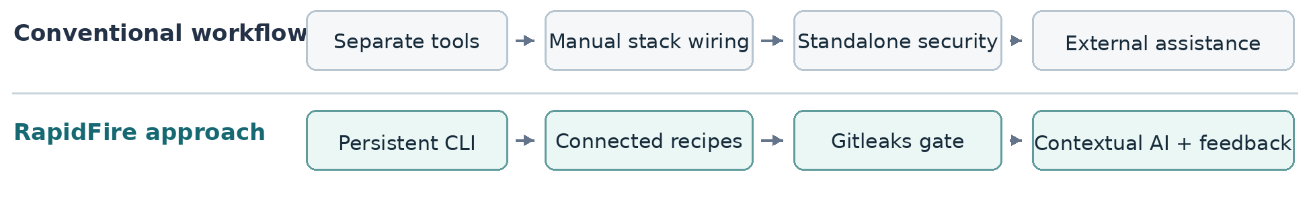
Figure 1. Comparison of fragmented setup tasks with the RapidFire integrated workflow.

1.3 Persistent PTY Shell Overlay and Command Routing
Unlike most project generators which produce initial files and exit, Rapid Fire remains a shell-pass-through REPL allowing users to continue working within the same session. The Rapid Fire node-pty bridge is designed to connect to the host shell, whether that be Bash, Zsh, PowerShell or Command Prompt. The design draws on established work in continuous delivery [7], Node.js concurrency [8] and Unix system architecture [9].
Rapid Fire's command router is then able to handle known operations (setup, ask, suggest, push, preset, deploy), but is capable of passing commands it does not recognise, such as cd, npm test, or Python scripts, to the underlying shell. This allows users to switch between Rapid Fire commands and native shell commands without losing terminal output, interactive behaviour, or current working directory.
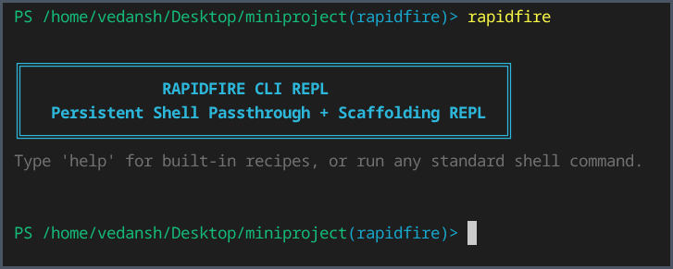
Figure 2. Actual RapidFire CLI REPL launch in a terminal session.
1.4 Deterministic Scaffolding and Offline Recipes
Currently, there are 13 rapidfire recipes, containing 8 inter-dependent frontend/backend pairs, 3 separate (standalone) frontends, and 2 separate (standalone) backends. All the following technology combinations are supported: react, vue, svelte, fastapi, django, flask, and express.js. For instance, the react+fastapi recipe sets up a React/Vite frontend with a FastAPI backend.
Recipes configure ports, CORS and produce a project manifest named .rapidfire.json. Recipes that run with Python may set up a separate virtual environment. Local fallback templates may generate project files without pulling a remote template, though the process of installing dependencies may require an internet connection or a cached dependency.

1.5 DevSecOps Guardrails: Pre-Push Secret Interception
RapidFire enables Gitleaks checks to local Git workflow: initializes repo, and can install pre-push hook during scaffolding. It has a single push operation that integrates: staging, prepare commit message, secret scanning and synchronize with GitHub. Should Gitleaks identify a potential credential, the push is prevented, allowing the developer to evaluate the situation. Alternatively, you can rely on the GitHub CLI to link the remote repository and push your changes. It provides a protection against accidentally sharing credentials.
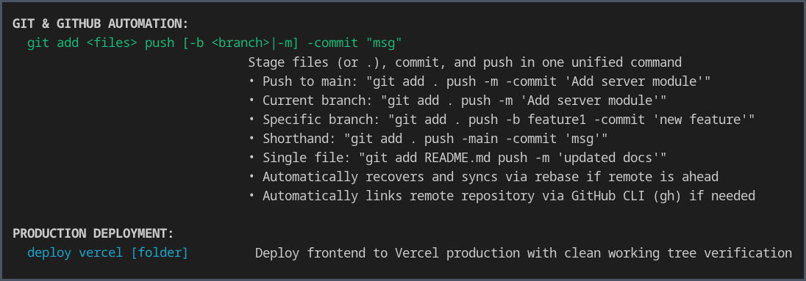
Figure 3. Actual CLI help showing Git and GitHub automation and Vercel deployment.
1.6 In-Terminal AI Assistance and Workspace Presets
Autocompletion Rapid Fire users can input commands for asking, suggesting, explaining, and telling coding questions and help in the context of the current project. When using Gemini, Groq, or a local Ollama model, information from recent terminal error messages, package manifests, and .rapidfire.json can be passed to the selected AI provider for context. Proposed commands to install dependencies are checked and require user approval before execution. This feature draws inspiration from research on language models trained for coding [10], although suggestions still need to be reviewed.
Preset save and preset load allows a developer to save the core structure of a project and reload that preset. Presets include chosen project files and metadata, but exclude large or ephemeral directories (node_modules, Python virtual environments,.git, etc.). This will probably make it easier to recreate a workspace or share its structure with others on a team.
1.7 Technical Terms and Nomenclature
PTY seems to be the pseudoterminal bridge that interfaces from Rapid Fire to the native shell.
A REPL is the persistent interface in which users enter commands and see the results.
CORS deals with cross-origin requests in web applications, and DevSecOps incorporates security controls into software development.
Gitleaks scan repository files and changes introduced in git commits for known credentials.
A .rapidfire.json manifest contains configuration settings used for a generated project.
Additional abbreviations can be found in the Notations and Nomenclature section on page 3.

2.0 LITERATURE REVIEW
2.1 Review of Contemporary Developer Tools
Tools that developers use help in all areas of app development. Tools such as yeoman and cookiecutter provide developers with software blueprints with reusable templates, and vite helps in the formation of the front-end project. These tools will most likely help optimize the process for developers by saving development time, yet developers will still likely have to connect the back-end by hand, look for CORS, pick the port, and prepare other services. The tightness of the coordination will most likely be even worse if a project has more than one component. Research into effective code-review feedback [11] emphasized that providing developers with actionable information is also very important.
Tools like tmux and GNU screen can allow you to keep the session in the shell alive and help juggle multiple processes, but neither of those tools can connect front end to back end nor can they scan Git changes for secrets. Other terminal extensions focus on prompt and discovery, and improving user input. Rapid Fire extends an existing, session-based shell by adding project setup and development tasks; its workflows for Git echo those in Pro Git [12].
2.2 Credential Protection and AI Assistance
Existing secret-scanning tools like Gitleaks and Truffle Hog can detect possible secrets inside source code files and entire repository histories (all the data stored in the project). Those checks might run via Git hooks or continuous-integration pipelines, but they rely on being configured and maintained. RapidFire’s intention is to provide the means for adding a pre-push hook at the project-scaffolding stage, so that secret-checking is ‘the way’ work is done, rather than a separate thing to remember.
AI CLI assistants may provide explanations for errors and suggestions for commands to use, but the developer must determine the utility of the suggestions and whether the actions are safe. Rapid Fire can use the current terminal context to assist and offer a dependency installer which prompts the user to give permission before running supported commands, so it is expected to be genuinely helpful while maintaining control.
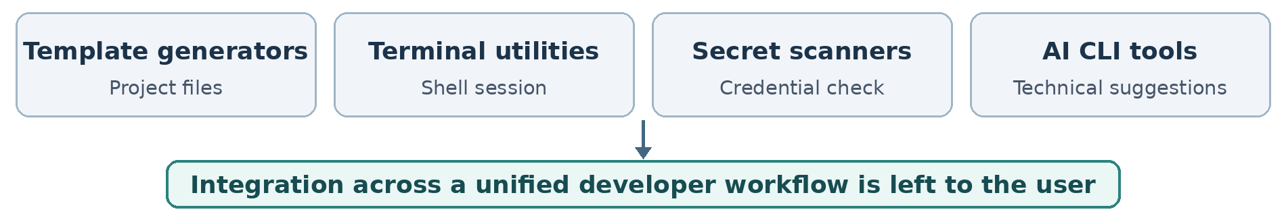
Figure 4. Tool categories reviewed in the literature and their integration gap.

2.3 Comparative Evaluation of Developer Toolchains
Table 1. Qualitative comparison of developer workflow tools
Tool / category | Established contribution | Remaining integration requirement
Yeoman, Cookiecutter and Vite | Automate generation of individual project templates. | Connecting frontend and backend services and configuring CORS may require extra steps.
tmux and GNU screen | Maintain multiple shell sessions and terminal processes. | Do not provide connected scaffolding or integrated secret scanning.
Gitleaks and Git hooks | Identify potential credentials before or during code sharing. | Protection depends on the developer configuring and maintaining the checks.
AI command-line assistants | Provide contextual explanations and suggested development commands. | Validation, package installation and project-state handling may require other tools.
2.4 Identified Research Gaps
The examination of the tools above illustrates that there is a practical gap between generator creation and further development. It is noted that once a template has been generated, generators tend to stop working, whilst terminal utilities, security scanners and AI assistants still operate independently. The developers themselves have to manually link parts of their applications together, configure checks and shuttle data between these various tools. REST architectural principles [13] are useful when deciding how networked parts of an application should communicate.
RapidFire intends to close that gap by allowing native shell access, connected scaffolding, pre-push checks and contextual AI support all within the same session. This qualitative comparison of workflows does not claim to do it better than anyone or anything else already on the market.
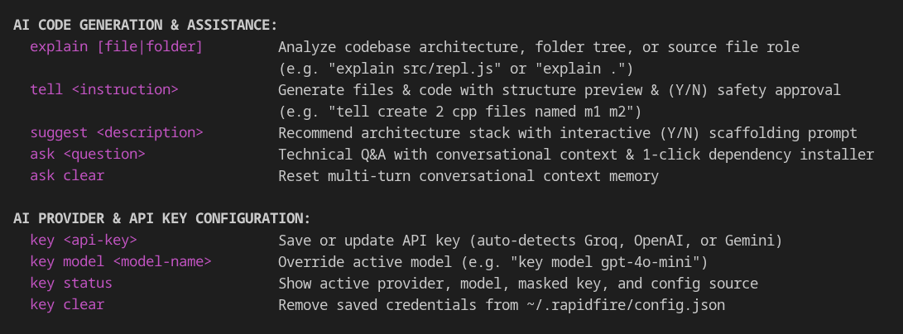
Figure 5. Actual CLI help showing AI assistance commands and provider configuration.
3.0 OBJECTIVES OF THE PROJECT
The goal of the project is to allow the handling of common full-stack development tasks from a terminal at local control. RapidFire concentrates on cutting set-up effort, keeping everyday shell work flowing and bringing a safety net to repo actions.
3.1 Primary Technical Objectives
• Continuing terminal overlay would aim to build a node-pty powered REPL to run Rapid Fire commands with native shell experience, interactive output and current working directory state.
• The linked scaffolding engine further aims to publish a total of thirteen frontend, backend and combined recipes with suitable port allocations, CORS configurations and Python environments if needed.
• Aimed at pre-push security audit one might see Gitleaks incorporated into the local Git flow to identify potential credential leaks and block the distribution of secret information.
• Lastly, a contextual AI dependency helper will utilize terminal errors and project files to inform the AI response, confirm that install commands are valid, and prompt the user for execution approval.
3.2 Engineering and Usability Objectives
• The things automated are typical git and Github tasks as staging, committing, switching branches, linking to remote repositories, and pushing to remote repositories through the Github CLI.
• Git workspace reproducibility would be improved by storing generated settings in a file on the workspace, such as .rapidfire.json and providing a set of json presets for storing/restoring the project tree.
• Provider flexibility is shown by allowing the user to choose among supported cloud AI providers or local model depending on available runtime.
3.3 Scope and Project Boundaries
Most developments involve local development, such as scaffolds, native shell commands, safe-package installation, Git security scans, and optional frontend deployment via Vercel CLI. Cloud-AI requests go to the Internet and transfer the selected project context to the provider. Local Ollama model usage may skip that step and avoid sending that context to a provider. And any generated application will likely need to fetch dependencies, additional testing, and hardening for production.
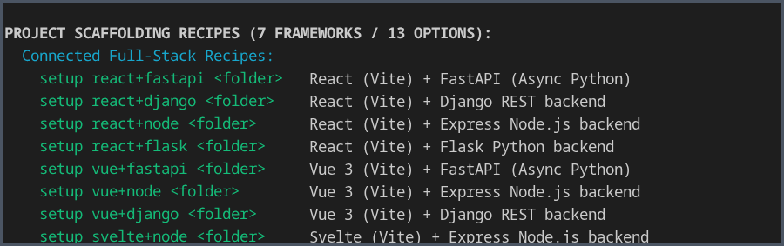
Figure 6. Actual help output showing the connected project-scaffolding recipes.

4.0 METHODOLOGY / PLANNING OF WORK
4.1 System Architecture and Data Flow Pipeline
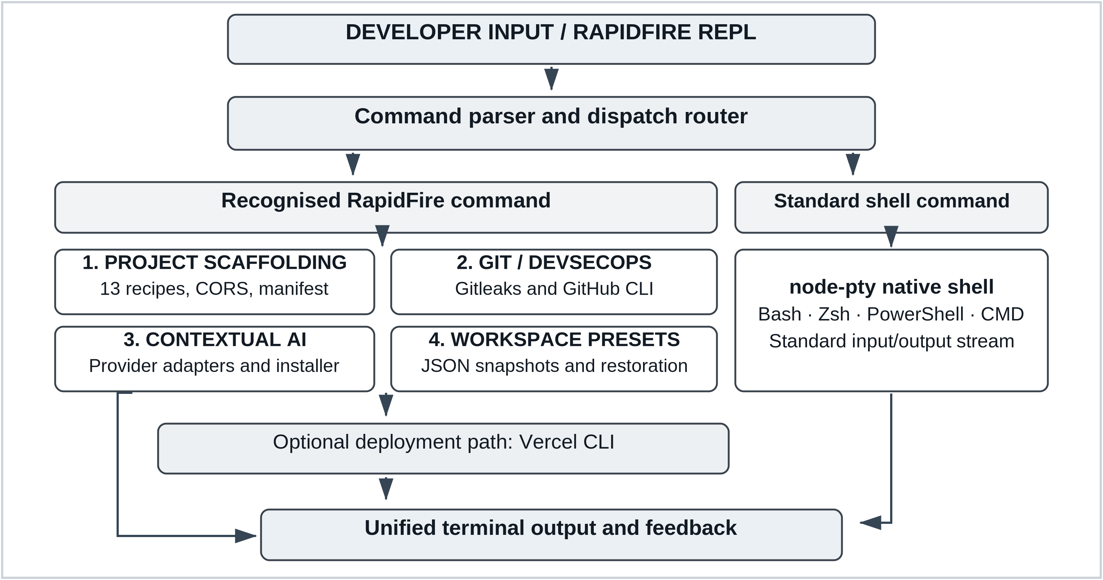
Figure 7. RapidFire CLI execution architecture, four core engines and optional Vercel deployment.
4.2 Phased Development and Planning of Work
Table 2. Work Breakdown Structure and Development Milestone Schedule
Phase | Milestone | Key technical deliverables | Duration
Phase 1 | Core terminal | Literature review, node-pty integration and REPL shell passthrough. | Weeks 1–3
Phase 2 | Project recipes | Thirteen scaffolds, CORS defaults, manifests and Python environments. | Weeks 4–7
Phase 3 | Git and security | Gitleaks pre-push checks, GitHub CLI and push recovery. | Weeks 8–10
Phase 4 | AI and presets | Provider adapters, approved dependency installation and JSON presets. | Weeks 11–13
Phase 5 | Validation | Recipe, shell and security tests; cross-platform checks and release. | Weeks 14–16
4.3 Verification and Quality Assurance
Validation is intended to validate the sending of the standard commands over to the native shell, to validate that all thirteen scaffolding recipes produce projects with the correct ports and CORS settings, as well as testing the responses for the test credentials, the workspace restoration, and the deployment via the Vercel CLI on supported host systems. The strategy for testing is based on the ISO/IEC/IEEE 291192:2021 [14].

5.0 REFERENCES
[1] W. R. Stevens and S. A. Rago, Advanced Programming in the UNIX Environment, 3rd ed. Boston, MA, USA: Addison-Wesley, 2013.
[2] E. Gamma, R. Helm, R. Johnson, and J. Vlissides, Design Patterns: Elements of Reusable Object-Oriented Software. Reading, MA, USA: Addison-Wesley, 1994.
[3] M. Howard and D. LeBlanc, Writing Secure Code, 2nd ed. Redmond, WA, USA: Microsoft Press, 2003.
[4] E. Kalliamvakou, G. Gousios, K. Blincoe, L. Singer, D. M. German, and D. Damian, “The promises and perils of mining GitHub,” in Proc. 11th Working Conf. Mining Software Repositories (MSR), Hyderabad, India, 2014, pp. 92–101, doi: 10.1145/2597073.2597074.
[5] M. Meli, M. R. McNiece, and B. Reaves, “How Bad Can It Git? Characterizing Secret Leakage in Public GitHub Repositories,” in Proc. 26th Annu. Netw. Distrib. Syst. Secur. Symp. (NDSS), San Diego, CA, USA, 2019, doi: 10.14722/ndss.2019.23418.
[6] Gitleaks, “Gitleaks: Detect and prevent hardcoded secrets,” GitHub repository. [Online]. Available: https://github.com/gitleaks/gitleaks
[7] J. Humble and D. Farley, Continuous Delivery: Reliable Software Releases through Build, Test, and Deployment Automation. Boston, MA, USA: Addison-Wesley, 2010.
[8] S. Tilkov and S. Vinoski, “Node.js: Using JavaScript to build high-performance network programs,” IEEE Internet Comput., vol. 14, no. 6, pp. 80–83, Nov.–Dec. 2010, doi: 10.1109/MIC.2010.145.
[9] D. Spinellis and P. Avgeriou, “Evolution of the Unix System Architecture: An Exploratory Case Study,” IEEE Trans. Softw. Eng., vol. 47, no. 6, pp. 1134–1163, Jun. 2021, doi: 10.1109/TSE.2019.2892149.
[10] M. Chen et al., “Evaluating large language models trained on code,” arXiv:2107.03374, 2021.
[11] A. Bosu, M. Greiler, and C. Bird, “Characteristics of Useful Code Reviews: An Empirical Study at Microsoft,” in Proc. IEEE/ACM 12th Working Conf. Mining Software Repositories (MSR), Florence, Italy, 2015, pp. 146–156, doi: 10.1109/MSR.2015.21.
[12] S. Chacon and B. Straub, Pro Git, 2nd ed. New York, NY, USA: Apress, 2014.
[13] R. T. Fielding, “Architectural styles and the design of network-based software architectures,” Ph.D. dissertation, Univ. of California, Irvine, CA, USA, 2000.
[14] ISO/IEC/IEEE 29119-2:2021, Software and systems engineering — Software testing — Part 2: Test processes, 2nd ed., Oct. 2021.

