КС-грамматика:

**G**({**if, then, else, a, uint, :=, or, xor, and, com, (, ), {, }, ;**}, {S,F,E,D,C},**P**,S) с правилами вывода P:

S → F | **{com}**

F → **if** E **then** T **else** F | **if** E **then** F | **a:=**E | F**;**F | F**{com}**

T → **if** E **then** T **else** T | **a:=**E | T**{com}**

E → E **or** D | E **xor** D | D | E**{com}**

D → D **and** C | C | D**{com}**

C → **a** | **uint** | **(**E**)** | C**{com}**

Классы лексем языка:

* Keyword: if+then+else+or+xor+and

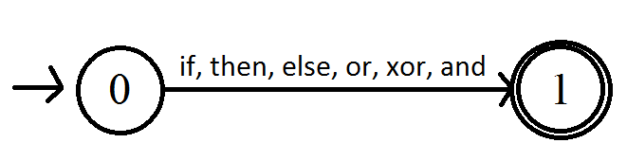

* Delimiter: (+)+;+{+}

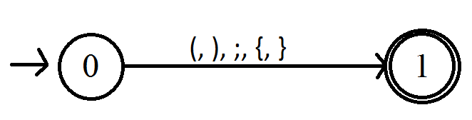

* Assignment: :=

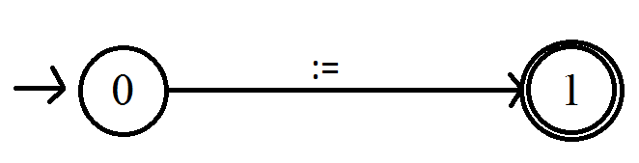

* Identifier: (a-z+A-Z+а-я+А-Я) (a-z+A-Z+а-я+А-Я+0-9)*

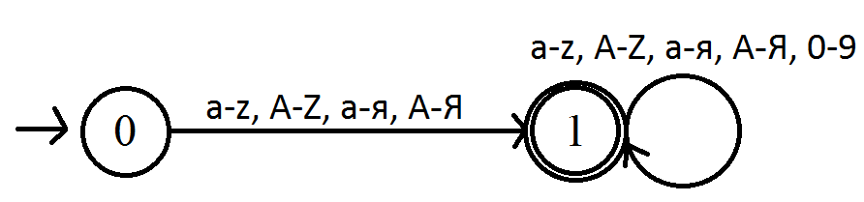

* Uint: (1-9)(0-9)*

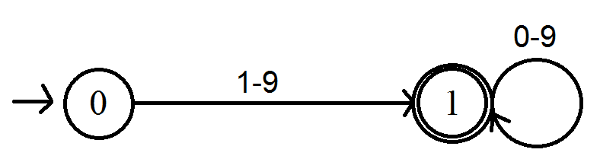

* Comment: (.)*

