

Foundations of Programming
Assignment No. : 07

PROBLEM STATEMENT:
Write a program in C to accept student details their result using array

ALGORITHM:
Step 1: START
Step 2: Define struct student (roll_no, name, marks)
Step 3: Initialize Declare a variable n to store the number of student
Step 4: Input and Process loop and for each student i from 0 to n-1
Step 5: Output loop repeat the following steps for each student
Step 6: Display result
Step 7: STOP

INPUT:
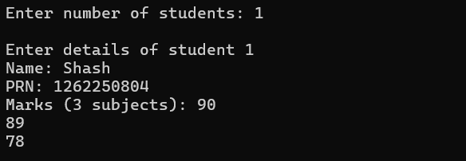

OUTPUT:
