

Foundations of Programming
Assignment No. : 08

PROBLEM STATEMENT:
Write a program to accept marks of first five courses of a student and compute the result a student is considered PASS if he/she score 40+ in each course. If the statement passes calculate the aggregate percentage and assign the grades as follows:
- Aggregate >= 75% : Distinction
- Aggregate >= 60% & 75% : First Division
- Aggregate >= 50% & 60% : Second Division
- Aggregate >= 40% & 50%: Third Division

ALGORITHM:
Step 1: START
Step 2: Declare variables for 5 subjects mark, total, percentage
Step 3: Read marks of 5 subject
Step 4: If any subject marks<40, set Result as FAIL
Step 5: Calculate total
Calculate percentage(total/500)*100
Set result as pass
Step 6: Assign grades based on percentage
Step 7: Display total, percentage, result, grade
Step 8: STOP

INPUT:
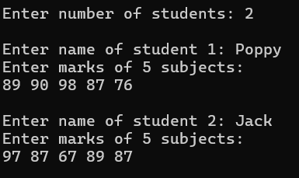

OUTPUT:

