

Foundations of Programming
Assignment No. : 19

PROBLEM STATEMENT:
Write a program in C to create a structure EMPLOYEE for string details. Define function members to compute
- Total number of employees in an organization
- Count of male and female employees
- Employee with salary more than 10,000
- Employee with designation “Assistant Manager”

ALGORITHM:
Step 1: START
Step 2: Define structure employee
Step 3: Input number of employee
Step 4: Input details of n employee
- Total Employees
Display Total
- Count of male and female employee
- Display employee with salary > 10,000
- Display designation “Assistant Manager”
Step 5: STOP

INPUT:
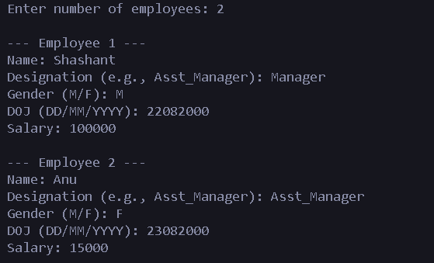

OUTPUT:
