

Foundations of Programming
Assignment No. : 02

PROBLEM STATEMENT:
Write a menu driven program in C to implement the basic arithmetic operations such as addition, subtraction, multiplication and division

ALGORITHM:
Step 1: START
Step 2: Declare a, b, Result and choice
Step 3: Input two values a and b
Step 4: Input Operator
Step 5: Switch (choice)
Step 6: If +, calculate sum
Step 7: If -, calculate difference
Step 8: If *, calculate product
Step 9: If /, check b not equal to 0 calculate quotient
Step 10: Display Result
Step 11: STOP

INPUT:
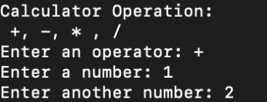

OUTPUT:

