

Foundations of Programming
Assignment No. : 09

PROBLEM STATEMENT:
Write a program to check whether the given number is an Armstrong number or not. Armstrong number is an integer with three digits such that sum of cubes of its digit is equal to the number

ALGORITHM:
Step 1: START
Step 2: Declare num, temp , rem, count and digit
Step 3: Input num
Step 4: Store number in variable
Step 5: Count the number of digit
Step 6: Restore original number
Step 7: Calculate sum of digits raised to power
Step 8: If rem = sum
Step 9: Yes, display “It is an Armstrong number”
Step 10: No, display “It isn’t an Armstrong number”
Step 11: STOP

INPUT:
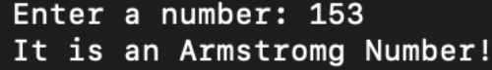

OUTPUT:



