

Foundations of Programming
Assignment No. : 10

PROBLEM STATEMENT:
Write a problem to simulate a calculator with addition, subtraction, multiplication, division. The calculator should also perform power and factorial function.

ALGORITHM:
Step 1: START
Step 2: Declare variables i, fact, num1 ,num2, result
Step 3: Read number “n”, from user
Step 4: Calculate sum of number , display result
Step 5: Calculate difference of number , display result
Step 6: Calculate division of number , display result
Step 7: Calculate multiplication of number , display result
Step 8: Calculate power of number , display result
Step 9: Find factorial of number, display result
Step 10: STOP

INPUT:
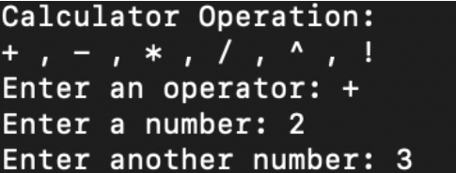

OUTPUT:


