

Foundations of Programming
Assignment No. : 12

PROBLEM STATEMENT:
Write a program in C to accept two numbers from the user and compute:
- The smallest common divisor of the two numbers (other than 1, if any)
- The Greatest Common Divisor (GCD) of the two numbers

ALGORITHM:
Step 1: START
Step 2: Declare variables a, b, I, scd and gcd
Step 3: Read two integers ‘a’ and ‘b’ from user
Step 4: Initialize scd = 0
Step 5: Find the smallest common divisor
- For i = 2 to the minimum of a and b
- If a % i == 0 & b % i == 0
- Set scd = i
- Break
Step 6: If scd == 0, display “No common divisor other than 1 ” Else display scd
Step 7: Find gcd using Euclidean algorithm :
- While b != 0
- Temp = b
- b = a % b
- a = temp
- After loop ends, gcd = 0
Step 8: Display gcd
Step 9: STOP

INPUT:

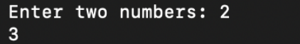

OUTPUT:
