

Foundations of Programming
Assignment No. : 16

PROBLEM STATEMENT:
Write a program in C to accept a list of integers and partition the list into two sublists containing even and odd numbers

ALGORITHM:
Step 1: START
Step 2: Input N
Step 3: Input N into a array
Step 4: For each element
If num % 2 == 0 -> add to even list
Else -> add to odd list
Step 5: Display even numbers
Step 6: Display odd numbers
Step 7: STOP

INPUT:
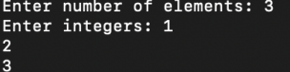

OUTPUT:
