

Foundations of Programming
Assignment No. : 17

PROBLEM STATEMENT:
Write a program in C to accept number of terms & sum of sine series

ALGORITHM:
Step 1: START
Step 2: Input value of x
Step 3: Input number of terms n
Step 4: Initialize variables
SUM = 0
SIGN = 1
Step 5: for i = I to n
Calc term, term = x^(2i-1)/(2i-1)!
Step 6: If sign = 1, the sum += term
Else sum = sum – term
Change sign = (-sign)
Step 7: STOP

INPUT:
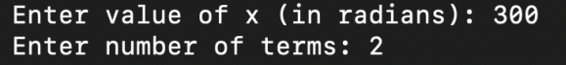

OUTPUT:

