

Foundations of Programming
Assignment No. : 18

PROBLEM STATEMENT:
Write a program in C that accepts a string from the user and performs the following string operations
- Calculate length of string
- String reversal
- Equality check of two strings
- Check palindrome
- Check substring

ALGORITHM:
Step 1: START
Step 2: Input str1
Step 3: Input str2
- Length of string
Len() function and increament
- String reversal
Swap array str[1] and str[2]
- Palindrome
Compare str1 and reverse str1
If equal “Palindrome” else “Nope”
- Substring
Compare sub with part of str1
If match “Substring” else “Nope”
Step 4: STOP

INPUT:
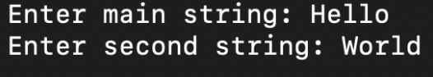

OUTPUT:
