

Foundations of Programming
Assignment No. : 20

PROBLEM STATEMENT:
Write a program in C function to swap two numbers with and without using pointers

ALGORITHM:
Step 1: START
Step 2: Declare variable a, b
Step 3: Input two number from user
Step 4: Call function swap(a,b)
a = temp
b = a
temp = a
Step 5: Call function
Step 6: Print swapped values
Step 7: STOP

INPUT:
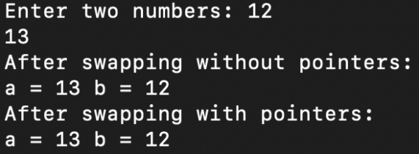

OUTPUT:



