

Foundations of Programming
Assignment No. : 22

PROBLEM STATEMENT:
Write a menu driven program in C to perform various string operation

ALGORITHM:
Step 1: START
Step 2: Declare character array str1 and str2
Step 3: String operations to compare, concentration length and copy
Step 4: Use do while loop to ensure user enter on and two tring
Step 5: Switch case:
Case 1: strcmp(str1, str2)
Case 2: strcal(str1, str2)
Case 3: strlen(str1, str2)
Case 4: strcpy(str1, str2)
Step 6: Display result
Step 7: STOP

INPUT:
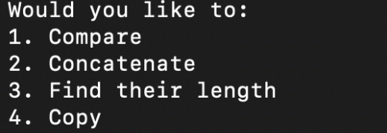

OUTPUT:
