Computational Geometry
Final Report
Spring ‘19

VLASSIS PANAGIOTIS
1115201400022

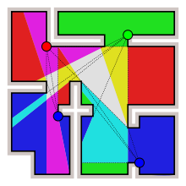
“Art Gallery Theorems and Visibility Graphs”

Table of Contents
1. Art Gallery Theorems 3
1.1 General 3
1.2 Related Problems 3
1.2.1 Art gallery theorem 4
1.2.2 Orthogonal Prison yard problem 5
1.2.4 Orthogonal polygons with h holes 8
1.2.5 Polygons with h holes 11
2. Visibility graphs 13
2.1 General 13
2.2 Obstructions to visibility 13
2.3 Goals 14
2.4 Types of visibility graphs 14
2.5 Open problems 14

1. Art Gallery Theorems

1.1 General
Definitions:
Art gallery theorem: A typical “art gallery theorem” provides combinatorial bounds on the number of guards needed to visually cover a polygonal region P (the art gallery) defined by n vertices.
Guard: A point, a line segment, or a line – a source of visibility of illumination.
Interior visibility: A guardcan see a pointif the segment xy is nowhere exterior to P:.
Exterior visibility: A guard x can see a point y outside P if the segment xy is nowhere interior to P; xy may intersect , the boundary of P.
Light bulb
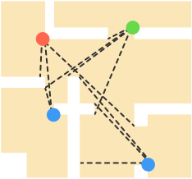
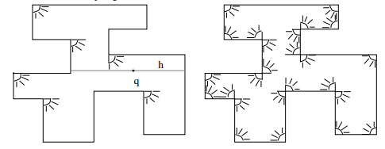

Figure 1.1 Illuminating a orthogonal polygon with orthogonal floodlights
Figure 1.2 Point guards to guard a museum

1.2 Related Problems
The most general combinatorial results obtained to date are summarized in Figure 1.3. For some of the problems, a analysis is following next.
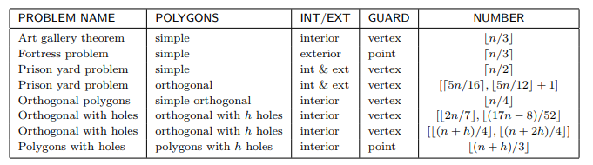
Figure 1.3 Table with problems related to art gallery theorems

1.2.1 Art gallery theorem

Definition: Any simple polygonal museum with n walls can be guarded by at most guards.
S.Fisk (1978) Short Proof
- First, the polygon is triangulated (without adding extra vertices). It is known that vertices of the resulting triangulation graph may be 3-colored.
- Clearly, under a 3-coloring, every triangle must have all three colors.
- The vertices with any color form a valid guard set, because every triangle of the polygon is guarded by its vertex with same color.
- Since the three colors partition the n vertices of the polygon, the color with the fewest vertices defines a valid guard set at most guards.

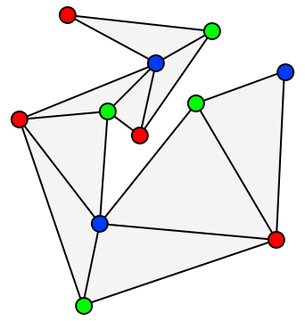

Figure 1.4 A 3-coloring of the vertices of a triangulated polygon. The blue vertices form a set of three guards, as few as is guaranteed by the art gallery theorem. However, this set is not optimal: the same polygon can be guarded by only two guards.

S.Fisk (1978) Constructive Proof
- Algorithm (or sequence of steps) that tells us exactly where to place the guards. To show that bound in the theorem is tight, consider the museum with 15 walls in the shape of a comb.
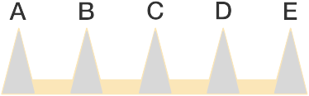

Figure 1.5 Museum in shape of a comb
- Then the guard for each point (A,B,C,D,E) must be stationed within the shaded triangle with related vertex (A,B,C,D,E).
- Since these triagles do not overlap, at least 5 guards are needed. But by the Art Gallery Theorem, guards are also sufficient, which we can be observe by placing the guards at the lower left corner of each shaded triangle.
- In general, the comb museum layout gives an example of a museum with 3n walls that requires exactly guards, which shows that the bound in the theorem is best possible.

1.2.2 Orthogonal Prison yard problem

In the prison yard problem, we are required to guard simaltaneously the interior and the exterior of a polygon. For arbitrary polygons this problem is closed. For orthogonal polygons, the problem reamins open. An upper bound was found by Hoffman & Krieger (1996), who showed that (resp.) vertex guards (resp. point) guards are always sufficient to guard the interior and the exterior of an orthogonal polygon polygon with n vertices and holes.
This bound was obtained via the following graph-coloring theorem.via the following graph-coloring theorem. Every plane, bipartite, 2-connected graph has an even triangulation (all nodes have even degree) and therefore the resulting graph is 3-colorable.
They also conjecture:
Conjecture (HK93): There is a constant c such that any orthogonal prison yard can be guarded with vertex guards.
This bound was subsequently improved to by Michael,Pinciu (2012).
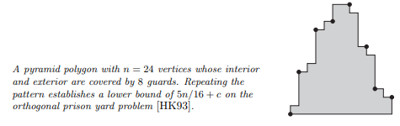
Figure 1.6

1.2.3 Orthogonal polygons without holes
Theorem (Kahn,Klawe,Kleitman 1980):guards are sometimes necessary and always sufficient to cover the interior of an orthogonal polygon of n vertices.
Proof:
- Necessity is established by the orthogonal version of Chvatal’s comb example: one guard is needed for each tong in Figure 1.7.
- For sufficiency, construct a graph G from a quadrilateralization of P by adding both diagonals to each quadrilateral, as illustrated in Figure 1.8. Although it is not immediately obvious, G is planar, and therefore 4-colorable. We can establish 4-colorability without invoking the Four Color Theorem as Follows.
  - Let Q be the dual of the quadrilateralization of P: each node of Q corresponds to a quadrilateral, and two nodes are connected by an arc if their quadrilaterals share a side. Then Q must be a tree, for if it contained a cycle, this would imply that P has a hole.
  - Now proceed by induction. Remove any leaf quadrilateral q, leaving the tree Q’. Since q has degree 1, it may be removed by cutting along a single diagonal d of quadrilateralization. Four-color Q’ by the induction hypothesis, and reattach q to Q’. Two of q’s vertices are assigned different colors at the reattachment points, the endpoint of d, and the other two vertices of q can be assigned the remaining colors.

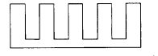

Figure 1.7 Orthogonal polygon establishes [n/4] necessity.

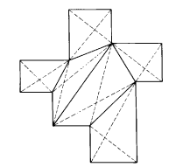

Figure 1.8 A 4-colorable graph derived from a quadrilateralization by adding all quadrilateral diagonals.

  - Since the quadrilaterals cover P and are convex placing guards at the vertices assigned the least frequently used color will cover the interior of P. As this color must be used no more than [n/4] times, the theorem is established. ⸋
Note that the quadrilaterals clipped in this proof are “orthogonal ears”; thus every orthogonal polygon has at least two such ears.

1.2.4 Orthogonal polygons with h holes

- Shermer’s Conjecture I (1982): Any orthogonal polygon with n vertices and h holes can always be guarded by vertex guards.
Lemma 1 : For any quadrilateralization Q of an orthogonal polygon with one hole, the graph is 4-colorable, although sometimes we have to split a vertex into two in order to get a legal 4-coloring.
Proof of Shermer’s Conjecture I:
- Let us first consider the dual graph of the quadrilateralization of the polygon from Fig. 1.9. It consists of four cycles connected by single edges, as illustrated in Fig. 1.10. Cutting along three diagonals of the quadrilateralization results in four one-hole polygons with quadrilateralizations and their quadrilateralization graphs, i=1,2,3,4, respectively. These polygons are usually not orthogonal, but it is easy to see that for each i=1,2,3,4, there exists a one-hole orthogonal polygonwith a quadrilateralization graphisomorphic to graph.Thus by Lemma 1, all graphs, i=1,2,3,4, are 4-colorable, after splitting at most four vertices in total. Now, we can reunite the polygons, thus getting a 4-coloring of graphwith at most four splits (we can recolor graphs, i=1,2,3,4, if necessary). The least frequently used color will be used not more than times.
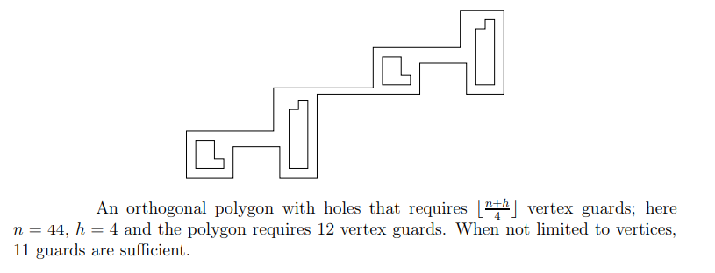
Figure 1.9
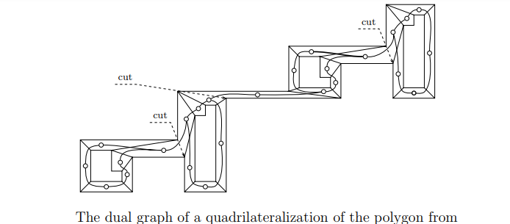
Figure 1.10
Figure 1.9
- The same argument can be applied to any orthogonal polygon with h holes, but only if the dual graph consists of h cycles connected by trees: cut the polygon along h − 1 diagonals of the quadrilateralization to get h “orthogonal” polygons with one hole, 4-color all graphs, i=1,2,…,h, and reunite the polygons. Placing guards at the vertices assigned to the least frequently used color (at most times) will cover the interior of P. This is the case when no two cycles in the dual graph have a vertex in common.
- Now, let us consider the dual graph of the quadrilateralization of the polygon in Fig. 1.11. It has two cycles with only one vertex v in common. We can also apply Lemma 1 to this case: we have to split the graph and duplicate vertex v, thus getting quadrilateralization graphsand, respectively. We can obtain a 4-coloring of the graphfrom 4-colorings of graphsand, and the least frequently used color must be used at mosttimes.
- Furthermore, we can extend this observation to any number of holes only if any two cycles of the dual graph have only one vertex in common, and any such vertex is a cut-vertex. More precisely, suppose that the dual graph of the quadrilateralization of an orthogonal polygon consists of h cycles, any two of them having only one vertex in common, and any such vertex is a cut-vertex — let v₁,...,v_{h-1} be these cut-vertices. We have to split the dual graph and duplicate vertices v₁,...,v_{h-1} , thus getting h cycles and their corresponding graphs ,…,, each of them isomorphic to a quadrilateralization graph of a one-hole orthogonal polygon, and each of them 4- colorable after splitting at most one vertex in each graph (by Lemma 1). Now, we can obtain a 4-coloring of graphby reuniting and possibly recoloring 4-colorings of graphsi = 1,...,h (compare Fig 1.11). As we have split at most h vertices in total, the least frequently used color is used at most times.
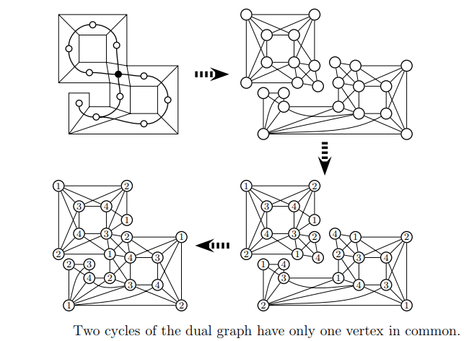

Hence by combining all the above observations, the thesis of Conjecture I follows.
Figure 1.11

1.2.5 Polygons with h holes

J.Sidarto discovered the one-hole polygon shown in Figure 1.12.a. It has n=8 vertices, h=1 hole, and requires 3 guards. Note that 3>. Shermer discovered the polygons in Figures 1.12.b and 1.12.c, which also have 8 vertices and requires 3 guards.
These one-hole examples can be extended to establishnecessity for one hole: Figures 1.13a and 1.13.b show two examples for n=11, due, respectively, to Shermer and Delcher.
Finally, the examples can be extended to more than one hole: Figure 1.14 shows Shermer’s method of stiching together copies of the basic one-hole example. The polygon shown has n=24 vertices, h=3 holes, and requires 9 guards. This example establishesnecessity for h holes.
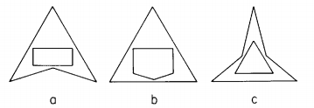

Figure 1.12 One hole polygons of 8 vertices that require 3 guards

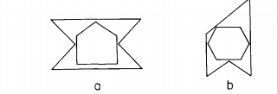

Figure 1.13 One-hole polygon of 11 vertices that require 4 guards

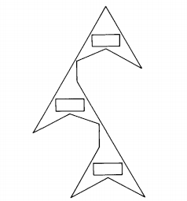

Figure 1.14 A polygon of 24 vertices with 3 holes that requires 9 guards

The following theorem summarizes the implications of these examples:
- Shermer’s Conjecture II (1982): Any polygon with n vertices and h holes can be guarded bypoint guards.

2. Visibility graphs

2.1 General

Whereas art gallery theorems seek to encapsulate an environment’s visibility into one function of n, the study of visibility graphs endeavors to uncover the more finegrained structure of visibility. The original impetus for their investigation came from pattern recognition, and its connection to shape continues to be one of its primary sources of motivation.

- Visibility graph: A graph with a node for each object, and arcs between objects that can see one another.
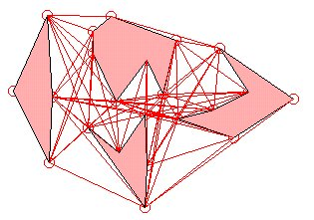

2.2 Obstructions to visibility

For polygon vertices, x sees y if xy is nowhere exterior to polygon, just as in art gallery visibility, this implies that polygon edges are part of the visibility graph. For segment endpoints x sees y if the closed segment xy intersects the union of all the segments either in just the two endpoints, or in the entire closed segment. This disallows grazing contact with a segment, but includes the segments themselves in the graph.

2.3 Goals
- Characterization: asks for a precise delimiting of the class of graphs realizable by a certain class of geometric objects.
- Recognition: asks for an algorithm to recognize when a graph is visibility graph
- Reconstruction: asks for an algorithm that will take a visibility graph as input, and output a geometric realization.
- Counting: concerned with the number of visibility graphs under various restrictions.

2.4 Types of visibility graphs
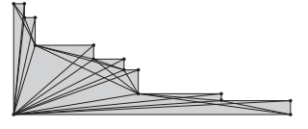
Point
Vertex
Endpoint
Obstacle
Visibility graph
Segment
Figure 2.1
A staircase polygon and its vertex visibility graph

Invisibility graph

2.5 Open problems

- Given a visibility graph G and a Hamiltonian circuit C, construct in polynomial time a simple polygon such that its vertex visibility graph is G, with C corresponding to the polygon’s boundary.
- Given a visibility graph G of a simple polygon P, find the Hamiltionian cycle that corresponds to the boundary of P.
- Develop an algorithm to recognize whether a polygon vertex visibility graph is planar. Necessary and sufficient conditions are known.

