Υπολογιστική Γεωμετρία

Παρουσίαση Τελικής Εργασίας

“Art Gallery Theorems and Visibility Graphs”
based on
Joseph O’Rourke, Visibility (2017)

ΒΛΑΣΣΗΣ ΠΑΝΑΓΙΩΤΗΣ
1115201400022

Εαρινό εξάμηνο
Ακαδ. Έτος: 2018-19

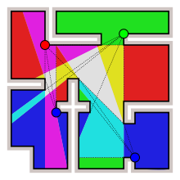

Table of Contents
1. Art Gallery Theorems 3
1.1 General 3
1.2 Related Problems 4
1.2.1 Art gallery theorem 4
1.2.2 Orthogonal Prison yard problem 5
1.2.3 Orthogonal polygons with h holes 6
1.2.4 Polygons with h holes 6
2. Visibility graphs 7
2.1 General 7
2.2 Obstructions to visibility 7
2.3 Goals 8
2.4 Types of visibility graphs 8
2.5 Open problems 8

1. Art Gallery Theorems

1.1 General
A typical “art gallery theorem” provides combinatorial bounds on the number of guards needed to visually cover a polygonal region P (the art gallery) defined by n vertices.

Point
Guard
Vertex
Line
A source of visibility
or illumination
Light bulb
Line segment

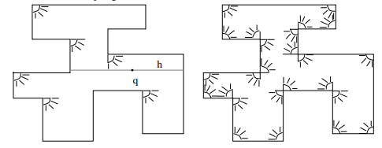
Figure 1.1 Illuminating a orthogonal polygon with orthogonal floodlights

1.2 Related Problems
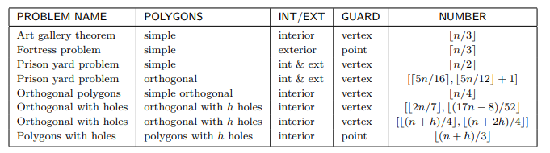
Figure 1.2 Table with problems related to art gallery theorems

1.2.1 Art gallery theorem

- Definition: Any simple polygonal museum with n walls can be guarded
by at most guards.
S.Fisk (1978) Constructive Proof
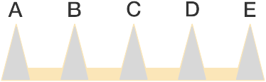
- Algorithm (or sequence of steps) that tells us exactly where to place the guards. To show that bound in the theorem is tight, consider the museum with 15 walls in the shape of a comb.

Figure 1.3 Museum in shape of a comb
- Then the guard for each point (A,B,C,D,E) must be stationed within the shaded triangle with related vertex (A,B,C,D,E).
- Since these triagles do not overlap, at least 5 guards are needed. But by the Art Gallery Theorem, guards are also sufficient, which we can be observe by placing the guards at the lower left corner of each shaded triangle.
- In general, the comb museum layout gives an example of a museum with 3n walls that requires exactly guards, which shows that the bound in the theorem is best possible.

1.2.2 Orthogonal Prison yard problem

- How many vertex guards are needed to cover both the interior and the exterior of an orthogonal polygon?
- An upper bound of was obtained by Hoffman,Kriegel (1996) via the following graph-coloring theorem. Every plane, bipartite, 2-connected graph has an even triangulation (all nodes have even degree) and therefore the resulting graph is 3-colorable.
- This bound was subsequently improved to by Michael,Pinciu (2012)

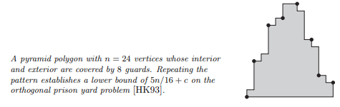
Figure 1.4

1.2.3 Orthogonal polygons with h holes

- Shermer’s Conjecture I (1982): Any orthogonal polygon with n vertices and h holes can always be guarded by vertex guards.
- Theorem O’Roorke (1987): Any orthogonal polygon with n vertices and h holes can always be guarded by vertex guards.
- Theorem Aggarwal (1984): Shermer’s Conjecture is true for h=1,2

1.2.4 Polygons with h holes

- Shermer’s Conjecture II (1982): Any polygon with n vertices and h holes can be guarded by point guards.

2. Visibility graphs

2.1 General

Whereas art gallery theorems seek to encapsulate an environment’s visibility into one function of n, the study of visibility graphs endeavors to uncover the more finegrained structure of visibility. The original impetus for their investigation came from pattern recognition, and its connection to shape continues to be one of its primary sources of motivation.

- Visibility graph: A graph with a node for each object, and arcs between objects that can see one another.
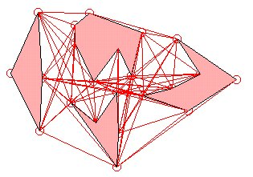

2.2 Obstructions to visibility

For polygon vertices, x sees y if xy is nowhere exterior to polygon, just as in art gallery visibility, this implies that polygon edges are part of the visibility graph. For segment endpoints x sees y if the closed segment xy intersects the union of all the segments either in just the two endpoints, or in the entire closed segment. This disallows grazing contact with a segment, but includes the segments themselves in the graph.

2.3 Goals
- Characterization: asks for a precise delimiting of the class of graphs realizable by a certain class of geometric objects.
- Recognition: asks for an algorithm to recognize when a graph is visibility graph
- Reconstruction: asks for an algorithm that will take a visibility graph as input, and output a geometric realization.
- Counting: concerned with the number of visibility graphs under various restrictions.

2.4 Types of visibility graphs
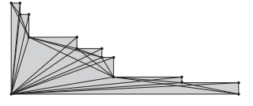
Point
Vertex
Endpoint
Obstacle
Visibility graph
Segment
Figure 2.1
A staircase polygon and its vertex visibility graph

Invisibility graph

2.5 Open problems

- Given a visibility graph G and a Hamiltonian circuit C, construct in polynomial time a simple polygon such that its vertex visibility graph is G, with C corresponding to the polygon’s boundary.
- Given a visibility graph G of a simple polygon P, find the Hamiltionian cycle that corresponds to the boundary of P.
- Develop an algorithm to recognize whether a polygon vertex visibility graph is planar. Necessary and sufficient conditions are known.

