Multi-Model Recommendation Systems In
e-commerce

Instructor: Md Faisal Kabir,
Member: Vu M H Tran
Arjun Kumar
Brandon Beck
Blake Wilson

CMPSC 445: Machine Learning in Applied Data Science

Abstract
In recent years, online shopping has grown rapidly, making recommendation systems an important part of modern e-commerce platforms. A well-designed recommendation system helps users discover relevant products more easily and improves their overall shopping experience. In this project, we develop several recommendation approaches to achieve two main goals: recommending products based on user behavior and recommending products based on product content. Specifically, we implement three variants of the KNN algorithm using different types of features, along with two additional models: Alternating Least Squares (ALS) and Light Graph Convolutional Networks (LightGCN). We compare the performance of these approaches in different scenarios. The results show that LightGCN and the KNN model using combined text, numerical, and categorical features achieve the best performance and effectively meet our goals. These findings provide a solid foundation for developing more advanced recommendation systems in real-world applications.

1 Introduction:
In recent years, online shopping has grown rapidly, and e-commerce websites now offer a huge number of products. As a result, it becomes harder for users to find what they are looking for. Without proper support, users may feel overwhelmed and have difficulty choosing suitable products. This is where recommendation systems become important. They help users discover relevant items more easily based on their preferences and behavior, which improves the overall shopping experience. In addition, recommendation systems are also important for businesses, as they can increase website traffic and boost sales. This can be seen in large eCommerce platforms such as Amazon and Walmart, where recommendation systems play a key role in maintaining user engagement and steady growth.
Several approaches have been widely used in recommendation systems. One common method is content-based recommendation, using product information such as name, description, and category to find similar items. Techniques like TF-IDF and cosine similarity are often used in this approach, and they work well when user interaction data is limited. However, content-based methods may struggle to capture user preferences beyond product similarity. Another popular approach is collaborative filtering, which focuses on user behavior, such as clicks or purchases. Methods like matrix factorization, including Alternating Least Squares (ALS), can learn user preferences effectively and provide personalized recommendations. However, these methods often face challenges when there is not enough user interaction data, especially for new users or products. More recently, modern collaborative filtering with graph-based models such as Light Graph Convolutional Networks (LightGCN) have been introduced. These models use relationships between users and items to improve recommendation performance and are able to capture more complex interactions. While they show strong results, they are more complex and require more computational resources.
Although many recommendation methods have been developed, each approach still has its own limitations. Content-based methods mainly rely on product information and may not fully capture user preferences, while traditional collaborative filtering methods depend heavily on user interaction data and often struggle with new users or products. Graph-based models can improve performance, but they are more complex and not always easy to apply in practice. Because of these challenges, it is important to explore and compare different approaches to understand their strengths and weaknesses. In this project, we aim to build and evaluate multiple recommendation models using different types of data, including product content and user behavior. By comparing these approaches in the same setting, we hope to gain better insights into which methods work best and provide a foundation for developing more effective recommendation systems in real-world e-commerce applications.

1.1 Our Contribution
- We created and prepared a dataset for the recommendation task based on an e-commerce setting (Vu).
- We performed exploratory data analysis (EDA) to understand better the data distribution and the main characteristics of the products and user interactions (Vu, Brandon, Blake, and Arjun).
- We applied feature engineering to transform raw product information into useful inputs for recommendation models (Vu, Brandon, Blake, and Arjun).
- For product-content recommendation, we built and tested three different KNN-based approaches:
- KNN using numerical and categorical features (Blake)
- KNN using text features (Brandon)
- KNN using a combination of numerical, categorical, and text features (Arjun)
- For user-behavior recommendation, we implemented two collaborative recommendation models: ALS and LightGCN (Vu).
- We compared the performance of these approaches to understand their strengths and weaknesses in different recommendation scenarios (Vu, Brandon, Blake, and Arjun).

2. Material and methods:

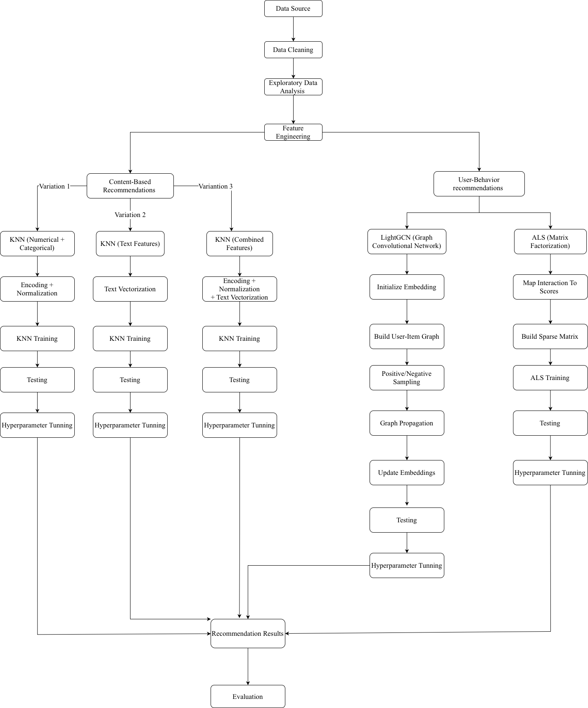
The process begins with collecting data from the source, followed by data cleaning and exploratory data analysis (EDA) to better understand the dataset. After that, feature engineering is applied to prepare the data for different recommendation approaches.
The system is then divided into two main parts. The first part focuses on content-based recommendation, where three variants of the KNN algorithm are developed using different types of features, including numerical and categorical data, text data, and a combination of all features. Each approach involves feature transformation, model training, testing, and tuning.
The second part focuses on user-behavior-based recommendation. In this part, two models are implemented. The first model is ALS, which uses user interaction data to build a sparse matrix and learn latent representations. The second model is LightGCN, which represents user-item interactions as a graph, initializes embeddings for users and items, and updates them through graph-based propagation. Both models are trained, tested, and tuned to improve performance.
Finally, the outputs from all models are used to generate recommendation results, which are then evaluated and compared.

2.1 Dataset Description
The dataset used in this project was collected from a custom e-commerce application. It includes two main parts: product information and user interaction data. This dataset was chosen because it reflects a real online shopping environment, where both product details and user behavior are important for building recommendation systems.
The product dataset contains 244 records, each with different attributes that describe the product. These include basic information such as name, brand, and category, as well as price and product descriptions. Text fields like short and long descriptions help capture the meaning of the product, while numerical and categorical features such as price and category help describe its structure.

The main product features are:
- product_id: unique identifier for each product
- product_name: name of the product
- brand_name: brand of the product
- category_name: main category
- sub_category_name: sub-category
- price: original price
- offer_price: discounted price
- qty: available quantity
- product_type: type of product (such as featured or new)
- short_description: short text description
- long_description: detailed description
- created_at: time when the product was added.
The user interaction dataset contains 10,000 records, where each record represents an interaction between a user and a product. These interactions reflect user behavior and preferences, which are important for collaborative recommendation models.
The main interaction features are:
- user_id: unique identifier for each user
- product_id: identifier of the product
- interaction_type: type of interaction (such as click, add to cart, add to Wishlist, or rating).
In this project, different types of data are used depending on the model. For content-based recommendation, product features such as text, category, and price are used to find similar items. For user-behavior-based (collaborative) models, interaction data is used to learn user preferences and recommend relevant products

2.2 Models Used

2.2.1 Content-Based recommendation
We use the K-Nearest Neighbors (KNN) algorithm to recommend products based on similarity between items. The idea is to find products that are similar to a given product using different types of features.
We implement three different approaches:

KNN with Numerical and Categorical Features
This KNN approach recommends products by using categorical and numerical features from the dataset to recommend similar products to users. The model uses category, sub-category, brand, and price as the input features. It focuses on product classifications and price information to measure similarity between items.

- Libraries Used
This model was implemented using scikit-learn, scipy, and pandas

- Methods
Categorical features - The features, category, sub-category, and brand, are encrypted using One-Hot Encoding to convert each category into a binary representation.
Numerical Features - The Price feature is standardized using StandardScaler so it contributes fairly to the model.
Next, both feature types are combined into a single feature matrix using horizontal stacking.
A KNN model is then trained using Euclidean distance as the distance metric. When given a product, the model identifies other similar products based on category, sub_category, brand, and price.

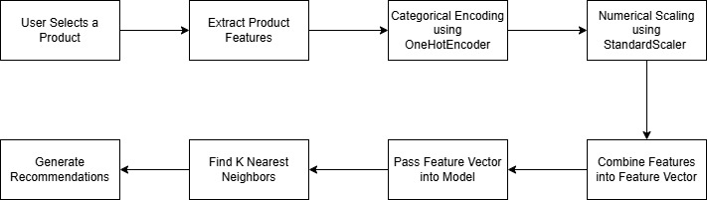
Figure 1 Model Flowchart

- Key Idea
The goal is to recommend similar products to users using only categorical and numerical columns. This allows the model to recommend items that are of the same category and around the same price, without using text description.

KNN with Text Features

[Brandon]

KNN with Combined Features
This approach of KNN combines multiple types of product features, including text, categorical, and numerical data, to improve the recommendation performance. Instead of relying on a single feature type, this method integrates all relevant product information to ensure a general representation of each item.
- Why do we use Combined Features
Using only one category type, like text or category, may limit the model’s ability to fully understand the product similarity. By combining text descriptions, categorical attributes, and numerical values, the model can generate a more accurate and meaningful recommendation. directly.
- Library Used
This model was implemented using scikit-learn, SciPy, and pandas library.
- Method
This process starts with data preprocessing and feature engineering:
Text Features- include product names, short descriptions, and long descriptions.
TD-IDF vectorization is then applied to convert the text into numerical representations. Additional weighting is applied to product names to increase their importance.
Categorical Features- Features such as brand name, category, and sub-category are encoded using One-Hot Encoding to transform them into numerical format.
Numerical Features- The price feature is scaled using Standard Scaler to normalize its values. The scaled data is then converted into a sparce matrix format.
Next, all feature types are combined into a single feature matrix using horizontal stacking. This combined matrix represents each product in a high-dimensional space.
A KNN model is then trained using cosine similarity as the distance metric. For a given product in the dataset, the model identifies the most similar products based on their combined features.
- Key Idea
The goal is to compute similarity between the products using descriptions, category/brand, and price. This allows the model to recommend items that are similar across multiple dimensions rather than just one.

2.2.2 User-Behavior Recommendation

ALS (Matrix Factorization)
ALS (Alternating Least Squares) is a collaborative filtering method that learns user preferences from interaction data. Instead of using product features, this model focuses on how users interact with products and uses a matrix factorization approach.
- Why do we use ALS
ALS is useful for learning hidden patterns from user behavior. It can recommend products based on interaction history, even when product descriptions are not used directly.
- Library Used
This model was implemented using the Implicit library.
- Method
The process starts by converting user interactions into numerical scores. Since the dataset is based on implicit feedback, there are no explicit ratings from users. Instead, different types of interactions are assigned different weights to represent their importance. In this project, the interaction weights are defined as:
  - click: 0.05
  - add to wishlist: 0.7
  - add to cart: 1.0
  - rating (R1–R5):Rating level
Next, a user-item matrix is built, where each row represents a user, each column represents a product, and each value represents the interaction score. This matrix is usually sparse because most users only interact with a small number of products.
ALS then factorizes this matrix into two smaller matrices: a user embedding matrix (also known as user factors) and an item embedding matrix (also known as item/product factors). The model works by repeatedly updating one matrix while keeping the other fixed. In other words, it first updates user embeddings based on item embeddings, then updates item embeddings based on user embeddings. This alternating process continues until the model becomes stable.
- Key Idea
The goal is to approximate:
R ≈ U × Vᵀ
Fix item embeddings (item factors) and update/solve user embeddings (user factors):
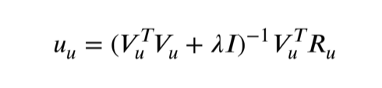

Fix users embeddings (user factors) and update/solve item embeddings (item factors):
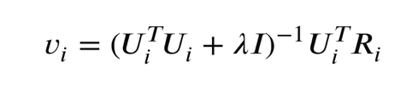

where:
R: user-item interaction matrix,
U: user embeddings,
V: item embeddings.
𝜆: a regularization parameter to prevent overfitting.
𝐼: the identity matrix.
- The hyperparameters:
  - factors: 50 — number of latent features used to represent users and items
  - regularization: 0.05 — controls overfitting by penalizing large values
  - iterations: 100 — number of times the model updates user and item matrices
  - alpha: 10 — controls the confidence level of interaction strength in implicit feedback
- Diagram:
User-Item Interaction Data
↓
Convert Interaction to Score
↓
Build Sparse Matrix
↓
Alternating Optimization:
Fix Items - Update Users
Fix Users - Update Items
↓
Final Embeddings
↓
Recommendation
Not Done

LightGCN (Graph-Based Model)
LightGCN is a graph-based recommendation model that learns from the relationships between users and products. Instead of using a matrix factorization approach, it represents the recommendation problem as a graph.
- Why do we use LightGCN
LightGCN can capture more complex relationships between users and products by using the structure of the interaction graph. This makes it a strong choice for personalized recommendation, especially when interaction data is limited.
- Libraries Used
This model was implemented using PyTorch and PyTorch Geometric (PyG).
- Method
First, user-product interactions are used to build a graph, where users and products are treated as nodes, and interactions between them are treated as edges.
Next, each user and each item is given a random embedding at the beginning. The model then updates these embeddings by passing information through the graph over multiple layers. During training, the model uses positive and negative sampling:
  - Positive items are items the user has interacted with
  - Negative items are items the user has not interacted with
The model learns to give higher scores to positive items than to negative ones. After training, the final embeddings are used to recommend products.
- Key Idea
The model is trained using Bayesian Personalized Ranking loss:
where:
- σ is the logistic sigmoid function.
- DS​ is the set of triplets (u,i,j), such that user u has interacted with item i but not with item j.
- λ is a regularization parameter to prevent overfitting.
- ∥U∥² and ∥I∥² are the regularization terms for user and item matrices.
- The hyperparameters:
  - embedding_dim: 64 — size of the vector used to represent each user and item
  - num_layers: 3 — number of graph propagation steps
  - batch_size: 30 — number of samples used in each training step
  - epochs: 500 — number of full training iterations
  - learning_rate: 0.01 — step size used to update model parameters
  - Optimization: Adam – Faster convergence when updating parameters

User & Item Nodes
↓
Initialize Embeddings
↓
Build User-Item Graph
↓
Sampling (Positive & Negative)
↓
Graph Propagation (3 Layers)
↓
Updated Embeddings
↓
Score Prediction
Not Done

2.3 Performance Evaluation
The main metrics used are Precision@K and Recall@K. Precision@K measures the proportion of recommended items in the top K results that are relevant to the user. Recall@K measures how many of the relevant items are successfully retrieved within the top K recommendations. These metrics help us understand both the accuracy and coverage of the recommendation models.

To evaluate the models, the interaction data is used as the ground truth. For each user, a set of interacted items represents their preferences. The models generate a list of top K recommended items, and these results are compared with the actual interactions to compute the evaluation metrics.
For training and evaluation, the dataset is divided using the train_test_split function from the scikit-learn library. In this project, 60% of the data is used for training and 40% is used for testing. This ensures that the models are evaluated on unseen data and can generalize to new users and interactions.

3. Experimental Analysis:

a. KNN with Numerical and Categorical Features
The KNN model using numerical and categorical features was used in our project to measure how well product recommendations can be without using text-based data. This model focuses on categorical and numerical features including category, sub-category, brand, and price.
- Results Overview
The model was able to group products that share the same category, sub-category, and brand, especially when they fell in similar price ranges. In many cases, the recommendations given were related to the initial product and looked like they could be actual recommendations given by a more advanced model.

Example of Model Working:

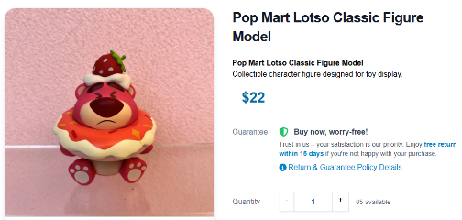
Figure 2 Initial Product Selected
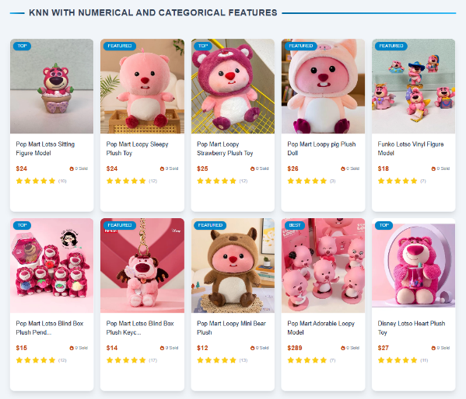
Figure 3 Recommended Products

On the left is the selected product and on the right are the products that are recommended under the initial product. All the recommendations given by the model look realistic for this item.

However, a key issue that we observed during testing was that the model would sometimes recommend the exact same product as the user initially selected. This occurred when multiple products share the exact same category, sub-category, and brand, and had similar or exact prices. As a result, the feature vectors for some of the products were identical, so the model had a difficult time distinguishing between the products and would return the same exact product.

Example of Error in Model:


Figure 4 Initial Product Selected

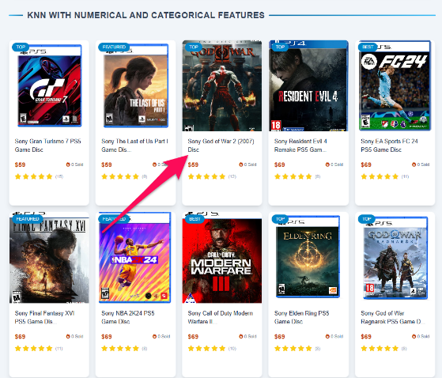
Figure 5 Recommended Products

Again, the left figure is the initial product, and the right figure is the products recommended for it. In the recommendations list for “Sony God of War 2 (2007) Disc” we can see that “Sony God of War 2 (2007) Disc” is a recommended product. This is an error that occurs due to all the products sharing the same category (Electronics), sub-category (Game Disc), and brand (Sony). Also, as shown in Figure 5, the model lists all the $59 Sony games first, then $69 games.

- Conclusion
The KNN model using numerical and categorical data can be implemented effectively in a simple content-based recommendation system. The model performs well at grouping products with similar categories, sub-category, brand, and pricing information. However, there are issues that can occur like recommending the same product that is initially selected. Overall, this is a simple and interpretable approach to a product recommendation system but including features like product descriptions significantly improves recommendations.

b. KNN with Text Features
[Brandon]

c. KNN with Combined Features
[Arjun]

d. ALS and LightGCN:
- Results Overview
The performance of the models is evaluated using Precision@K and Recall@K. Multiple experiments were conducted by changing model settings such as hyperparameters and observing their impact on performance.
Not Done
- Hyperparameter Analysis
We also tested different hyperparameter values to see how they affect performance. For example, in LightGCN, we varied the number of layers and embedding size. We observed that increasing the number of layers helps the model capture more information from the graph, but too many layers may lead to over-smoothing.
Similarly, for ALS, increasing the number of factors improves the model’s ability to learn user preferences, but may also increase training time.
Not Done

- Model Comparison
From the experiments, we observe that LightGCN performs better than ALS when user interaction data is sparse, such as in the case of new users with very few interactions. This is because LightGCN uses the graph structure to share information between users and items, allowing it to learn even with limited data.
On the other hand, ALS performs very well when the interaction data becomes dense, meaning users have interacted with many products over time. In this case, ALS is able to learn strong user preferences and provide accurate recommendations.
This shows that each model has its own advantage depending on the data condition. LightGCN is more suitable for cold-start or sparse scenarios, while ALS is effective in long-term usage where sufficient interaction data is available.
Not Done

- Convergence Analysis
During training, we also observed how the models converge over time. For LightGCN, the training loss decreases steadily as the number of epochs increases, showing that the model is learning effectively. After a certain number of epochs, the improvement becomes smaller, indicating that the model has reached a stable state.
Not Done

