Multi-Model Recommendation Systems In
e-commerce

Instructor: Md Faisal Kabir,
Member: Vu M H Tran
Arjun Kumar
Brandon Beck
Blake Wilson

COMPSC 445: Machine Learning in Applied Data Science

Abstract
In recent years, online shopping has grown rapidly, making recommendation systems an important part of modern e-commerce platforms. A well-designed recommendation system helps users discover relevant products more easily and improves their overall shopping experience. In this project, we develop several recommendation approaches to achieve two main goals: recommending products based on user behavior and recommending products based on product content. Specifically, we implement three variants of the KNN algorithm using different types of features, along with two additional models: Alternating Least Squares (ALS) and Light Graph Convolutional Networks (LightGCN). We compare the performance of these approaches in different scenarios. The results show that LightGCN and the KNN model using combined text, numerical, and categorical features achieve the best performance and effectively meet our goals. These findings provide a solid foundation for developing more advanced recommendation systems in real-world applications.

1 Introduction:
In recent years, online shopping has grown rapidly, and e-commerce websites now offer a huge number of products. As a result, it becomes harder for users to find what they are looking for. Without proper support, users may feel overwhelmed and have difficulty choosing suitable products. This is where recommendation systems become important. They help users discover relevant items more easily based on their preferences and behavior, which improves the overall shopping experience. In addition, recommendation systems are also important for businesses, as they can increase website traffic and boost sales. This can be seen in large eCommerce platforms such as Amazon and Walmart, where recommendation systems play a key role in maintaining user engagement and steady growth.
Several approaches have been widely used in recommendation systems. One common method is content-based recommendation, using product information such as name, description, and category to find similar items. Techniques like TF-IDF and cosine similarity are often used in this approach, and they work well when user interaction data is limited. However, content-based methods may struggle to capture user preferences beyond product similarity. Another popular approach is collaborative filtering, which focuses on user behavior, such as clicks or purchases. Methods like matrix factorization, including Alternating Least Squares (ALS), can learn user preferences effectively and provide personalized recommendations. However, these methods often face challenges when there is not enough user interaction data, especially for new users or products. More recently, modern collaborative filtering with graph-based models such as Light Graph Convolutional Networks (LightGCN) have been introduced. These models use relationships between users and items to improve recommendation performance and are able to capture more complex interactions. While they show strong results, they are more complex and require more computational resources.
Although many recommendation methods have been developed, each approach still has its own limitations. Content-based methods mainly rely on product information and may not fully capture user preferences, while traditional collaborative filtering methods depend heavily on user interaction data and often struggle with new users or products. Graph-based models can improve performance, but they are more complex and not always easy to apply in practice. Because of these challenges, it is important to explore and compare different approaches to understand their strengths and weaknesses. In this project, we aim to build and evaluate multiple recommendation models using different types of data, including product content and user behavior. By comparing these approaches in the same setting, we hope to gain better insights into which methods work best and provide a foundation for developing more effective recommendation systems in real-world e-commerce applications.

1.1 Our Contribution
- We created and prepared a dataset for the recommendation task based on an e-commerce setting (Vu).
- We performed exploratory data analysis (EDA) to understand better the data distribution and the main characteristics of the products and user interactions (Vu, Brandon, Blake, and Arjun).
- We applied feature engineering to transform raw product information into useful inputs for recommendation models (Vu, Brandon, Blake, and Arjun).
- For product-content recommendation, we built and tested three different KNN-based approaches:
- KNN using numerical and categorical features (Blake)
- KNN using text features (Brandon)
- KNN using a combination of numerical, categorical, and text features (Arjun)
- For user-behavior recommendation, we implemented two collaborative recommendation models: ALS and LightGCN (Vu).
- We compared the performance of these approaches to understand their strengths and weaknesses in different recommendation scenarios (Vu, Brandon, Blake, and Arjun).

2. Material and methods:

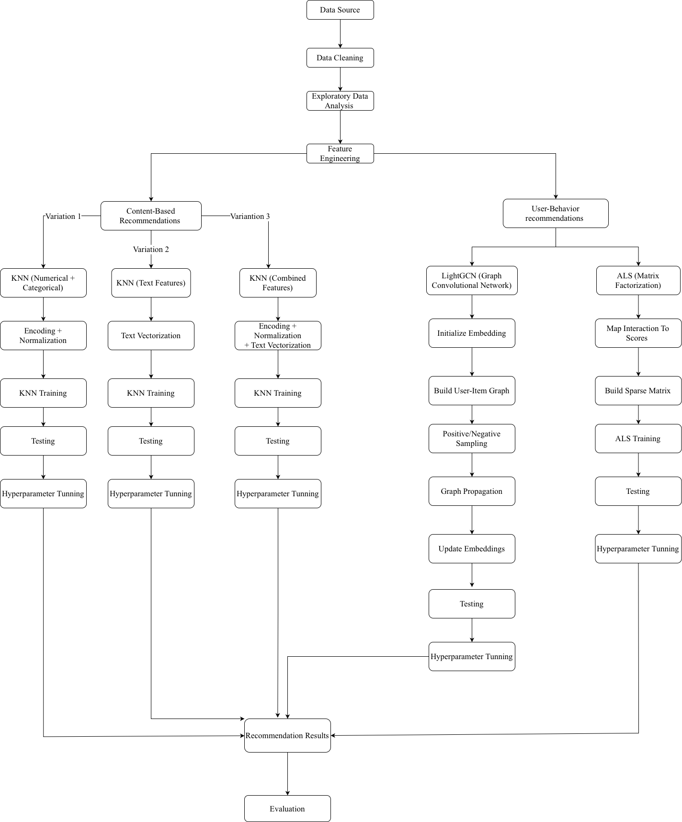
The process begins with collecting data from the source, followed by data cleaning and exploratory data analysis (EDA) to better understand the dataset. After that, feature engineering is applied to prepare the data for different recommendation approaches.
The system is then divided into two main parts. The first part focuses on content-based recommendation, where three variants of the KNN algorithm are developed using different types of features, including numerical and categorical data, text data, and a combination of all features. Each approach involves feature transformation, model training, testing, and tuning.
The second part focuses on user-behavior-based recommendation. In this part, two models are implemented. The first model is ALS, which uses user interaction data to build a sparse matrix and learn latent representations. The second model is LightGCN, which represents user-item interactions as a graph, initializes embeddings for users and items, and updates them through graph-based propagation. Both models are trained, tested, and tuned to improve performance.
Finally, the outputs from all models are used to generate recommendation results, which are then evaluated and compared.

2.1 Dataset Description
The dataset used in this project was collected from a custom e-commerce application. It includes two main parts: product information and user interaction data. This dataset was chosen because it reflects a real online shopping environment, where both product details and user behavior are important for building recommendation systems.
The product dataset contains 244 records, each with different attributes that describe the product. These include basic information such as name, brand, and category, as well as price and product descriptions. Text fields like short and long descriptions help capture the meaning of the product, while numerical and categorical features such as price and category help describe its structure.

The main product features are:
- product_id: unique identifier for each product
- product_name: name of the product
- brand_name: brand of the product
- category_name: main category
- sub_category_name: sub-category
- price: original price
- offer_price: discounted price
- qty: available quantity
- product_type: type of product (such as featured or new)
- short_description: short text description
- long_description: detailed description
- created_at: time when the product was added.
The user interaction dataset contains 10,000 records, where each record represents an interaction between a user and a product. These interactions reflect user behavior and preferences, which are important for collaborative recommendation models.
The main interaction features are:
- user_id: unique identifier for each user
- product_id: identifier of the product
- interaction_type: type of interaction (such as click, add to cart, add to Wishlist, or rating).
In this project, different types of data are used depending on the model. For content-based recommendation, product features such as text, category, and price are used to find similar items. For user-behavior-based (collaborative) models, interaction data is used to learn user preferences and recommend relevant products

2.2 Models Used

2.2.1 Content-Based recommendation
We use the K-Nearest Neighbors (KNN) algorithm to recommend products based on similarity between items. The idea is to find products that are similar to a given product using different types of features.
We implement three different approaches:

KNN with Numerical and Categorical Features

[Blake]

KNN with Text Features
This model uses only text product features like product name, brand name, and description to recommend products.
- Why do we use Text Features
When products have similar wording in their descriptions, or have a similar brand name or product name, this model will determine those to be more similar and recommend them first.
- Library Used
This model was implemented using scikit-learn and pandas libraries.
- Method
The process starts by taking the data from all relevant product features, converting and concatenating the values into one string, with empty text replacing missing values. Repeated weighting was applied to product and brand names to give them importance over the short and long descriptions.

Next, a feature matrix was created using the TfidfVectorizer from scikit-learn where rows represent products and columns represent features. Unigrams and bigrams were used to represent single words and small phrases as features. Stop words were removed for words that appear too often and are not informative to reduce noise in the data. Additionally, minimum and maximum document frequency thresholds (min_df/max_df) were applied to automatically eliminate words that appeared too frequently or infrequently.

Finally, a KNN model was trained using cosine similarity as the distance metric. Using cosine similarity allows the model to find the k nearest neighbors based on similarity between feature vectors.
- Parameters/Hyperparameters Used
The number of k neighbors was set to a maximum of eleven and adjusted based on the size of the dataset to ensure effective similarity comparisons.
- Key Idea
The key idea for this model is to convert text into a numerical value so the model can analyze it and recommend other similar products based on the results.

- Diagram

KNN with Combined Features
This approach of KNN combines multiple types of product features, including text, categorical, and numerical data, to improve the recommendation performance. Instead of relying on a single feature type, this method integrates all relevant product information to ensure a general representation of each item.
- Why do we use Combined Features
Using only one category type, like text or category, may limit the model’s ability to fully understand the product similarity. By combining text descriptions, categorical attributes, and numerical values, the model can generate a more accurate and meaningful recommendation. directly.
- Library Used
This model was implemented using scikit-learn, SciPy, and pandas library.
- Method
This process starts with data preprocessing and feature engineering:
Text Features- include product names, short descriptions, and long descriptions.
TD-IDF vectorization is then applied to convert the text into numerical representations. Additional weighting is applied to product names to increase their importance.
Categorical Features- Features such as brand name, category, and sub-category are encoded using One-Hot Encoding to transform them into numerical format.
Numerical Features- The price feature is scaled using Standard Scaler to normalize its values. The scaled data is then converted into a sparce matrix format.
Next, all feature types are combined into a single feature matrix using horizontal stacking. This combined matrix represents each product in a high-dimensional space.
A KNN model is then trained using cosine similarity as the distance metric. For a given product in the dataset, the model identifies the most similar products based on their combined features.
- Key Idea
The goal is to compute similarity between the products using descriptions, category/brand, and price. This allows the model to recommend items that are similar across multiple dimensions rather than just one.
- Diagram


2.2.2 User-Behavior Recommendation

ALS (Matrix Factorization)
ALS (Alternating Least Squares) is a collaborative filtering method that learns user preferences from interaction data. Instead of using product features, this model focuses on how users interact with products and uses a matrix factorization approach.
- Why do we use ALS
ALS is useful for learning hidden patterns from user behavior. It can recommend products based on interaction history, even when product descriptions are not used directly.
- Library Used
This model was implemented using the Implicit library.
- Method
The process starts by converting user interactions into numerical scores. Since the dataset is based on implicit feedback, there are no explicit ratings from users. Instead, different types of interactions are assigned different weights to represent their importance. In this project, the interaction weights are defined as:
  - click: 0.05
  - add to wishlist: 0.7
  - add to cart: 1.0
  - rating (R1–R5):Rating level
Next, a user-item matrix is built, where each row represents a user, each column represents a product, and each value represents the interaction score. This matrix is usually sparse because most users only interact with a small number of products.
ALS then factorizes this matrix into two smaller matrices: a user embedding matrix (also known as user factors) and an item embedding matrix (also known as item/product factors). The model works by repeatedly updating one matrix while keeping the other fixed. In other words, it first updates user embeddings based on item embeddings, then updates item embeddings based on user embeddings. This alternating process continues until the model becomes stable.
- Key Idea
The goal is to approximate:
R ≈ U × Vᵀ
Fix item embeddings (item factors) and update/solve user embeddings (user factors):
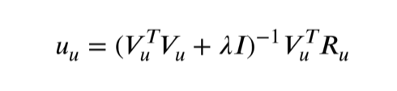

Fix users embeddings (user factors) and update/solve item embeddings (item factors):
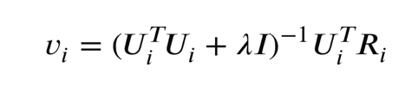

where:
R: user-item interaction matrix,
U: user embeddings,
V: item embeddings.
𝜆: a regularization parameter to prevent overfitting.
𝐼: the identity matrix.
- The hyperparameters:
  - factors: 50 — number of latent features used to represent users and items
  - regularization: 0.05 — controls overfitting by penalizing large values
  - iterations: 100 — number of times the model updates user and item matrices
  - alpha: 10 — controls the confidence level of interaction strength in implicit feedback
- Diagram:
User-Item Interaction Data
↓
Convert Interaction to Score
↓
Build Sparse Matrix
↓
Alternating Optimization:
Fix Items - Update Users
Fix Users - Update Items
↓
Final Embeddings
↓
Recommendation
Not Done

LightGCN (Graph-Based Model)
LightGCN is a graph-based recommendation model that learns from the relationships between users and products. Instead of using a matrix factorization approach, it represents the recommendation problem as a graph.
- Why do we use LightGCN
LightGCN can capture more complex relationships between users and products by using the structure of the interaction graph. This makes it a strong choice for personalized recommendation, especially when interaction data is limited.
- Libraries Used
This model was implemented using PyTorch and PyTorch Geometric (PyG).
- Method
First, user-product interactions are used to build a graph, where users and products are treated as nodes, and interactions between them are treated as edges.
Next, each user and each item is given a random embedding at the beginning. The model then updates these embeddings by passing information through the graph over multiple layers. During training, the model uses positive and negative sampling:
  - Positive items are items the user has interacted with
  - Negative items are items the user has not interacted with
The model learns to give higher scores to positive items than to negative ones. After training, the final embeddings are used to recommend products.
- Key Idea
The model is trained using Bayesian Personalized Ranking loss:
where:
- σ is the logistic sigmoid function.
- DS​ is the set of triplets (u,i,j), such that user u has interacted with item i but not with item j.
- λ is a regularization parameter to prevent overfitting.
- ∥U∥² and ∥I∥² are the regularization terms for user and item matrices.
- The hyperparameters:
  - embedding_dim: 64 — size of the vector used to represent each user and item
  - num_layers: 3 — number of graph propagation steps
  - batch_size: 30 — number of samples used in each training step
  - epochs: 500 — number of full training iterations
  - learning_rate: 0.01 — step size used to update model parameters
  - Optimization: Adam – Faster convergence when updating parameters

User & Item Nodes
↓
Initialize Embeddings
↓
Build User-Item Graph
↓
Sampling (Positive & Negative)
↓
Graph Propagation (3 Layers)
↓
Updated Embeddings
↓
Score Prediction
Not Done

2.3 Performance Evaluation
The main metrics used are Precision@K and Recall@K. Precision@K measures the proportion of recommended items in the top K results that are relevant to the user. Recall@K measures how many of the relevant items are successfully retrieved within the top K recommendations. These metrics help us understand both the accuracy and coverage of the recommendation models.

To evaluate the models, the interaction data is used as the ground truth. For each user, a set of interacted items represents their preferences. The models generate a list of top K recommended items, and these results are compared with the actual interactions to compute the evaluation metrics.
For training and evaluation, the dataset is divided using the train_test_split function from the scikit-learn library. In this project, 60% of the data is used for training and 40% is used for testing. This ensures that the models are evaluated on unseen data and can generalize to new users and interactions.

3. Experimental Analysis:

a. KNN with Numerical and Categorical Features
[Blake]

b. KNN with Text Features

- Results Overview
The performance of the model was evaluated by analyzing the similarity scores and the relevance of recommended products. We tested the model multiple times using different products and observing the recommendations. The products with similar names, brand names, and keywords in the descriptions were consistently recommended and given higher similarity scores.

Figure 3: Example Recommendations for “God of War PS2 Chains of Olympus”


Table: Example Recommendations for Input Product ID 241 (God of War PS2 Chains of Olympus).
Input Product ID | Recommended Product ID |  | Similarity Score
241 | 242 |  | 0.826
241 | 244 |  | 0.820
241 | 67 |  | 0.752
241 | 255 |  | 0.355
241 | 254 |  | 0.322
241 | 248 |  | 0.309
241 | 249 |  | 0.293
241 | 66 |  | 0.292
241 | 71 |  | 0.276

The figure three and table above show the results of searching for the product God of War PS2 Chains of Olympus. This highlights the strength of this model because there are several other products that share many of the same words or phrases. The highest-ranked recommendations are other God of War titles, which share identical or highly similar keywords in their names. As the similarity score decreases, the model begins to recommend other Sony video games that still share relevant terms such as platform or genre, demonstrating that the model maintains meaningful similarity even beyond exact title matches. This behavior is a result of the TF-IDF representation, where shared keywords such as ‘God of War’ are given high importance, leading to strong similarity between related products.

- Hyperparameters Analysis
We analyzed the impact of different hyperparameters on the quality of the recommendations. The number of k neighbors affects how many similar products are returned. Smaller values would produce more specific recommendations while larger values would produce less similar recommendations as the neighbors became more distant. Using unigrams and bigrams improved the model’s ability to capture words and short phrases, leading to more effective similarity comparisons. Applying the maximum and minimum thresholds to reduce noise improved the model as well.
- Model Comparison
The KNN text based model performs well when the product descriptions contain important and meaningful information because it can better identify similarities based on keywords and phrases. Because the model uses product data instead of user data, it can be effective if there is no user information. However, because it only takes text into consideration, it may fall short when comparing certain products that have similar wording but are completely different.

Figure 4: Example of Recommendations for “Lay’s Classic Potato Chips”
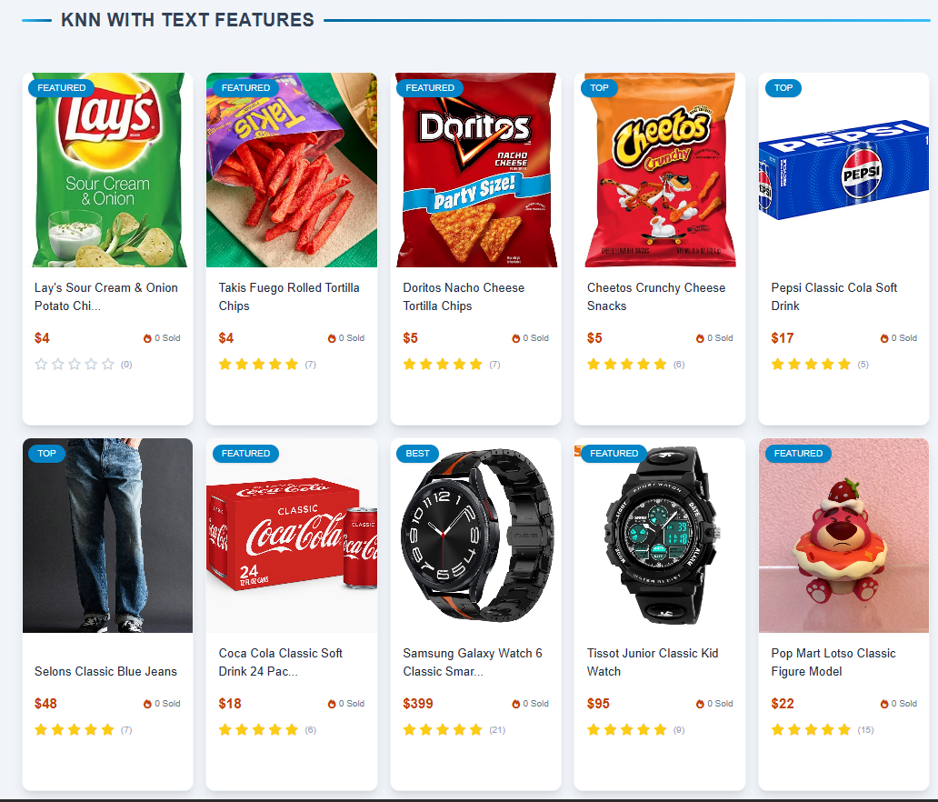
In figure four, the model generated recommendations for the product Lay’s Classic Potato Chips. The first four recommendations are fine, but as the similarity score gets lower, the word “classic” confuses the model. Because the model assigns importance to frequent terms like “classic” within a product’s name or description, it will group products together based on shared words instead of how similar the products actually are.

- Convergence Analysis
The KNN text based model does not use an iterative training process, so convergence is not applicable. Instead, the model is fitted on the TF-IDF feature matrix, so the outputs are stable.

c. KNN with Combined Features:
- Results Overview
The performance of the model was evaluated by looking at similarity scores and how relevant the recommended products were. We tested the model using different products and observed the results. The model consistently recommended products with similar names, descriptions, categories, and brand names, which also had higher similarity scores. Including features like category and price helped improve the recommendations, since products in the same category and similar price range were more likely to be suggested. Overall, combining different types of features helped the model produce more accurate and useful recommendations.
Figure 5: Example Recommendations for “God of War PS2 Chains of Olympus”



Table: Example Recommendations for Input Product ID 241 (God of War PS2 Chains of Olympus).

Input Product ID | Recommended Product ID |  | Similarity Score
241 | 243 |  | 0.856
241 | 244 |  | 0.845
241 | 67 |  | 0.844
241 | 242 |  | 0.838
241 | 255 |  | 0.794
241 | 252 |  | 0.787
241 | 249 |  | 0.786
241 | 248 |  | 0.784
241 | 250 |  | 0.782

In figure 5, the performance of the model was evaluated by looking at similarity scores and how relevant the recommended products were. We tested the model using different products and observed the recommendations. The model consistently recommended products that were very similar in name, description, and category, and these products received higher similarity scores. For example, when testing a God of War product, the model mainly recommended other God of War titles and similar action games. As the similarity score decreased, the model began recommending products that were still related but slightly less similar. Because this model uses text, category, and price together, it was able to produce more accurate and well-rounded recommendations.
- Hyperparameters Analysis
We analyzed the impact of different hyperparameters on the quality of the recommendations. The number of k neighbors affects how many similar products are returned. Smaller values produce more specific recommendations, while larger values may include less similar products. Using both numerical/categorical and text features helped improve how the model understands product text by capturing important words and short phrases. In addition, applying maximum and minimum thresholds helped reduce noise in the data. Scaling the price feature also improved the model by making sure it did not overpower the other features. Overall, combining and tuning these settings helped improve the accuracy of the recommendations.

- Model Comparison
The KNN model with combined features performs well because it uses multiple types of information, including text, category, and price, to find similar products. This allows the model to generate more accurate and well-rounded recommendations compared to using only text-based features. Like the text-based model, it does not rely on user data, so it works well even when user interaction data is not available. However, the model may still have limitations if some features are missing or not well represented. Overall, combining multiple features helps reduce errors and improves recommendation quality.

Figure 6: Example of Recommendations for “Lay’s Classic Potato Chips”

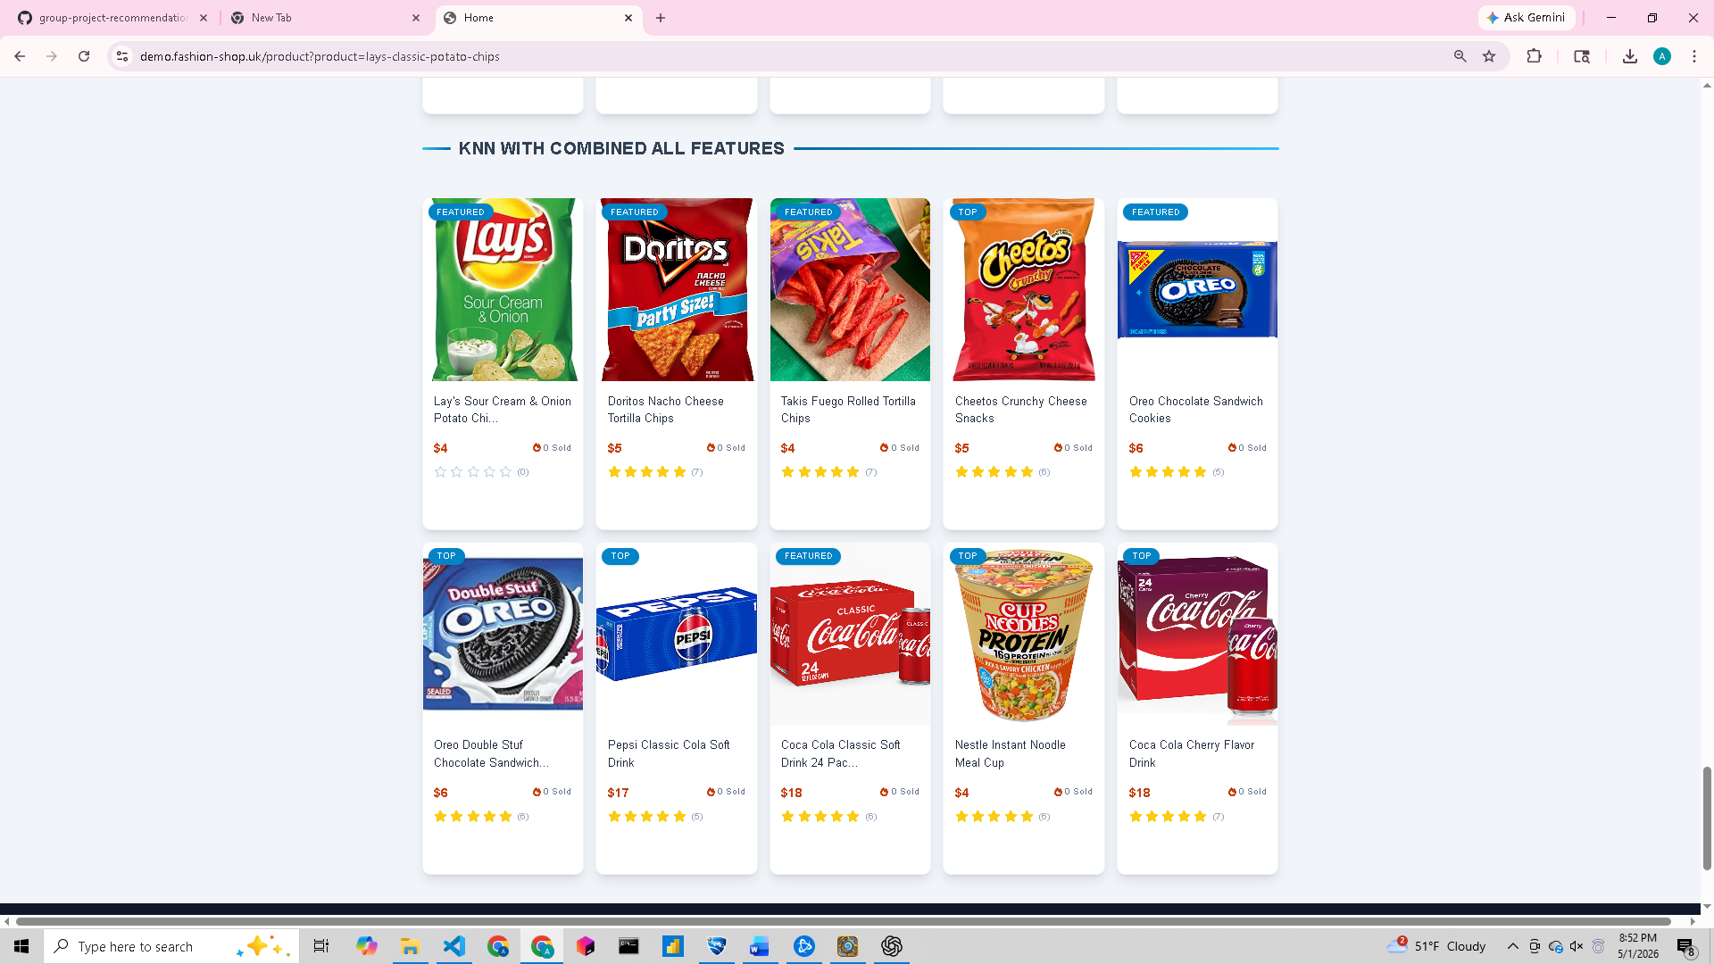
In figure six, the model generated recommendations for the product Lay’s Classic Potato Chips. The recommendations show that the model correctly groups similar snack items such as Doritos, Cheetos, and Takis, which share similar categories and product types. Higher similarity scores are given to products that are closely related in both description and category. As the similarity score decreases, the model begins to recommend items that are still somewhat related, such as drinks or other packaged foods. This behavior shows that the model is not only using text, but also category and price information to make more balanced recommendations. Overall, the model maintains meaningful similarity across different types of products by considering multiple features instead of relying on just one.

- Convergence Analysis
The KNN combined features model does not use an iterative training process, so convergence analysis is not applicable. The model is built by transforming the data into a combined feature matrix and fitting the KNN algorithm once. Because of this, the results remain stable after the model is created.

d. ALS and LightGCN:
- Results Overview
The performance of the models is evaluated using Precision@K and Recall@K. Multiple experiments were conducted by changing model settings such as hyperparameters and observing their impact on performance.
Not Done
- Hyperparameter Analysis
We also tested different hyperparameter values to see how they affect performance. For example, in LightGCN, we varied the number of layers and embedding size. We observed that increasing the number of layers helps the model capture more information from the graph, but too many layers may lead to over-smoothing.
Similarly, for ALS, increasing the number of factors improves the model’s ability to learn user preferences, but may also increase training time.
Not Done

- Model Comparison
From the experiments, we observe that LightGCN performs better than ALS when user interaction data is sparse, such as in the case of new users with very few interactions. This is because LightGCN uses the graph structure to share information between users and items, allowing it to learn even with limited data.
On the other hand, ALS performs very well when the interaction data becomes dense, meaning users have interacted with many products over time. In this case, ALS is able to learn strong user preferences and provide accurate recommendations.
This shows that each model has its own advantage depending on the data condition. LightGCN is more suitable for cold-start or sparse scenarios, while ALS is effective in long-term usage where sufficient interaction data is available.
Not Done

- Convergence Analysis
During training, we also observed how the models converge over time. For LightGCN, the training loss decreases steadily as the number of epochs increases, showing that the model is learning effectively. After a certain number of epochs, the improvement becomes smaller, indicating that the model has reached a stable state.
Not Done

